Tutorial

2024-03-17

## Introduction

This tutorials explain how to use the code for applying the method in *Arcara G.(2024) Improving Equivalent scores: a new method for regression model selection.*

## Set up R

To work with the method you need to load some functions that will be used. Here I included all the required functions in a folder called R functions.

source("R_functions/adjscores_A2024_v3.R")  
source("R_functions/formula_transf_text.R")  
source("R_functions/model_transf_text.R")  
source("R_functions/transf_functions.R")  
source("R_functions/tolLimits.adjscores.R")  
source("R_functions/tolLimits.obs.R")  
source("R_functions/ES.R")

I then load some required packages.

require(effects)  
require(car)  
require(performance)

## Import data

In the following lines I import the data and make some check everything is ok

Test.dat = read.csv("Original_Data/MOCA_Dataset.csv", sep=",", dec=".")  
  
dim(Test.dat)

## [1] 440 5

head(Test.dat)

## ID Age Education Sex Score  
## 1 482 58 27.0 M 25  
## 2 428 70 26.0 F 24  
## 3 236 59 23.0 F 26  
## 4 217 58 23.0 F 28  
## 5 34 89 22.0 M 23  
## 6 414 51 21.5 F 26

str(Test.dat)

## 'data.frame': 440 obs. of 5 variables:  
## $ ID : int 482 428 236 217 34 414 116 336 104 85 ...  
## $ Age : int 58 70 59 58 89 51 65 54 61 63 ...  
## $ Education: num 27 26 23 23 22 21.5 21 21 20 20 ...  
## $ Sex : chr "M" "F" "F" "F" ...  
## $ Score : int 25 24 26 28 23 26 24 27 26 26 ...

# fix values for participants with zero Education otherwise some transformations (e.g. 1/x, log) could give inappropriate results  
Test.dat[Test.dat$Education==0, "Education"] = 1  
  
Test.dat = na.omit(Test.dat)

## Use the method to select regression model

Test.ARC.res = adjscores_A2024(df = Test.dat, dep="Score",   
 age="Age", edu="Education", sex="Sex",  
 dep.range = c(0, 100))

Inspect model results. The results is a list of objects (see adjscores_A2024.R file for details):

* the first is a dataset in which a new column with adjusted scores is added

head(Test.ARC.res$new.df)

## ID Age Education Sex Score dep age edu sex age_tr edu_tr ADJ_SCORES  
## 1 482 58 27.0 M 25 25 58 27.0 M 3364 0.03703704 27.58802  
## 2 428 70 26.0 F 24 24 70 26.0 F 4900 0.03846154 27.48967  
## 3 236 59 23.0 F 26 26 59 23.0 F 3481 0.04347826 28.77122  
## 4 217 58 23.0 F 28 28 58 23.0 F 3364 0.04347826 30.70450  
## 5 34 89 22.0 M 23 23 89 22.0 M 7921 0.04545455 28.33882  
## 6 414 51 21.5 F 26 26 51 21.5 F 2601 0.04651163 28.32426  
## RESIDUALS  
## 1 -2.466498  
## 2 -2.564851  
## 3 -1.283304  
## 4 0.649978  
## 5 -1.715703  
## 6 -1.730263

* the second is the linear model estimated (here I use summary to better inspect the model) and I plot the partial effects

summary(Test.ARC.res$lm.model)

##   
## Call:  
## lm(formula = Score ~ quadr(Age) + inv(Education), data = df)  
##   
## Residuals:  
## Min 1Q Median 3Q Max   
## -8.1796 -1.4153 0.2001 1.5930 6.3890   
##   
## Coefficients:  
## Estimate Std. Error t value Pr(>|t|)   
## (Intercept) 3.005e+01 4.407e-01 68.201 < 2e-16 ***  
## quadr(Age) -5.702e-04 1.027e-04 -5.553 4.89e-08 ***  
## inv(Education) -1.808e+01 2.272e+00 -7.959 1.50e-14 ***  
## ---  
## Signif. codes: 0 '***' 0.001 '**' 0.01 '*' 0.05 '.' 0.1 ' ' 1  
##   
## Residual standard error: 2.401 on 437 degrees of freedom  
## Multiple R-squared: 0.2729, Adjusted R-squared: 0.2696   
## F-statistic: 82.02 on 2 and 437 DF, p-value: < 2.2e-16

plot(allEffects(Test.ARC.res[[2]], partial.residuals=TRUE))

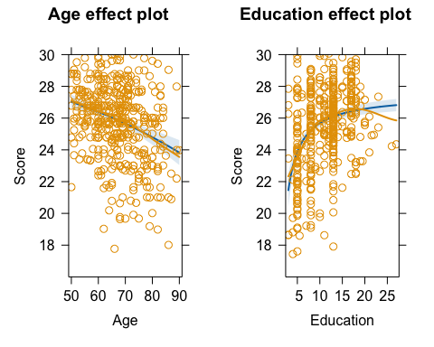

* I can also print the final formula

print(Test.ARC.res$model_text)

## [1] "30.1 + quadr(Age) * -0.00057 + inv(Education) * -18.1"

# Model diagnositc

An appropriate model selection should also include some diagnostics

check_model(Test.ARC.res$lm.model)

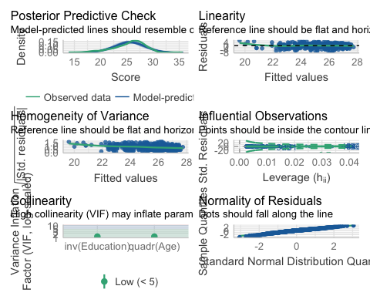

# some disomogeneity in variance, but overall a good fit

# Calculate Equivalent Scores

To calculate thresholds for Equivalent Scores I can use some some few additional code.

Test.ES = ES(adjscores=Test.ARC.res$new.df$ADJ_SCORES)  
  
print(Test.ES)

## $Observations  
## ES0(oTL) ES1 ES2 ES3   
## 15 49 119 219   
##   
## $Adjusted_Scores  
## ES0(oTL) ES1 ES2 ES3   
## 25.26611 27.05381 28.68470 30.22182

# Citing the Method

If you use the regression method script please cite: *Arcara G. (2024) Improving Equivalent Scores: A new method for regression model selection*

If you use the ES, please cite: *Aiello, E. N., & Depaoli, E. G. (2022). Norms and standardizations in neuropsychology via equivalent scores: software solutions and practical guides. Neurological Sciences, 43(2), 961-966.*