* 1. Macro economic outlook through national accounts
     1. Overview

The European Green Deal aims to transform the EU into a modern, resource-efficient, and competitive economy, ensuring no net emissions of greenhouse gases by 2050. To achieve this ambitious target, it's essential to analyse the trends in greenhouse gas emissions across different sectors and understand trend with the help of key indicators related to the intensity of these emissions in relation to employment. This chapter provides an in-depth analysis of these aspects, utilizing data from Eurostat, extending the broad analysis proposed in the Statistics for the European Green Deal (EGD).

This introduction focuses on a gap analysis of key indicators related to air emissions and greenhouse gas (GHG) emissions by activity, highlighting the importance of these metrics in the context of the European Union (EU27-2020). The analysis is based on relevant sources provided by Eurostat, with a detailed breakdown of macroeconomic variables across time in EU27-2020 aggregate.

The purpose of this analysis is to identify gaps and trends in these key indicators across the macro sectors, highlighting areas where improvements can be made to reduce environmental impact and promote sustainable economic growth.

The analysis considers the following key indicators aligned with the Eurostat Statistics for the EGD:

1. Air emissions by activity (production side): This indicator measures the total GHG emissions by activity, providing insights into the environmental impact of different sectors.
2. GHG per Unit of Gross Value Added (GVA) by Activity: This indicator calculates the GHG emissions per unit of GVA, allowing for the comparison of environmental performance across sectors.
3. GHG per employed person by activity: This indicator measures the GHG emissions intensity of employment, providing insights into the environmental impact of employment across sectors.
   * 1. Sectoral contributions

The analysis is based on the macroeconomic sectors of the European Union (EU27-2020):

* + **Food system (Agri+Food)**, including agricultural activities, food processing, and related services.
  + **Industry** , encompassesing all manufacturing activities excluding food processing.
  + **Energy and mining**, including the extraction and production of energy resources and minerals.
  + **Trade**, including wholesale and retail trade activities.
  + **Transport and storage**, including transportation services and storage facilities.
  + **Building**,including construction activities.
  + **Rest of the economy (REST)**, that includes all other economic activities not classified under the above categories.
    1. Data Sources

The data used in this analysis comes from the following sources:

|  |  |  |  |
| --- | --- | --- | --- |
| **Macro variable** | **Dataset** | **Source** | **Unit** |
| Value added (B1G) by activity | National Accounts (Use table) | Eurostat database [naio_10_cp1610] | in mln EUR |
| Greenhouse gases by activity (production side) | Air emissions accounts | Eurostat database [env_ac_ainah_r2] | in mln tonnes |
| Total Employment Domestic concept by activity | National Accounts employment data | Eurostat database [nama_10_a64_e] | in ths persons |

**Supply and Use Tables (SUT)**: These tables provide a comprehensive and economy-wide database of economic transactions, including data on institutional sectors, economic activities, goods and services, and factors of production.

**National Accounts**: These accounts provide data on macroeconomic variables such as GVA, employment, and investments.

**Air Emissions Accounts**: These accounts provide data on GHG emissions by activity (production side).

Figure 1 Greenhouse gas emissions in Mtonnes of CO2eq

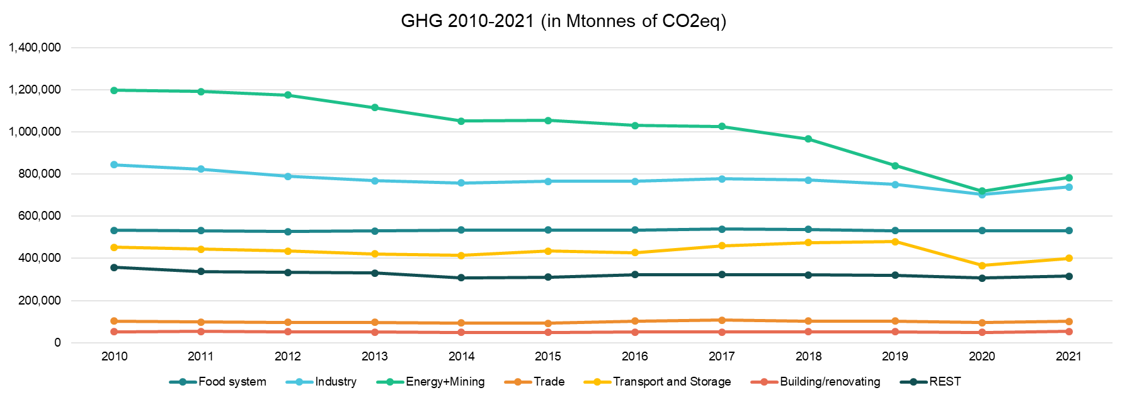

Source: Authors’ elaboration based on Eurostat “Air emissions accounts by NACE Rev. 2 activity” [env_ac_ainah_r2]

Figure 1 illustrates the greenhouse gas (GHG) emissions from various economic activities over the period from 2010 to 2021. This chart is crucial for understanding how different sectors contribute to overall emissions and how their contributions have changed over time. It includes emissions data from sectors such as the food system, industry, energy and mining, trade, transport and storage, building/renovating, and the rest (other sectors not specifically listed). The emissions are presented in million tonnes of CO2 equivalent (Mtonnes CO2eq), showing the annual emissions for each sector. This chart helps identify which sectors are the largest emitters and how their emissions profiles have evolved. For instance, sectors like energy and mining typically have higher emissions compared to others like trade or building/renovating.

Figure 2 presents GHG per unit of GVA by activity. This indicator normalizes greenhouse gas emissions by economic output. It shows the efficiency of an economy in terms of carbon emissions and can be used to assess the environmental impact of economic growth.

Figure 2 Greenhouse gas emissions per unit of GVA by activity

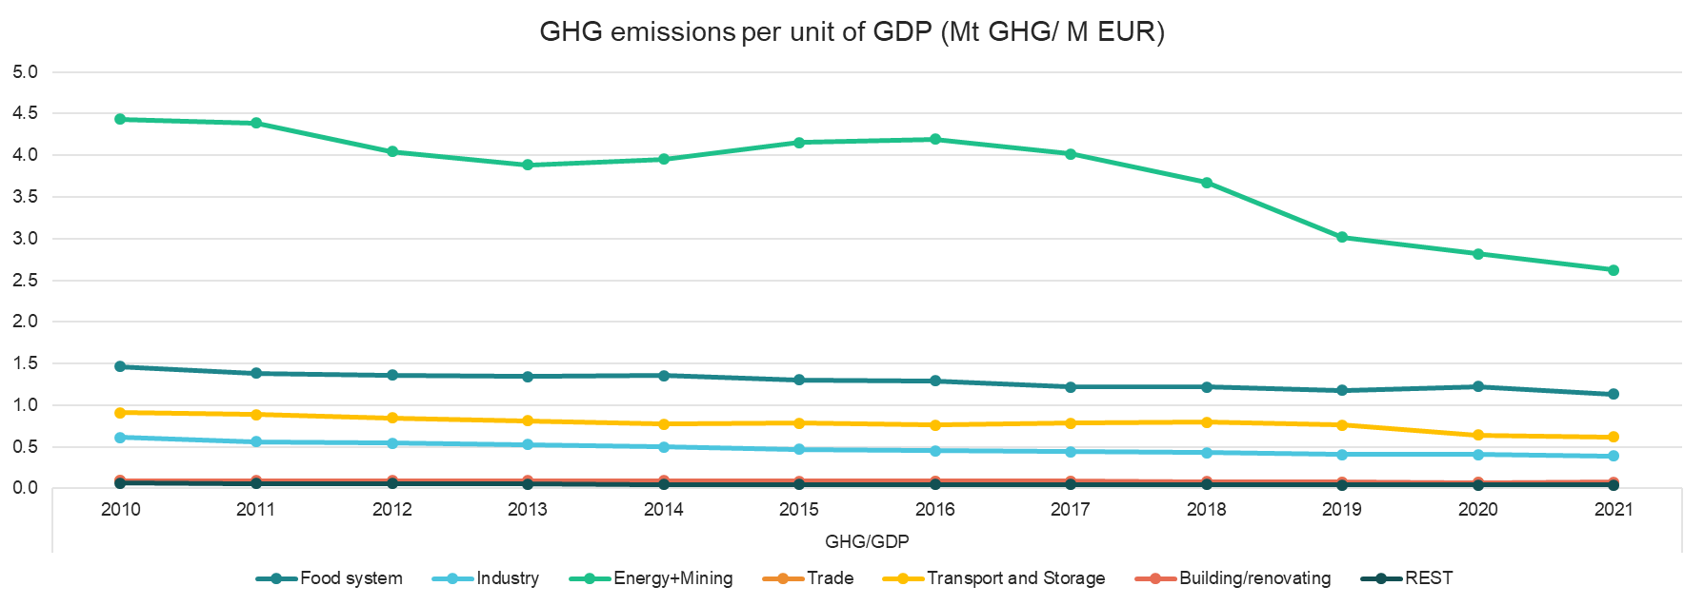

Source: Authors’ elaboration based on Eurostat “Air emissions accounts by NACE Rev. 2 activity” [env_ac_ainah_r2] and Value added (B1G) by activity [naio_10_cp1610]

The chart shows the greenhouse gas emissions per unit of GVA (in Mtonnes of GHG per million EUR) for various activities from 2010 to 2021. The sectors cover the food system, industry, energy and mining, trade, transport and storage, building/renovating, and the rest. This metric indicates the efficiency of different sectors in terms of their economic output relative to their emissions. Lower values represent more efficient, less carbon-intensive economic activities. By normalizing emissions by economic output, this chart helps assess the environmental impact of economic growth in each sector. It is a crucial indicator for identifying sectors where improvements in carbon efficiency are most needed.

Figure 3 Greenhouse gas emissions per employed person, by activity

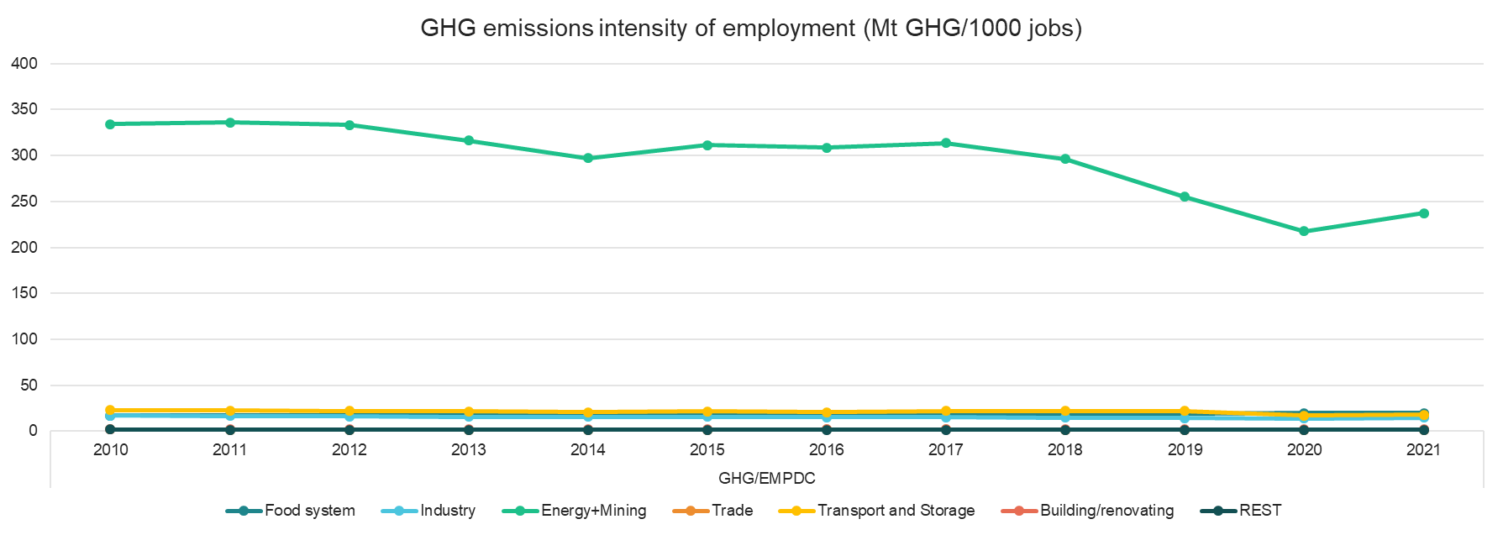

Suorce: Authors’ elaboration based on Eurostat “Air emissions accounts by NACE Rev. 2 activity” [env_ac_ainah_r2] and Total Employment Domestic concept by activity [nama_10_a64_e]

Figure 3 presents the greenhouse gas emissions intensity per employed person (in Mtonnes of GHG per 1,000 jobs) for various sectors from 2010 to 2021. This chart shows how the emissions associated with employment in each sector have changed over time. This metric highlights the carbon intensity of employment within each sector, indicating which sectors generate the most emissions per worker. It is valuable for understanding the environmental impact of employment and for developing strategies to reduce emissions while maintaining or growing employment levels. .

These charts collectively provide a comprehensive view of the environmental impact of different economic activities in the EU. They highlight the importance of targeted policies to reduce emissions in high-impact sectors, improve carbon efficiency, and support a transition to a low-carbon economy. By analysing emissions by production activity, per unit of GVA, and per employed person, policymakers can better understand the challenges and opportunities in achieving the goals of the European Green Deal l.

Table 1. Quantification (shares and absolute numbers) of main indicators (GVA, jobs, emissions, investments) of the EGD sectors, for EU27, 2021

|  |  |  |  |  |  |  |  |  |
| --- | --- | --- | --- | --- | --- | --- | --- | --- |
|  | **GVA** | | **EMP_DC** | | **GHG emissions** | | **Investments** | |
|  | % share | million EUR | % share | 1000 persons | % share | Mtonnes CO2 eq | % share | million EUR |
|
| **Food system** | 4% | 469,661 | 6% | 26,899 | 18% | 531,171 | 0% | 6,623 |
| **Industry** | 15% | 1,890,553 | 12% | 49,964 | 25% | 739,074 | 27% | 805,341 |
| **Energy+Mining** | 2% | 298,540 | 1% | 3,301 | 27% | 783,454 | 0% | 1,561 |
| **Trade** | 12% | 1,508,107 | 14% | 59,274 | 3% | 101,532 | 6% | 168,749 |
| **Transport and Storage** | 5% | 643,506 | 5% | 22,127 | 14% | 399,978 | 1% | 18,534 |
| **Building/renovating** | 6% | 723,499 | 7% | 27,828 | 2% | 53,989 | 40% | 1,184,370 |
| **REST** | 57% | 7,459,266 | 55% | 229,830 | 11% | 315,196 | 27% | 797,310 |

Source: Authors’ compilation, based on ESTAT statistics from SUT 2021, “Air emissions accounts by NACE Rev. 2 activity” [env_ac_ainah_r2] and Total Employment Domestic concept by activity [nama_10_a64_e].