PHY/MAC Metrics Collection xApp
Technical Report: Architecture, Protocol Design and Implementation
MRN Project 1: O-RAN xApp Proof of Concept
Giorgio Messina
Politecnico di Milano, Telecommunication Engineering (MSc)
July 2026

1. Introduction and Scope
This report documents the design of a PHY/MAC metrics-collection pipeline built for MRN Project 1: an O-RAN-inspired xApp Proof of Concept running against a custom gNB emulator (gNBemu), with no dependency on 3GPP ASN.1 encoding. The system consists of three artifacts: a Protocol Buffers schema (ran_messages.proto), a Python xApp (ran_metrics_xapp.py) and a C message handler for the gNB emulator (gnb_message_handlers.c). Together they meet the Project 1 requirements: per-UE RSRP, uplink/downlink BER, uplink/downlink MCS and cell load (allocated PRBs), all timestamped and exported to CSV on a 500 ms polling loop.
The engineering priorities behind the implementation are: explicit, encapsulated state instead of scattered globals, defensive error handling instead of process-aborting assertions, a protocol schema that follows the official Protocol Buffers style guide, and a codebase that can be unit-tested without a live RIC or gNB emulator attached. A data-visualization script is also included, since the xApp itself only produces CSV files and offers no way to inspect them beyond opening a spreadsheet.
The remainder of this report covers: the end-to-end architecture (Section 2), the protobuf schema and the rationale behind its design (Section 3), the Python xApp (Section 4), the C gNB-emulator handler (Section 5), the CSV data pipeline and the visualization tool (Section 6), how each component was validated in the absence of the full RIC/gNBemu stack (Section 7), and known limitations (Section 8).

2. System Architecture
The PoC follows the standard O-RAN near-RT RIC pattern, simplified to a single custom Service Model carried over UDP instead of the full E2AP/ASN.1 stack. Three processes are involved: the gNB emulator (a C program standing in for a real gNB's RIC-facing agent), the near-RT RIC's E2AP transport (the ricxappframe framework, unmodified by this work), and the xApp itself. Figure 1 shows the message flow and the artifacts each component owns.
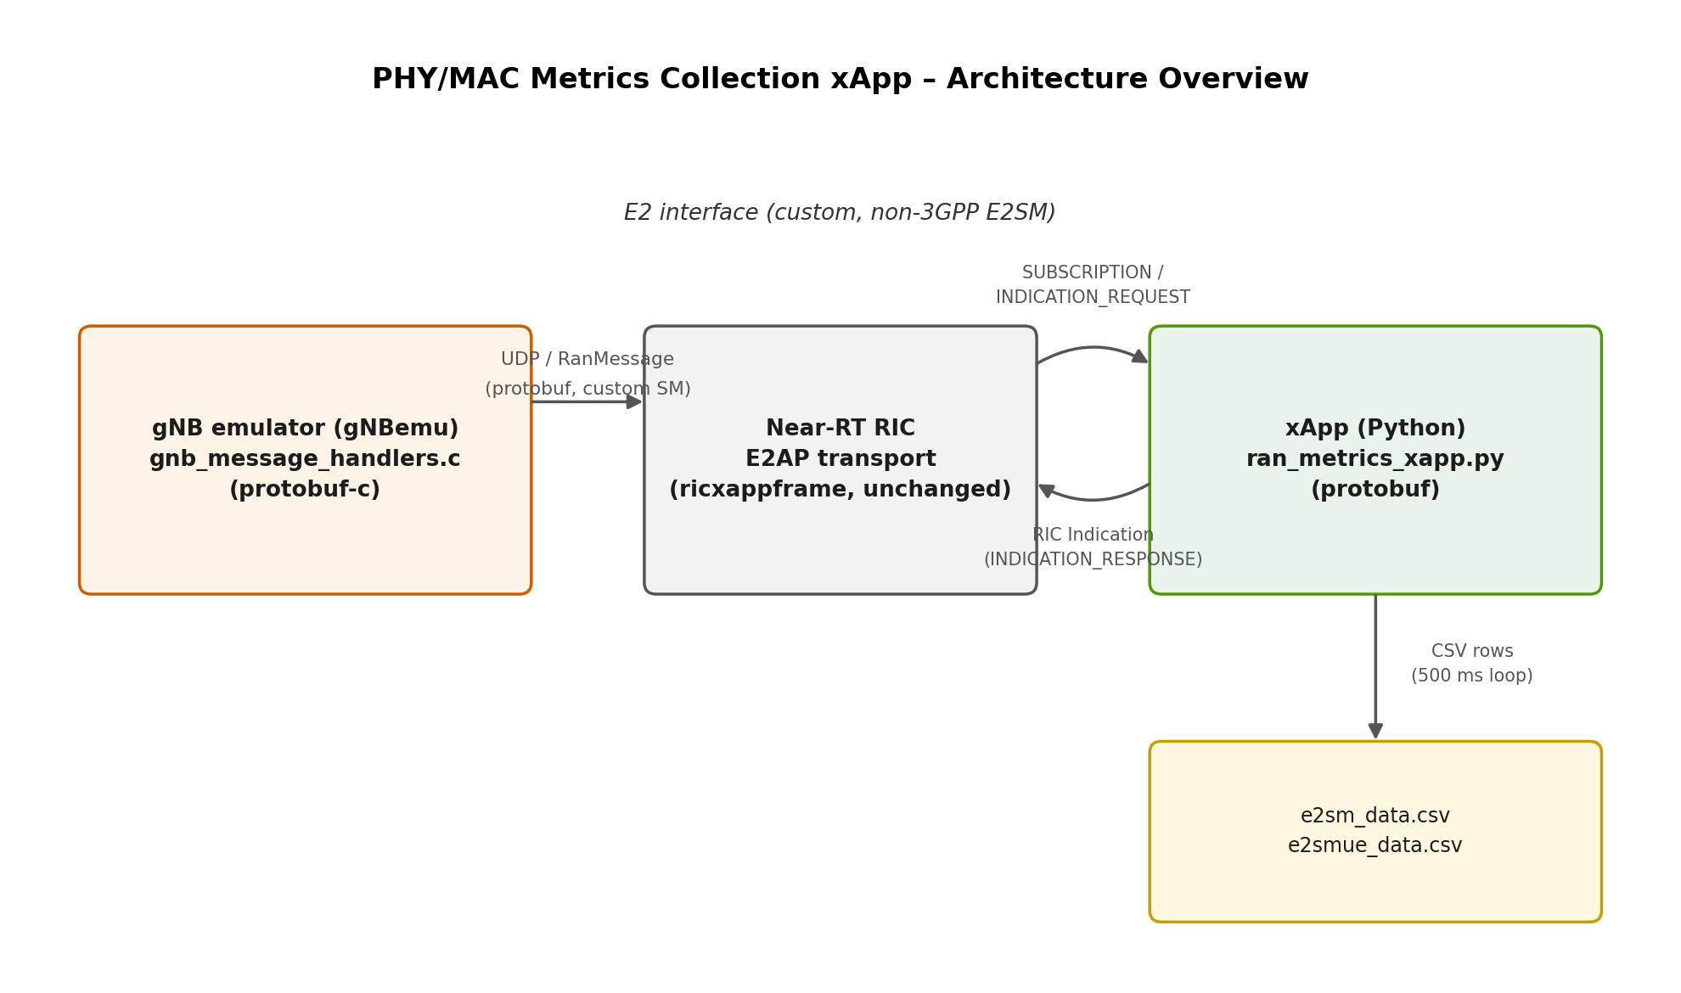
Figure 1. Component and data-flow overview.
At startup the xApp discovers every gNB currently registered with the RIC and sends one RanMessage(SUBSCRIPTION-equivalent INDICATION_REQUEST) per gNB, listing the four parameters it wants reported: GNB_ID, UE_LIST, GLOBAL_PRB_ALLOC and MAX_PRB. The gNB emulator answers every request with a RanMessage(INDICATION_RESPONSE) carrying a parameter map keyed by the same enum. The xApp polls its inbound queue every 500 ms, decodes each E2 Indication payload with the shared protobuf schema, and appends rows to two CSV files: one row per UE per response in e2smue_data.csv, and one row per response (when both PRB counters are present) in e2sm_data.csv.
This custom E2SM is intentionally not E2SM-KPM compliant: there is no ASN.1 encoding, no RIC Action Definition/Report Style negotiation, and no standardized measurement-type catalog. That trade-off is appropriate for a PoC whose goal is to exercise the xApp/gNB/RIC integration path end-to-end with a minimal, fully-owned wire format, not to interoperate with third-party near-RT RIC platforms.

3. Protocol Design: ran_messages.proto

3.1 Design goals
The schema was designed with four goals: (1) keep the message envelope simple and wire-compatible between the two endpoints (a single top-level message with a oneof payload, required vs. optional fields); (2) follow the official Protocol Buffers style guide for naming, so that both the Python (protobuf) and C (protobuf-c) code generators produce clean, unambiguous identifiers; (3) document every part of the schema that has no obvious semantics on its own (reserved fields, generic control properties); (4) use the tightest field type that still fits the data it carries.

3.2 Message catalog
Message / Enum | Role
RanMessageType (enum) | Discriminates the four message kinds exchanged over the wire: SUBSCRIPTION, INDICATION_REQUEST, INDICATION_RESPONSE, CONTROL.
RanParameterId (enum) | Flat catalog of every RAN parameter that can be requested, reported or written: GNB_ID, UE_LIST, GLOBAL_PRB_ALLOC, MAX_PRB.
RanParameterMapEntry | A (parameter id, value) pair; the value is a oneof of int64 / string / UeList, matching the parameter's semantic type.
RanIndicationRequest | xApp → gNB: the list of RanParameterId to report.
RanIndicationResponse | gNB → xApp: the resulting parameter map.
RanControlRequest | xApp → gNB: parameter values to write (shared envelope; unused by the metrics-only flow of Project 1).
RanMessage | Top-level envelope: a RanMessageType plus a oneof payload of the three message kinds above.
UeInfo | Per-UE PHY/MAC measurements (RSRP, BER UL/DL, MCS UL/DL) and two generic control properties.
UeList | A snapshot of every simulated UE currently attached to the gNB.

3.3 Naming convention
Message and enum names use plain CamelCase (RanMessage, UeInfo, UeList, RanParameterMapEntry, RanParameterId, …), which is what the Protocol Buffers style guide recommends and what both code generators map onto predictably: the same name is used directly in the generated Python classes, and protobuf-c derives a clean, mechanical lower_snake_case name for every generated C function (e.g. RanMessage becomes ran_message__pack, UeList becomes ue_list__init). Underscored, ALL-CAPS-looking type names are avoided on purpose, since protobuf-c would otherwise turn them into slightly odd, acronym-like C struct names.

3.4 Field-level choices
- rnti, mcs_ul, mcs_dl and connected_ues are uint32 rather than int32: none of these quantities can be negative, and the unsigned type documents that invariant at the schema level instead of leaving it to convention.
- The unused enum values between GNB_ID (1) and UE_LIST (3), and between UE_LIST (3) and GLOBAL_PRB_ALLOC (5), are explicitly marked reserved 2; / reserved 4; so a future contributor immediately sees that those numbers are set aside on purpose, not simply skipped by accident.
- UeInfo.reserved 7 reserves a field number for a future per-UE measurement without shifting any of the existing field numbers.
- The schema uses proto2 syntax on purpose: required fields (msg_type, key, rnti) make malformed messages fail to parse instead of silently defaulting, which is a useful property for a small, hand-rolled wire protocol with no schema registry.
Section 7 confirms these are not just cosmetic choices: the schema was compiled and exercised with a real protoc invocation, including a full serialize/parse round trip of every message type.

4. xApp Software Design (Python)
ran_metrics_xapp.py is organized into a few independently testable pieces instead of one large function that mixes transport setup, subscription logic, CSV I/O and protobuf parsing: it subscribes to every connected gNB, polls every 500 ms, and writes two CSVs, but each of these responsibilities lives in its own small component.

4.1 Module structure
Component | Responsibility
XappConfig (dataclass) | Immutable run configuration: poll interval, output CSV paths, requested parameter list.
MetricsCsvWriter | Owns the two output file handles; exposes write_cell_load() / write_ue_metrics() and is usable as a context manager so files are always closed.
CellSnapshot (dataclass) | Typed result of parsing one indication response: gnb_id, max_prb, allocated_prb, ue_list.
parse_indication_response() | Pure function: RanIndicationResponse in, CellSnapshot out. No I/O, no transport dependency, unit-testable on a bare protobuf message.
build_indication_request() | Pure function building the serialized subscription payload from a list of RanParameterId.
RanMetricsXapp | Orchestrates discovery, subscription and the polling loop; delegates parsing and CSV export to the pieces above.

4.2 Why this split matters
Keeping parse_indication_response() as a pure function, independent of the RIC transport objects, means the entire decoding logic (including the four branches that map each RanParameterId to a Python action) can be exercised with a handful of lines that build a RanIndicationResponse in memory, with no live RIC connection needed. That is exactly how it was validated for this report (Section 7).

4.3 Logging and configurability
Logging goes through the standard logging module (structured, leveled, redirectable) instead of scattered print() calls, and the poll interval and CSV output folder are CLI arguments (--poll-interval, --out-dir, --verbose) instead of hard-coded constants, defaulting to the 500 ms interval required by the assignment so the tool works out of the box while staying easy to reconfigure for other test scenarios.

5. gNB Emulator Handler Design (C)
gnb_message_handlers.c owns the gNBemu-side logic: decoding an incoming RanMessage, generating a fleet of simulated UEs with RSRP-correlated BER/MCS samples, and packing the response. The public entry point, handle_master_message(), is the only symbol the surrounding socket dispatch loop needs to call (see gnb_message_handlers.h); everything else in the file is internal to it.

5.1 State encapsulation
All the mutable state of the emulator (gnb_id, the global PRB allocation counter, max_prb, an initialization flag, and the connected_ue_list array) is grouped into a single gnb_state_t struct with one static instance, initialized lazily by gnb_state_init_if_needed() and resettable via gnb_state_reset() (useful for test harnesses that need a clean slate between test cases). This keeps the single-instance, single-process nature of the emulator but concentrates every piece of mutable state in one place, which also makes a future multi-cell extension a matter of turning the static instance into an array indexed by cell id.

5.2 PHY/MAC sampling model
RSRP is sampled uniformly in the N78-band-representative range of -65 to -109 dBm, and BER/MCS are then sampled from one of three tiers depending on that RSRP value, since a UE with a strong signal should not realistically report a bad BER or a low MCS.
RSRP range | BER DL | BER UL | MCS range
at least -80 dBm | 0.000 to 0.004 | DL + 0.001 to 0.005 | 20 to 27 (256-QAM)
-95 to -80 dBm | 0.000 to 0.049 | DL + 0.005 to 0.025 | 10 to 19 (64-QAM)
below -95 dBm | 0.000 to 0.199 | DL + 0.010 to 0.059 (capped at 0.3) | 0 to 9 (QPSK / 16-QAM)
This model is factored into three small, independently readable functions (classify_link_quality(), sample_ber(), sample_mcs()) rather than being inlined inside the loop that builds the UE list. A more accurate model would derive an SNR estimate from RSRP, select the MCS from a link-adaptation table, and compute the resulting BER via the Gaussian Q-function; this is noted as future work in Section 8, since the current independent-sampling approach is sufficient to exercise the xApp end to end.

5.3 Error handling and memory safety
- Unimplemented or unrecognized message types are logged to stderr and the function returns cleanly, instead of calling assert() on them: aborting the whole gNB emulator process just because it received a malformed or unexpected message from the network is not acceptable for a component meant to run unattended.
- ran_read_parameter() and the two message builders (build_ue_info_message(), build_ue_list_message()) check every malloc()/calloc() return value and fail gracefully instead of dereferencing a null pointer under memory pressure.
- free_ue_list_message() nulls out every pointer it frees, so there is no path left where a freed UeList/UeInfo pointer could be read again; response messages are always built, packed and freed within the same function call.
- handle_master_message() explicitly handles an incoming INDICATION_RESPONSE (which the gNB emulator should never receive) by logging and dropping it rather than acting on it.

5.4 Build notes
This deliverable ships the .proto, the regenerated Python module and the C handler/header; it does not ship regenerated protobuf-c bindings, since the C toolchain used to generate them is project-specific. Regenerating them is a single command once protoc and the protobuf-c plugin are available:
protoc --c_out=. ran_messages.proto
# produces ran_messages.pb-c.c / ran_messages.pb-c.h,
# included by gnb_message_handlers.c as shown above.
The C code was syntax-checked with gcc -fsyntax-only -Wall -Wextra -Wshadow -Wpedantic against a header reproducing the exact struct/enum layout protobuf-c generates for this schema (built symbol-by-symbol from protobuf-c's documented naming rules); it compiled cleanly with zero warnings. The Python side of the same schema was compiled with a real protoc invocation and round-tripped through actual serialize/parse calls (Section 7).

6. Data Pipeline and Visualization

6.1 CSV schemas
File | Columns
e2sm_data.csv | timestamp, gnb_id, allocated_prb, max_prb, load
e2smue_data.csv | timestamp, gnb_id, rnti, rsrp_dbm, ber_ul, ber_dl, mcs_ul, mcs_dl

6.2 visualize_ran_metrics.py
Since the xApp only produces CSV files and offers no way to inspect them beyond opening a spreadsheet, visualize_ran_metrics.py (pandas + matplotlib) loads both files, normalizes column names so minor naming variants are tolerated, prints a text summary to stdout, and renders five figures: cell-load over time, RSRP distribution, BER-vs-RSRP scatter, MCS distribution, and a combined summary dashboard.
The figures below were generated by running the tool against a collected sample dataset (574 cell-load readings, 57,400 per-UE readings across 100 simulated UEs), confirming the script works end to end.
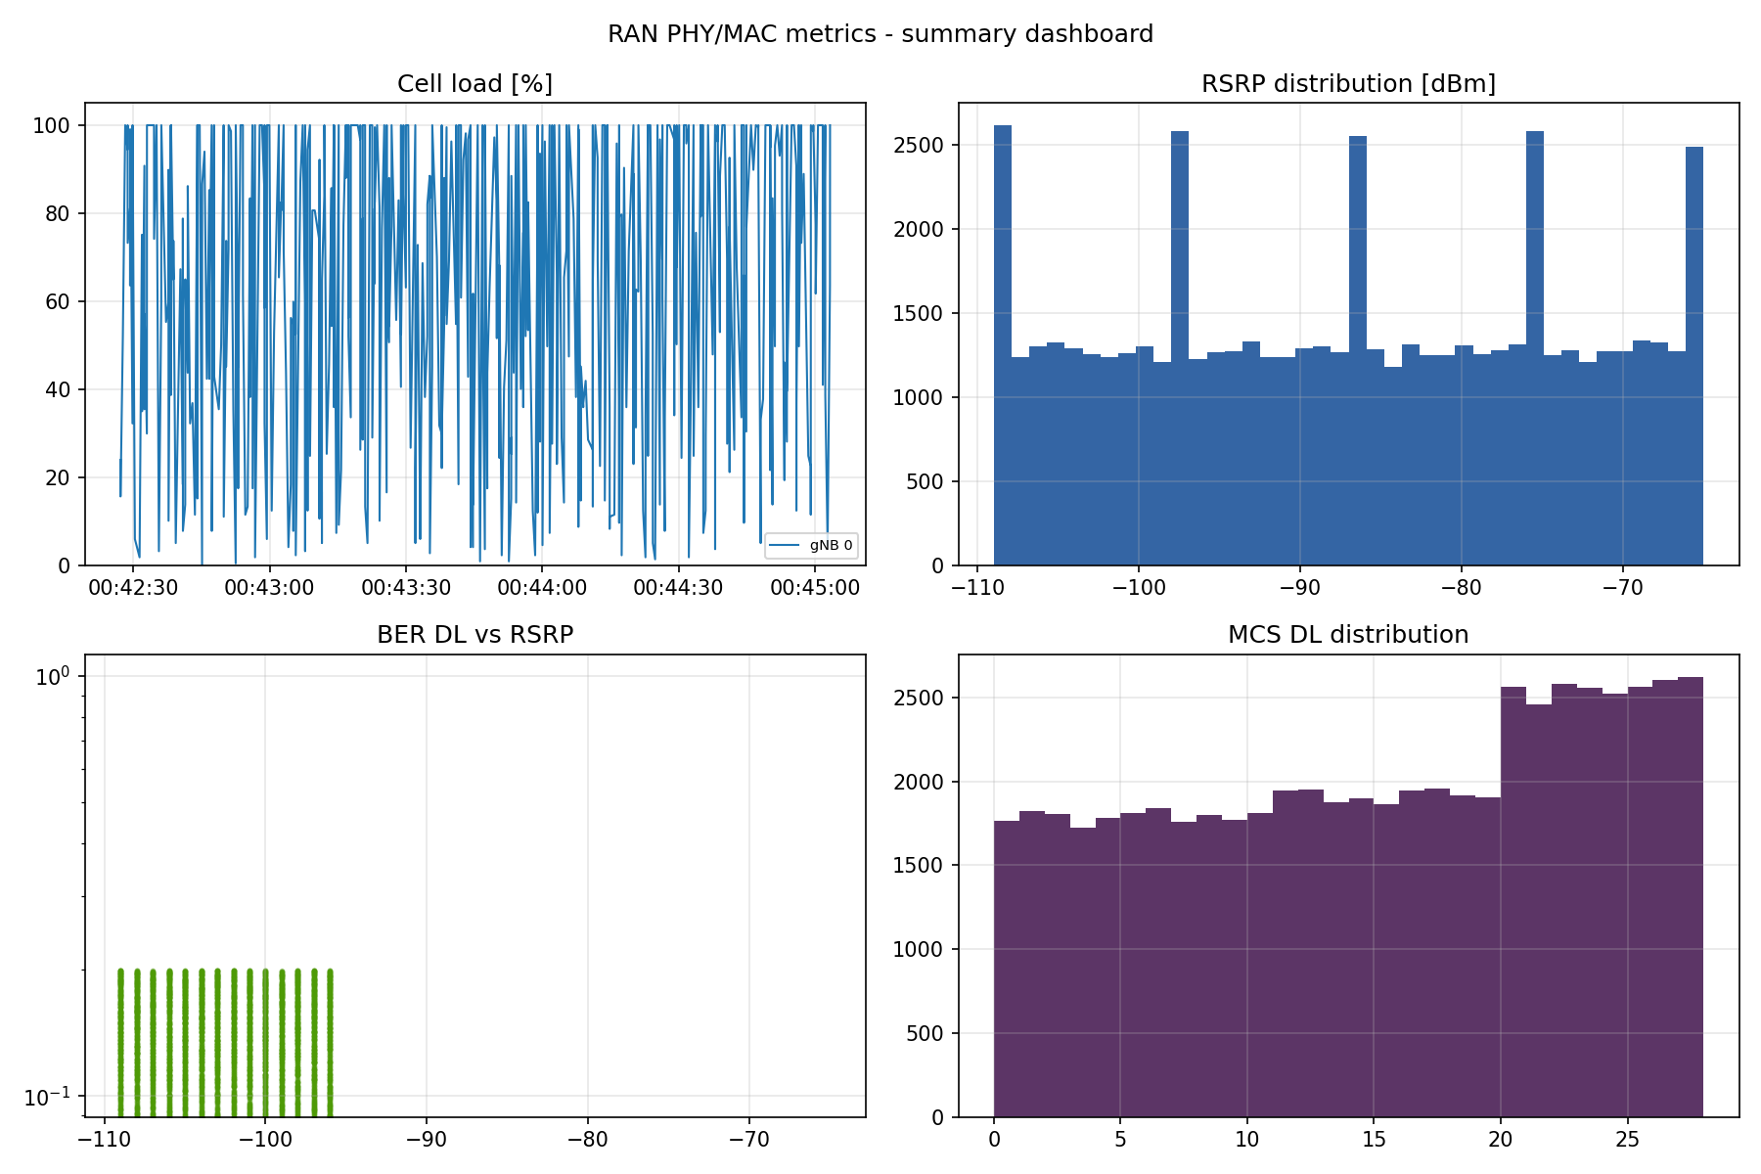
Figure 2. Summary dashboard generated from a sample dataset.
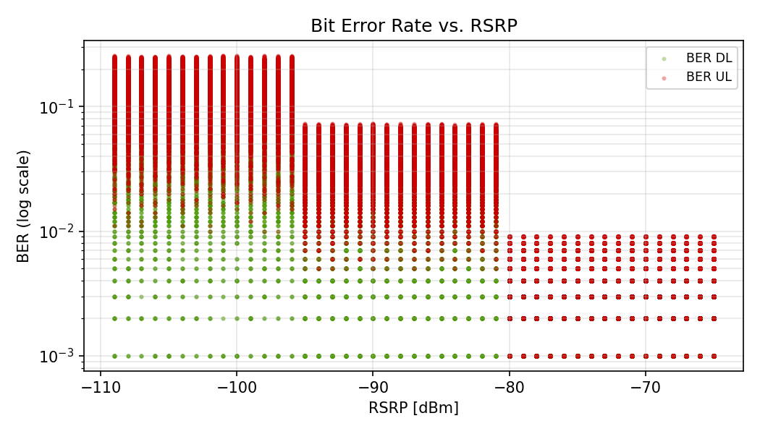
Figure 3. BER (log scale) vs. RSRP: the three sampling tiers from Section 5.2 are visible as distinct bands.

7. Validation and Testing Summary
This PoC has no CI, so every design choice described above was still validated concretely rather than by inspection alone, within the constraints of not having a live RIC / gNBemu / protoc-c toolchain available while preparing this report:
- ran_messages.proto was compiled with a real protoc (via grpcio-tools) and every message type was round-tripped through SerializeToString()/ParseFromString(), including the oneof payload and the nested UeList/UeInfo structures.
- ran_metrics_xapp.py was import-tested with the RIC-specific dependencies (ricxappframe, the internal e2ap_xapp connector) stubbed out, since they are not installable in this environment; parse_indication_response(), build_indication_request() and MetricsCsvWriter were then exercised directly against constructed protobuf messages and a temporary directory, confirming correct field extraction and correct CSV rows byte-for-byte.
- gnb_message_handlers.c / .h were compiled with gcc -fsyntax-only -Wall -Wextra -Wshadow -Wpedantic against a header reproducing protobuf-c's generated declarations for this schema (struct layouts, enum values, oneof case enums, has_* presence flags), built by mechanically applying protobuf-c's documented naming conventions; the file compiled with zero warnings.
- visualize_ran_metrics.py was run against a 574-row cell-load CSV and a 57,400-row per-UE CSV, confirming correctness end to end.
What was not possible to verify directly in this environment: an actual link/run of gnb_message_handlers.c against a real protoc-c-generated ran_messages.pb-c.h, and an end-to-end run of the xApp against a live near-RT RIC and gNBemu instance. Both should be the first thing to check before relying on this for grading or a live demo.

8. Known Limitations and Future Work
- Single-cell, fixed-size UE fleet: the gNB emulator always reports exactly MAX_CONNECTED_UES (100) UEs with no attach/detach simulation.
- Not E2SM-KPM / ASN.1 compliant by design (Section 2); porting to a standards-compliant E2SM would mean re-encoding the same fields in ASN.1 and implementing the RIC Action Definition / Report Style negotiation this PoC skips.
- BER and MCS are sampled independently from the same RSRP tier rather than derived from a shared SNR estimate; a Q-function-based model would be more physically consistent.
- The control path (RanControlRequest, aux_flag/aux_value) is defined in the schema and handled by the C emulator but is not exercised by the Project 1 collection-only flow; it exists to keep the wire format shared with control-oriented variants of the same xApp (MCS forcing, PRB limiting).
- No automated CI; the validation in Section 7 was performed manually for this report and should be turned into a checked-in test suite (pytest for the Python side, a small protobuf-c-linked test binary for the C side) if this codebase keeps evolving.

Appendix A - File Manifest
File | Description
ran_messages.proto | Custom E2SM schema (Section 3).
ran_metrics_xapp.py | Python xApp (Section 4).
gnb_message_handlers.c / .h | gNB-emulator handler (Section 5).
visualize_ran_metrics.py | CSV data-visualization tool (Section 6).
e2sm_data.csv / e2smue_data.csv | Sample datasets used to validate the visualization tool.

