IWFM and SAFE Calculation for One node

# Problem description

The example is shown in the following figure. To minimize the influence of the boundary conditions in the river, I used only 2 nodes as constant head boundary conditions highlighted with green circles.

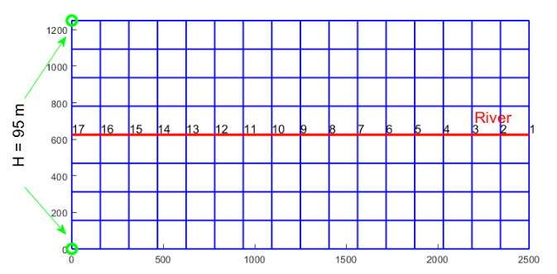

Cross section of the example along the river:

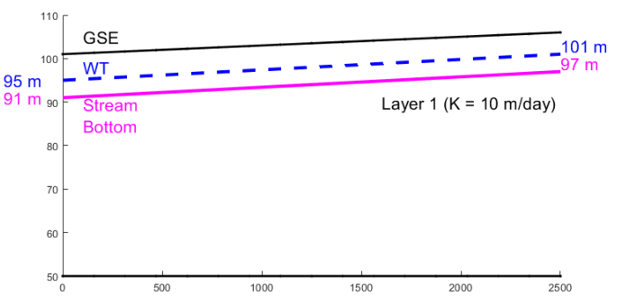

The water table (WT) line corresponds to the initial conditions.

# Calculations

In the following we calculate the stream water groundwater exchange for on node at the last time step of the simulation.

Each time step, the IWFM executes several Newton Raphson iterations. The data correspond to the last iteration of the Newton Raphson of the last time step.

In this document I picked the node with id 10.

## Common parameters

Below we set a few common parameters.

The length  of the river segment of the node is equal to:

L = 156.25;

The area of influence in this example can be calculated as:

A = L*156.25;

Nevertheless, in IWFM the calculation is executed using the standard finite element formula.

The horizontal and vertical hydraulic conductivity  and  are:

Kh = 10;

Kv = 10;

The conductivity  and thickness  of the clogging layer are:

K_cl = 2;

e_cl = 1;

The thickness of the aquifer  and stream bottom  for the selected node are:

W_aq = 53.1875;

hb = 93.6250;

The thickness of the aquifer is measured from the ground surface elevation which is 

GSE = 103.1875;

The absolute elevation of the bottom of the aquifer is 

El_bot = GSE - W_aq

El_bot = 50

The wetted perimeter is expressed as , where is a user defined function as rating table. A plot of the function is shown in the following figure.

ratingTable = [0 0 0;...

2 734.94 10;...

5 3299.29 15;...

15 19033.6 36;...

25 41568.45 2000];

clf

set(gcf,'position',[0,0,800,400]);

plot(ratingTable(1:4,1), ratingTable(1:4,3),'.-', "LineWidth",2)

hold on

xlabel('max(h,h_s) - h_b',"FontSize",14)

ylabel('Wetted Perimeter',"FontSize",14)

title('Rating table')

grid on

hold off



The groundwater head  and stream head  for the node 10 are:

h = 97.0287;

hs = 97.0269;

For IWFM (I'm referring to code not to the manual) stream head is expressed as elevation from the common datum.

To avoid confusion, I'll denote stream stage as 

By interpolating the rating table, we find that the wetter perimeter  for the node 10 where  is:

Wper = 12.3395;

Last we calculate the head difference which is common for all methods.



Hdiff = max(hs, hb) - max(h, hb)

Hdiff = -0.0018

## IWFM

In IWFM code (not in the documentation) the unit conductance is first calculated in a preprocessing step before the simulation starts and it is equal to

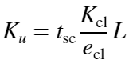

where is scaling parameter to account for the time units. In our example the time step is a month and therefore in IWFM 

For the node 10 this is equal to:

Kunit = 30*K_cl*L/e_cl

Kunit = 9375

Next the conductance  is:

Cs = Kunit * Wper;

fprintf('Cs = %f\n',Cs)

Cs = 115682.812500

And finally, the stream-groundwater interaction  is

Qsint = Cs .* Hdiff;

fprintf('Qsint = %f\n',Qsint)

Qsint = -208.229063

## SAFE

### Pre - processing

The following parameters of the SAFE method do not change during the simulation and can be calculated prior to the simulation.

SAFE width

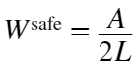

Wsafe = A / (2 * L)

Wsafe = 78.1250

The SAFE grid size  which has nothing to do with any mesh element is computed as

Gsafe = 2 * Wsafe

Gsafe = 156.2500

## Simulation step

### Flat conductance

Calculate the river stage 

h_stage = hs - hb

h_stage = 3.4019

Calculate the saturated thickness 

Daq = h - El_bot % Groundwater head - Bottom of the aquifer

Daq = 47.0287

Next, the degree of penetration is computed as

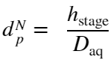

d_Np = h_stage / Daq

d_Np = 0.0723

The average saturated thickness  is also used to calculate the normalized wetted perimeter:

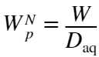

W_Np = Wper / Daq

W_Np = 0.2624

Next, we compute the  value:



kappa = exp(-pi*W_Np)

kappa = 0.4385

The conductance for a flat recharge area is calculated as

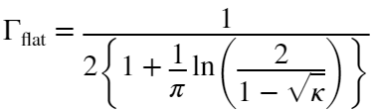

G_flat = 1 / (2 * (1 + (1/pi) * log(2/(1-sqrt(kappa)))))

G_flat = 0.3193

### Isotropic case

If the aquifer is isotropic the conductance is calculated as



where the coefficients  are estimated as a function of the normalized degree of penetration  and normalized wetter perimeter 

According to the table

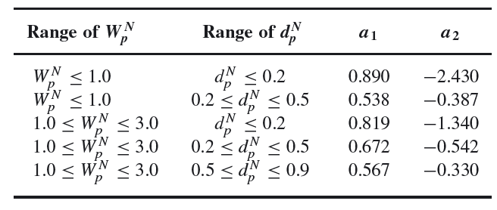

The values  and  get the values:

a1 = 0.890;

a2 = -2.430;

Therefore  is calculated as:

G_iso = G_flat * (1 + a1 * d_Np + a2 * (d_Np^2))

G_iso = 0.3358

### Excess far distance

To estimate the excess far distance  we must calculate the half river width  where  is the river width.

The river width is not known but it can be estimated from the equivalent rectangle for the IWFM cross-section. If we preserve the river stage  and the wetted perimeter , then the wetted perimeter can be expressed as . The wetted perimeter is interpolated from user defined rating tables (see the common parameters) and the river width can be computed as 

Wr = Wper - 2.*h_stage

Wr = 5.5357

Bsafe = 0.5.*Wr

Bsafe = 2.7679

Then the far distance is calculated as

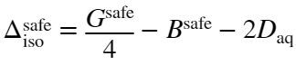

Delta_iso = Gsafe/4 - Bsafe - 2*Daq

Delta_iso = -57.7628

Finally, the extended value of the dimensionless conductance is calculated as:

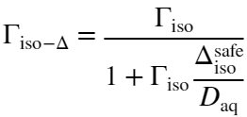

G_iso_D = G_iso / (1 + G_iso * (Delta_iso/Daq))

G_iso_D = 0.5714

### Correction for clogging

In IWFM a clogging layer is always assumed to exist, therefore the final conductance is calculated as

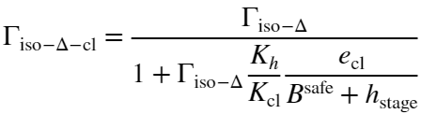

G_iso_D_cl = G_iso_D/(1 + G_iso_D * (Kh/K_cl) * (e_cl/(Bsafe+h_stage)))

G_iso_D_cl = 0.3905

To be consistent with the summary, let's call the conductance as 

G_Q = G_iso_D_cl

G_Q = 0.3905

The sw-gw interaction finally can be calculated as



where  is the groundwater head and  is the river head and  is the horizontal hydraulic conductivity.

Q_sint_safe = 2.*L.*Kh.*G_Q.*(hs - h)

Q_sint_safe = -2.1968

The above value has the same time units as the hydraulic conductivity which is expressed in days.

Therefore, the actual comparable to IWFM value is

Q_sint_safe*30

ans = -65.9044

# Modflow

For Modflow the SW-GW interaction is calculated as

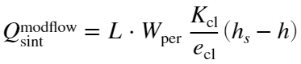

Q_sint_modflow = L*Wper*(K_cl/e_cl)*(hs-h)

Q_sint_modflow = -6.9410

If we include the time conversion parameter 

Q_sint_modflow * 30

ans = -208.2291

which is very similar to IWFM

# Incipient desaturation

The incipient desaturation is expressed as

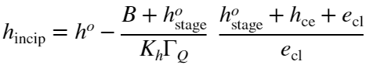

The terms with superscript  are supposed to be the values at the previous step. However in IWFM each time step is solved iteratively until there is a converge. Therefore we can use as old values the ones from the previous convergance iteration. For the first iteration we will use the values from the previous step as a starting point.

In the following final head  and river stage  are used in place of  and . (I also assume that  is identical to )

For the above formula we need the entry pressure term . I assume that this is a user input but it is unknown at the moment, so I'll test a range of values

h_ce = -10:0.1:1;

Calculate the incipient and plot the values for the above range

When the term is positive then  the connection is saturated.

If the term is negative then the  and the connection is unsaturated.

h_incip = h - ((Bsafe + h_stage)./(Kh.*G_Q)) .* ((h_stage + h_ce + e_cl)./(e_cl));

clf

plot(h_ce, h_incip, 'LineWidth',2)

hold on

plot(h_ce, h*ones(1,length(h_ce)), '--r','LineWidth',2)

ylabel('Incipient desaturation')

xlabel('Entry pressure')

grid on



For entry pressure below -4.4 the connection remains saturated.