

User Test Report

(2603) Αλέξανδρος Χαρισιάδης, harisiad@csd.uoc.gr
(2617) Γιώργος Καραγιαννίδης, gkaragia@csd.uoc.gr
(2643) Σταύρος Καφετζογιαννάκης, kafetzog@csd.uoc.gr
(3129) Γιασμίν Ανδρουλάκη, csd3129@csd.uoc.gr
Table of Contents

Introduction 3
Results 4
Scenario 1 4
Scenario 2 5
Scenario 3 6
Scenario 4 7
Scenario 5 9
Scenario 6 10
Scenario 7 12
Scenario 8 15
Scenario 9 16
Scenario 10 17
Scenario 11 18
Scenario 12 20
Scenario 13 21
Scenario 14 23
Scenario 15 24
Scenario 16 24
Scenario 17 25
Scenario 18 27
Scenario 19 29
Scenario 20 30
Scenario 21 32
Scenario 22 34
Scenario 23 35
Debriefing 36
System Usability Scale 38
Problems and Solutions 39
Possible Improvements 40
Conclusion 40

Introduction

Platform
The Archive is a learning platform designed to help students of the Computer Science department keep up with their university responsibilities.
It offers a wide range of functionalities; from keeping up with your semester’s courses, to keeping tabs with your fellow students. We invited 6 users to help up evaluate the usability of our system.

Target Users
We invited 6 users (5 male - 1 female) to help us evaluate the usability of our system by conducting an experiment where they were asked to complete a series of scenarios. Five of those users had High Experience in using similar systems and one had Medium Experience.

Time and Place
The experiments took place at the University of Crete over the course of two days, with each one lasting from 25-35 minutes.

Hardware
We used a MacBook Pro laptop with a 13-inch display and the resolution was set at 720p.

Results

Note: The Optimal Way represents the least number of clicks to complete the scenario.

Scenario 1
Log in to the system with your credentials:
Username: csd1234@csd.uoc.gr
Password: 456123

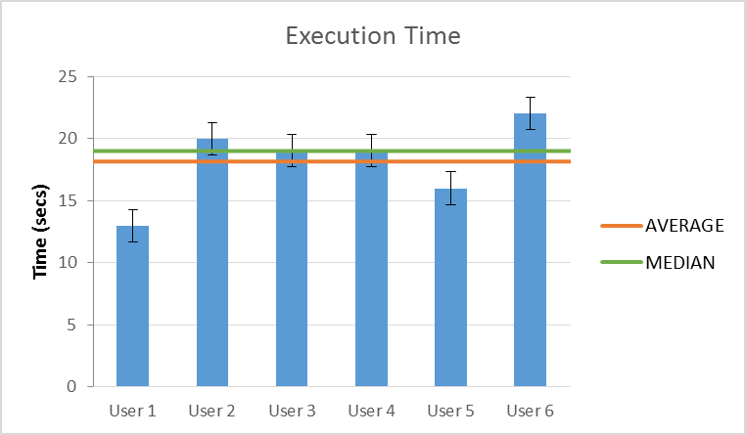

All users managed to complete this task with no difficulty whatsoever.

Conclusion:
The scenario was performed on average in 18sec compared to the optimal time of 15sec. The inconsistencies in times can be linked to whether the user chose to click on the remember me option (which was not mandatory) as well as whether they waited for the whole animation to load before moving on to the next step.

Scenario 2
You know that tomorrow (Friday 5th of May) you have a CS464 tutorial. You want to see the time and room the class takes place.

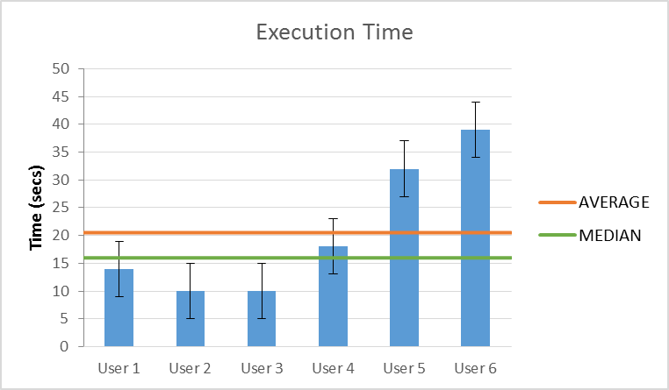

Optimal way to complete Scenario 2 (from dashboard):
See “Schedule” module.

User 2, User 3, User 4, User 5 and User 6 completed the scenario the optimal way. However, some of them did take a while to notice it (User 6 took 39sec).

User 1 accessed the information from the calendar tab in 10sec, a lot faster than the majority of the users did from the homepage.

Conclusion:
All users successfully completed the scenario. It was performed on average in 20sec compared to the optimal time of 4sec. The inconsistencies in times can be linked to personal cognition as well as observational skills.

Scenario 3
A little while ago the description for Phase C of CS464 has been published. Find out when the deadline for submission is and download the relevant file.

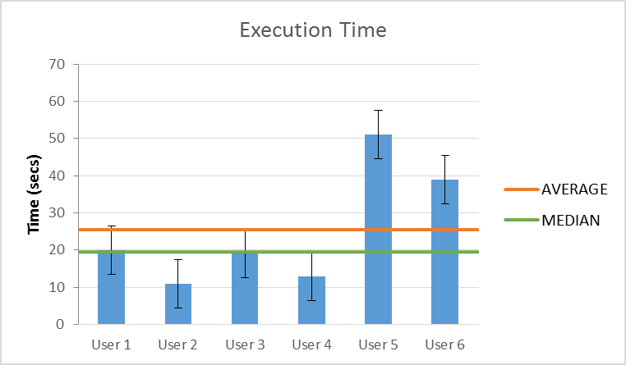

Optimal way to complete Scenario 3 (from dashboard):
See “Assignments” module.

User 2 and User 4 completed the scenario the optimal way.

User 3 completed the scenario the optimal way, however, she had a quick look at the “Schedule” module before noticing the “Assignments” one.

User 6 completed the scenario the optimal way, however, he clicked on the upload icon instead of the title of the assignment in order to view and download it.

User 1 and User 5 accessed the information from the project timeline on the corresponding course page (with user 5 taking the longest amount of time, 51sec).

Conclusion:
All users successfully completed the scenario. It was performed on average in 25sec compared to the optimal time of 9sec. The inconsistencies in times can be linked to personal cognition as well as observational skills.

Scenario 4
You have to submit an assignment for CS340 by tomorrow afternoon. You know that the assistants have opened the assignment submission system since last night and after speaking with your group, you will upload the two (2) deliverables and you will add as a notice that your team has also implemented the Syntax Parser bonus (manually):
PhaseC.zip
Report.doc

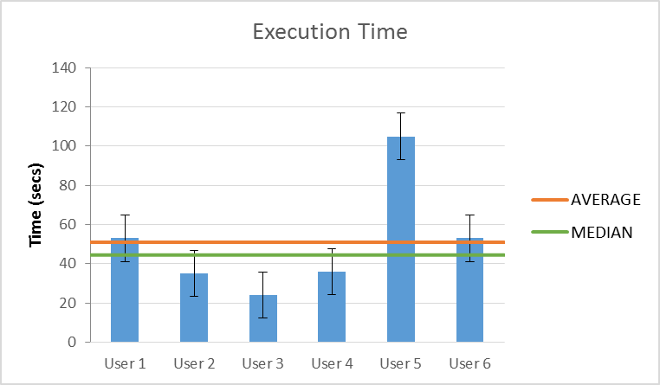

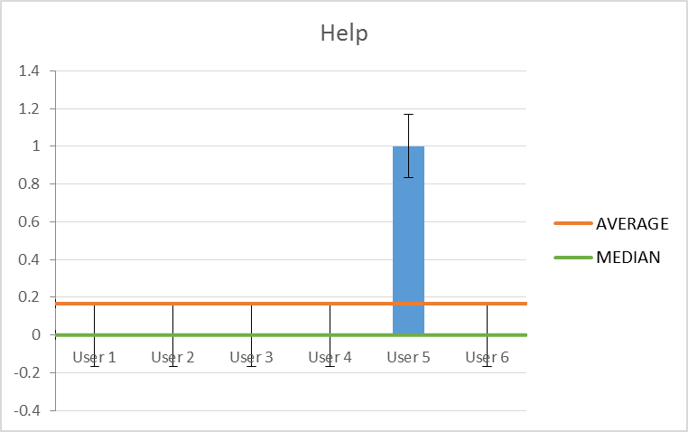
Optimal way to complete Scenario 3 (from dashboard):
See “Assignments” module.

User 2, User 3, User 4 and User 6 completed the scenario the optimal way.

User 1 went to the HY340 course page from the courses tab and tried to submit his assignment from the project timeline, which was not linked to the submission page, and went on to submit it from the assignments tab on the course page.

User 5 also went to the HY340 course and tried to submit his assignment from the project timeline. However he was “stuck” for about a minute in the information tab not knowing what to do.
Help: At this point help was requested and he was guided to click on the assignments tab, where he then managed to complete the task.

Conclusion:
All users successfully completed the scenario. It was performed on average in 51sec compared to the optimal time of 16sec. The confusion with User 1 and User 5 was made due to our mistake of not connecting the project timeline to the assignment submission. To be more specific, the issue was with reaching the drag and drop page. Once there, everything went on as expected and the users efficiently managed to upload the assignment. Other time inconsistencies can be linked to personal cognition as well as observational skills.

Scenario 5
You just realized that you did not have the most recent version of PhaseC.zip so you want to change your deliverable.

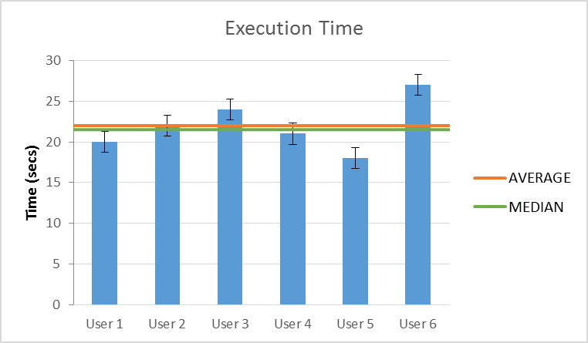

All users managed to complete this task with no difficulty whatsoever.

Conclusion:
The scenario was performed on average in 22sec compared to the optimal time of 15sec.

Scenario 6
Can you see your grade in the previous CS340 Phase (Phase B) that was recently posted?

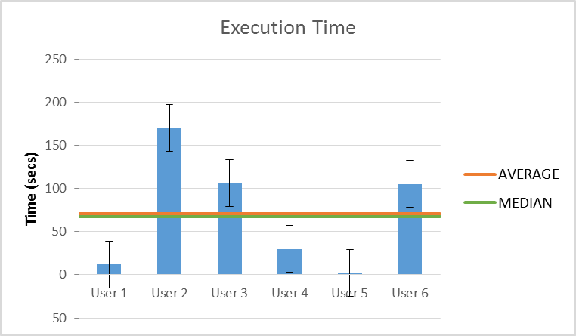

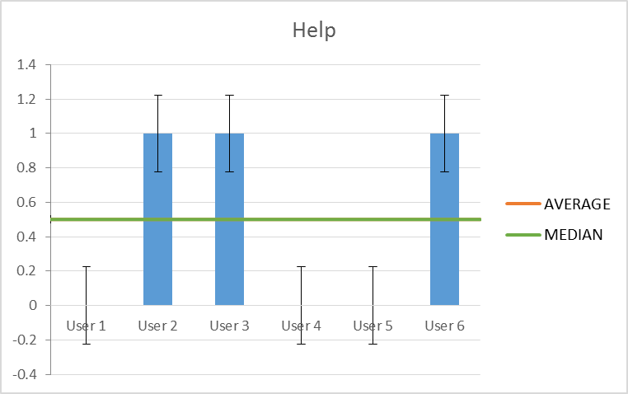

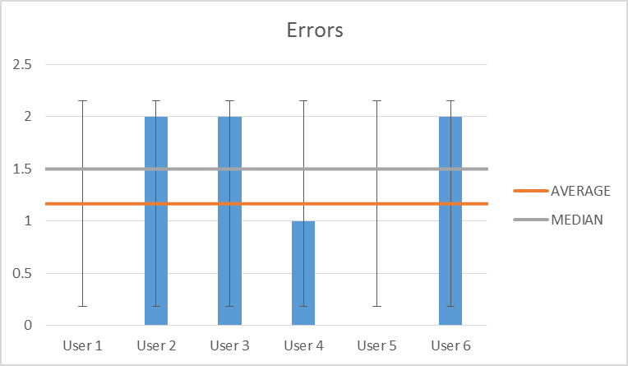
Optimal way to complete Scenario 6 after Scenario 5:
View grade from Assignments tab.

User 1 went to the Courses tab from the menu, followed by the HY340 course page (at this point realizing his mistake), assignments and viewed his grade.

User 2 and User 3 clicked on the Grades tab from the menu and realized it referred to the overall grades of a course.
User 2 then went back to the HY340 course page, from the Courses tab, and spent a large amount of time trying to find his grade in the Description tab of the course page.
User 3 searched in the Groups tab.
Help: Both users requested at this point help and they were guided to click on the Assignments tab, from where they noticed their grade.

User 4 went back to the homepage, followed by the Grades tab and then the CS340 course page, from where he managed to view his grade.

User 6 clicked on the Grades tab twice. He also considered searching in the notes tab on the course page.
Help: At this point help was requested and he was guided to click on the Assignments tab, from where he noticed his grade.

User 5 was the only one to notice the grade immediately (he took the optimal time of 2s).

Conclusion:
All users managed to eventually complete the task; 3 of them however requested some help and 4 of them made mistakes in the process. As this scenario follows the assignment submission scenario, the users were basically already at the right place to view their grade. However, most users failed to notice this, and tried to find their grade elsewhere. As most students are used to viewing their grades in a PDF file, we figure that this could be the main reason behind their errors. Or the grade just wasn’t visible enough from the “list” view. Possible solutions to this is making the grade a different color, larger or bold, or even including a PDF file with the student’s grades in the course page. Another solution would be including the assignment grades in the Grades tab as well, so students would be able to see both their overall grades on a course as well as the detailed ones.

Scenario 7
You want to plan a trip before the semester is over and you want to see your assignments’ submission deadlines, so that you won’t be absent during a critical period

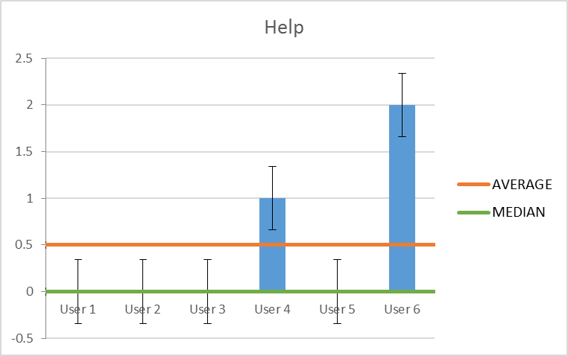

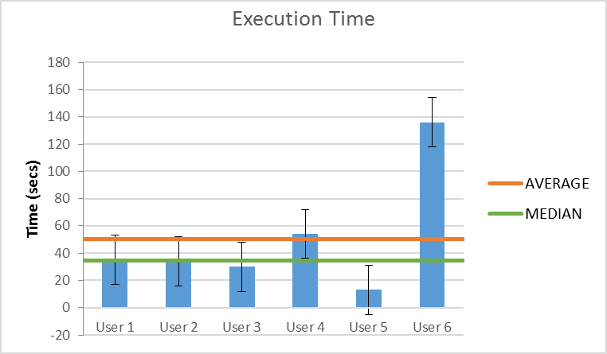

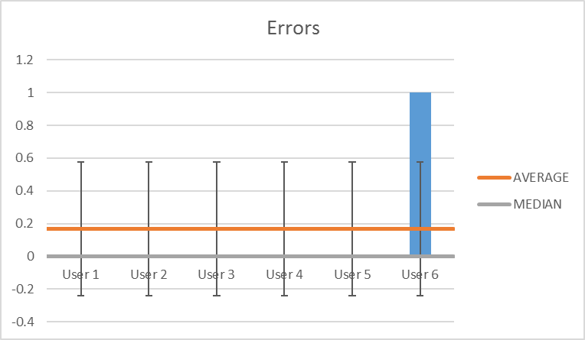

Optimal Way 1 to complete Scenario 7 (From Dashboard):
Is in Dashboard.
Click on Calendar on the Left Side Nav (Main_Nav) and check the assignments due (Red Bullets).
Optimal Way 2 to complete Scenario 7 after Scenario 6:
Click on Calendar on the Left Side Nav (Main_Nav) and check the assignments due (Red Bullets).

User 1 – User 2
As we can see User 1, User 2 successfully completed the scenario in approximately the same time.
Used Optimal Way 1(first went to the Dashboard and then clicked on the Calendar).

User 3
We can assume that the extra 5 sec User 3 took to complete the scenario compared to User 1 and User 2 is due to his personal cognitive, observational and memory retention skills.
Used Optimal Way 1(first went to the Dashboard and then clicked on the Calendar).

User 4
Moving on to User 4 he took an extra ~20sec because he was trying to access the information he needed through the Assignments module (Dashboard) until he asked if he could actually do it through there. After answering him that he cannot actually attain the information through here he correctly pressed on Calendar and checked the deadlines.
Used Optimal Way 1
Help: The only help he was given was a simple “No” answer at his question if he can actually access the assignments deadlines through the Assignments Module (Dashboard).
What we make of it:
This is our mistake. We wanted to show the assignments approaching sooner (never mind the 1st of June Assignment) but we missed the fact that a user might actually want to access all the assignments info through there. We should indicate that there are more than 3 assignments and when the user clicks onto the module header, the window should expand showing all the assignments and when they are due (to fit with the other “Expand” modules).

User 5
This is the fastest time out of all the Users and indicates that 1 in 6 can actually achieve times close to the optimal. (This is a very small sample and we cannot actually make any real stats out of it)
Used Optimal Way 2

User 6
This is the slowest time out of all the Users by far.
User 6 spent a lot of time trying to figure out the calendar.
He then tried to change the month and that’s when we told him that the end of this month is the end of the semester. (Scenario Miss)
He read the scenario again.
After that he tried to filter by deadlines.
He asked for help at that point and we told him that red bullets indicated the assignment deadlines.
He then successfully proceeded to complete the scenario.
Help: The help he got was that the end of May is actually the end of the semester and that red bullets indicate assignment deadlines.
Error: He could not find out which the assignments deadlines bullets are.

What we make of it:
The scenario should be rewritten to indicate that May is the end of the semester.
The bullets should have a description at some place in the Calendar (or some other form of event-indication).
As with User 5 this indicates that 1 in 6 can actually have a problem completing this scenario but since this is a really small sample we cannot make any real stats of it.

Conclusion:
All Users successfully completed the scenario
Again, because the sample is too small we can’t really say if these “problems” that arose are actual problems but if the sample was 1000 people and 16.6%(which is 1 in 6) had one of those problems we could consider them a low priority usability problem.
Scenario 8
You want to find some free time during the week between 8/5 – 12/5 to arrange a 2-hour appointment with Phoebe. The appointment must not coincide with a class or a meeting with the assistants.

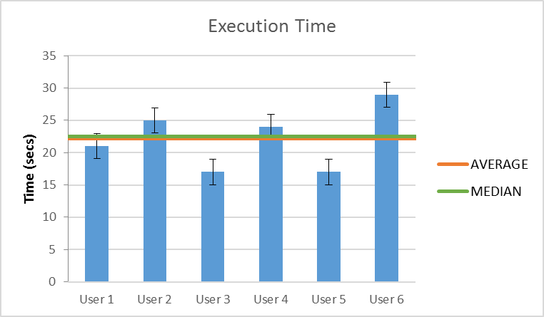

Optimal Way 1 to complete Scenario 8(From Dashboard):
Click on Calendar on the Left Side Nav (Main_Nav) and check the events’ times.
Optimal Way 2 to complete Scenario 8 after Scenario 7:
Is in “month calendar” view.
Checks events’ times.
Conclusion:
As we see from the diagram above the time is pretty consistent.
All Users successfully completed the scenario
User 1, User 2, User 5 and User 6 directly assessed a time period they are available through the “month” Calendar while User 3 and User 4 used the “week” calendar.
Since there are users in both cases with the “best times” and no errors or helps given,
we can assume that both “week” and “month” calendar are equally fast ways to complete the scenario.
Even though the optimal way 2 was not used by all, we can see that the extra click User 3 and User 4
made to go into “week” view made no difference at the execution times.
The rest of the discrepancies between times can be linked to personal cognitive and observational skills.

Scenario 9
You figured you’re free to meet Phoebe on Wednesday, 10th May from 20:00-22:00. Add it to your calendar so you don’t forget.

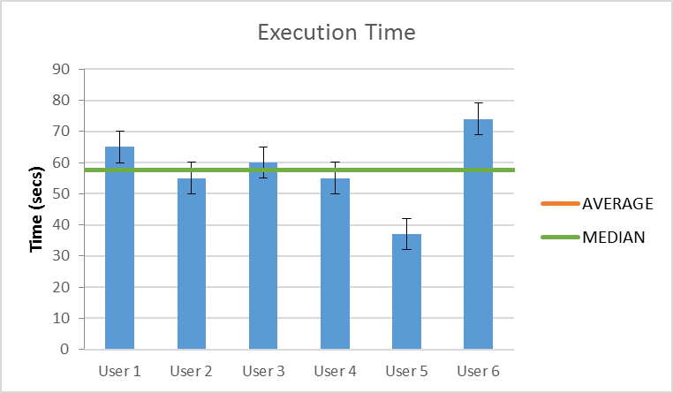

Optimal Way 1 to complete Scenario 9(From Dashboard):
Click on Calendar on the Left Side Nav (Main_Nav) and click on add event.
Optimal Way 2 to complete Scenario 9 after Scenario 8:
Is in “month calendar” view.
Click on add event.
User 1, User 2, User 5 and User 6 directly clicked on “add event” from the “month” Calendar while User 3 and User 4 clicked on “add event” when in the “week” calendar.

Conclusion:
As we see from the diagram above the time is pretty consistent.
All Users successfully completed the scenario.
Since there are users in both cases with the “best times” and no errors or helps given,
we can assume that both “week” and “month” calendar are equally fast ways to complete the scenario.
The rest of the discrepancies between times can be linked to personal cognitive and observational skills.
The only “problem” here was that the hotspot for scrolling down to the time the scenario dictates is small and some users took some seconds more to click on it.
Scenario 10
The course registration period is now open. Can you see until when you can register for courses?

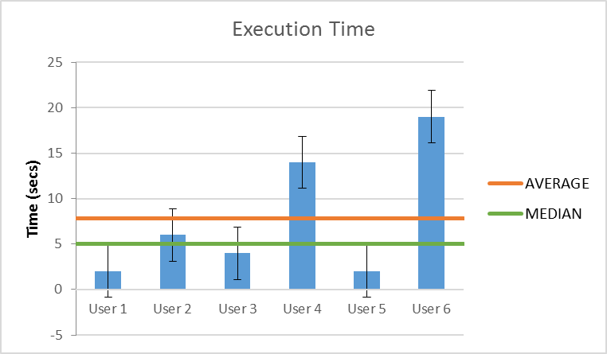

Optimal Way 1 to complete Scenario 10(From Dashboard):
See the “Important Notices” module (Red border).

Optimal Way 2 to complete Scenario 10 after Scenario 9:
Click on Dashboard (Home).
See the “Important Notices” module (Red border).

User 1, User 2, and User 5 remembered at once that they saw it on dashboard and went right for it.
User 3 found it through “Registrations”.
User 4 found it through the “Dashboard” as well but discovered it at that time (he did not remember it).
User 6 took more time because he expected the notice to be in the “Announcements” module (Dashboard). Then after thoroughly examining the Dashboard he found it.

Conclusion:
All Users successfully completed the scenario.
The inconsistencies in times can be linked to personal cognitive, observational and memory retention skills.
Scenario 11
You want to modify your registration statement that contains the following courses and you want to add “CS457: Introduction to Secure Systems (6 ECTS)”. How many credits have you gathered after this addition?
CS464: Human-Computer Interaction (6 ECTS)
CS340: Languages and Compilers (6 ECTS)
CS100: Introduction to Computer Science (Re-evaluation for grade improvement) (6 ECTS)
CS565: Process Management Systems (6 ECTS)
Bachelor's thesis (2 semesters) (18 ECTS)

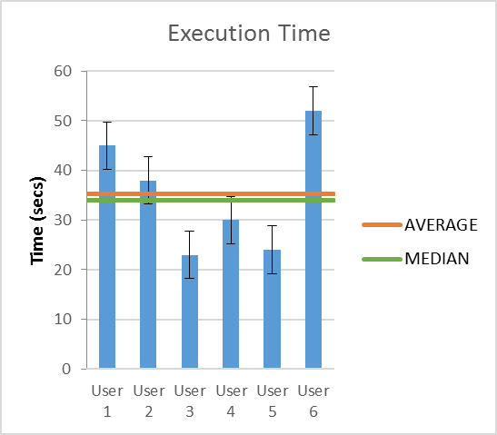

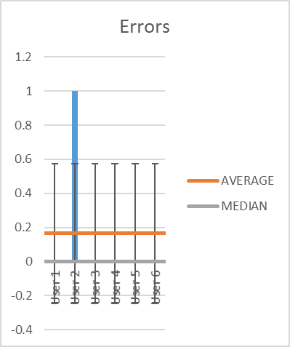

Optimal Way 1 to complete Scenario 11(From Dashboard):
Click on the “Registrations now open” in the “Important Notices” module (Red border) and proceed with the edit form.
Optimal Way 2 to complete Scenario 11(From Dashboard):
Click on the “Registrations” on Left Main Nav and proceed with the edit form.
User 2, User 3, User 4, User 5 and User 6 directly pressed on the “Important Notices” module and proceeded with the edit (Used Optimal Way 1).

User 1 used Optimal Way 2.

Error: User 2 could not see how many ECTS he had before he resent the form(He counted them to come to a conclusion).
Help: The help he received was that we told him that there is a donut chart on the same page indicating the remaining ECTS.

Conclusion:
Most of our testers checked their ECTS after they resent the form. (5 in 6)
User 2 tried to check his ECTS before he actually resent the form (after the addition of the course) so we cannot really say if this is a remote incident or that it may happen again to some users.
In the end all users successfully completed the scenario.
Scenario 12
You remember that your colleague Manos told you that he had taken a very interesting course. You don’t remember the exact title but you are sure it had the word Technology and that it was a 3rd year course. Find out what is that course.

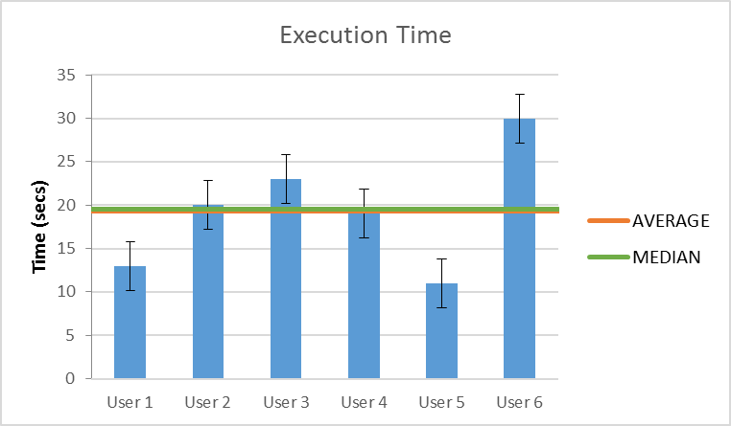

Optimal Way (Only Way) to complete Scenario 12(Global):
Click on the “Search Bar” on the static container on top.

User 1 and User 5 were aware of its existence (search bar) from the start.
User 2, User 3, User 4 had a quick overall look of the dashboard before finding it.
User 6 spent some more time going from left to right scanning the Left Nav, then the dashboard.
He eventually found it.

Conclusion:
All users successfully completed the scenario.
All users were aware that CS 3xx correspond to a 3rd year course.
Scenario 13
You know there is a lecture right now on CS340. Watch its’ livestream.

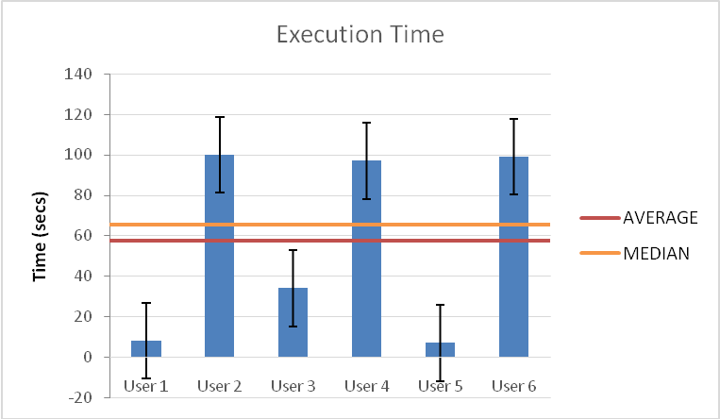

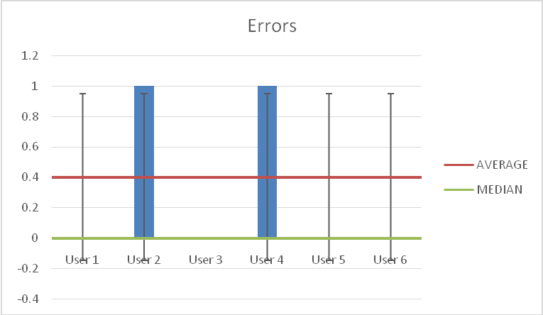

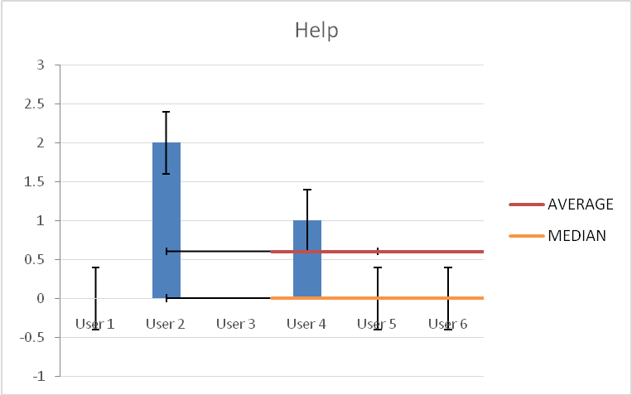

Optimal Way 1
Click livestream button in calendar in homepage.

Optimal Way 2
Go through CS340 lectures (not implemeted).

User_1, User_3 and User_5 managed to complete the task with the optimal way 1.

User_6 chose way 2, then without any help or error, managed to find way 1.

Errors:
User_2, User_4 chose optimal way 2. It was correct, but it was not implemented, so we gave them some time to find the optimal way 1.
Both of them still couldn't find the livestream and they received help.
At that point, they were given help and eventually they found it.

Help:
The help they received was:
"If you want to see something that is happening now, where would you go?"

Conclusion:
All users completed task, resulting average time of 57.5sec, compared to the optimal time of 4sec. In a full-functional system, all users might have completed the task with optimal ways and lower times. So, the errors that occur for users 2,4 are made after they been told that there's another way (way 1) than the way they chose (way 2).
Scenario 14
You have 5 new notifications. Go view them.

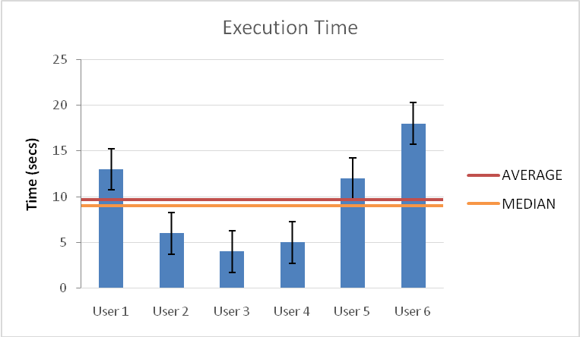

Optimal way (only way):

Click notification bell. Scroll. Close notification bell.

All users managed to complete the task successfully.

User_6 thought that notification bell might be in navigation bar, but eventually found it.
He also suggested: “I would like to have notifications in navigation bar".

Conclusion:
All users managed to complete the task successfully, without committing any errors or asking any help, resulting average time of 9.6sec, compared to the optimal time of 4.5sec.
User_6, who didn't see notification bell right away, made the highest time(18sec).
Scenario 15
You are now somewhat accustomed to the system. You want to upload a profile picture. Go on and do it.

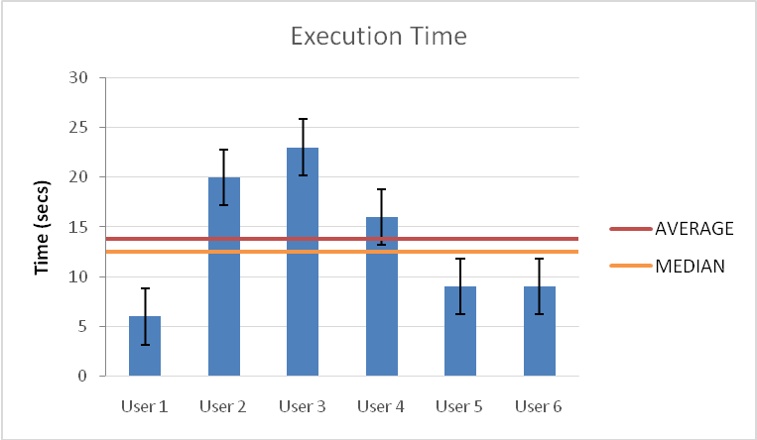

Conclusion:
All users managed to complete the task successfully, without committing any errors or asking any help, with average time of 13.8sec, compared to 7.5sec optimal time.

Scenario 16
You want to upload some personal files and check the remaining free space.

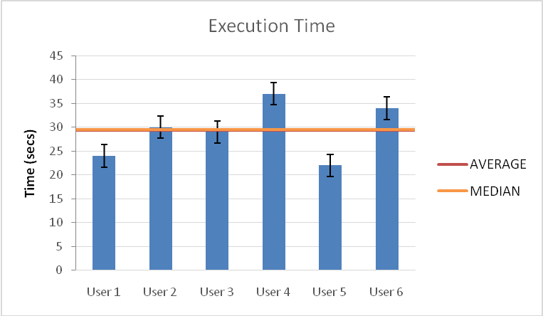

Conclusion:
All users managed to complete the task successfully, without any errors or help, resulting average time of 29.3sec, compared to 10sec optimal time.
Scenario 17

You have made some great notes for the 3rd lecture of CS464 and you want to submit them. Go ahead and do that and also check your submission status.

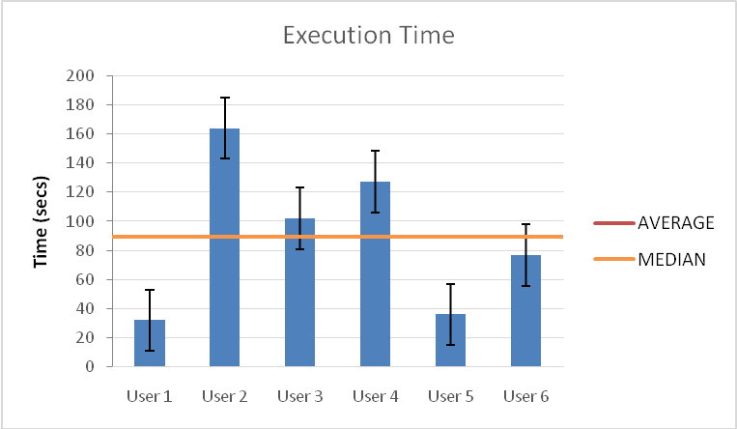

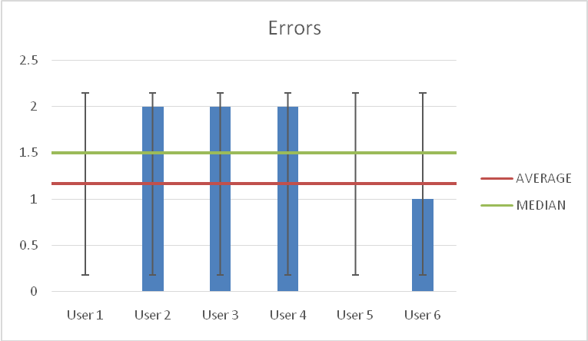

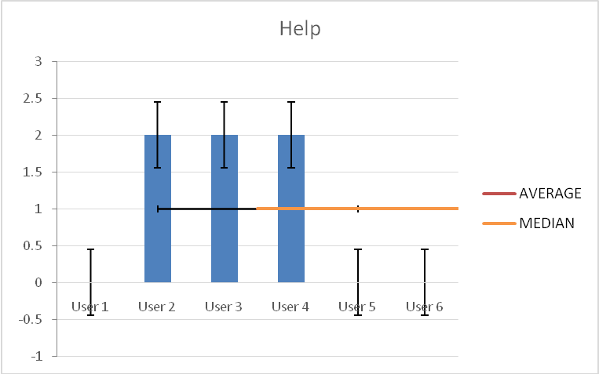
Optimal Way (only way):
Go to CS464 course page, go to Notes, select lecture 3, upload your notes, check the verification status.

User_1 and User_5 managed to complete the task without any errors or help.

User_6 managed to complete the task without any help.

Errors:
Users 2,3,4, and 6 had the same errors:
a) They thought that the notes, that were already uploaded in the system, were their notes.
b) They couldn't figure out, that the submit button stood for upload button.
At both points they asked for help (except for User_6 who figured out both of them by himself).

Help:
a) We made clear that the notes they see are others' students notes.
b) We told them that the 'submit 'button stands for the 'upload' button.

Conclusion:
All users managed to complete the task successfully, resulting average time of 73.1 sec, compared to optimal time of 16.5sec.
This scenario was a little tricky for the users.
- First thing, we have to make clear to the users, that the notes they saw in the notes tab, were already uploaded to the system. This can be made by a label like: "Current notes online" or "Other users uploads".
- Second, there was an 'submit' button instead of 'upload' button. This is our mistake. This mistake can be solve by change the 'submit' button to an 'upload' button.
Scenario 18
You have attended the book presentation “The book of Nazism” by Vaggelis Tzoukas and want to remove it from your announcement favorites.

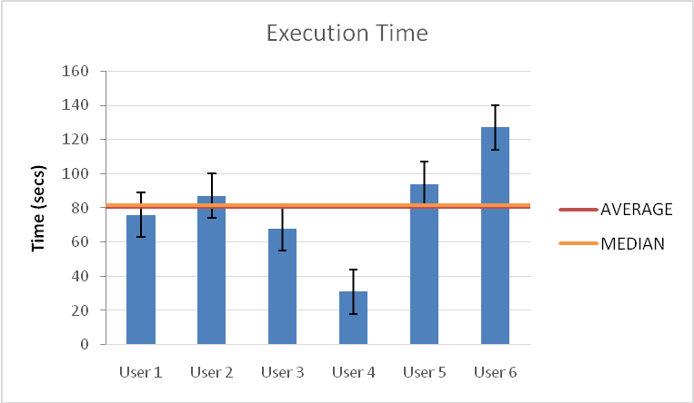

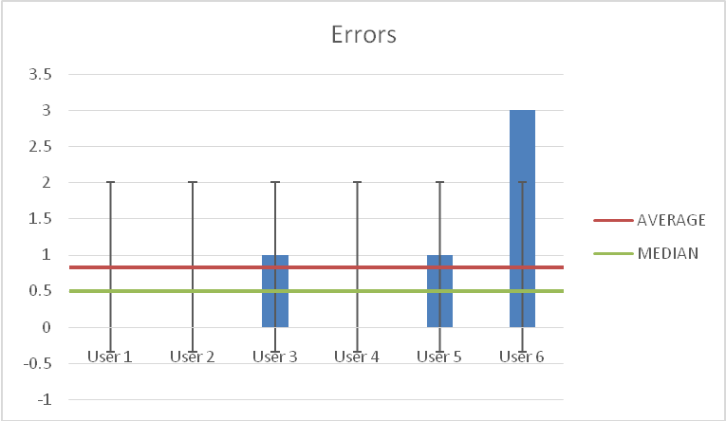

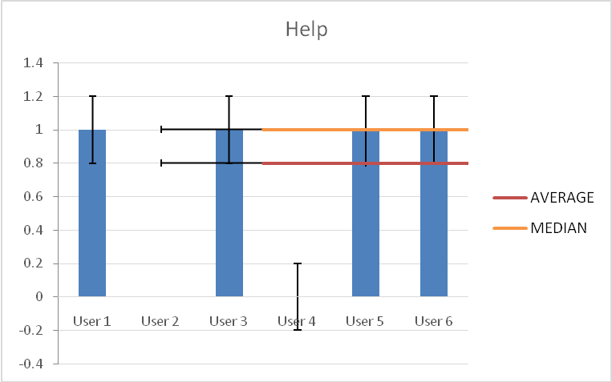

Optimal way 1:
Navigate to announcements, remove from favorites the specific announcement .

All users managed to complete the task successfully, resulting average time of 80.5sec, compared to 5.5sec optimal time.
User_4 managed to complete the task relatively fast compared to the rest users, resulting the lowest time of 31sec.

Errors:
The rest 5 users had problems completing the task. The reason is that the scenario is ambiguous (in Greek), in result of confusing the users:

Κάποια στιγμή πρόσθεσες στα Αγαπημένα σου την ανακοίνωση για τη παρουσίαση βιβλίου “Το βιβλίο του Ναζισμού” του Βαγγέλη Τζούκα στην οποία έλαβες μέρος, οπότε τώρα θές να τη βγάλεις απο τα αγαπημένα.

So, the first thought of the 5 users were:
"Maybe my favorites are in profile page".
So, all of them went to profile page seeking for favorites. Which is normal, if there was something called favorites, it might be in profile. So, this task, even thought it was wrong, it wasn't practically error.
User_5 also thought: "I was attending, maybe I had an event about it.”, so he went in the Calendar searching for it, which also wasn’t an error.
After they received help, User_3 and User_5 couldn't find the expand button(Error).
Although the scenario wasn't clear, User_6, after going to profile, tried to find Favorites in Course Registration, Groups and then he received help. This was an actual error, because he already made the scenario with the registration form (scenario 11) and he knew the purpose of this feature.
Also, the scenario with the Groups wasn't performed yet, but again the scenario didn't mention anything about groups.

Help:
Users 1,3,5 and 6 users asked for help and the hint that we gave was:
-"Read the scenario again". Only User_2 managed to complete without help, after going to profile page.

Conclusion:
If the scenario was clear enough, users' first thought could be:
"I have to go to the announcements", so there was no confusion, committing any errors and resulting better times.
Scenario 19
You and your friend decide to take on the CS340 project as a team, so you want to create a group for it. (enter group’s name, members and color).

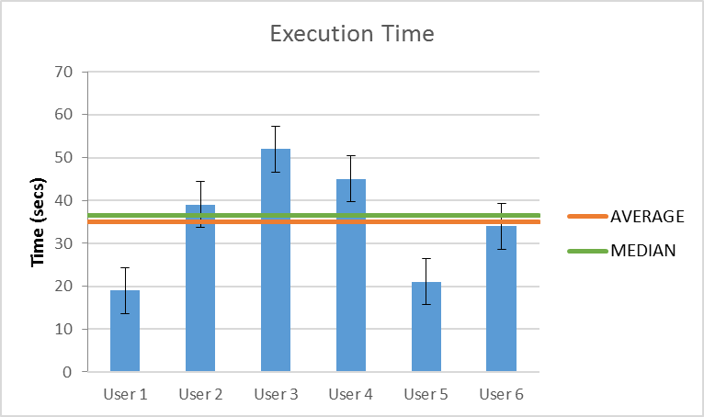

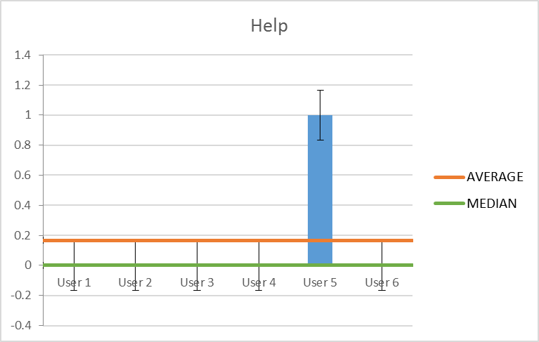

User 1, 2, 3, 4 and 6 completed the task without receiving help and without errors, relatively quickly.

User 5 completed the task without any help and in the minimal amount of time.
Errors: The user assumed that since he is the one creating the group he should be automatically included, so he inserted one person on the group.
Conclusion
All the users completed their tasks without any help.
From the error of user 5 we can see the logic behind of not including yourself inside the group, so it would be a good idea to automatically include the user who makes the group automatically included without the user inserting him/herself.
The scenario was completed with a small average time and everyone followed Optimal Way 1.
Scenario 20
Now that you have started working on the project, you want to upload some files and make a commit, so your partner can see your progress.

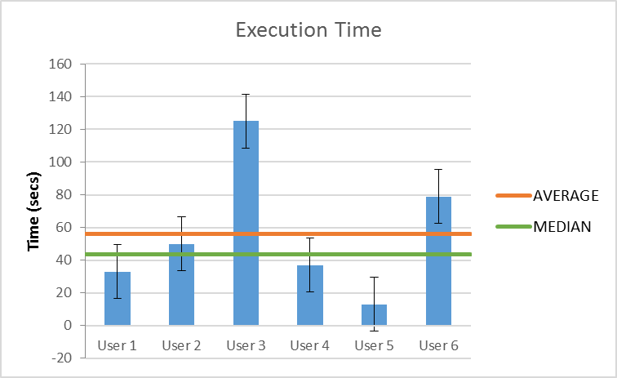

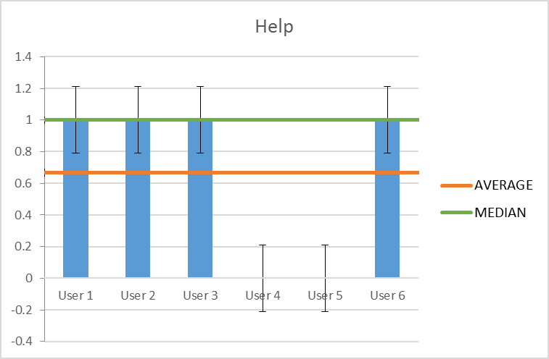

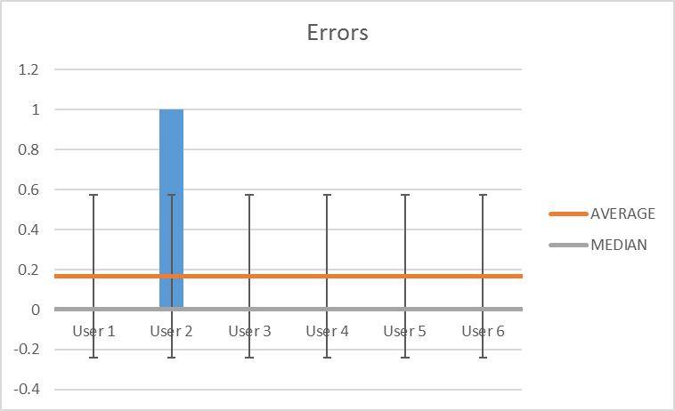
User 1 completed the scenario after he wandered first by trying to edit the group then going to calendar and then he received help.
Help: The user received guidance in opening the group page to continue the scenario.
Observations: The user looked for a way to upload his files without entering the group page.
Also went to calendar to check his submission date in case he could find a way to upload files from there.

User 2 completed the scenario after wandering inside the groups’ page and then receiving help.
Help: The user was instructed that upload and commit are similar terms inside that function of our site by using terms of GitHub services.
Errors: Also couldn’t at first understand the term of committing files.
Observations: The user could not enter the group from the Groups Overview.

User 3 completed the task after receiving help without making any errors.
Help: The user was instructed to open the group page by clicking on the title of the group created on the previous scenario 19.

User 4 and 5 completed the task without receiving any help and making any errors.

User 6 completed the task after receiving help without making any errors.
Help: The user was instructed that upload and commit are similar terms inside that function of our site by using terms of GitHub services.

Conclusion
All the users completed their tasks successfully, some after receiving some guidance and usually the ones that weren’t accustomed with terms of GitHub services.

By looking at some of the errors we can understand that groups need some refining by:
Changing the label of “Commit” button to “Upload”
Adding an upload button outside the groups page on the container of the group.
Also needs to be connected correctly with the projects and assignments of each course that allows groups.
Scenario 21
You recently submitted Phase B of CS464. You want to book an appointment for its examination on Wednesday, 10th of May at 15:15.

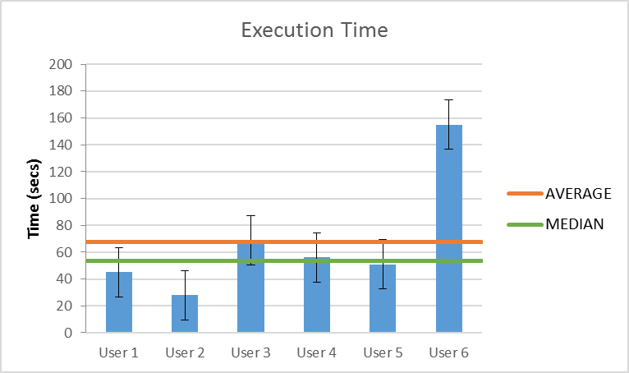

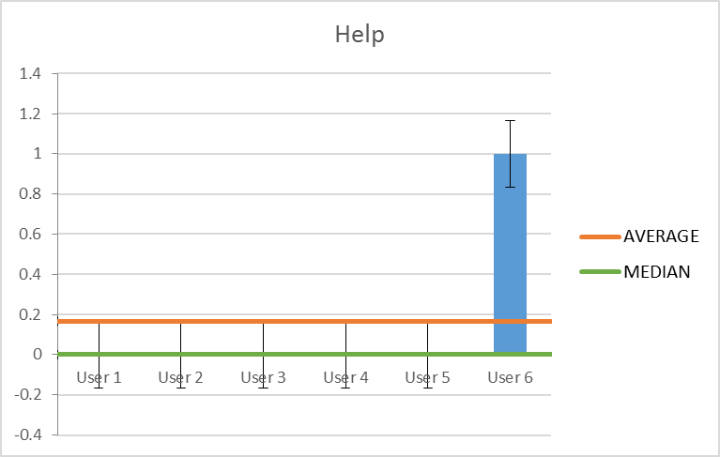

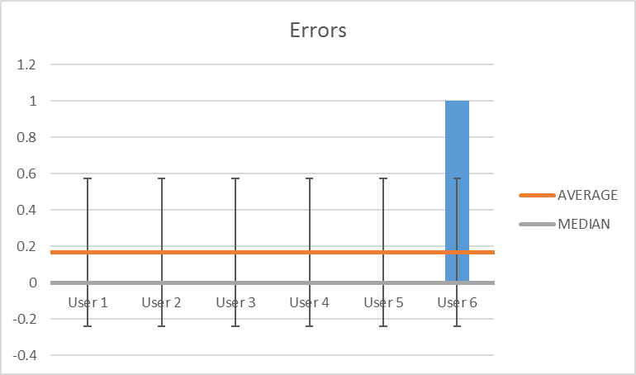
Users 1,2,3,4 and 5 completed the task without receiving any help and making any errors.

User 6 completed the task after receiving help.
Help: The user was instructed to go to the course page of CS464 and look in that region.
Error: The user was unable to see clearly the “Book” button twice.
Observations: The user wandered inside the site going to calendar and to homepage.

Conclusion
All the users completed the scenario successfully relatively quickly except user 6 who had to be given guidance and was wandering inside the site.

The only error occurred by User 6 who missed the “Book” button twice, which is a design error. Also from the movements of User 6 inside the site shows us that booking for an assignment could be included and on other parts of the page.
Scenario 22
Exams are coming up and it’s time to start studying. Download all the lectures of CS464.

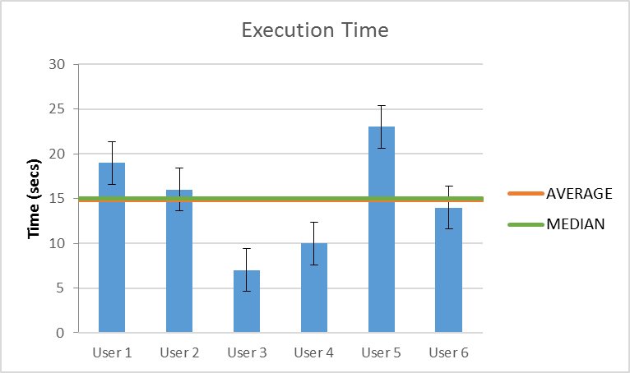

All users completed this scenario without receiving any help and making any errors.

Conclusion
All users completed this scenario relatively quickly and their way was straightforward with every user understanding clearly the path they should follow and the places they had to press to complete it.
Scenario 23
Send Rachel a message “Hey! Can we make it 5?”

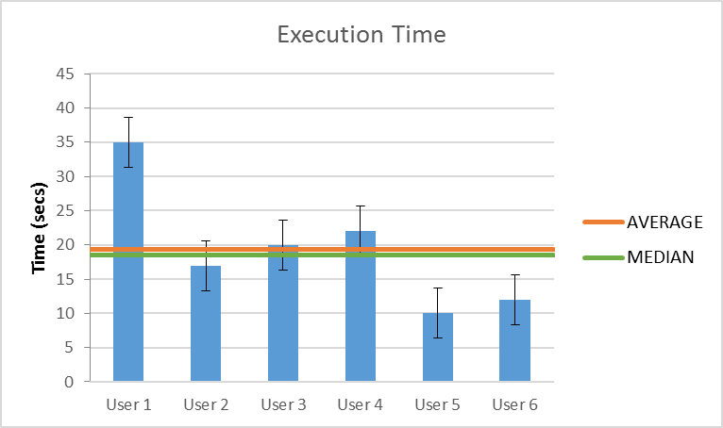

All users completed this task without receiving any help and making any errors.
Observations: User 1 tried first to access Rachel’s’ messages from the profile.

Conclusion
All users completed this scenario successfully relatively quickly since the path was straightforward and easy to find by accessing the messages through the homepage.

From the observations we see that we might need to add an access to messages through the users’ profile. But since the amount of testers is small we can’t be quite sure to do so.
Debriefing

What did you think about the system generally?

The users’ answers were very positive for the design and the features included in the system.

Would you use it?

All the users responded positively and assured us that they would use the system.

What did you have the most difficulty with?

Users responded that they found difficulty in features of Groups, Notes, Livestream and Announcements

User 1: Difficulties on Groups and Announcements
User 2: Difficulties on Notes and Groups
User 3: Didn’t find any difficulties
User 4: Difficulties on uploading Notes
User 5: Didn’t find any difficulties
User 6: Difficulties on Livestream

What did you like the most?

User 1: Liked the title of the system and added “What you see is what you get”
User 2: Mostly liked Calendar and Messages
User 3: Liked everything that he saw in the system.
User 4: Mostly liked the feature of booking an assignment examination and Groups also added “Very beautiful, minimal and easy on the eye”
User 5: Mostly liked Groups feature and Calendar.
User 6: “Design is very clear and not too much information”

Was there something that you did not like and would prefer it to change?

User 1: He wouldn’t change a thing.
User 2: He would change the labels of Submit button in Notes and Commit button in Groups.
User 3: He would change the label of Submit button on Notes, design an easier way to enter the Group page, would like more information in the Homepage and finally he would add color definitions for the Calendar events.
User 4: He wouldn’t change a thing.
User 5: “It was really good, but probably too much information”
User 6: “I could not access everything from Homepage”

Was there any feature / functionality that you would want to have but did not find?

User 1 and 2: They would like to be able to send and read emails from the system.
User 3, 4 and 6: They couldn’t think of something to add.
User 5: He would like to be able to evaluate teaching staff performance from within the system.

Do you have anything else to add?

User 1: “Very good and professional work. Easy on the eye”.
The rest of the users didn’t add anything.

System Usability Scale

The System Usability Scale (SUS) provides a “quick and dirty”, reliable tool for measuring the usability. It consists of a 10-item questionnaire with five response options for respondents; from Strongly agree to Strongly disagree.

We asked our users to fill out the questionnaire for us and here are the results:
(The table below shows the results of all the users)

 | Strongly Disagree | Disagree | Neutral | Agree | Strongly agree
I think that I would like to use this system frequently. |  |  |  | 1 | 5
I found the system unnecessarily complex. | 3 | 3
I thought the system was easy to use. |  |  |  | 2 | 4
I think that I would need the support of a technical person to be able to use this system. | 5 | 1
I found the various functions in this system were well integrated. |  |  |  | 2 | 4
I thought there was too much inconsistency in this system. | 5 | 1
I would imagine that most people would learn to use this system very quickly. |  |  |  | 3 | 3
I found the system very cumbersome to use. | 5 | 1
I felt very confident using the system. |  |  |  | 4 | 2
I needed to learn many things before I could get going with this system. | 5 | 1

User 1: 92.5 User 4: 92.5
User 2: 90.0 User 5: 90.0
User 3: 97.5 User 6: 90.0

Average score: 92.0

Problems and Solutions
Taking our users results into account we could make the following changes:

Sorted by Priority:

- Announcement Module(favorites):
The idea at first was that the user would be able to see the latest Announcements in the Dashboard.
With that said, we missed the fact that when searching for an announcement favorite, the user must first expand the announcement module to actually find the favorite announcement and proceed with the scenario.
Since the user expects the Module(mini-version) and Module(expanded-version) to resemble each other.
Possible Fix: We should make the favorite announcements to also being shown on Announcement-Module(Dashboard).

- Notes feature:
Most users mistook the already uploaded notes as their own.
Perhaps that was partially a result of the label of the button which was misleading (Was meant Upload notes and was actually called “Submit”).
Possible Fix: Change the label of the button from “Submit” to “Upload”.
Make a header on top of the already uploaded notes that says something like “Other Users Uploaded” or at the bottom something like “My notes”.

- Groups Feature:
Users that are not familiar with version control services like GitHub did not know what Commit/Pull stands for.
In addition, some of the users did not know where the commit button was.
Possible Fix: Make the Group-Name appear more vividly so that they feel inclined to press on it when in Groups-Overview.

- Assignment Grades:
Some users went through the “Assignments” tab (Course_Nav) but did not notice the grade of their assignments.
Possible Fix: Make the grades appear more vividly.

- Livestream Feature:
Some Users tried find the livestream through the Lectures Tab in the Course Page. That was a correct way to proceed with the scenario but we had not connected any image to the Lectures of CS340 (We had a Lecture page for CS464).
Some Users could not find the Livestream button at all.
A User actually saw the button but because he had it linked with YouTube he overlooked it.
Possible Fix: Change the play button to a compact red box with “LIVE” as a label. Make it bigger.

- Calendar Feature(Event-Bullets):
Some users did not understand the bullets’ meaning.
Possible Fix: Show the bullets’ meaning-color association.

Possible Improvements
(Based on the users results)

We thought of some of these during the prototype phase but it was added work so we did not design them.

- Treat the Dashboard modules as deletable/movable units.
This way the user can rearrange/modify the look of his dashboard.
- Personal features like messages and groups can be added to Profile Page (removed from Dashboard).
- File Manager can be added to the Left Navigation (Main Nav) as an individual tab (removed from Profile).
- An email client can be added to further expand our platform.
- Make it available to submit a Group Project directly from Groups.
- Make the add event available through a click on all available calendar containers (Month, Week, Day same as Google Calendar).

Conclusion

Overall, the user testing brought up some problems that we were already aware of but also highlighted problems that we missed.
The errors that we were already aware of, mostly observed on the pilot testing, we chose not to fix them because the deadline had already passed and we wanted a legitimate experience.
The platform design can be considered a success since the users had an average SUS score of 92.0, with all users having a score over 90.

