Introduction
Housing Price Dynamics in Portuguese regions: Time Series Forecasting
The Portuguese housing market has become a topic of great discussion in Portugal but also internationally. It has undergone severe transformations over the past decade. Following the large contraction of 2010-2013 due to the 2008 financial crisis, housing prices have been increasing at a fast and sustained pace

Materials and Methods

2.1 Data
The primary dataset used in this study is the Median Bank Appraisal Value of Housing per square meter, collected by the Instituto Nacional de Estatística (INE). This series captures the median value attributed to residential properties by financial institutions, expressed in euros per square meter (€/m²), and is published every month.
The dataset consists of Portugal’s aggregate data and nine Portuguese regions corresponding to NUTS II: Norte, Centro, Oeste e Vale do Tejo, Grande Lisboa, Península de Setúbal, Alentejo, Algarve, Região Autónoma dos Açores, and Região Autónoma da Madeira. The data goes from January 2011 to March 2026, resulting in 183 monthly observations per region with no missing values.
The second part of our analysis adds a set of macroeconomic and supply-side variables to give context to the price dynamics, in accordance with the literature. These variables are the following:
Inflation Rate was obtained from INE at monthly frequency for the full sample period. Oeste e Vale do Tejo and Península de Setúbal only have data starting in December of 2025, meaning the models that use this variable exclude the period with no data for these two regions. Inflation affects housing prices through two channels: it decreases the real cost of mortgage debt, making homeownership relatively more attractive, and it increases the replacement cost of housing through higher construction costs, putting upward pressure on prices (Himmelberg, Charles, & Mayer, Christopher, & Sinai, Todd (2005). “Assessing High House Prices: Bubbles, Fundamentals and Misperceptions”. Journal of Economic Perspectives. VOL. 19, NO. 4, pp. 67–92).
Mortgage Interest Rate was sourced from INE at monthly frequency for the full sample period. This variable is only available at a national level, but we will use it for the regional series as we can assume that differences between regions would not be meaningful. This series captures the implied interest rate paid on outstanding house loans. Interest rates are one of the most mentioned determinants of housing prices in the literature, as they directly affect housing demand (Iacoviello, Matteo (2005). “House Prices, Borrowing Constraints, and Monetary Policy in the Business Cycle”. American Economic Review. VOL. 95, NO. 3, pp. 739–764); Tsatsaronis, Konstantinos, & Zhu, Haibin (2004). “What Drives Housing Price Dynamics: Cross-Country Evidence”. BIS Quarterly Review). Rising rates increase mortgage costs, reducing housing demand and thus, pressuring housing prices to go down.
Number of New Houses Completed was obtained from INE at quarterly frequency and interpolated to match the monthly frequency of the target variable, an approach also used in Balázs, Égert, & Dubravko, Mihaljek (2007). “Determinants of house prices in central and eastern Europe”. BIS Working Papers. NO. 23. In essence, a straight line is drawn between each pair of known quarterly values to fill the missing monthly values. For instance, if quarter 1’s value is 100 and quarter 2’s is 130, February will be 110 and March will be 120. This is considered appropriate as this is a slow-moving variable, unlikely to display great month-to-month changes. Data spans until the end of 2025. This variable captures the flow of new housing supply entering the market. More houses in the market generally exert a downward pressure on prices, particularly where demand has outpaced construction activity (Malpezzi, Stephen & Maclennan, Duncan (2001). “The Long-Run Price Elasticity of Supply of New Residential Construction in the United States and the United Kingdom”. Journal of Housing Economics. NO. 3, VOL. 10, pp. 278-306; Glaeser, Edward, L., & Gyourko, Joseph, & Saks, Raven, E. (2005). "Why Have Housing Prices Gone Up?". American Economic Review. VOL. 2, NO. 95, pp. 329–333).
Unemployment Rate was sourced from INE at quarterly frequency and interpolated to monthly frequency using the same approach as for the variable “Number of New Houses Completed”. Data spans until the first quarter of 2026. The unemployment rate serves as a proxy for labor market conditions and household income uncertainty. Other variables such as income and purchasing power were considered, but the lack of higher frequency regional data led us to pick unemployment rate instead. Higher unemployment reduces housing demand by reducing household disposable income and thus, purchasing power, and increasing financial vulnerability. This frequently leads to declining housing prices (Muellbauer, J., & Murphy, A. (1997). “Booms and Busts in the UK Housing Market”. The Economic Journal. VOL. 107, NO. 445, pp. 1701–1727; Case, Karl, & Shiller, Robert (2003). “Is There a Bubble in the Housing Market?”. Brookings Papers on Economic Activity. VOL. 34, NO. 2, pp. 299-362).
Table 1 — Variable Description
Variable | Description | Source | Frequency | Period
Median bank appraisal value | Median bank appraisal value in €/m² | INE | Monthly | 2011–2026
Inflation rate | Consumer price inflation | INE | Monthly | 2011–2026
Mortgage interest rate | Implied rate on housing credit | INE | Monthly | 2012–2026
New houses completed | Number of new completed houses | INE | Quarterly | 2011–2026
Unemployment rate | Regional unemployment rate | INE | Quarterly | 2011–2026

Other variables could explain housing dynamics such as demographics and urbanization, given urban housing prices have increased much faster than in the countryside (Balázs, Égert, & Dubravko, Mihaljek (2007)) and internal and external migration, along with the concentration of economic activity and jobs in Lisbon, could help explain the higher price increase in Portugal’s capital and surrounding areas.
Particularly relevant for Portugal, foreign investment and tourism have also driven the increase in prices.
There are even more variables mentioned in the literature that explain housing price dynamics. In this study, we will only focus on the ones in Table 1.

2.2 Methodology
This study applies two time series modelling frameworks to monthly regional housing price data for ten Portuguese regions over the period January 2011 to March 2026 (or October 2025, depending on the analysis).
2.2.1 Stationarity Testing
Before we estimated the models, we tested each region series for stationarity using the Augmented Dickey-Fuller (ADF) test and the KPSS test. The integration order d was determined by the number of differences required to achieve confirmed stationarity under both tests. Seasonality was tested for through additive decomposition with a period of 12 months.
2.2.2 Univariate Model — ARIMA
Following the Box-Jenkins methodology, the autoregressive (p) and moving average (q) orders were identified through visual inspection of the ACF and PACF of the differenced series. We identified nine candidate ARIMA(p,d,q) specifications with p,q ∈ {0,1,2} and d=2, which were then estimated by Maximum Likelihood and compared using the AIC. Model adequacy was assessed via the Ljung-Box test at lags 12 and 24, complemented by visual inspection of residual’s time plots, residual ACF and PACF plots, histograms, and Q-Q plots. To test for the possibly of uncaptured seasonality, we also ran a full grid search over SARIMA(p,1,q)(P,D,Q,12) models with p,q ∈ {0,1,2} and P,D,Q ∈ {0,1}.
2.2.3 Multivariate Model — SARIMAX
To incorporate economic variables mentioned in the literature as determinants of housing price dynamics, the ARIMA framework was extended to a SARIMAX model with four exogenous variables: inflation rate, mortgage interest rate, number of new housing completions, and unemployment rate. The mortgage interest rate, available only at the national level, was applied uniformly across all regions. For Oeste e Vale do Tejo and Península de Setúbal, where regional inflation data is unavailable for most of the sample period, the inflation variable was excluded. Quarterly variables were converted to monthly frequency through linear interpolation between adjacent quarterly values. A full grid search over 36 SARIMAX(p,d,q)(P,D,Q,12) specifications with p,q ∈ {0,1,2} and P,D,Q ∈ {0,1} was conducted per region. Again, models were compared using the AIC.
2.2.4 Model Comparison and Forecast Evaluation
To ensure a fair comparison between ARIMA and SARIMAX models, ARIMA(2,2,2) was refitted on the identical estimation sample used for each SARIMAX model. Out-of-sample forecast accuracy was evaluated over a 12-month holdout period using Mean Absolute Error (MAE), Root Mean Squared Error (RMSE), and Mean Absolute Percentage Error (MAPE).

3. Results
3.1 Stationarity Analysis
3.1.1 Visual Inspection
First, we plotted the national aggregate and regional housing prices over the full sample from January 2011 to March 2026. As shown in figures 1 and 2, all ten series exhibit a strong and sustained increasing trend, except the 2011-2013 period, when the aftermath of the 2008 Financial Crisis led to lower housing prices. Afterward, there was a prolonged appreciation phase with record-breaking increases in the last year (2025).
Although the sharp increase in housing prices was felt at the national level across all regions, there are differences when it comes to the magnitude. Grande Lisboa consistently recorded the highest housing prices (Algarve led for brief periods before 2014) and the difference to the other regions only increased, reaching 3.278 €/m², 152% of the national average, in March 2026. Algarve is second, followed by Península de Setúbal and R. A. Madeira, all above the national average. Norte, Oeste e Vale do Tejo, R. A. Açores, Centro and Alentejo are all below the national average, with the last two at 63% of Portugal average home prices in the last month of our sample. One trend the series shows is the increasing price differences between regions, reflecting the increasing attractiveness of some regions over others.
Regarding non-stationarity, which is needed to use standard time series models (e.g., ARMA), the following features are required:
- Constant mean (trend);
- Constant variance;
- Non-Seasonal (periodic) behavior
The visual inspection strongly suggests the presence of non-stationarity in all series, with the upward trend meaning non-constant mean and acceleration in price growth suggesting a non-constant variance. Even though there seems to be no seasonal behavior, these patterns led us to perform the tests we will describe below.
These patterns motivated the formal stationarity testing described below.

Figure 1 – Median Bank Appraisal Value of Housing by Region
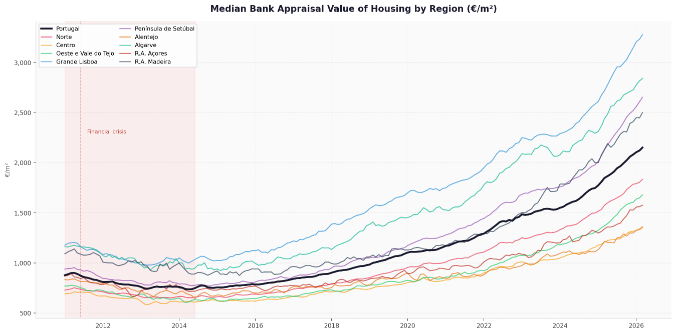
Figure 2 – Median Bank Appraisal Value of Housing by Region vs. Portugal
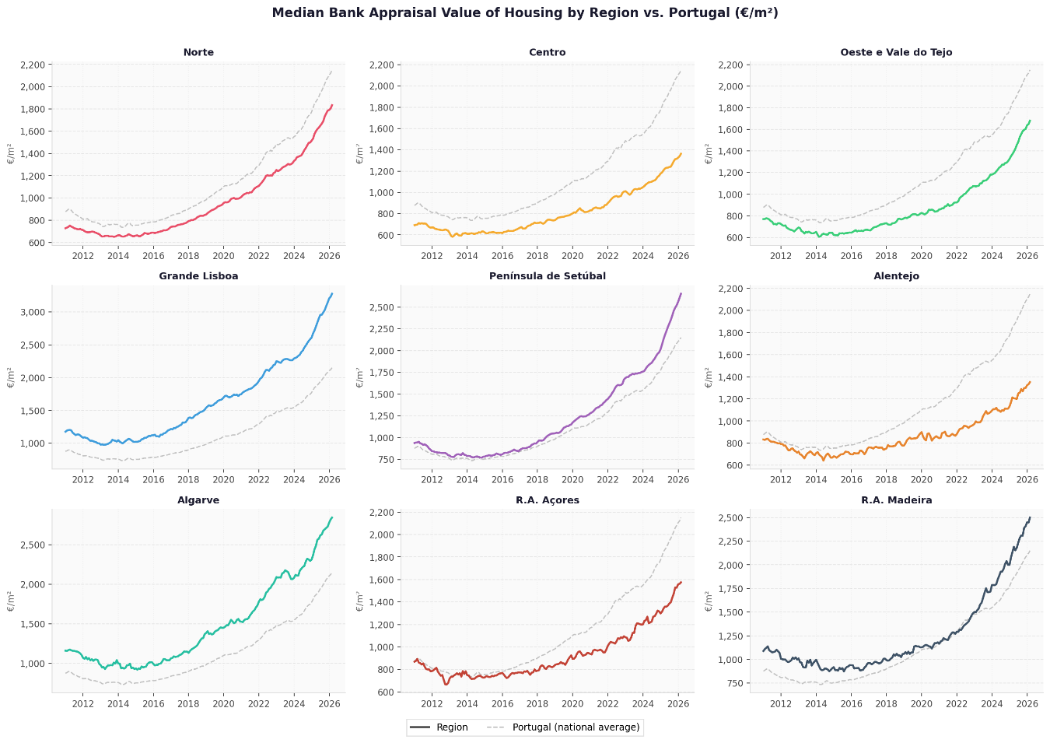

3.1.2 ADF and KPSS Tests
The results of the Augmented Dickey-Fuller (ADF) test applied to the raw series are presented in Table 2. The null hypothesis of a unit root could not be rejected even at the 10% significance level for any of the ten series, confirming that all series are non-stationary, consistent with the visual inspection.
Table 2 – ADF Test Results on the Raw Series
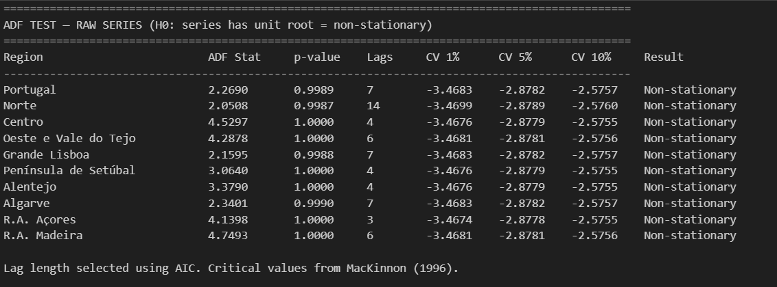
Thus, we performed the first differencing of all series. Afterwards, the AFDF test was repeated. According to Table 3, only Alentejo and R. A. Açores achieved stationarity at the first difference, with all remaining series failing to reject the null hypothesis at the 5% significance level. A further KPSS test was performed on all series to double-check these results. As Table 4 shows, the KPSS test confirms both Alentejo and R. A. Açores are stationary series (the null hypothesis is not rejected), leading to conflicting results. Hence, we perform the second difference of all series.
Table 3 – ADF and KPSS Test Results on the First Difference
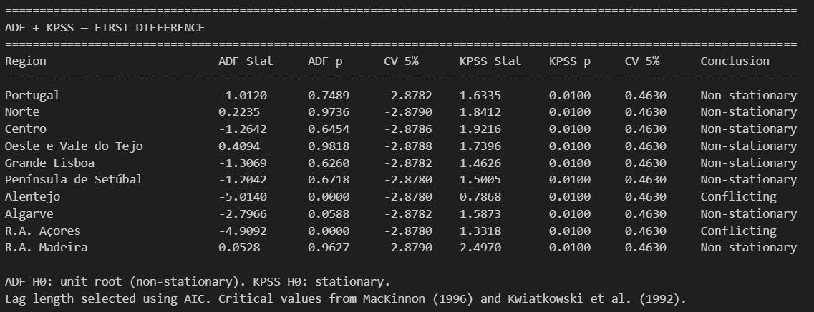
Table 4 – ADF and KPSS Test Results on the Second Difference
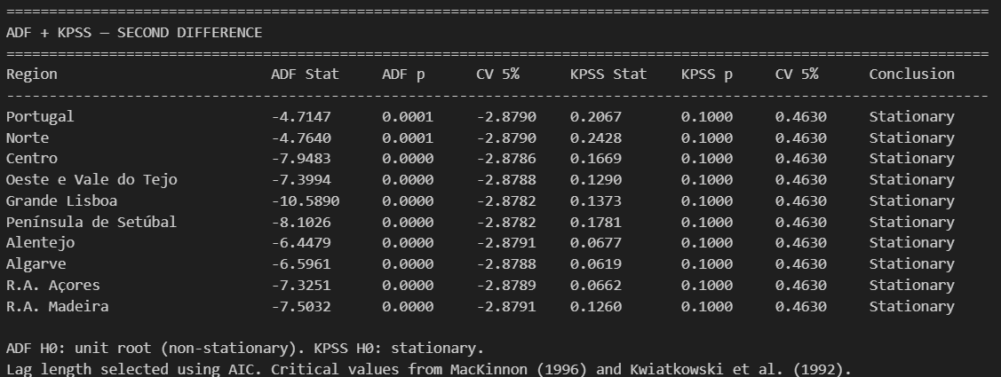
ADF and KPSS tests in Table 4 confirm that the second difference series are all stationary. The second-difference series for all regions are plotted in Figure 3, confirming the absence of trends and oscillation around zero, consistent with stationarity.
Figure 3 – Series Second-differences
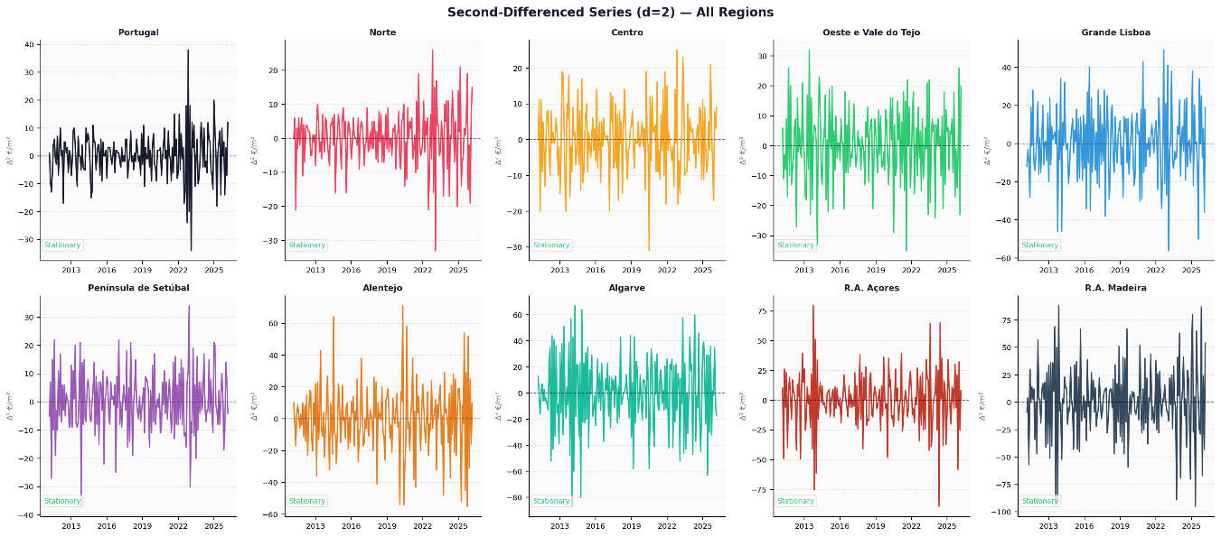

3.2 Model Identification and Selection
3.2.1 ACF and PACF Analysis
The ACF and PACF of the second-differenced series were computed for all ten series up to 24 lags and are presented in Figure 4. The patterns observed were broadly consistent across all regions. The PACF had multiple significant lags with a gradual decay pattern rather than a sharp cutoff, while the ACF showed a more pronounced cutoff after the first four lags. This pattern is characteristic of a moving-average-dominated ARMA process, where the absence of a clean PACF cutoff precludes a pure AR specification and the sharper ACF decay suggests a finite MA component.
Figure 4 – PACF and ACF Results
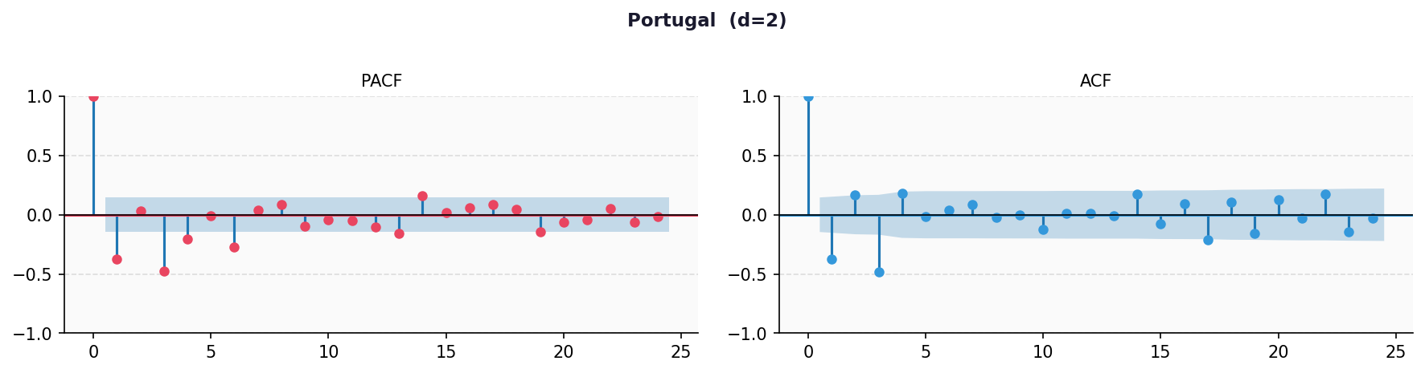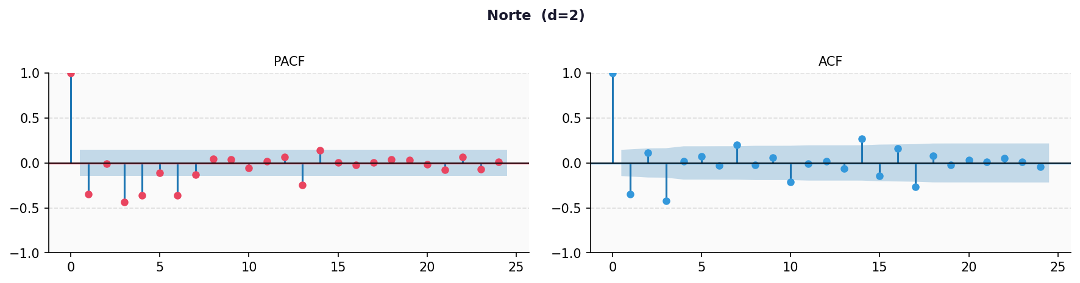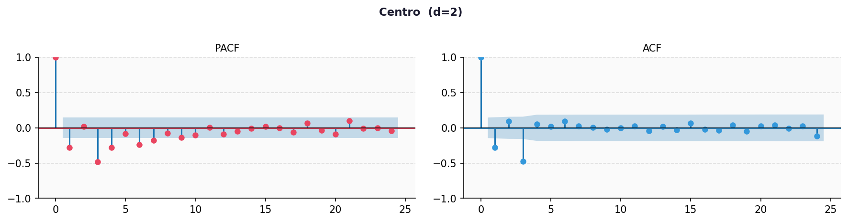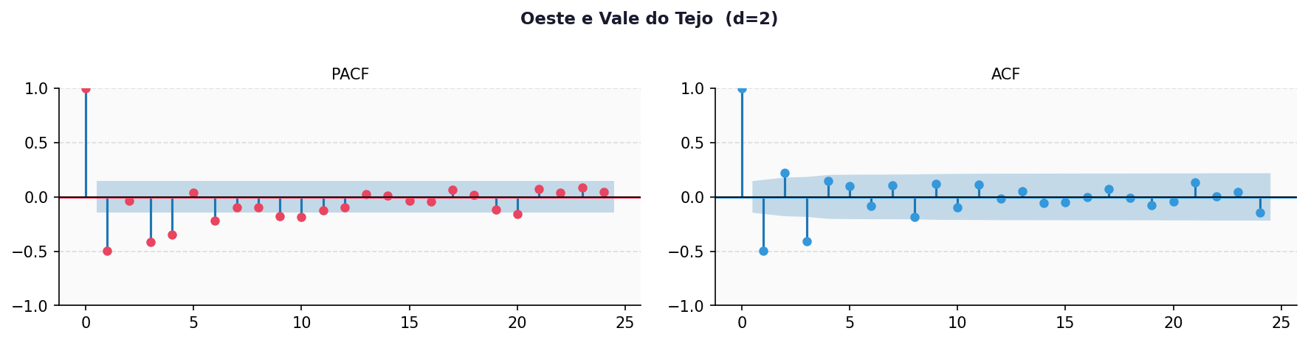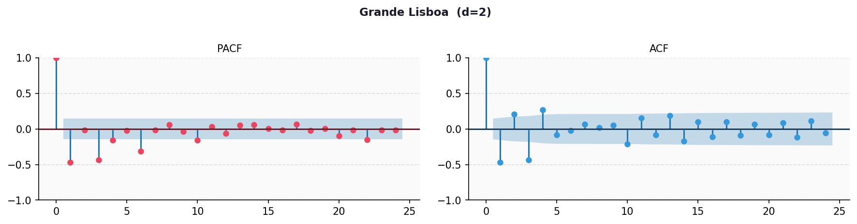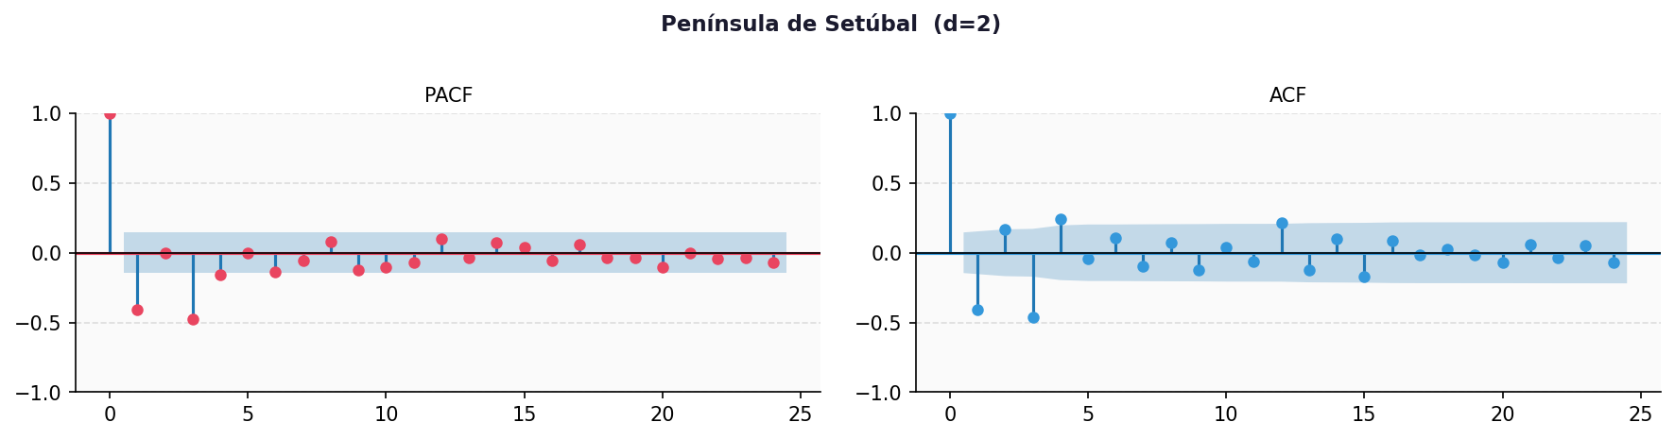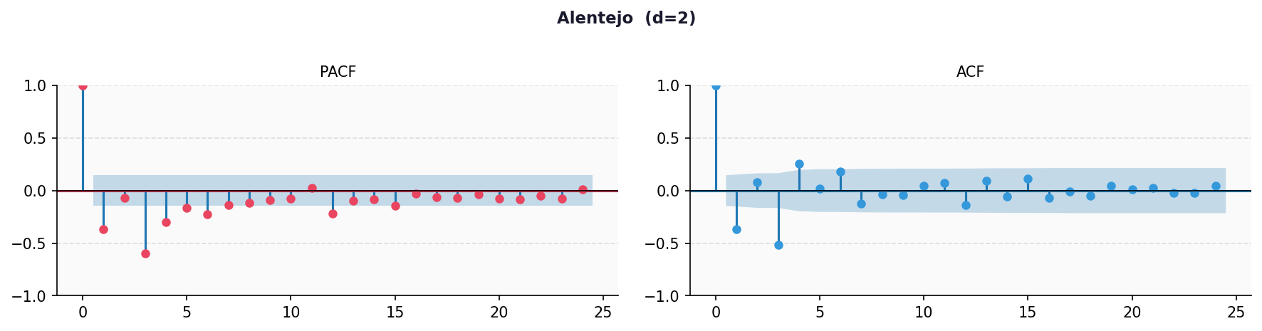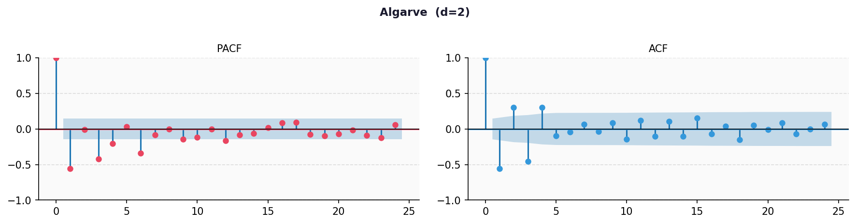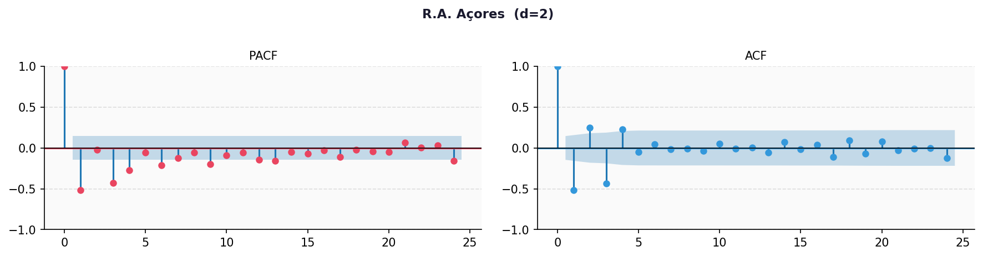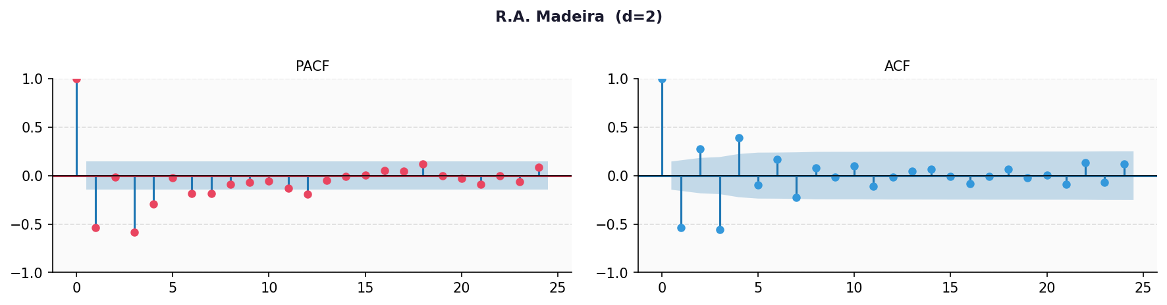
Based on these patterns, six candidate ARIMA(p,2,q) specifications were defined with p ∈ {0,1,2} and q ∈ {0,1,2} for evaluation. The ‘2’ in ARIMA(p,2,q) refers to a second-difference series.
3.2.2 Seasonality Analysis
Visual inspection suggests that there are no strong seasonal patterns. However, a more thorough analysis was conducted to double-check our assumption. Hence, seasonality was tested for through additive seasonal decomposition of each regional series using a period of 12 months, consistent with the monthly frequency of the data. Seasonal strength was quantified as the ratio of the standard deviation of the seasonal component to the standard deviation of the observed series. As shown in Table 5, seasonal strength values range from 0.0042 for Portugal to 0.0218 for Alentejo, all significantly below the usual threshold of 0.05 used to indicate meaningful seasonality. These results confirm that seasonal adjustment is not necessary and that we reject the SARIMA model in favor of the standard ARIMA model, without a seasonal component, for all ten series.
Table 5 – Seasonal Strength Results
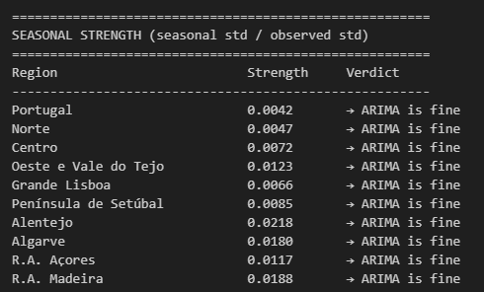
3.2.3 Model Selection by AIC
The six candidate models were fitted to each series using maximum likelihood estimation, and AIC and BIC values were computed. AIC, an estimator of prediction error that allows us to compare different models, was ultimately chosen as the deciding factor over BIC. The full results are presented in Table 6.

Table 6 – AIC Results for Candidate Models
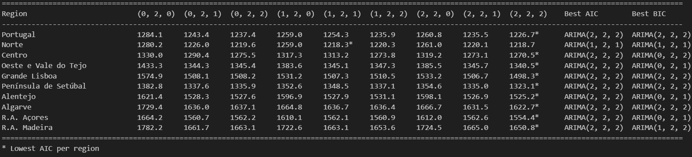

ARIMA(2,2,2) yielded the lowest AIC for nine of the ten series. Norte was the only exception, where ARIMA(1,2,1) produced a marginally lower AIC of 1218.3 compared to 1218.7 for ARIMA(2,2,2) - a difference of 0.4 AIC points. For better consistency and comparability across regions, ARIMA(2,2,2) was chosen for all ten regions.
3.2.4 Residual Analysis
To test for the adequacy of the model, we ran the Ljung-Box test, which, as shown in Table 7, identified statistically significant autocorrelation at lag 12 in the residuals of all regional ARIMA(2,2,2) models, while lag 24 showed no significant autocorrelation. Although stationarity and seasonality tests pointed towards having second-differenced series, there may be seasonality that was not properly captured by the tests. To try to overcome this problem, we ran a seasonal ARIMA model called SARIMA.
Table 7 – Ljung-Box Test Results
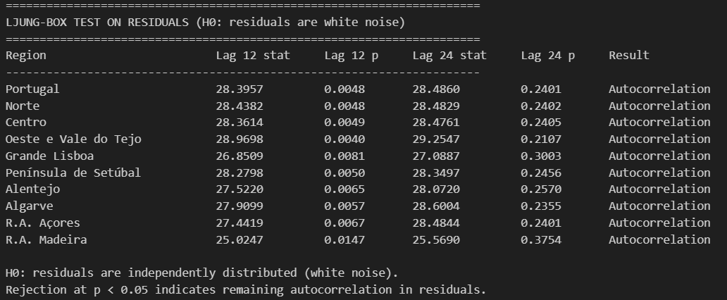

3.3 Seasonality-adjusted model
3.3.1 ACF and PACF Analysis
The ACF and PACF of the first-differenced series were computed for all ten series up to 24 lags and are presented in Figure 5. The PACF pattern was similar across all regions, with multiple significant lags with a gradual decay rather than a sharp cutoff. The ACF pattern of the ten regions can be grouped into two: multiple significant lags slowly decaying, or a sharp cutoff after lag 1 or 2. The first group is characteristic of an ARMA model, while the second is more closely associated with a moving-average-dominated ARMA process.
Figure 5 – PACF and ACF Results
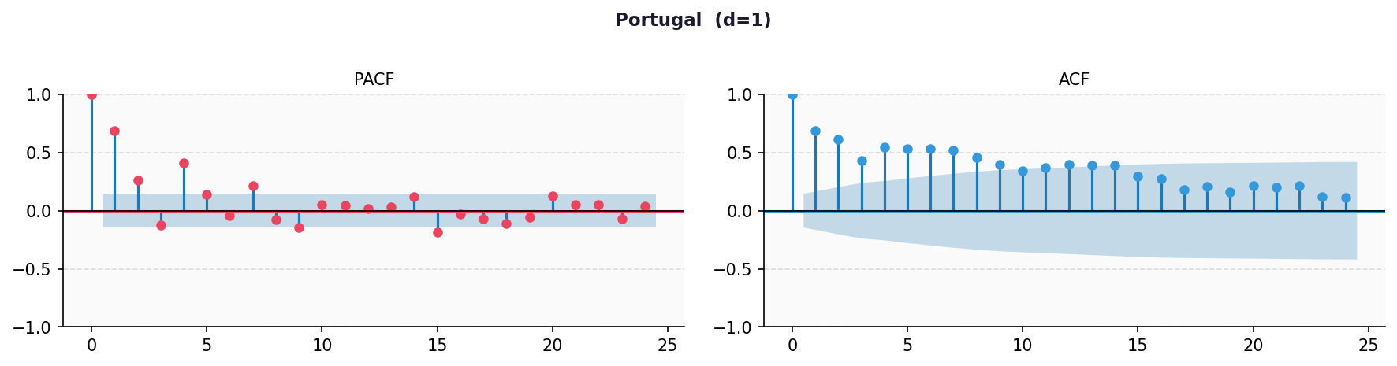
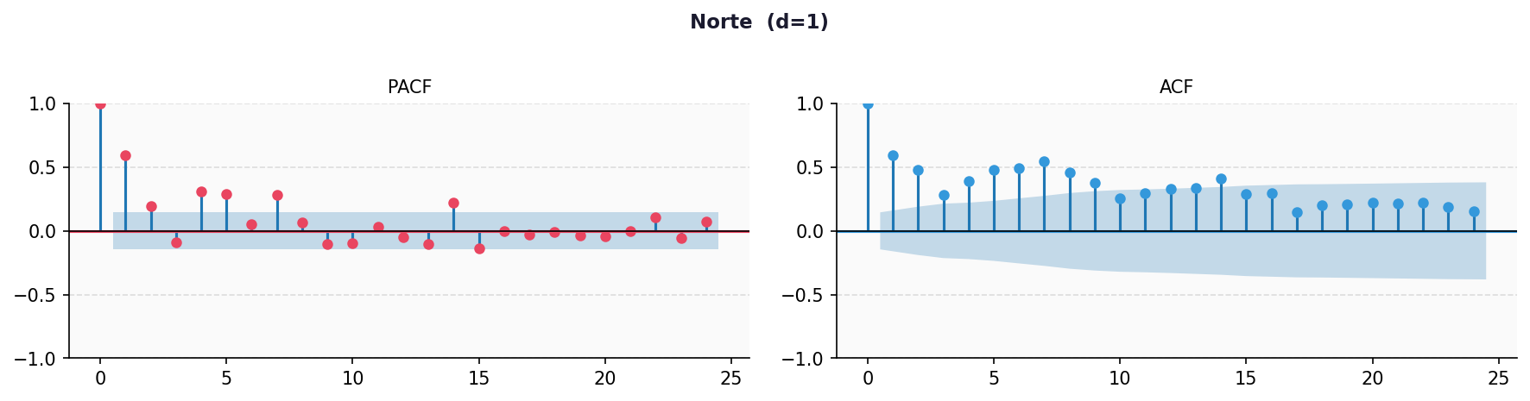
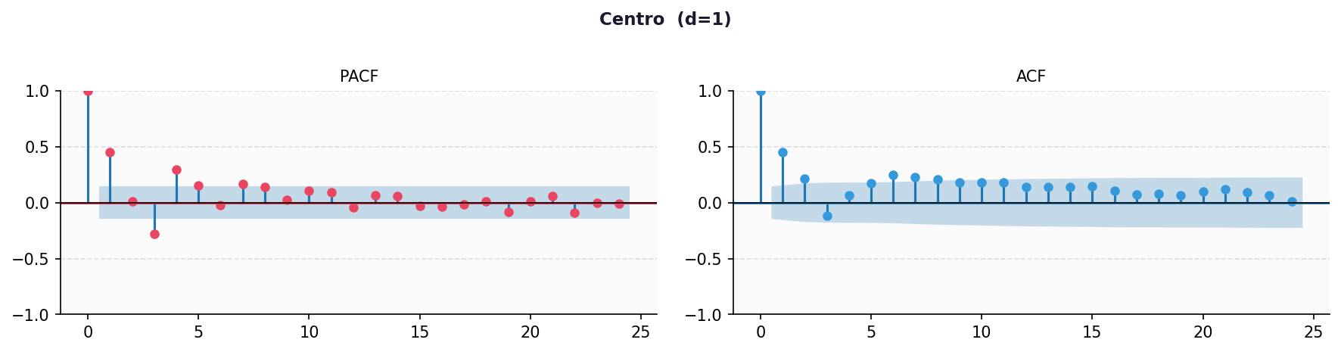
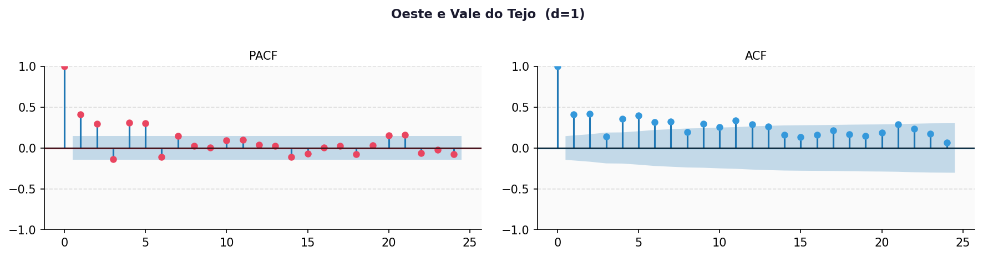
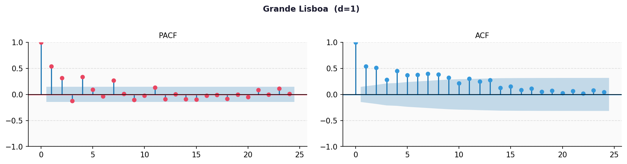
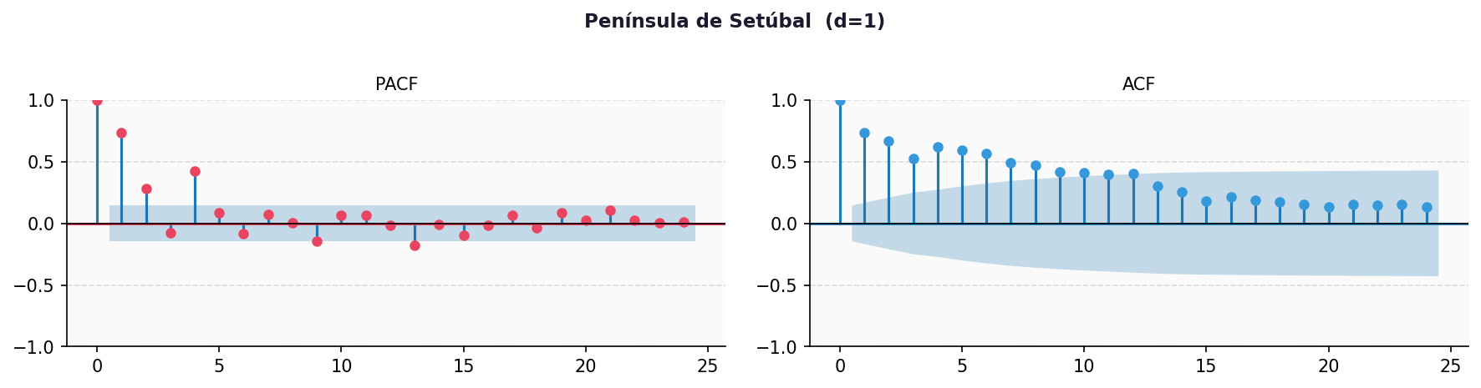
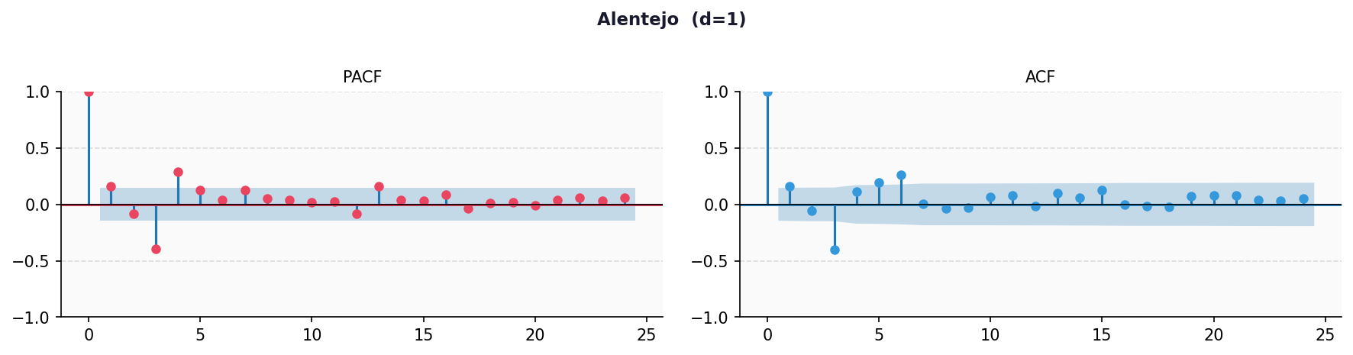
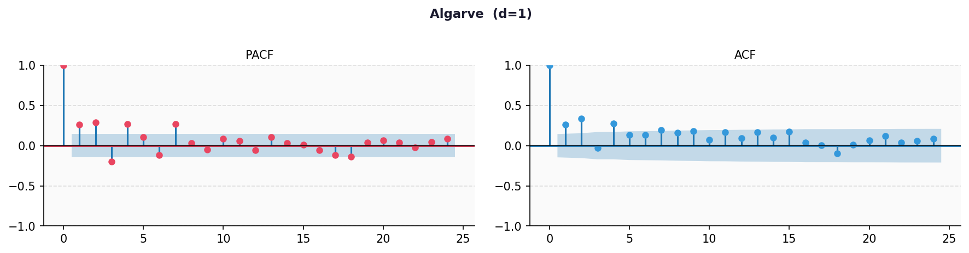
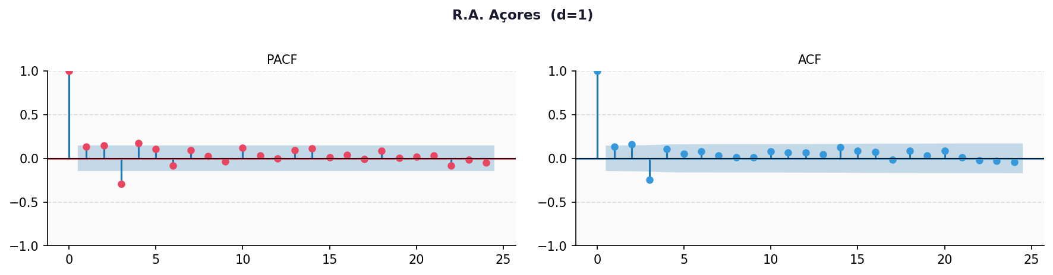
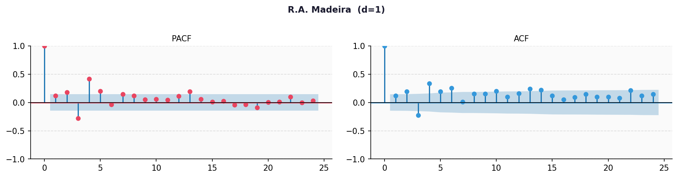
A full grid search was conducted over SARIMA(p,1,q)(P,D,Q,12) models with p,q ∈ {0,1,2} and P,D,Q ∈ {0,1}. We went with the first differences now instead of the second differences.
3.3.2 Model Selection by AIC
As shown in Table 8, the models with the lowest AIC and BIC did not pass the Ljung-Box test for residual autocorrelation. Crucially, a model must possess independent, white-noise residuals to ensure the statistical validity of its forecasts, construct accurate confidence intervals, and avoid biased parameter estimates. Therefore, AIC was considered a secondary criterion to choosing a model in favor of models that pass the Ljung-Box test. Thus, the lowest AIC models that pass the test were chosen, under column “Best Passing” in Table 8. The results of the Ljung-Box test are presented in Table 9. In Figure 6, we see the residuals’ time plot, Sample ACF and PACF of residuals, residual’s histogram, and Q-Q plot. All these diagnostics confirm what the Ljung-Box test already validated: residuals of all models behave approximately as a white noise process.
Table 8 – AIC Results for Candidate Model
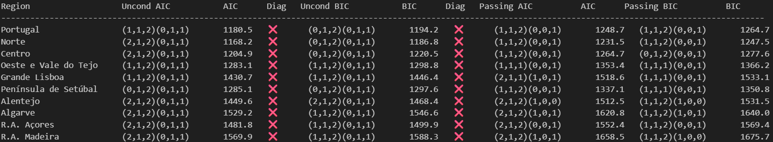
Table 9 – Ljung-Box Test Results
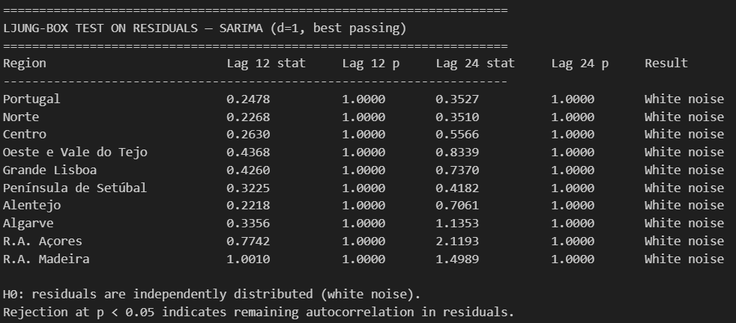
Figure 6 – Residuals’ Time Plot, Sample ACF and PACF, Residual’s Histogram and Q-Q plot
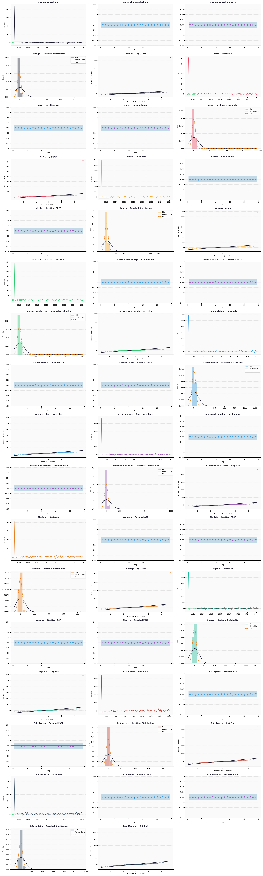



3.4 Forecast Results
3.4.1 Forecast Results
Final SARIMA models were estimated on the full sample period for all ten regions. The 12-month ahead point forecasts, together with 95% confidence intervals, are plotted in Figure 7 and the forecast values are showcased in Table 10.
Figure 7 – SARIMA - 12-Month Forecast by Region (€/m²) - plots
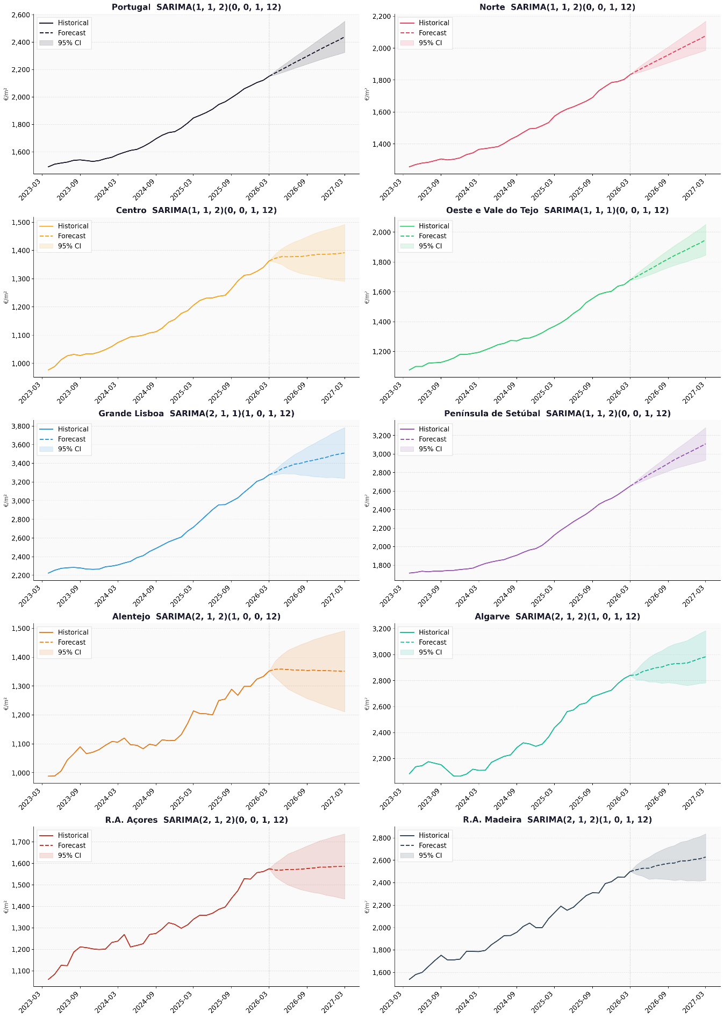
Table 10 – SARIMA - 12-Month Forecast by Region (€/m²) - values

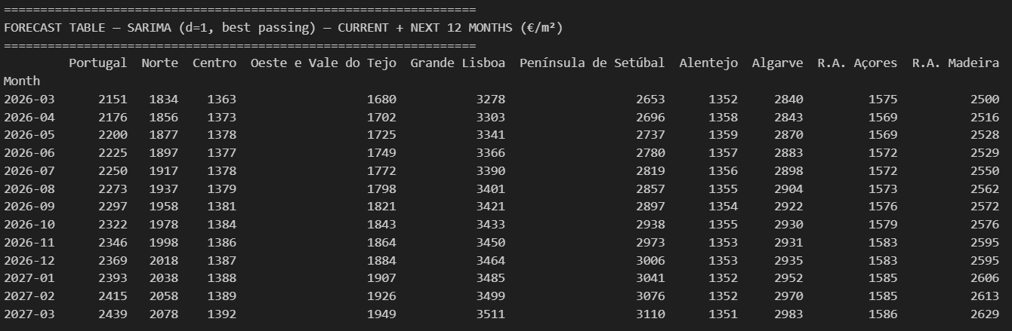
All regions except Alentejo are projected to continue their upward price trajectory throughout the forecast horizon, which reflects the momentum captured by the models. At a national level, prices are expected to keep rising at a fast pace, a 13.4% year-on-year increase.
Grande Lisboa remains the most expensive region in Portugal by a substantial margin, with median bank appraisal values projected to rise from €3,278/m² in March 2026 to €3,511/m² by March 2027, representing a 7.1% increase over the forecast horizon. Algarve, the second most expensive market, is projected to reach €2,983/m² by March 2027, a 5% increase. However, Península de Setúbal, the third most expensive region in March 2026 at €2,653/m², is expected to take Algarve’s number two spot, reaching €3,110/m² by March 2027, a sharp 17.2% increase, the highest out of all regions. This could be due to the spillover effects from buyers priced out of Grande Lisboa turning to nearby municipalities. Norte (the second most important economic region) and Oeste e Vale do Tejo (once again, spillovers from Grande Lisboa due to its proximity) are also projected to experience substantial rises, with R. A. Madeira registering more modest price increases.
At the lower end of the price spectrum, Alentejo remains the most affordable region throughout the forecast period, with prices remaining stable between €1,351/m² and €1,359/m². R.A. Açores is forecasted to have a slight price increase of less than 1%, while Centro has a higher increase, albeit small, rising from €1,363/m² to €1,392/m² — an increase of just 2.1%.
Now, there are a couple of limitations in these forecasts. First, the large confidence intervals reduce the capacity to make precise inferences. Second, these models do not incorporate economic variables that could potentially change price dynamics. This will be covered in the next section.

3.5 Multivariate SARIMAX Model
3.5.1 Model Selection
A full grid search over 36 SARIMAX(p,1,q)(P,D,Q,12) specifications was conducted for each region, with exogenous variables comprising regional inflation, mortgage interest rate, new housing completions, and unemployment rate. For Oeste e Vale do Tejo and Península de Setúbal, where regional inflation data’s sample is insufficient, inflation was excluded, and the remaining three variables were used. Using first passing the Ljung-Box test as selection criteria, and second, the lowest AIC, in Table 11, we present the best models.
Table 11 - SARIMAX Best Models
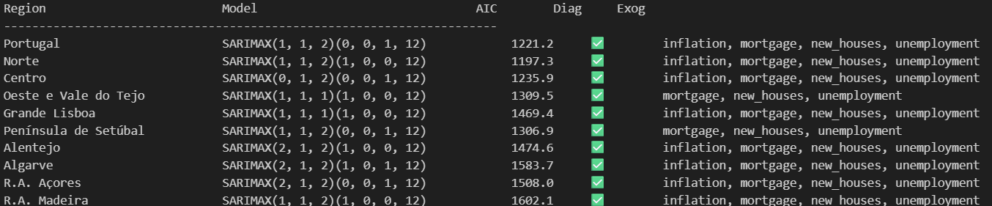
3.5.2 Comparison with SARIMA
To ensure a fair comparison, the SARIMA models were estimated again on the smaller sample used for each SARIMAX model, as explained before. The AIC comparison is presented in Table 12.
Table 12 – SARIMAX vs SARIMA Comparison
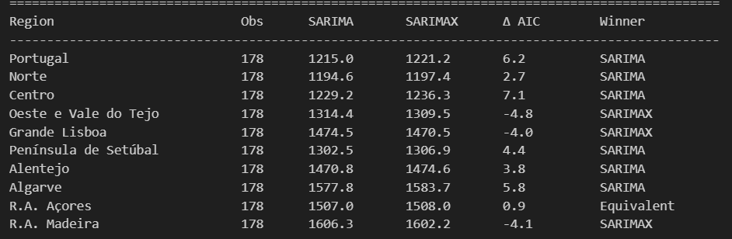
SARIMAX outperforms the ARIMA model in three out of ten regions, with low AIC improvements between 4 and 4.8 points in Oeste e Vale do Tejo, Grande Lisboa, and R.A. Madeira, suggesting that macroeconomic conditions are particularly important in explaining price dynamics in these markets.
R.A. Açores best SARIMA and SARIMAX models’ AIC are less than 1 point apart, so we keep the simple SARIMA model. As for the remaining regions, SARIMA is chosen.
Ljung-Box test and further residuals analysis were made, which confirmed that the residuals of all models behave approximately as a white noise process.
Markets highly sensitive to macroeconomic variables utilize multivariate SARIMAX models, while markets driven primarily by historical momentum and seasonality rely on univariate SARIMA models.
3.5.3 Forecast Accuracy
Forecast accuracy was evaluated using MAPE, MAE, and RMSE on a 12-month holdout period. An important note is that these findings do not change model selection, as selecting based on out-of-sample accuracy measures is prone to data leakage. The results reveal that the univariate SARIMA model, without exogenous variables, outperforms the SARIMAX model on forecast accuracy in eight of the ten regions. Portugal and Oeste e Vale do Tejo are the only regions where SARIMAX’s forecast accuracy is better than SARIMA’s. The latter is in accordance with the AIC findings, while the former is in contrast to the model chosen through AIC. There are two other regions in which SARIMAX was chosen according to AIC, but SARIMA’s forecast accuracy is better: Grande Lisboa and R.A. Madeira. Hence, the exogenous variables, in some regions, contribute to the explanatory power of the model but do not improve its predictive accuracy.
3.5.4 Exogenous Coefficients
As per Table 13, there are several regions where the economic indicators are revealed to be statistically significant, which justifies using a more complex SARIMAX model instead of the simpler univariate SARIMA model. In these areas, as discussed in Section 3.5.2, except for Norte and R.A. Açores, the inclusion of these variables yielded a lower AIC score:
- Grande Lisboa: The number of new houses built is highly significant, even at a 1% significance level, meaning this variable is particularly relevant in forecasting price variations in this region. It has the expected effect on prices - an increase in houses built decreases prices. Ceteris paribus, an increase of ten thousand new houses lowers prices by €896/m².
- Oeste e Vale do Tejo: This region is the only one where labor market conditions are extremely important in explaining housing price dynamics, with unemployment levels showing strong statistical significance at 5% (and having a downward effect on prices), along with new housing (p < 0.10), which has an upward effect on prices.
- R.A. Madeira: R.A. Madeira has two statistically significant variables – inflation and new houses built. The latter has the opposite effect on prices that one would expect, maybe due to an increase in housing usually being attributed to luxury housing which actually increases the average prices in the region (or due to poor model specifications that go beyond the scope of this work).
Overall, the number of new houses built is the strongest predictor of housing price dynamics in Portugal among the variables used in this study.
On the other hand, several regions showed no statistical reliance on the selected macroeconomic variables. Price dynamics in these regions are mostly driven by price momentum and seasonality.
Table 13 – SARIMAX Coefficients Results
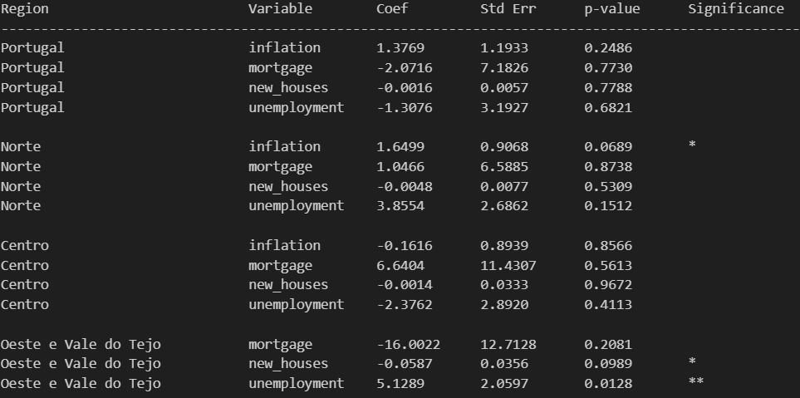
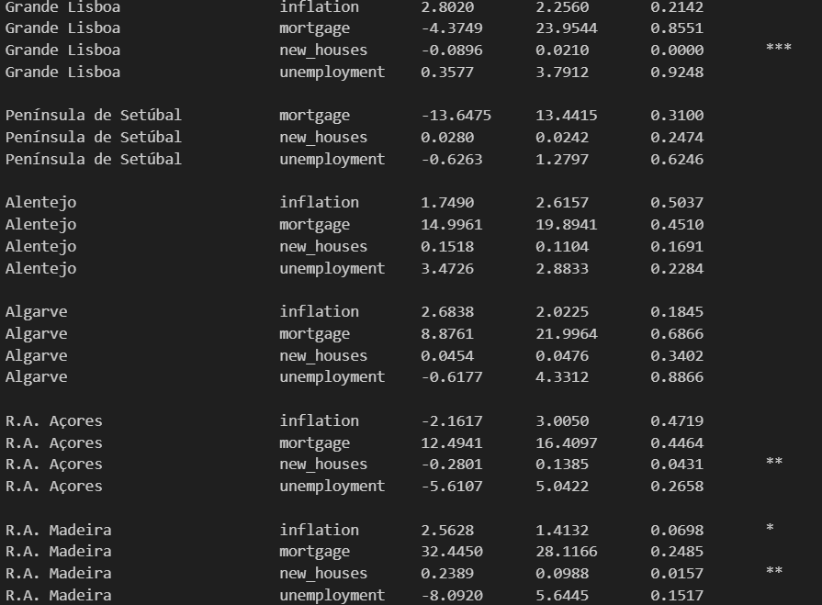
3.5.5 Final Forecast Results
Discussion regarding the SARIMA models’ results is in Section 3.4.1. We will focus here on the SARIMAX models. For the SARIMAX models, we assumed a baseline projection where the variables take the same value throughout the forecast period – the last known value. We also made forecasts based on a 15%, 30%, and 50% increase in the number of houses built relative to the previous year, based on known data. This is to account for the new fiscal package that the Portuguese government has announced regarding housing, which includes reduced VAT, among other measures, and they believe will help solve the housing crisis. And even if the package ends up not having the desired effects, this analysis can still be useful in helping with future policy decisions.
According to Figure 8 and Table 14, both Oeste e Vale do Tejo and Grande Lisboa SARIMA and SARIMAX models’ forecasting values are identical, while R.A. Madeira has a massive discrepancy between the models, with the SARIMAX forecasting a much more tame price increase of just 2.1% (although comparisons should be taken carefully as the sample period is different).
Regarding the projections with housing supply increases, R.A. Madeira suffers a price increase as the supply is higher (justification provided in Section 3.5.4), while Oeste e Vale do Tejo and Grande Lisboa suffer a low price decrease, around 1% when comparing the 50% increase in the number of new houses with the baseline model. This highlights a market dominated by price momentum, with short-term price growth highly inelastic to construction in the same period.
Figure 8 – Final Models’ Forecasts
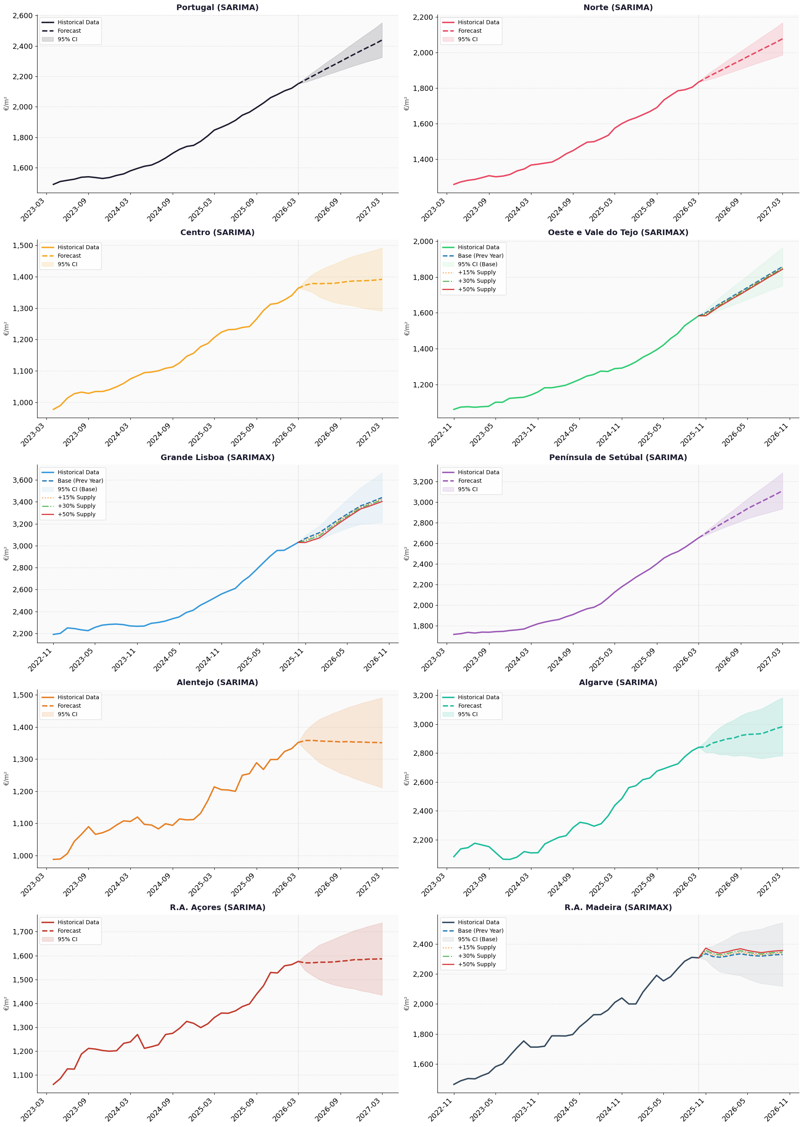
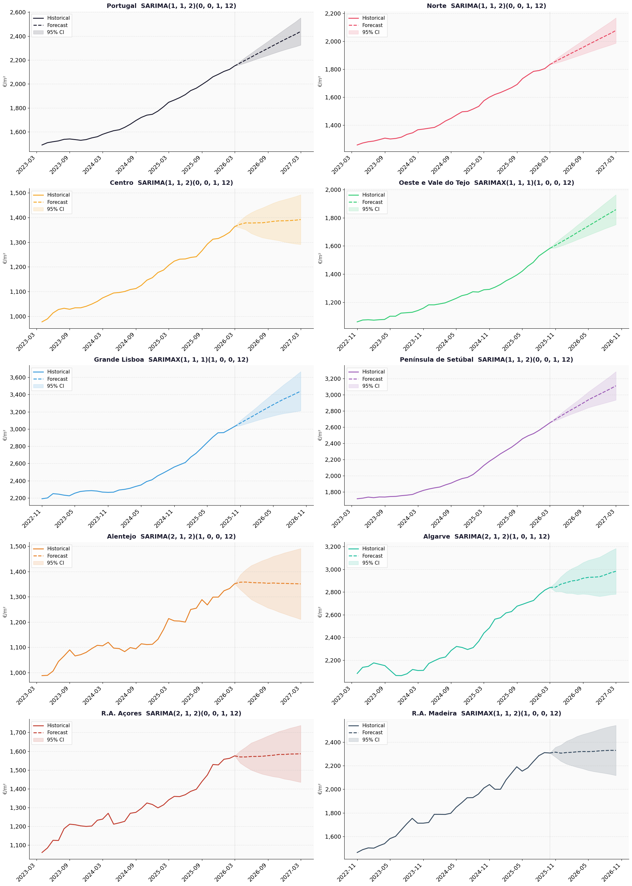
Table 14 – SARIMAX - 12-Month Forecast by Region (€/m²) - values
