1. Robot installation

<https://github.com/robotframework/robotframework#installation>

1. Selenium Library installation

<http://robotframework.org/SeleniumLibrary/#installation>

1. Chrome driver installation

The general approach to install a browser driver is downloading a right driver, such as [chromedriver](http://chromedriver.chromium.org/downloads) for Chrome, and placing it into a directory that is in [PATH](https://en.wikipedia.org/wiki/PATH_(variable)).

1. Download and install SOAP UI Open Source version

<https://www.soapui.org/downloads/soapui.html>

1. Download and install Jenkins

<https://jenkins.io/download/>

1. Run it from command line, running this command: java -jar jenkins.war, from the directory where you put Jenkins.war.

If you install Jenkins as service, you will not be able to see execution of robot framework test suite, because it will be executed on background

1. Install robot framework plugin on Jenkins from Manage Jenkins section.
2. Run following command on “Manage Jenkins\Script Console” to work around a Jenkins defect, still in progress, that doesn’t allow to see log, clear cache of your browser and login again.

**System.setProperty("hudson.model.DirectoryBrowserSupport.CSP","sandbox allow-scripts; default-src 'none'; img-src 'self' data: ; style-src 'self' 'unsafe-inline' data: ; script-src 'self' 'unsafe-inline' 'unsafe-eval' ;")**

Now you could see robot framework log from Jenkins.

1. Create following jobs

Back end Job

In the build section insert a step of type “Execute windows batch command” with this content

set workspace="C:\Users\Giovanni Renna\go\src\qa_demo\demo\backend\test"

set result="C:\Users\Giovanni Renna\go\src\qa_demo\demo\backend\test\result"

DEL /s /q %result%

cd %workspace%

"C:\Program Files (x86)\SmartBear\SoapUI-5.4.0\bin\testrunner.bat" -A -f ./result REST-Project-Empatica-soapui-project.xml

Front End Job

In the build section insert a step of type “Execute windows batch command” with this content

set workspace="C:\Users\Giovanni Renna\eclipse-workspace\Empatica"

set result="C:\Users\Giovanni Renna\eclipse-workspace\Empatica\Result"

DEL /s /q %result%

cd %workspace%

cd Suites

pybot -N Empatica_Frontend --outputdir %result% login.robot

In the post build section, add a post build action of this type “Publish robot framework test result” how you can see in the following image

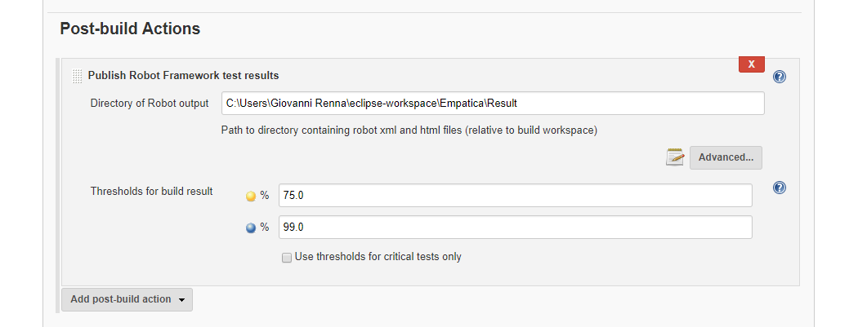

1. Create following pipeline

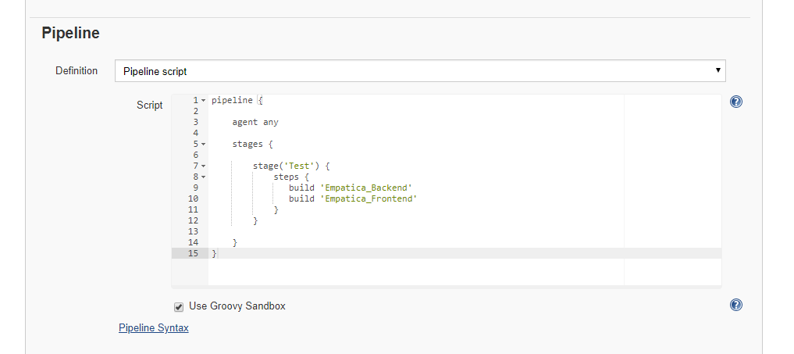

1. Put SoapUI project under directory that you set in your back end Jenkins job
2. Put robot framework project in the same directory that you set in the front end Jenkins Job
3. Run your pipeline from Jenkins
4. Check Front End Job log from Jenkins
5. Check backed end job log from the directory that you set for result option in your back end Jenkins job