BI-TJV semestral work description

Oh, no! Recently there was an incident in our local hospital. One of nurses which worked late night was responsible for doctors appointments planning for the next month and she shredded all the planning papers on accident.

It made a huge fuss on media, because she also shredded some prescriptions for seriously ill patients and 12 of them died next day. This was really unlucky! Our managers are not happy and the nurse was fired.

Managers want to prevent such accidents in the future so they want to have a simple time slot management system for making doctor appointments. All the data needs to be stored in database now, no more paper!

Managers also decided that for different patient cases we want to know which doctors can work on which cases so patients could have appointments only for doctors who can solve their issues.

Our decision was to start small. We want you to implement project for the following model so we can improve it later and develop a bigger thing.

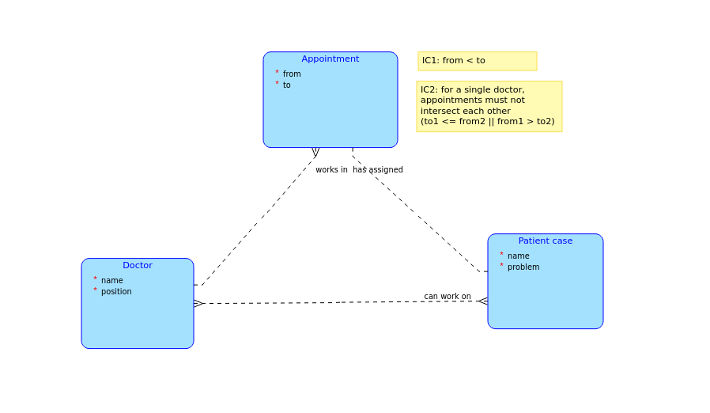

Ok, so fun part is over. Let’s describe some mandatory stuff for the semester work.

List of business operations on client part:
- Add doctor
- Create appointment for doctor
- Add patient case and set doctors who can solve it
- Assign appointment to patient case
- Get all doctors
- Get all patient cases
- Get all appointments
- Get all doctors with given position
- Get all doctors who can work on given case
- Get all doctor’s appointments which don’t have assigned case

Complex query on server part:
Creation of appointment will check IC1 and IC2 (IC2 is a complex one)

