BI-TJV semestral work description

(Description taken from BI-DBS):
//------------------------------------------------------------------------------------------------------------------//

Office of Offices and Documents (OOD)

Clerks of office OOD found out, that in a town, called "Sheriffgrad", live only clerks, rich people and one sheriff. Of course, they wish to help their colleagues, so they made up a system for creating requests (for rich people) to bring documents for 'control purposes', which should operate with a database.
OOD wants thier DB to contain information about every citizen of the town: first name, family name, address, ID in DB and an identity document of any allowed type (identity document type - entity) with it's own ID number. Every citizen is a clerk, a rich man or the sheriff (exaclty one relation takes place). Also the sheriff has passed a sheriff's certification of some level , which shows his level of understanding of how to be a good sheriff (DB shows only the level of the highest level certification, which was passed by him).
Every clerk works exactly in one office, which is owned by exactly one organization. In the OOD's system every organization will have the ability to create a request for a single rich man to bring and show (he won't lose it) one document (owned by this man), which is a document of the requested type. Every request can be received only by defined clerks (relation between request and clerks) and has it's expire date and an expire fee, so the rich man have to bring the document or pay the fee (he always has enough money).
It's also required for the system to maintain the clerk's shedules (from, to term for one request), so rich people could chose, when to come and to which office.
But one of the many problems of "Sheriffgrad" is, that the only person, who can produce and pass (any) documents is the sheriff. He has his own shedule terms (from, to), when he can give one document to one man for undefined price (it's defined only by the term itself).
//------------------------------------------------------------------------------------------------------------------//

Conceptual schema taken from BI-DBS:
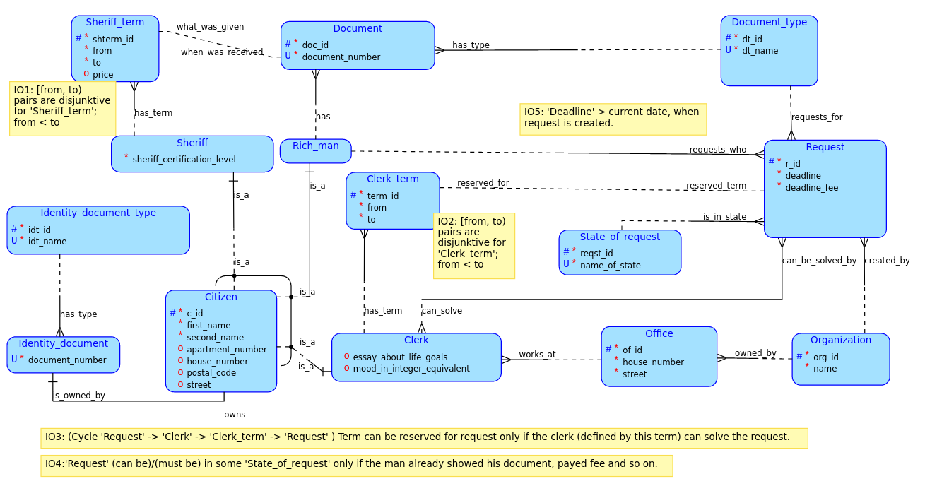
//------------------------------------------------------------------------------------------------------------------//

//------------------------------------------------------------------------------------------------------------------//

For BI-TJV semestral work, I limited used entities to the next ones:
Clerk, Rich_Man,
ClerkTerm(→(renamed) ClerkTimeSlot),
Request, Organization,
State_Of_Request(→(renamed) RequestState).

All other entities won’t be used for BI-TJV semestral work.

Office entity is removed, so we make a new one-to-many relation between Organization and Clerk entities.

The next integrity constraints will be solved in business logic: IO2, IO3, IO4, IO5

//------------------------------------------------------------------------------------------------------------------//

2. KB Notes:
- Used DB – HyperSQL in-memory
- Some tests are written in “server/test-requests.http”
- For now, I didn’t add more api requests, just added JPA and solved some problems around it.

//------------------------------------------------------------------------------------------------------------------//

//------------------------------------------------------------------------------------------------------------------//
Changed PUT to work according to RFC 7231 and RFC 5789.
Implementation before should have used PATCH instead of PUT.
//------------------------------------------------------------------------------------------------------------------//

