# CONTACTS

+39 351 906 0167 carlinogiovanni04@gmail.com [giovannicarlino04.github.io](https://giovannicarlino04.github.io/)



# WHO AM I?

# Software Developer and Reverse Engineer with over 5 years of freelance experience in delivering tailored digital solutions for small businesses and private clients. Specialized in developing high-performance, fast software with a strong focus on code quality and project scalability. Experienced in building proprietary game engines and developing video games, with solid expertise in 3D graphics, as well as advanced knowledge in cybersecurity and binary analysis.

# SKILLS

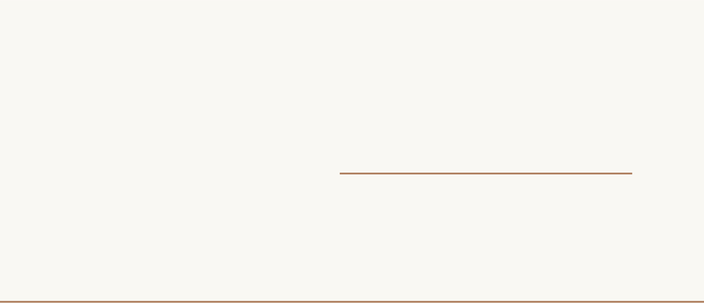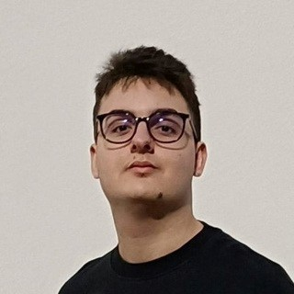

**Giovanni Carlino**

SOFTWARE ENGINEER

* Programming Languages: C#,

C/C++, Python, Java, ASM x86/64

* Web Development: HTML, CSS
* Reverse Engineering & Binary Analysis: Ghidra, IDA Pro, Binary Ninja
* OSes: Windows, Unix
* Version management: Git

# LANGUAGES

Italian (native) | English (advanced)

# EDUCATION

**High School Diploma**Istituto Tecnico Economico Liborio Salomi (Lecce)

**Middle School Diploma**

Scuola Media Statale Dag Hammarskjold (Nardò)