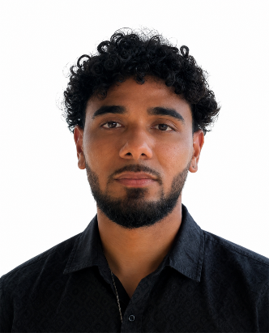
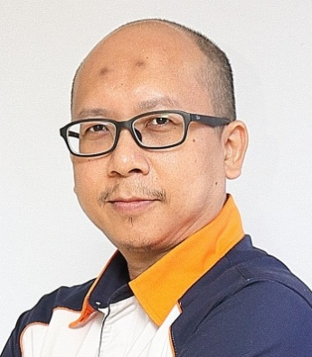
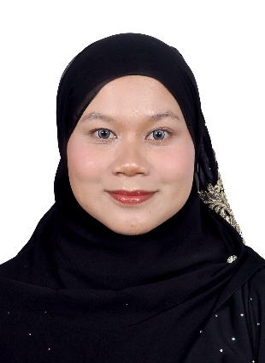
Giovanni Honakoko received a B.Sc. double degree in Mathematics and Physics from the University of New Caledonia in 2024. He is currently pursuing an Engineering degree in Applied Mathematics and Modeling at Polytech Nice Sophia, France. His primary research interests include machine learning, data science, and numerical optimization. His recent applied research focuses on environmental data analysis—specifically studying marine heatwaves with IFREMER—and the development of two-stage hybrid predictive AI models for food security risk assessment.
Muhd Khairulzaman Abdul Kadir starts off his first degree in BEng (Hons) in Electrical and Electronics at Universiti Tenaga Nasional. First job as Electronics R&D Engineer in Asia R&D Center for Matsushita Television Network Co. which currently known as Panasonic Audio Video Company in Shah Alam, Malaysia. After few years, then, a change career from engineer to academics in British Malaysian Institute, Gombak, Malaysia which currently known as Universiti Kuala Lumpur – British Malaysian Institute in 2003. Then, received master’s in engineering electrical-Electronics and Telecommunication at Universiti Teknologi Malaysia year 2007. Started to do research in embedded system, image processing and continue to enhance knowledge in intelligent system till pursue study in PhD Engineering at University of Warwick, UK in the same area. Main interests of research area are Data Mining, Machine Learning, Big Data Analysis, Intelligent System Design, any related Electronics and Electrical project, image processing, embedded system and food security. He really would like to work and collaborate with anybody that involves on the application of artificial intelligence techniques in any discipline (multidisciplinary) areas or any of the interest area.
Sha'elah Mohd Safri will receive a Bachelor of Electronic Engineering Technology with Honours from Universiti Kuala Lumpur - British Malaysian Institute (UniKL BMI) in 2024. She previously earned a Diploma in Embedded System Electronics Engineering from MARA Japan Industrial Institute in 2020. Her technical expertise encompasses full-stack software development, demonstrated during her tenure as a Software Engineer at Hatio Sea Sdn Bhd utilizing Python, C++, and TypeScript. Alongside her engineering proficiency in tools like MATLAB and AutoCAD, she exhibits strong leadership, having served as President of the Student Representative Committee at UniKL BMI.

