COS 214 Practical Assignment 1: u18009035

1.4 Template Method

2.3

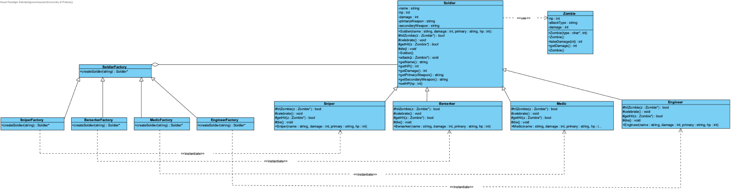

2.4 Factory Method

4.5

