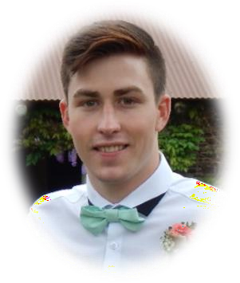

Brad Allan Zietsman

Hatfield, Pretoria

[u15228194@tuks.co.za](mailto:u15228194@tuks.co.za.)

084 076 3231

PROFESSIONAL PROFILE

Currently seeking to grow my individual capital through any and all means available, I am privileged enough to currently be a student at Pretoria University in the field of Information Technology. I hope someday to use this privilege in a field wherein I can both show innovation and create value in the work I produce. As an individual, I pride myself on living with passion and zest, an attitude I carry through into the work environment. I am in equal parts ambitious, enthusiastic and committed with a genuine interest in working as a team to tackle problem solving tasks.

EXPERIENCE

**Waitron**

Cut & Craft Bistro / 159 Queens Street, 2094 Kensington, Gauteng, South Africa / December 2018 – February 2018

**Tutor**

University of Pretoria / Lynnwood Rd, Hatfield, Pretoria, South Africa

3rd Year Undergraduate Student / COS 212 Tutor

SKILLS

Attention to Detail Accountability Confident

Dynamic & Innovative Diverse Thinker

Enjoy Challenges Public Speaking Problem Solving



github.com/Bradford-700/

linkedin.com/in/brad-zietsman-32a632189/

INTERESTS

Fishing Gym

Photography

Playing Pool

Rugby

Travel

EDUCATION

MATRICULATION, IEB

Thomas More Collage 2002 – 2014

BACHELOR OF SCIENCE IN INFORMATION TECHNOLOGY

University of Pretoria 2015 – 2020

Nico Brant

Owner

Cut & Craft Bistro

+27 62 465 9477 / 011 6150 230

REFERENCES

Ray Griesel for Allan Chandler

Headmaster

Thomas More Collage 031 764 8640

Anna Bosman

Lecturer

University of Pretoria

annar@cs.up.ac.za

# ACHIEVEMENTS

Confirmation

St. Dominic’s Catholic Church

2013

Member of the Matric Monitor Committee

Thomas More Collage 2014

First Aid

Level 1

2015

TEHNICAL SKILLS

Advanced Understanding & Comprehension in Multiple Programming Languages.

* Object-Orientated
  + C
  + C++
  + C#
  + Java
* Scripting
  + HTML
  + CSS
  + Bootstrap
  + PHP
  + Python
  + JavaScript
  + JQuery
  + AJAX
  + NodeJS
  + Flutter
* Data Storage
  + SQL
  + Firebase
  + MongoDB
  + Neo4j
  + XML
  + DTD Schemas
  + XSLT
* Other
  + Microsoft Office
  + Assembly
  + Prolog
  + Scheme

3rd Year Undergraduate Student / COS 212 Tutor

BRAD ALLAN ZIETSMAN