UMCG entrance examination

For a smooth appointment procedure:

- Please complete the enclosed questionnaire and send the completed and signed form, with appendices if relevant, to the following email address as soon as possible to:
International.office@umcg.nl

Postal address:
University Medical Center Groningen
Occupational Health Service / KA 10
Attn. Infection Prevention
Antwoordnummer 549
9700 WB Groningen, the Netherlands
(no stamp needed if sent from within the Netherlands)

- If you have any questions, please contact us as soon as possible via infectiepreventie@ag.umcg.nl or tel. +31503614535.

Visiting address
University Medical Center Groningen
Hanzeplein 1
Occupational Health Service
Triade building, entrance 24, 1st floor,
7.45 a.m. - 4.30 p.m. on weekdays
(see directions)
Open office hour for TB and MRSA: 11 a.m. - 12 noon on weekdays; no Mantoux tests taken on Thursdays.

Content:

- Information about UMCG entrance examination
- Questionnaire: infectious diseases, national and other vaccinations and information regarding hepatitis B vaccination
- Departments, positions and countries with a high TB risk
- Directions

Information about the entrance examination

You have applied for a position at the University Medical Center Groningen. The last phase of your application procedure will comprise a entrance examination performed by the Occupational Health Service, the UMCG’s internal Health, Labour and Environmental department. This screening aims to determine whether you are medically fit for the position in question and whether or not you will jeopardize your own health or that of others. You can read more about the component parts of the entrance examination below.

Hepatitis B
The UMCG has a preventative hepatitis B policy. Staff members who may come into contact with patients or patient material during their work must be vaccinated against hepatitis B. This means that compulsory hepatitis B vaccination applies to most positions.
We will check whether you have been vaccinated and are still sufficiently protected against hepatitis B, and whether you can prove this with sufficient evidence and thus satisfy the hepatitis B requirements that apply to your position. If you do not satisfy the applicable requirements, we will make an appointment with you to discuss how to take the necessary action.
If you are unable to present proof of vaccination we will assume that you have not been vaccinated. If you have not been vaccinated and a vaccination requirement applies to your position, we will immediately start a hepatitis B vaccination programme for you free of charge.

Screening for infectious diseases
The risk with regard to hospital staff and infectious diseases, including childhood diseases, is twofold: they can come into contact with infected patients during their work and thus become infected, or, if they are in the contagious phase of an infectious disease themselves, they can infect vulnerable patients, which may have serious consequences.
The UMCG aims to map its staff’s disease protection levels and offer MMR (mumps, measles and rubella) vaccinations to staff members who are insufficiently protected.

Depending on your position and workstation you may come into direct or indirect contact with patients. If this is the case, we must be provided with all relevant information about possible infection with TB or the MRSA hospital bacterium. We will use your completed questionnaire to investigate whether such information is relevant in your case. If necessary we will examine you for TB* or MRSA.

If you have any information with regard to vaccinations, childhood diseases or previous TB or MRSA screenings you may have had, please enclose this with your screening documents so we can include it in our records.

Accidental contact with patient material
If you come into contact with patient material as a result of a sting, cut, bite or splash accident during your work at the UMCG, you must report this immediately to your manager and to Accident & Emergency (tel. 18020). Your hepatitis B protection level and your risk of having contracted hepatitis B, hepatitis C, HIV or other diseases that are transmissible by blood will then be examined. If there is a possibility that you have been infected, A&E will if necessary start treatment and discuss further proceedings with you.

* The UMCG uses PPD Tuberculin Mammalian in accordance with national protocol. PPD Tuberculin Mammalian is not registered in the Netherlands, but it is registered in France, the United States and Canada. The RIVM has acquired an import licence for PPD Tuberculin Mammalian. The safety or this test is similar to that of the previously used skin test fluid (product PPD RT 23 of Statens Serum Institut in Copenhagen).

Medical confidentiality
All information you provide is covered by the duty of medical confidentiality.

Results of the entrance examination
You will in principle be appointable once you satisfy any applicable hepatitis B requirements and have had all the necessary examinations without any unusual results. The occupational health physician will discuss any unusual results with you. The employer will only be informed of the screening results with your permission.
You can lodge an appeal against the results of the screening by sending a letter with all relevant information to the Head of the Occupational Health Service within 14 days. A new screening will then take place, the result of which will also be sent to you first and will be binding.

When you have any questions about infection prevention policy regard to employee, then you can send an email at international.office@umcg.nl

Information regarding Hepatitis B vaccination and infectious diseases

This information concerns:
A new employee / intern / clerk / guest (incl. from abroad) / volunteer (please circle the relevant option)
Name: |  | M/F
Address: |  | Date of birth:
Postcode, town/city: |  | Telephone no.:
E-mail address: |  | Date of appointment:
Position:
Position:
Department:

Name/Contact information
Manager/supervisor:

Does your position involve contact with patients and or patient material? | - No
 | - Yes

HEPATITIS B

Have you already been vaccinated against hepatitis B?
- No
- Yes, please find copies of my vaccination documents and/or official titre results enclosed. Official documents can be requested from the institution that performed the vaccination.
- Yes, the UMCG already has my vaccination information.

Additional information with regard to your hepatitis B vaccinations or blood tests

Infectious diseases (i. childhood diseases) and national/other
vaccinations

Please indicate which infectious diseases you have had, whether you have been vaccinated against them via a national vaccination programme or whether you are not sure.
If you have filled in ‘not sure’ under measles and/or rubella, you can request an MMR vaccination via tel. 050-3614535

Disease (abbreviation) | Had | Vaccinated | Not sure
Mumps (M) | ❒ | ❒ | ❒
Measles (M) | ❒ | ❒ | ❒
Rubella (R) | ❒ | ❒ | ❒
Diphtheria (D) | ❒ | ❒ | ❒
Tetanus (T) | ❒ | ❒ | ❒
Polio (P) | ❒ | ❒ | ❒
Whooping cough (K; kinkhoest) | ❒ | ❒ | ❒
Chickenpox (VZV) | ❒ | ❒ | ❒

Covid-19 | r | Complete Basis Vaccination | r Yes  r No

Overview
Year of vaccination introduction according to the Dutch national vaccination programme (RVP, Rijksvaccinatieprogramma) https://rijksvaccinatieprogramma.nl/vragen

 | Vaccination
From 1953 | D Diphtheria vaccine
From 1954 | DTP Diphtheria, Tetanus and Polio combination vaccine
From 1957 | P Polio vaccine
From 1962 | DKTP Diphtheria, Whooping cough, Tetanus and Polio combination vaccine for babies
From 1974 | R Rubella vaccine for 11-year-old girls (year of birth 1962 or later)
From 1976 | M Measles vaccine
From 1987 | MMR Mumps, measles and rubella combination vaccine (for boys and girls aged 14 months and up)
N.B. | Chickenpox (varicella): no vaccination included in the Dutch national vaccination programme

TUBERCULOSIS

Have you ever had a BCG vaccination? BCG is a vaccine against tuberculosis (TB), which is not included in the standard Dutch national vaccination programme.
- No
- Yes
- Unknown

Have you ever been infected with TB?
- No
- Yes. We will examine you for TB, unless you have a TB-free statement and enclose it with this form.
- If yes, in which year?

Have you ever had treatment for active or latent TB?
- No
- Yes. We will examine you for TB, unless you have a TB-free statement and enclose it with this form.
- If yes, in which year?

Do you have any complaints, such as a cough? (only for employees who have ever had TB or latent TB)
- No
- Yes

Have you ever had a tuberculin skin test (Mantoux)?
- No
- Yes
- If yes, on what date and what was the result (pos/neg)?

Have you ever had an IGRA test (Quantiferon)?
- No
- Yes
- If yes, on what date and what was the result (pos/neg)?

Have you visited a country with a high TB risk in the past 2 years? (see attached list of high-risk countries)
- No (please skip the next question)
- Yes (please go to the next question)
- If yes, when did you return?

Did you spend more than 3 months in this country and/or did you have intensive contact with patients and/or the local population?
- No
- Yes. We will examine you for TB, unless you have a TB-free statement that is no more than 6 months old and enclose it with this form.

Have you ever worked at a department/ward with a high TB risk or in a high-risk position? (see attached list of high-risk departments and positions)
- No
- Yes. We will examine you for TB, unless you have a TB-free statement and enclose it with this form.

Will you be working at a department/ward with a high TB risk or in a high-risk position? (see attached list of high-risk departments and positions)
- No
- Yes. We will examine you for TB, unless you have a TB-free statement and enclose it with this form.

Have you ever been in contact with a TB patient?
- No
- Yes. We will examine you for TB, unless you have a TB-free statement and enclose it with this form
- If yes, on what date?

Do you have a disease or chronic illness that compromises your resistance?
- No
- Yes
- If yes, which disease?

Do you take any medication that could compromise your resistance?
- No
- Yes
- If yes, which medication?

MRSA

Have you worked at or been admitted to a hospital or care institution out of the Netherlands in the past year?
- No
- Yes.
- If yes, when did you return?

Have you ever had unprotected contact with an MRSA patient or have you ever been diagnosed with an MRSA infection?
- No
- Yes. We will examine you for MRSA.
- If yes, on what date?

Do you have any skin problems such as eczema or psoriasis?
- No
- Yes
- Other skin problems, namely……………………………………………………………………

A&G will review your questionnaire, if it appears that you need to be checked for TB and/of MRSA than you will get an e-mail.
When you have a TB and/of MRSA proof, send them along with the questionnaire.

OTHER INFECTIOUS DISEASES

Will you be appointed to a position that involves direct patient care or working with food (kitchen staff or food service assistant)?
- No. You have now reached the end of the questionnaire. Please sign the form on the next page.
- Yes. Please go to the next question.

Do you have any gastro-intestinal problems that result in diarrhoea and nausea?
- No. You have now reached the end of the questionnaire. Please sign the form below.
- Yes. Please answer the following questions:

The complaints were traceable to a meal: Yes/No
I had the complaints during or after a stay in a tropical or subtropical country: Yes/No
The complaints were accompanied by a fever: Yes/No

Explanatory notes (date, cause, effects):

SIGNATURE

The undersigned declares that all information has been provided truthfully.

Date: Name:

Signature:

Please send the completed questionnaire and any relevant copies of hepatitis B, TB or MRSA information
to:

international.office@umcg.nl

Department and positions within the UMCG with a high TB risk

Department: Tuberculosis Department (UMCG Beatrixoord)
Position: Intern

All staff members working (or possibly working) at high-risk departments or wards will also be examined for TB.

Countries with a high TB risk

Afghanistan
Angola
Bangladesh
Bhutan
Birma
Bolivia
Botswana
Burundi
Cambodja
Centraal
Afrikaanse
Republiek
Congo
(Brazaville)
Congo D.R.
(Kinshasa)
Djibouti
Ellice Eil.
Equatoriaal-
Guinea
Ethiopië
Filipijnen
Frans Guyana
Gabon
Gambia
Ghana
Guinee
(Conakry)
Guinee-Bissau
Haiti
India
Indonesië
Ivoorkust
Kenia
Kirzigstan
Kiribati
Korea Noord
Loas
Leshoto
Letland
Liberia
Madagaskar
Malawi
Mariana
eilanden (US)
Marshall Eil.
Mauretanië
Mongolië
Mozambique
Myanmar
Namibië
Nepal
Nigeria
Norfolk Eil.
Oeganda
Papoea Nieuw
Guinea
Peru
Sao Tomé en
Principe
Senegal
Sierra Leone
Somalië
Swaziland
Taiwan
Tanzania
Thailand
Tsjaad
Tuvalu
Vietnam
Zaïre
Zambia
Zimbabwe
Zuid-Afrika

Refugee Center (AZC, asielzoekerscentrum)

Directions to UMCG, Occupational Health Service Triade building, entrance 24, 1st floor,  050-36 14535

Directions by car
- Parkeergarage Noord, Vrydemalaan (please use this car park as Parkeergarage Zuid is always very busy)
To reach the UMCG by car, please follow the road signs. Leave the ring road,
head in the direction of Damsterdiep and follow the signs for “UMCG Noord”. Follow the Vrydemalaan “Ingang Noord” to “Parkeergarage Noord”.
When you leave the car park (near building 43) turn right and follow the dotted line on the map.
- Parkeergarage Zuid (Hanzeplein)
To reach the UMCG by car, please follow the road signs. These will automatically lead you to the car park underneath the central hall. From the central hall, go outside and follow the dotted line on the map.

Public transport
- The UMCG is easy to reach by public transport. From the P+R via Central Station, the number 3 (P+R
Hoogkerk/Lewenborg) and 4 (P+R Hoogkerk/Beijum) buses will take you to the corner of Bloemsingel and Antonius Deusinglaan in about 10 minutes. From Antonius Deusinglaan take Ingang Noord and follow the dotted line on the map.
- You can also take the number 5 bus ( P+R Euroborg/ P+R Haren) from the P+R via Central Station; which will bring you to the main entrance (Hanzeplein) of the UMCG. From here you can follow the dotted line on the map.
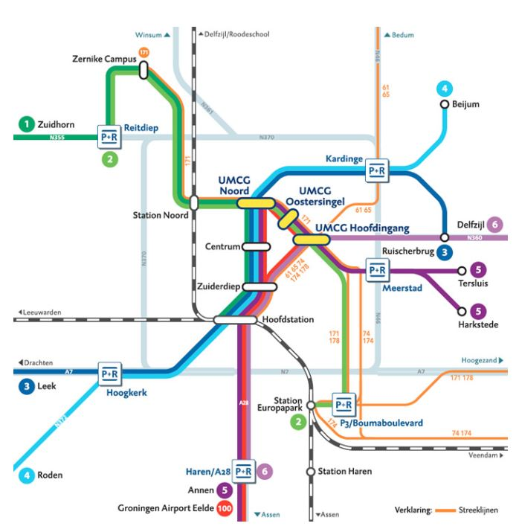
By bike or on foot
There are 4 different entrances you can take: via Hanzeplein, Petrus Campussingel, Antonius Deusinglaan/Vrydemalaan and Oostersingel. The various routes are shown as dotted lines on the map.

