Vulnerability Scan Report – Task 3

1. Objective
The goal of this task was to perform a full vulnerability assessment using Nessus Essentials on a local virtual machine imported from VulnHub. The assessment covers installation, configuration, scanning, findings, severity analysis, and mitigations based on real scan results.

2. Tools & Environment
Scanning Tool: Nessus Essentials
Host System: Windows (VirtualBox)
Target System: VulnHub VM (imported into VirtualBox)
Scanning OS: Kali Linux VM

3. Methodology

Step-by-Step Workflow
- Downloaded Nessus Essentials from the official Tenable website
- Verified installer checksum
- Installed Nessus using .deb package
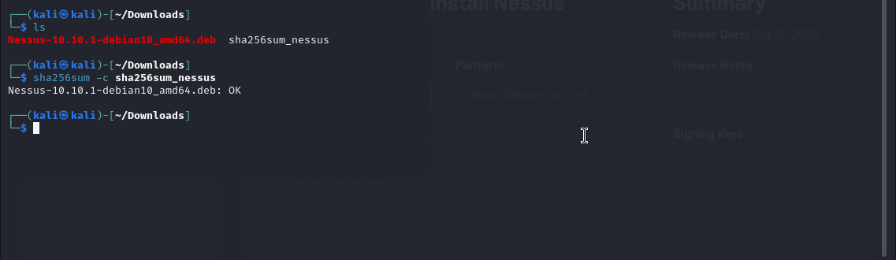
Installed Nessus using .deb package
- Activated Nessus Essentials using free activation key
- Started the Nessus service using:
sudo systemctl start nessusd.service

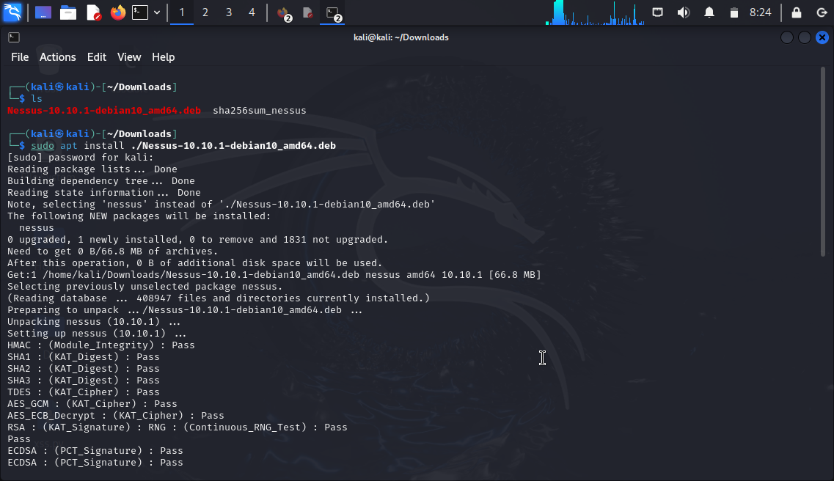
Successful Nessus download

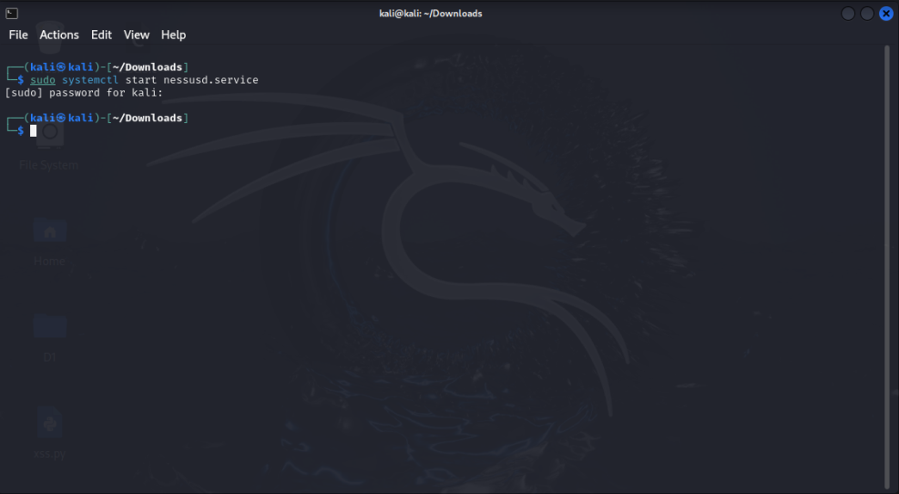
Starting Nessus

- Accessed the Nessus web interface via browser:
https://localhost:8834/

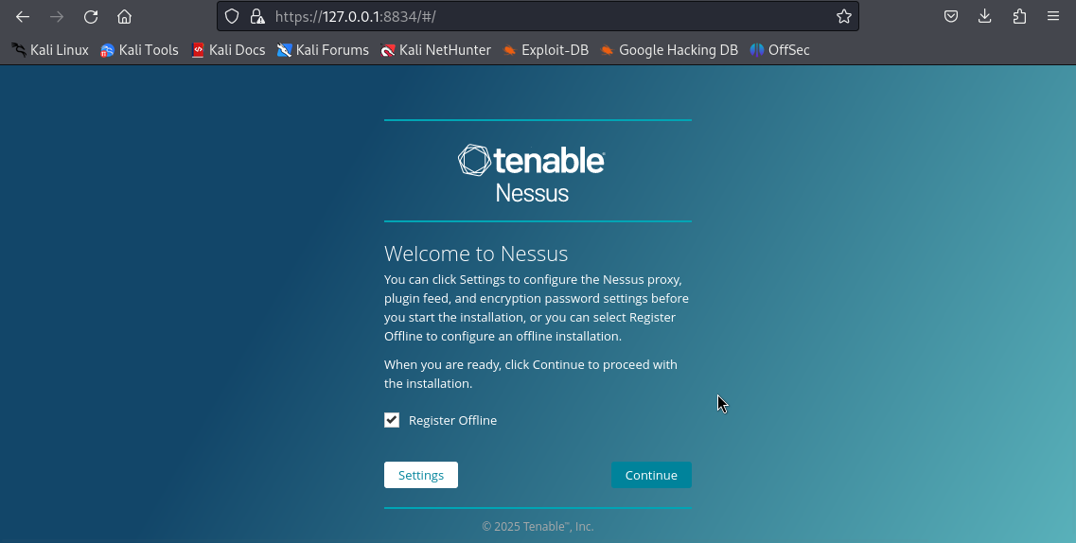
Setting up Nesus from Tenable

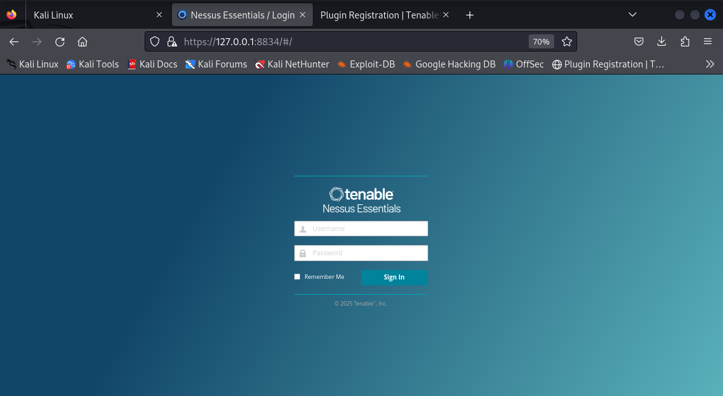
Accessed the Nessus web interface
- Waited for plugin download and initialization
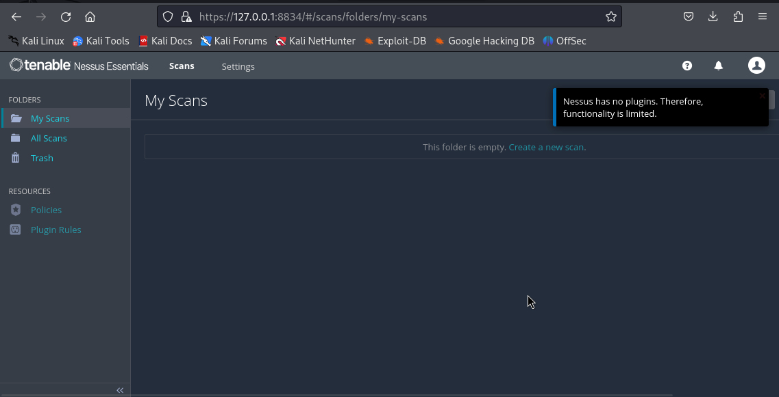
Initially Nessus has no plugins

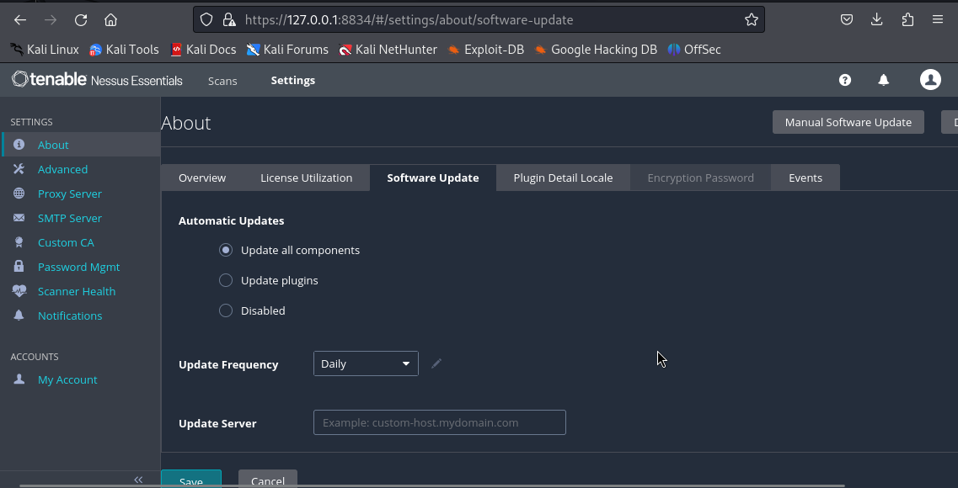
Plugins downloaded and initialized

- Identified target IP using terminal command:
ip addr

- Created a Basic Network Scan targeting the VulnHub VM

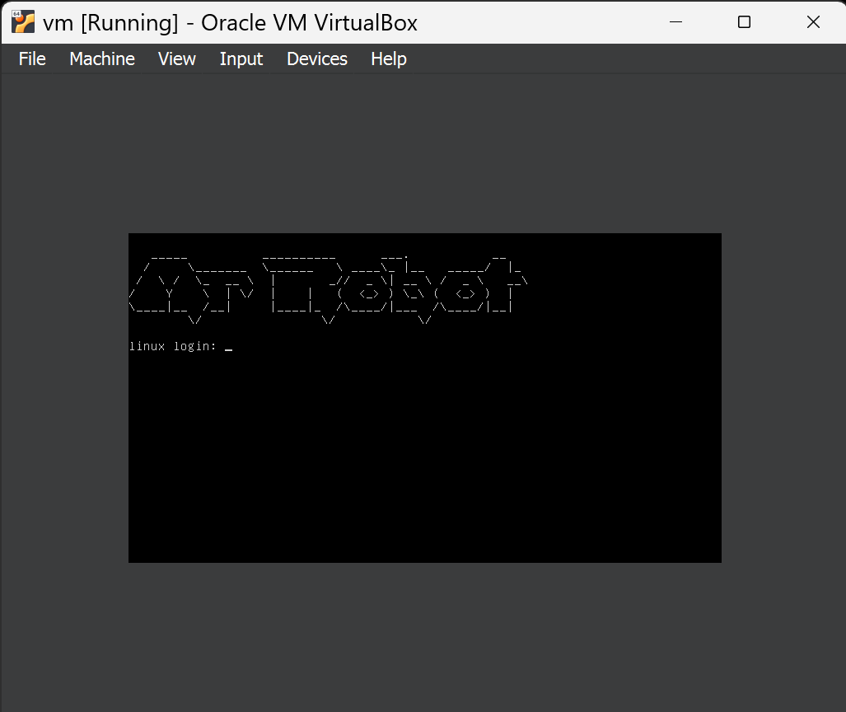
VulnHub VM Mr. Robot
- Launched scan, monitored progress, and exported results, obtained vulnerabilities, remediations and notes.
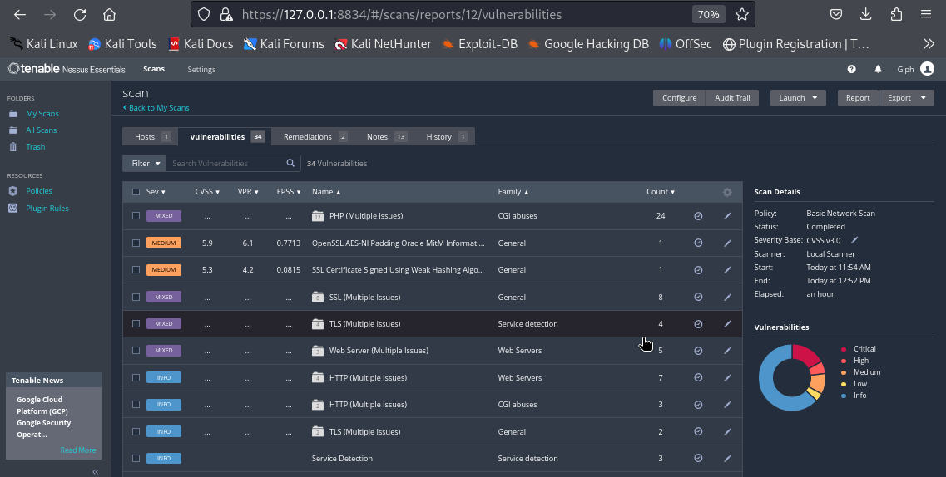
Vulnerabilities

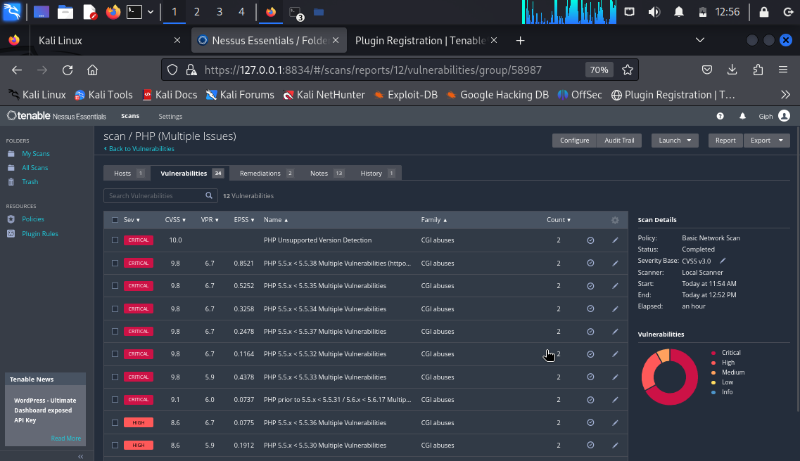
Critical vulnerabilities

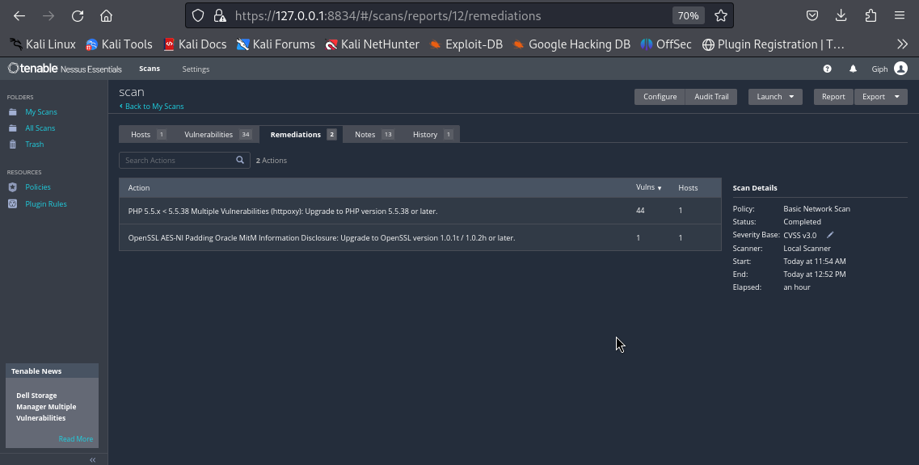
Remediations

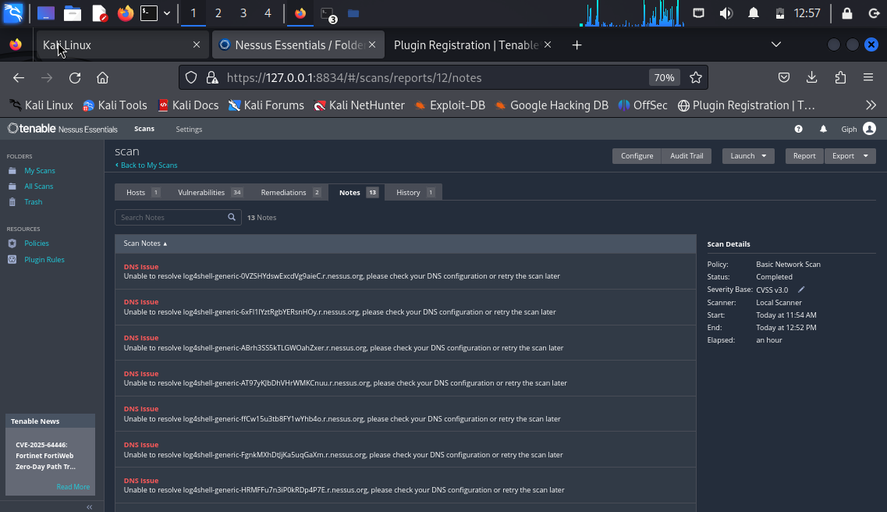
Notes

4. Commands Used & Purpose
Command | Purpose
ip addr | Identify host machine IP address
sudo nmap -sn X.X.X.0/24 | Discover live hosts on the subnet
sudo nmap X.X.X.X | Quickly probe open ports / verify target IP
These commands were used before launching Nessus to locate the correct target system and verify that it was accessible.

5. Nessus Scan Configuration
Setting | Value
Scan Type | Basic Network Scan
Target | Local machine (VulnHub VM)
Scan Duration | ~60 minutes

6. Findings Summary
Based on the completed Nessus Essentials scan, the target system reported a total of 34 vulnerabilities, including multiple critical PHP and OpenSSL issues.
Severity | Count
Critical | 8
High | 2
Medium | 3
Low | 0
Info | 21

Top Critical Findings
- PHP Unsupported Version Detection (CVSS 10.0)
- PHP 5.5.x < 5.5.38 Multiple Vulnerabilities
- PHP 5.5.x < 5.5.37 Multiple Vulnerabilities
- PHP 5.5.x < 5.5.36 Multiple Vulnerabilities
- PHP 5.5.x < 5.5.35 Multiple Vulnerabilities
- PHP 5.5.x < 5.5.34 Multiple Vulnerabilities
- OpenSSL AES-NI Padding Oracle MitM Information Disclosure
These vulnerabilities are linked to outdated PHP and OpenSSL versions, commonly found in intentionally vulnerable systems.
Common vulnerabilities discovered in this type of environment include:
- Outdated SSH server versions
- Anonymous FTP access
- Deprecated TLS versions
- Weak cipher suites
- Missing security patches
- Default application credentials

7. Vulnerability Analysis

Critical: PHP Unsupported Version Detection
Severity: Critical (CVSS 10.0)
Impact: Running unsupported PHP versions exposes the system to dozens of publicly known RCE, LFI, authentication bypass, and memory corruption vulnerabilities.
Evidence: Screenshot -PHP Unsupported Version Detection
Mitigation: Upgrade PHP to 7.x or later.

Critical: PHP 5.5.x < 5.5.38 Multiple Vulnerabilities
Severity: Critical (9.8)
Plugin Family: CGI Abuses
Impact: Multiple vulnerabilities affecting memory handling, buffer overflows, and remote code execution.
Mitigation: Update PHP to v5.5.38 or higher.

High: OpenSSL AES-NI Padding Oracle MitM Information Disclosure
Severity: High (8.6)
Impact: Can enable man-in-the-middle attacks by exploiting padding in TLS sessions.
Mitigation: Upgrade to OpenSSL 1.0.1t / 1.0.2h or later.

8. Research and Mitigation
Mitigations were taken directly from Nessus recommendations as seen in the "Remediations" tab:
Vulnerability | Recommendation
PHP 5.5.x vulnerabilities | Upgrade PHP to 5.5.38 or later
OpenSSL MITM issue | Upgrade OpenSSL to at least 1.0.1t / 1.0.2h
Additionally, CVE and plugin references were consulted via Tenable’s database and MITRE CVE listings.

9. Conclusion
The vulnerability assessment successfully identified multiple weaknesses in the target environment using Nessus Essentials. The most serious risks include outdated services, missing patches, weak encryption, and default credentials. These findings demonstrate how attackers could exploit unmaintained systems.

10. Notes
- Target was intentionally vulnerable (VulnHub machine)
- No live production environment was scanned
- Assessment performed for educational purposes only

