Photographer Matching Platform

System and Software Architecture Description (SSAD)

Team 2

- 2014210011 고나현 rhskgus@korea.ac.kr
- 2013210086 김영훈 2013210086@korea.ac.kr
- 2014210101 김원경 kwk2392@korea.ac.kr
- 2013210081 박진호 onlylove6913@kroea.ac.kr
- 2013210039 이민섭 alexn0@korea.ac.kr
- 2014210065 이상진 eesj@korea.ac.kr
- 2015410005 이정섭 james319@korea.ac.kr
- 2013210020 임원준 rhimjun@korea.ac.kr
- 2014210059 정희석 poco2889@korea.ac.kr

Table of Contents

1 Introduction 7
1.1 Purpose of SSAD 7
1.2 Standards and Conventions 7
1.3 References 7
2 Architectural Analysis 8
2.1 Component Model 8
2.2 Behavior Model 12
2.3 Enterprise Model 15
3 System Design 17
3.1 Architectural Views 17
3.2 Class Model 19
3.3 Operations Model 20
4 Common Definition Language 33

Version control
Date | Author | Revise | Version
11/24/2018 | 고나현, 이정섭, 임원준, 정희석 | Initial draft | 0.1
11/26/2018 | All | Overall revise | 0.2

List of Figures
Figure No. | Caption
Figure 2-1 | Component Model Diagram | 8
Figure 2-2 | Behavior Model – Access through application | 12
Figure 2-3 | Behavior Model – User | 13
Figure 2-4 | Enterprise model – Web Interface | 15
Figure 2-5 | Enterprise model – Photographer Matching | 15
Figure 2-6 | Enterprise model - behaviors | 16
Figure 3-1 | Layered Architecture | 15
Figure 3-2 | Class Model Diagram | 17
Figure 3-3 | Object Model Diagram | 17
Figure 3-4 | Registration OP-01 | 18
Figure 3-5 | Login OP-02 | 19
Figure 3-6 | View Profile OP-03 | 20
Figure 3-7 | Manage Profile OP-04 | 21
Figure 3-8 | Search Photographer OP-05 | 22
Figure 3-9 | Search Photo OP-06 | 23
Figure 3-10 | Exchange message OP-07 | 24
Figure 3-11 | Upload photo OP-08 | 25
Figure 3-12 | Edit photo OP-09 | 26
Figure 3-13 | Delete photo OP-1 | 27
Figure 3-14 | Give “Like” OP-11 | 28
Figure 3-15 | View Photo OP-1 | 29

Introduction

The section covers the purpose of the system and software architecture description document as well as all the references used in the preparation of this document.

Purpose of SSAD

The System and Software Architecture Description describes how the Photographer Matching PlatformWebMailWebMailWebMail will be implemented. The document contains two major sections, system analysis and architectural design of the proposed system.

The system analysis section focuses on the high level architectural components and interactions that satisfy the system requirements. It will describe how the system will be decomposed into three main components. It also analyzes the behaviors of the photographer(s) and photographee(s).

The architectural design section focuses on the how the software is implemented using specific software framework, components and technologies. The section describes to the implementers such that it is clear for them to proceed to construction phase. The architecture details presented here will be the committed architecture and design that will be built in the construction phase.

Standards and Conventions

- Standards used (DOD, IEEE)
- Notation used (UML)
  - Any exceptions to the standard notation employed
- Naming Conventions
  - Consistent use of names for elements
    - e.g., anObject, the_attribute, MyClass, theOperation()
    - e.g., nouns for Components, Objects; verbs for Behaviors, Operations
    - e.g., label for relationships and outlets
MBASE framework is used for overall software engineering process.

Unified Modeling Language (UML) is used for diagram illustrations. Use case diagram, class diagram, sequence diagrams are used for graphical presentation in a standard notation.

References

1. UML Documentation (10/22/2018)
2. WinWin Negotiation Results (10/14/2018)
3. Project Developer Meeting Minutes: 가자쏘공0920.docx, 가자쏘공0927.docx 가자쏘공1010.docx 가자쏘공1014.docx
4. System and Software Requirements Description (SSRD) v0.5

Architectural Analysis
The intention of the architectural analysis is to identify the high-level software components and interactions from different perspectives.

Component Model

The component model in figure 2-1 is derived and refined from Entity Model of OCD 4.5.2. Components are identified by rejecting non-component entity classes, such as Photo DB, Message DB, etc. Those entities will be described in SSAD 3.2 Object Model.
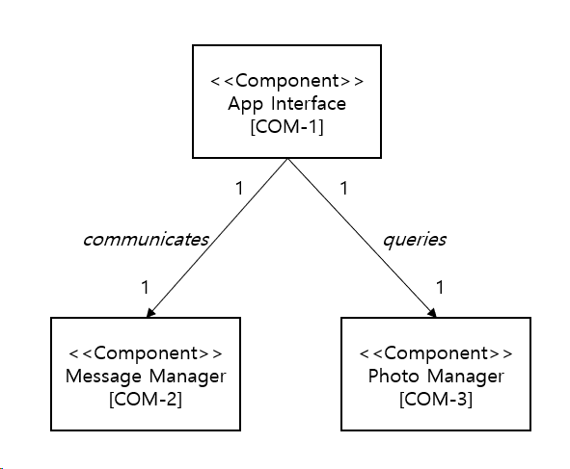
Figure 2-1 Component Model Diagram

Component Specification:

Identifier | COM-1
Defining quality | A user interface that allows to display photo and photographer's profile and message exchange.
Name | App Interface
Attributes | - Customer ID  - Customer Profile  - Display Photo  - Message index
Behaviors | Refer to SSRD v0.4,  Figure 2-2 Behavior Model – Access through
Relationships | - COM-2 Message Manager  - COM-3 Photo Manager
Roles | Request initiator
State Groups | 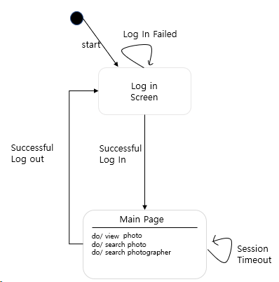
Constraints | Dependencies | COM-2 Message Manager  COM-3 Photo Manager
 | Candidate Key
 | Cardinality | 1, each app interface serves one user

Identifier | COM-2
Defining quality | A service to provide client to access and exchange messages between photographee(s) and photographer(s). Messages are stored in DB.
Name | Message Manager
Attributes | - Message server address  - Message protocol
Behaviors | - Response to customer’s request  - Read messages from the message server  - Send messages through the message server
Relationships | COM-1 App Interface
Roles | Middle-man between App Interface and existing message server(s)
State Groups | 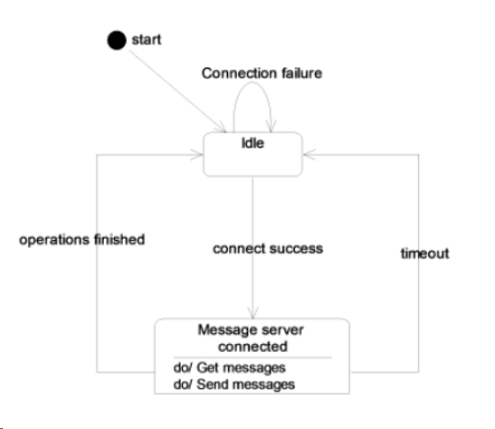
Constraints | Dependencies | Nil.
 | Candidate Key
 | Cardinality | 1, one app interface interacts 1 message manager component

Identifier | COM-3
Defining quality | A service providing access to search for pictures and find the pictures you want. This is done by connecting to message server.
Name | Photo Manager
Attributes | - Photo server address  - Retrieval photo
Behaviors | Lookup photo which customer wants
Relationships | COM-1 App Interface
Roles | Middle-man to existing photo server
State Groups | 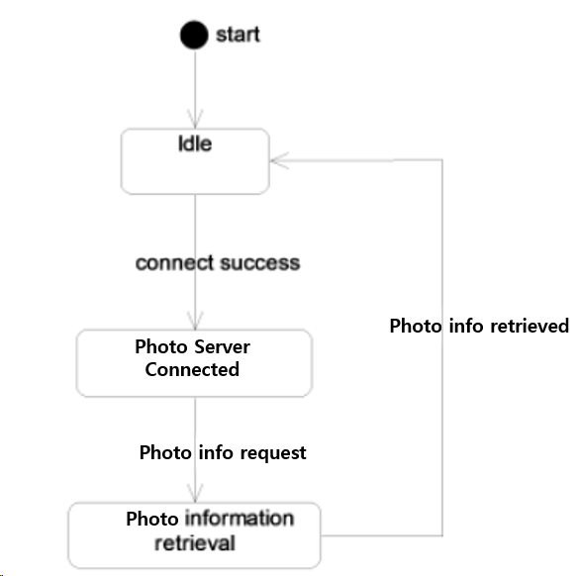
Constraints | Dependencies | Nil.
 | Candidate Key
 | Cardinality | 1, each app interface component has photo manager component

Behavior Model

The behavior model describes the behaviors that will be carried out in our system from the actors’ perspective.

Behaviors breakdown

CAP-01 Anytime and anywhere access the system
- BH-01 Access through application
- BH-02 Login <<policy>>

CAP-02 Search and View Photo and Photographer
- BH-03 Search Photo
- BH-04 View Photo
- BH-05 Search Photographer

CAP-03 Exchange Message between photographer and photographee
- BH-06 Send Message

Diagram illustration
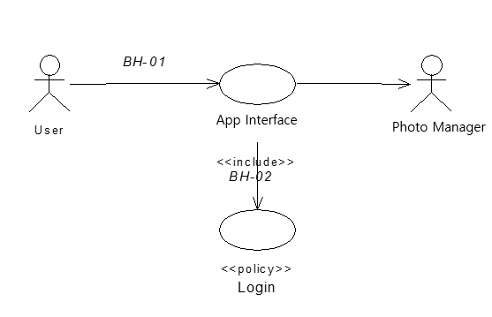
Figure 2-2 Behavior Model – Access through application

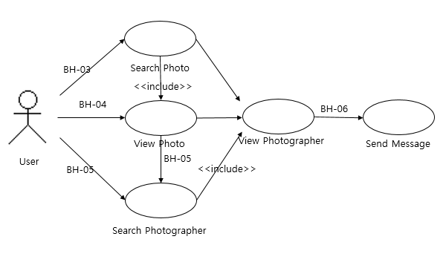
Figure 2-3 Behavior Model – User

Behavior Specification

Identifier | BH-01
Name | Access app interface
Trigger | User motivation of using platform service
Preconditions | Open a application
Postconditions | Open application main page
Input | UserID, password
Output | Main page of application displayed
Exceptions | Invalid user login
Use Case | Refer to SSRD Figure 3-2

Identifier | BH-02
Name | Login
Trigger | Signin button clicked
Preconditions | Login page shown
Postconditions | Open application main page
Input | Username, password
Output | Main page of application displayed
Exceptions | Invalid user login
Use Case | Refer to UML_Diagram Sequence Diagram 2. Login

Identifier | BH-03
Name | Search Photo
Trigger | Click search button and type keyword(s)
Preconditions | A photographer uploads a photo, he/she can include a photo-taken location information and keyword(s).
Postconditions
Input | Keyword(s), location
Output | Show photos related to keyword(s) or a location
Exceptions | - There is no photo matched with a keyword  - There is no photo matched with a location
Use Case | Refer to UML_Diagram Sequence Diagram 6. Search Photo

Identifier | BH-04
Name | View Photo
Trigger | Success Login
Preconditions | Only logged-in users can view uploaded photo(s)
Postconditions
Input | Photo ID
Output | A photo with description
Exceptions
Use Case | Refer to UML_Diagram Sequence Diagram 14. View Photo

Identifier | BH-05
Name | Search Photographer
Trigger | Click search button and put location or name
Preconditions | Information of photographers and locations should be stored in their profile.
Postconditions
Input | Location, Name
Output | Show the list of photographers
Exceptions | - When there is no photographer in the location  - In case you search a photographer by his/her name and there is no one having the name
Use Case | Refer to UML_Diagram Sequence Diagram 5. Search Photographer

Identifier | BH-06
Name | Send Message
Trigger | Click message button
Preconditions | Service user(s) who register the app is given an authority to send and receive messages
Postconditions | The Matching between photographee(s) and photographer(s)
Input | What to say to a photographer or a photographee
Output | Chat room with history of sender/recipient
Exceptions | Message server is down
Use Case | Refer to SSRD RQ-7

Enterprise Model

The enterprise model describes the overall inter-relationship of application structures including components and behaviors. Relationships such as generalization will be shown here.

Component Classifications

Classification hierarchy of components based on SSAD The intention of the architectural analysis is to identify the high-level software components and interactions from different perspectives.

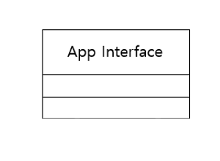
Figure 2-4 Enterprise model – App Interface

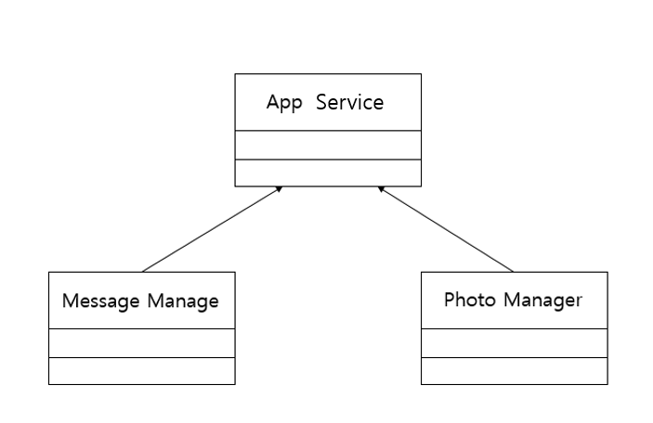
Figure 2-5 Enterprise model – Photographer Matching

Behavior Classifications

Classification hierarchy of the behaviors presented in SSAD 2.2 Behavior Model

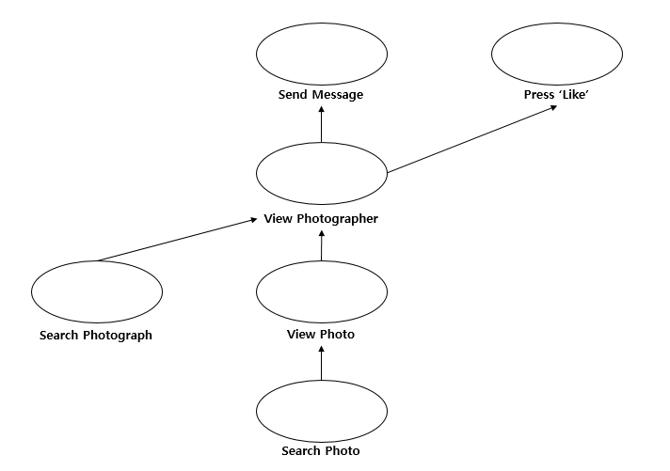
Figure 2-6 Enterprise model - behaviors

System Design
The system design section of the document describes how the system will be implemented in software. Specific technology choices such as software framework, protocols and implementation objects are mentioned such that the implementers receive clear and precise architectural design proposed.

Architectural Views

The architectural views provide a high level blueprint for implementation from different perspectives. They act as a bridge that transforms from system analysis result to implementation.

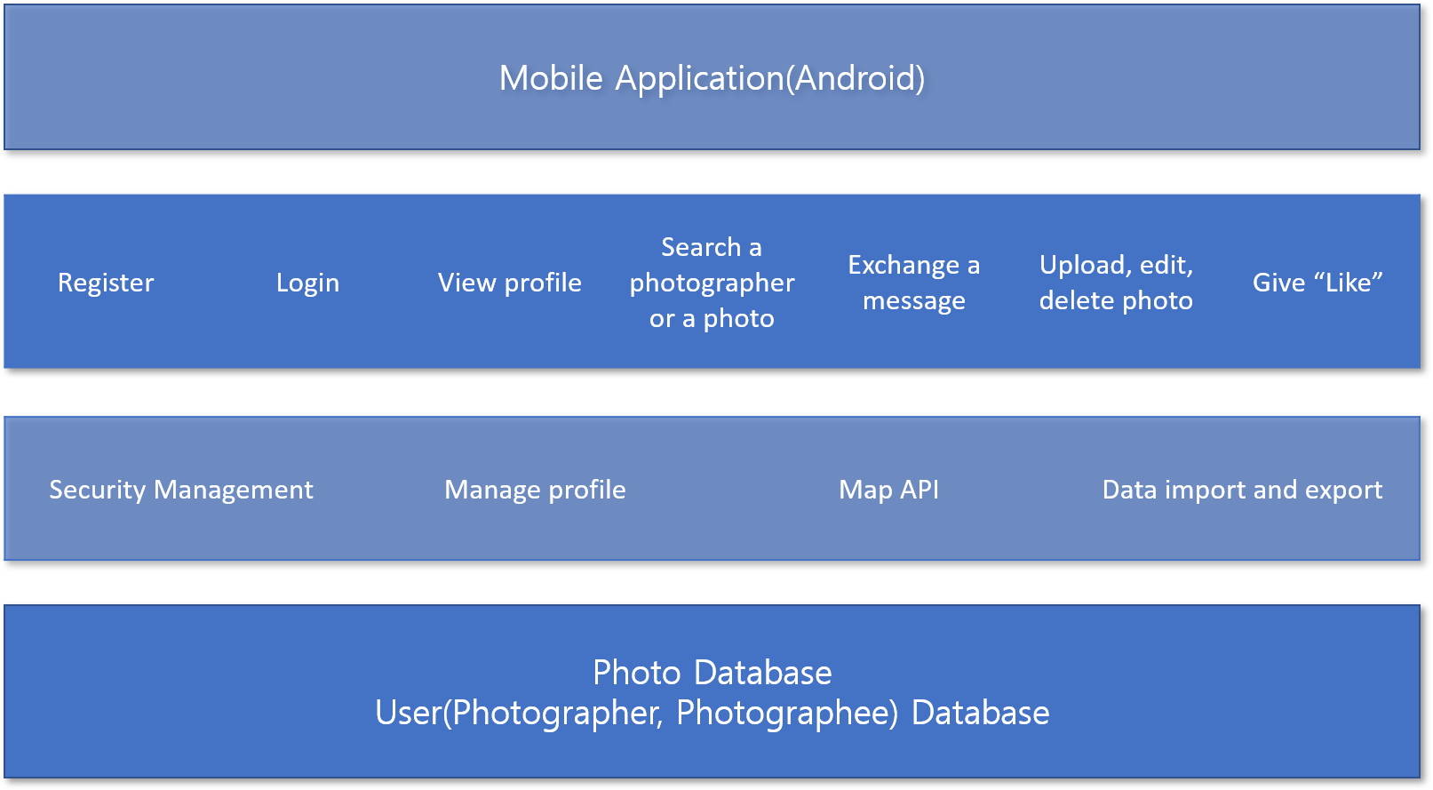
Figure 3-7 Layered Architecture

Layered Architecture

Description | Organizes the system into layers with related functionality associated with each layer. A layer provides services to the layer above it so the lowest-level layers represent core services that are likely to be used throughout the system.
Advantages | It is simple that it is easy to learn and visible in the project at first. It is consistent across different projects that the layers. Separation of concerns is guaranteed that concerns having a layer and to the point that you stick to the rules of Layered Architecture, but it is easy with the code organization it implies.
Disadvantages | It is confusing to find the right levels of abstraction. For example, ‘Exchange a message’, which is on 2nd layer, includes some functionality factors. As it is normally on 3rd layer, ‘Exchange a message’ should be placed on 3rd layer. But messaging is too ambiguous to put 3rd layer because its properties are also into 2nd layer. Also, it is very hard to tell what a project is doing by looking at the code organization. To understand the overview you should read the class names and even the implementation.

Component Specification:
Layered architecture is appropriate to our project because of its simplicity. It is easy to understand that a layer communicates with an adjacent layer. For instance, we can find out at first grasp that ‘Login’ which is on user interface management layer(2nd layer) is related to ‘Security Management’ which is on functionality layer(3rd layer). Also, we divide the whole project into various small ones, consistency is highly required in order to prevent any confusion. It helps to keep the overall code organization is the same in every layered project.

Class Model
- The Object Model is a refinement of the Component Model (SSAD 2.1)
- Specify objects to be built in the system using suggested Object Specification template.
- Object interaction diagrams may be used in the Operations Model. They are helpful in determining which operations are assigned to this object, and reference them as needed
- When detailing the design, include specifications for:
  - DB tables
  - file structures
  - HTML templates (dynamic generation)
  - runtime environment
  - COTS interface parameters
  - Utility libraries

You may want to specify detailed information for non-trivial objects. This might include (on a risk driven basis) the following:
Object Specification Template:
Identifier - Unique identifier used for traceability (e.g., OBJ-xx)
Defining quality -
Name -
Variables - {public, private, protected}
Specify for each whether it's:
Global (shared attribute by all instances)
Instance (attribute specific to a particular instance)
a) ...
b) ...
c) ...
Object Interactions -
Operations - List operations and determine accessibility {public, private, protected}
a) ...
b) ...
c) ...
...
Outlets - interface relationships (references, pointers, etc.) to objects and components.
a) ...
b) ...
c) ...
...
States -
Use state transition diagrams
...
Constraints -

Component Membership -
Which component from the Component Model (SSAD 2.1) does it belong to?
or
Which component from the Component Model (SSAD 2.1) participates in its implementation?

Implementation - (kind of object)
e.g., Java object, API, HTML page, Database table
Common Pitfalls:
- Including Objects that do not reference Components
- Omitting Objects Specification Templates
- Not including the Implementation for (or kind of) a given object, especially during the detailed design
- Including operations in Operation Model that are not assigned to Objects in the Object Model
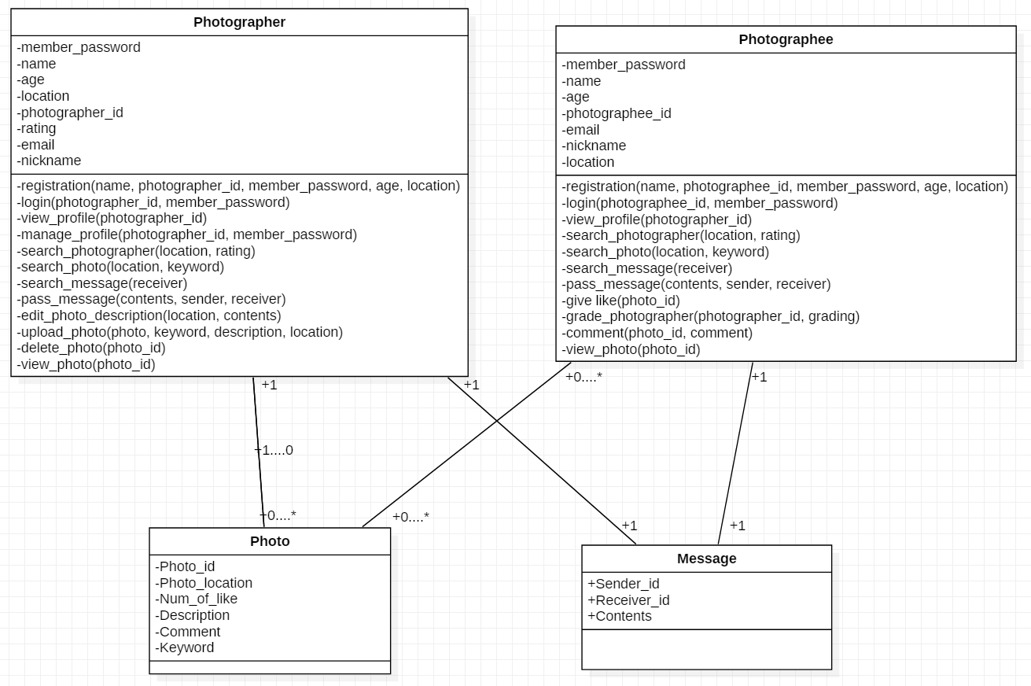
Figure 3-2 Class Model Diagram

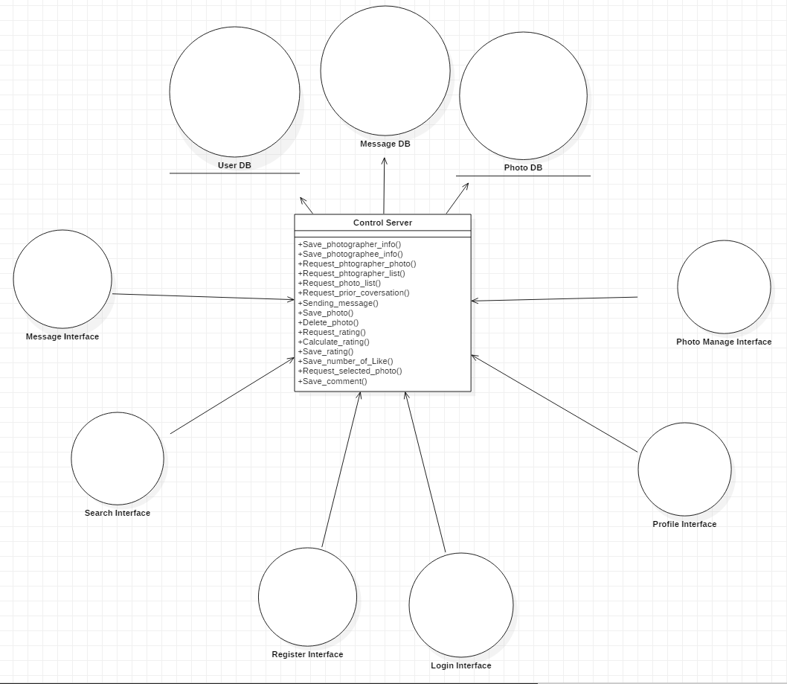
Figure 3-3 Object Model Diagram

Operations Model
- The Operations Model should be a refinement of the Behavior Model (SSAD 2.2)
- Operations are the specific sequences of computation that realize System Requirements (SSRD 3.2) according to the behaviors specified in SSAD 2.2. Operations are performed within objects and when the objects are implemented, the System Requirements should by design be satisfied.
- Create operations by refining behaviors from the Behavior Model (SSAD 2.2) to “leaf” behaviors (operations)
- Augment behavior model with critical operations needed to carry out
- Events (<event>) imply operations are needed to respond to this event (often you will need to add operations that perform “notification” that this particular event has occurred.
- Use sequence diagram to detail order of operations
  - non-critical operations (such as notifications)
  - assign operations to objects
  - Try to use existing objects, minimize messages that go outside an object
  - Take care when introducing new objects to handle ops – remember elegance!!
- Algorithms (<algorithm>) imply that you will need to detail a sequence of operations that perform the particular algorithm indicated
- Haphazard introduction of objects to handle operations: only create new objects as absolutely needed
- Not tying operations to System Behaviors and Capabilities
- Including operations that do not references Behaviors, System Requirements or Level of Service Requirements
- Including operations in the Operations Model that are not assigned to objects in the Object Model
- Not covering all the behaviors from the Behavior Model (SSAD 2.2)
- Not covering all the System Requirements from SSRD 3.2

Critical Algorithms
- Detail and explain critical custom algorithms
- Detailed policies and associated algorithms for carrying out policies as identified in OCD 3.6.3
Common Pitfalls:
- Identifying algorithms without providing a description of the algorithm (this is allowed at LCO, but at LCA all critical algorithms should either be assigned to identified COTS or described in detail)
No critical algorithm used in this Photographer matching platform project.

Operation Specifications
- Describe the operations performed to demonstrate all the system behaviors described in Behavior Model (SSAD 2.2).
- Identify the flow of control through the system during system execution and provide operation signatures and entry/exit conditions.
- Provide an Operation Specification Template for non-trivial operations. These often need to refer to System Requirements Specifications. You may wish to include the following information:
Operation Specification Template:
Identifier - Unique identifier used for traceability (e.g., OP-xx)
Initiator - An Initiator can be one of {Event, Policy, Behavior}
Event - Reference which one
Policy - Reference which one
Behavior - Reference which one
Passed parameters -
Return values -
Exception handling -
Guards -
Validation -
Messages - A message can be any of {Notification, Request, Custom}
Notifications - Reference which one
Requests - Reference which one
Custom - Reference which one
Exits -
Constraints -
Synchronization - (valid event sets, timing, concurrency, etc.)
Relates to - Reference corresponding Behavior (SSAD 2.2) or System Requirement (SSRD 3.2)

Registration
Common Pitfalls:
- Including analysis level operations specifications which do not identify the operation signatures
- Including operations in Operations Model that are not assigned to Objects in the Class Model
- Haphazard introduction of objects to handle operations: only create new classes as absolutely needed
- Not tying operations to System Behaviors and Capabilities
- Including operations that do not references Behaviors, System Requirements or Level of Service Requirements
- Including operations in the Operations Model that are not assigned to classes in the Object Model
- Not covering all the behaviors from the Behavior Model (SSAD 2.2)
Identifier | OP-01
Initiator | SSAD 2.2.3 Registration <Behavior>
Passed parameters | a) Username  b) Password  c) Account type(photographee, photographer)
Return values | Main page of the photographer matching platform with welcoming message
Exception handling | Registration failed, a pop-up message “Fail” shows up.
Guards | Entries cannot be empty
Validation | Connect to server to validate the user registration
Messages | Registration request {Request}
Exits
Constraints
Relates to | SSAD 2.2.3 BH-01

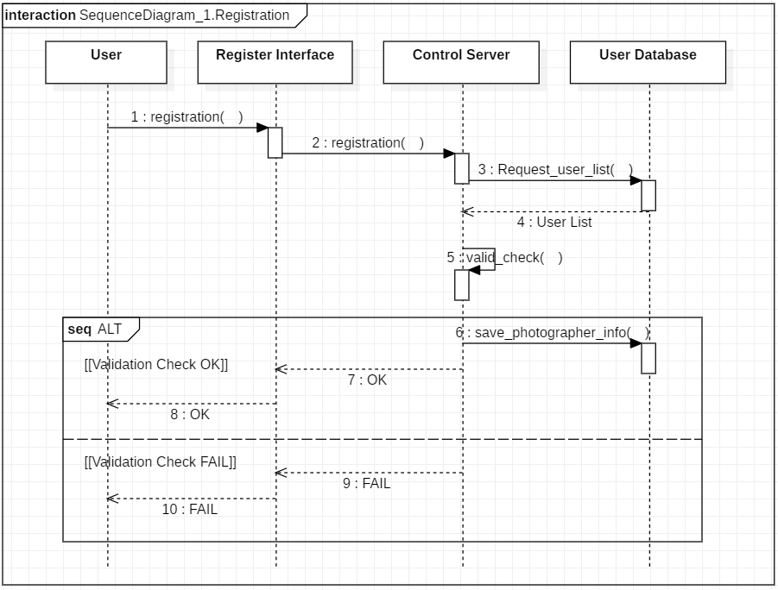
Figure 3-4 Registration OP-01

Login

Identifier | OP-02
Initiator | SSAD 2.2.3 Login <Behavior>
Passed parameters | a) Username  b) Password  c) Account type
Return values | Main page of the photographer matching platform
Exception handling | - Login failed, a pop-up message “Fail” shows up.
Guards | Entries cannot be empty
Validation | Connect to server to validate the user registration
Messages | Login request {Request}
Exits
Constraints
Relates to | SSAD 2.2.3 BH-02

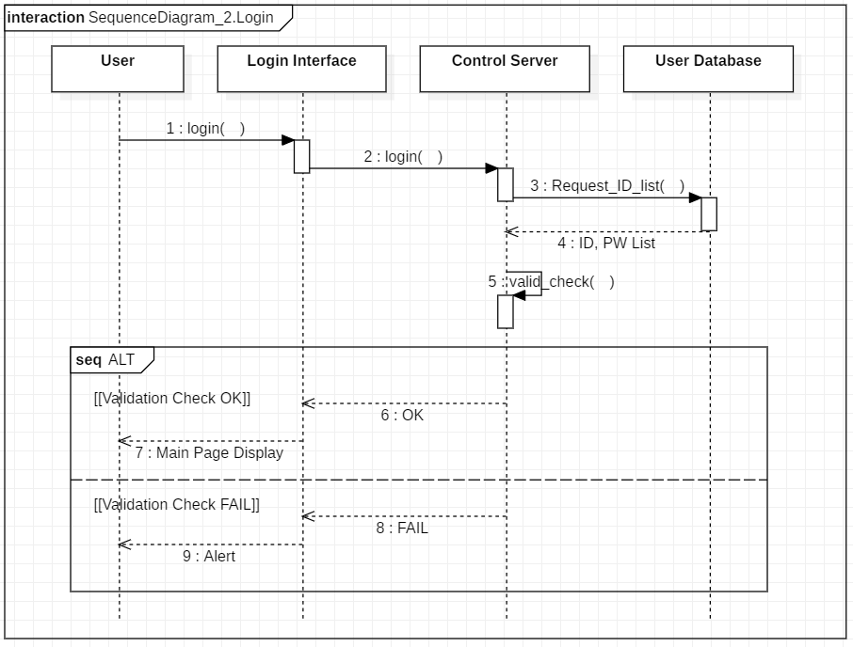
Figure 3-5 Login OP-02

View Profile

Identifier | OP-03
Initiator | SSAD 2.2.3 View Profile <Behavior>
Passed parameters | - Photographer
Return values | photographer’s profile page
Exception handling | Failing to get response from server, a pop-up message “Fail” shows up.
Guards | Information of a photographer’s profile should be contained in DB.
Validation | The photographer that a user intends to see should be identical to information of a photographer’s profile saved in DB.
Messages | View profile request {request}
Exits
Constraints
Relates to | SSAD 2.2.3 BH-03

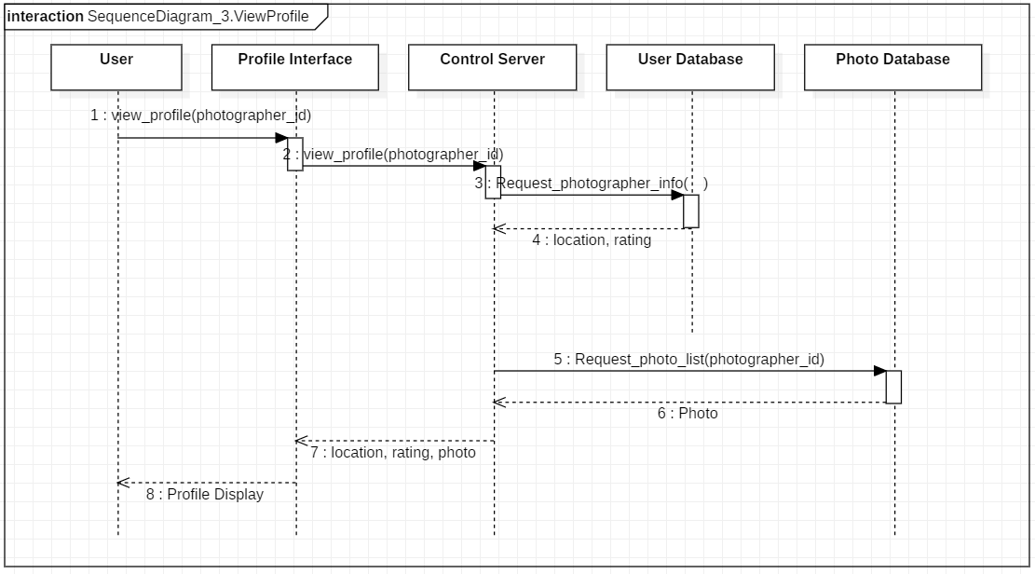
Figure 3-6 View Profile OP-03

Manage Profile

Identifier | OP-04
Initiator | SSAD 2.2.3 Manage Profile <Behavior>
Passed parameters | a) modified profile
Return values | revised profile page
Exception handling | Failing to get response from server, a pop-up message “Fail” shows up.
Guards | Information of a user’s profile should be contained in DB.
Validation | Revised information in profile should be saved in his/her own DB.
Messages | Manage profile request <request>
Exits
Constraints
Relates to | SSAD 2.2.3 BH-04

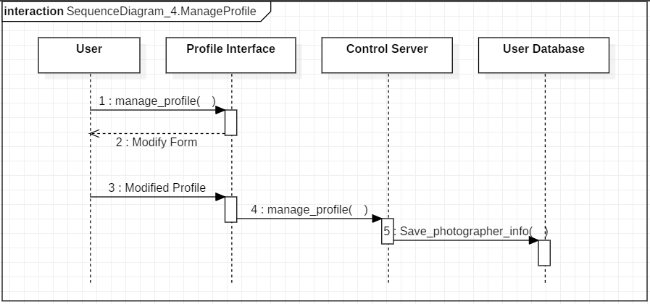
Figure 3-7 Manage Profile OP-04

Search Photographer

Identifier | OP-05
Initiator | SSAD 2.2.3 Search Photographer <Behavior>
Passed parameters | a) search term(s)
Return values | The list of photographers matched by search term(s)
Exception handling | Failing to get response from server, a pop-up message “Fail” shows up.
Guards | Input string is not empty
Validation | A search term should be identical to the resulted data in DB.
Messages | Search photographer request <request>
Exits
Constraints
Relates to | SSAD 2.2.3 BH-05

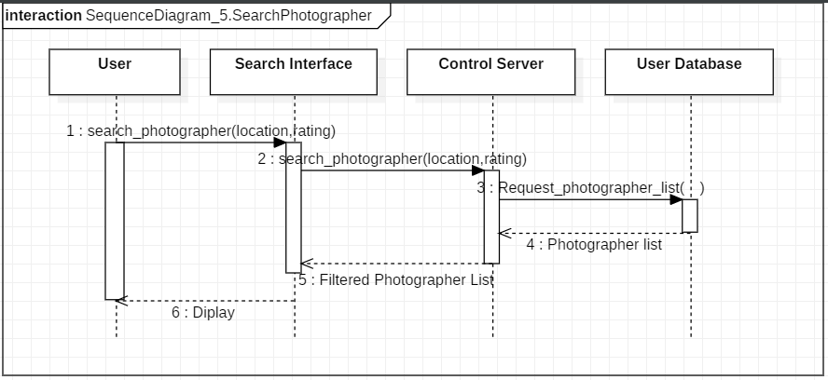
Figure 3-8 Search Photographer OP-05

Search Photo

Identifier | OP-06
Initiator | SSAD 2.2.3 Search Photo <Behavior>
Passed parameters | a) search term(s)
Return values | The list of photographers matched by search term(s)
Exception handling | Failing to get response from server, a pop-up message “Fail” shows up.
Guards | Input string is not empty
Validation | A search term should be identical to the resulted data in DB.
Messages | Search photo request <request>
Exits
Constraints
Relates to | SSAD 2.2.3 BH-06

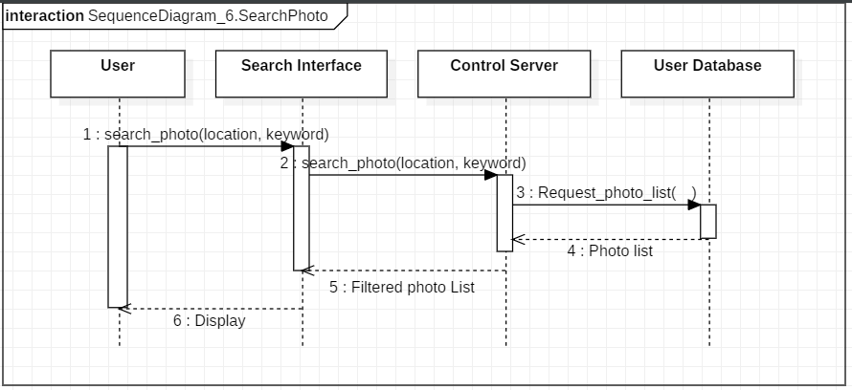
Figure 3-9 Search Photo OP-06

Exchange Message

Identifier | OP-07
Initiator | SSAD 2.2.3 Exchange Message <Behavior>
Passed parameters | a) Message content
Return values | Chat room with history of sender/recipient
Exception handling | Failing to get response from server, a pop-up message “Fail” shows up.
Guards | Message content is not empty
Validation | Letters should be shown identically in the chat room as they are typed in.
Messages | Exchange message request <request>
Exits
Constraints
Relates to | SSAD 2.2.3 BH-07

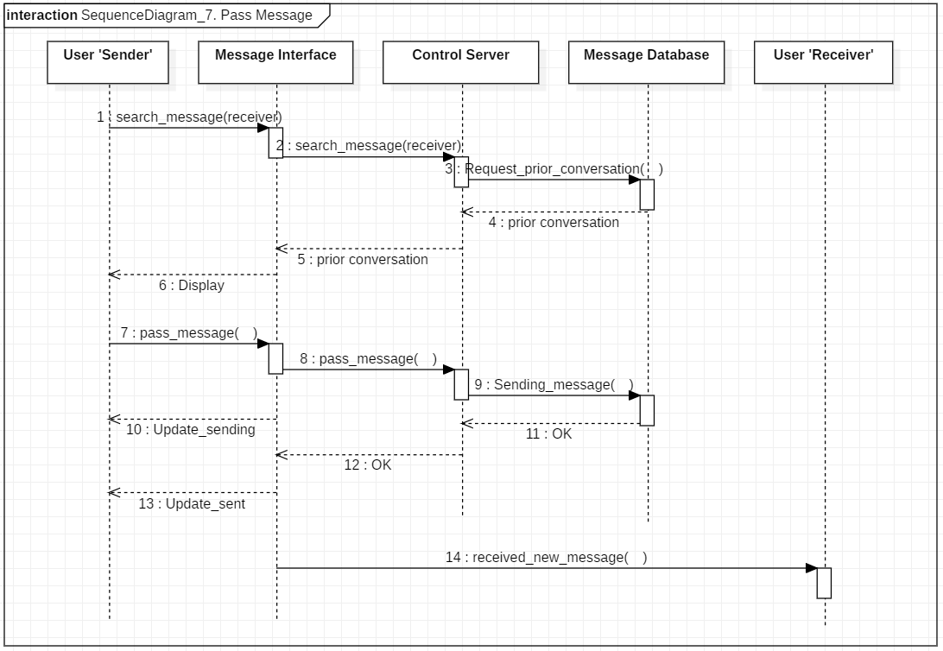
Figure 3-10 Exchange message OP-07

Upload Photo

Identifier | OP-08
Initiator | SSAD 2.2.3 Upload Photo <Behavior>
Passed parameters | a) photo  b) description of photo
Return values | The page which shows uploaded photo(s)
Exception handling | Failing to get response from server, a pop-up message “Fail” shows up.
Guards | Input photo should exist.  The size of photo(s) should be less than the limit of a file size.
Validation | Uploaded photo should be saved in his/her own DB.
Messages | Upload photo request <request>
Exits
Constraints
Relates to | SSAD 2.2.3 BH-08

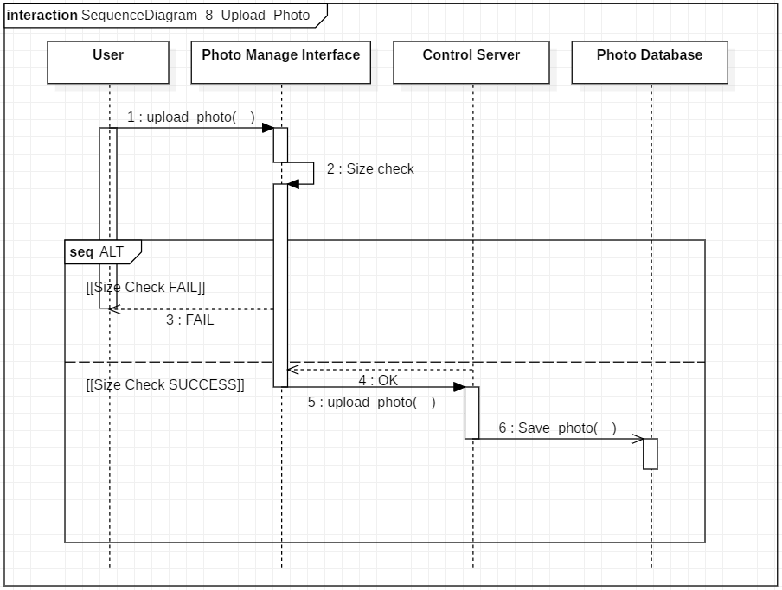
Figure 3-11 Upload photo OP-08

Edit Photo Description

Identifier | OP-09
Initiator | SSAD 2.2.3 Edit Photo Description <Behavior>
Passed parameters | a) description of photo
Return values | The page which shows edited description of photo(s)
Exception handling | Failing to get response from server, a pop-up message “Fail” shows up.
Guards | Photos cannot be replaced.
Validation | Edited description of photo should be saved in his/her own DB.
Messages | Edit photo description request <request>
Exits
Constraints
Relates to | SSAD 2.2.3 BH-09

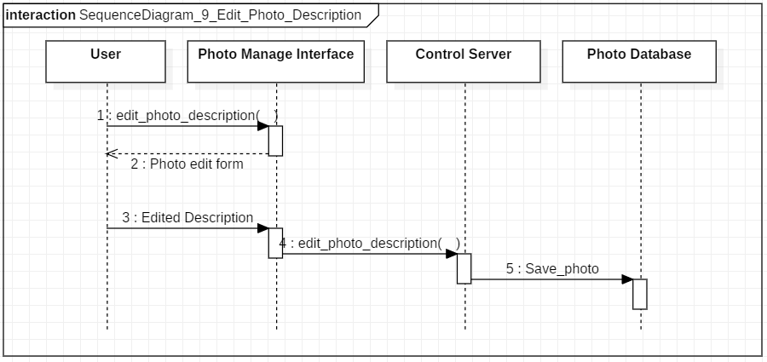
Figure 3-12 Edit photo OP-09

Delete Photo

Identifier | OP-10
Initiator | SSAD 2.2.3 Delete photo <Behavior>
Passed parameters | a) photo(s)
Return values | Pop-up message “Success!” shows up.
Exception handling | Failing to get response from server, a pop-up message “Fail” shows up.
Guards
Validation | Photo should be successfully deleted from his/her own DB.
Messages | Delete photo request <request>
Exits
Constraints
Relates to | SSAD 2.2.3 BH-10

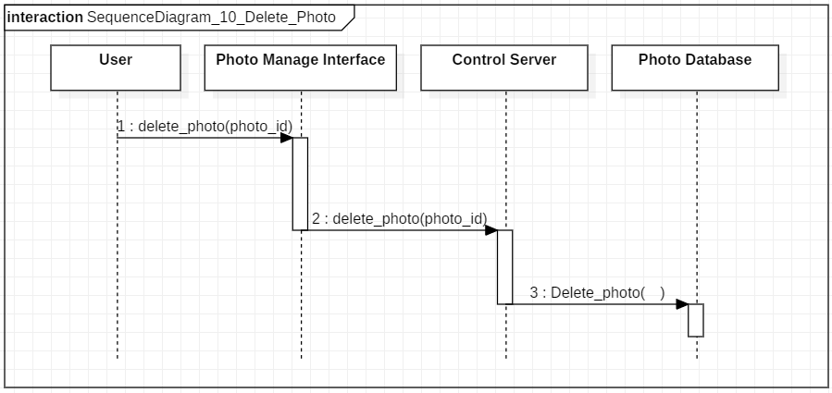
Figure 3-138 Delete photo OP-10

Give “Like”

Identifier | OP-11
Initiator | SSAD 2.2.3 Give “Like <Behavior>
Passed parameters | a) a click of “Like”
Return values | Updated page which shows the change of the number of “Like”
Exception handling
Guards
Validation | The change of the number of “Like” should be reflected in intended photographer’s DB.
Messages | Give “Like” request <request>
Exits
Constraints
Relates to | SSAD 2.2.3 BH-11

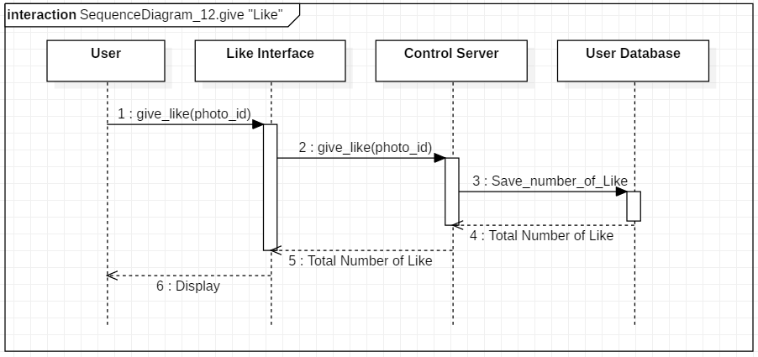
Figure 3-14 Give “Like” OP-11

View Photo

Identifier | OP-12
Initiator | SSAD 2.2.3 View Photo <Behavior>
Passed parameters | a) Photographer ID
Return values | photographer’s profile page
Exception handling | Failing to get response from server, a pop-up message “Fail” shows up.
Guards | Information of a photographer’s profile should be contained in DB.
Validation | The photographer that a user intends to see should be identical to information of a photographer’s profile saved in DB.
Messages | View photo request <request>
Exits
Constraints
Relates to | SSAD 2.2.3 BH-12

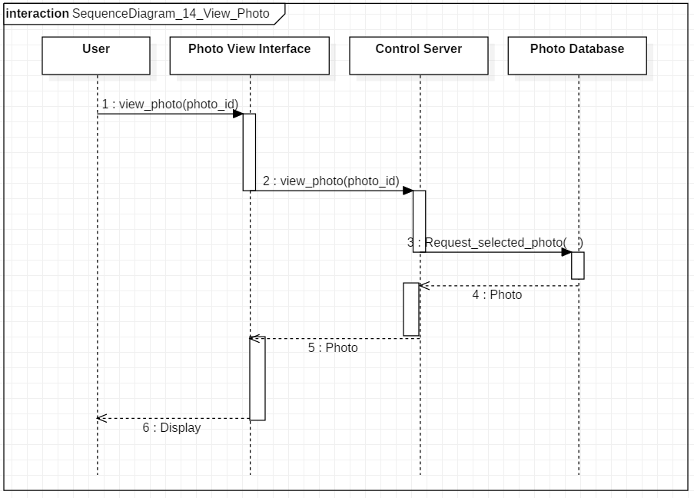
Figure 3-15 View Photo OP-12

Common Definition Language

- Define new terms and acronyms encountered or introduced during System Design
- May include technology implementation terms
Naver map API
A Naver map service draws visualized maps on website or mobile apps. It consists of a map JavaScript API and Static Map API.

Java
Java is a language developed by Sun Microsystems. Programs written in Java can run on many platforms without any changes or re-compilation.

Servlet
Java programs that runs on the Server-side. Can replace CGI scripts and requires fewer resources.

Photographer
One who is taking a photograph

Photographee
One who is photographed.

Retouch
Change original photo to be an edited photo by controlling some attributes like contrast, sharpness, tone, etc.

Keyword
Some specific words for searching

Review
Comment or feedback about a uploaded photo

Rating
Represent a photographer's rank in the platform by reflecting the number of “Like”

Like
A feature that allows users to show their support for specific comments or photos.

Profile
Photographer's information such as name, sex, location, photos, etc.

Platform
Such an operating system, software, etc. having a standard design for use with compatible programs, applications, etc.

User
Representing both of photographer and photographee

User Interface
General user interface(for mobile)

