**CS 4323**

**Operating Systems**

**Project**

Team members: Jeremy Broyles, Michael McQuade

In this project we analyze the scheduling techniques in homework two and three. The scheduling technique in homework two, is a preemptive, round robin scheduling algorithm. The system assigns each process a numerical priority and also has an idle task. The scheduling order of the processes is represented by this Gantt chart:

|  |  |  |  |  |  |  |  |  |  |  |  |  |  |  |
| --- | --- | --- | --- | --- | --- | --- | --- | --- | --- | --- | --- | --- | --- | --- |
| **P1 0-10** | **P1 10-15** | **Idle 15-25** | **P2 25-35** | **P3 35-45** | **P2 45-50** | **P4 50-60** | **P4 60-65** | **P3 65-75** | **P2 75-85** | **Idle 85-95** | **Idle 95-100** | **P5 100-105** | **P6 105-115** | **P5 115-125** |

The scheduling technique in homework three is a round robin, multi level queue scheduler with two queues. The scheduling order of the processes is represented by this Gantt chart.

|  |  |  |  |  |  |  |  |  |  |
| --- | --- | --- | --- | --- | --- | --- | --- | --- | --- |
| Q1: p1: 0-3 | Q1: p1: 3-6 | Q1: p3: 6-9 | Q1: p1: 9-12 | Q1: p3: 12-15 | Q1: p1: 15-18 | Q2: p2: 18-22 | Q2: p4: 22-26 | Q2: p5: 26-30 | Q2: p2: 30-34 |

|  |  |  |
| --- | --- | --- |
| Q2: p4: 34-35 | Q2: p5: 35-39 | Q2: p5: 39-41 |

Our project was implemented as a React application utilizing node.js. To run the program, node.js need to be installed.

You can install Node.js from the following location: <https://nodejs.org/dist/v12.0.0/node-v12.0.0.pkg>

After installing, you may need to restart your command line.

You can check that it was successfully installed by typing **node -v** into a command line and seeing that it returns the currently installed node version.

Once you have it installed, open a command line interface and navigate to the project folder. Then enter “npm install” to install the required packages. Afterwards, start the application with “npm start”.

A web browser will open the project. If not, navigate to <http://localhost:3000/> in the browser. The first scheduling technique can be stepped through, one unit at a time or set to automatically step. The second technique will be completed on load.

The source code and screenshots of source code can be located separate to this document. A readme is included which details the steps of running the program (see above).

See next page for program output.

The programs output is below: 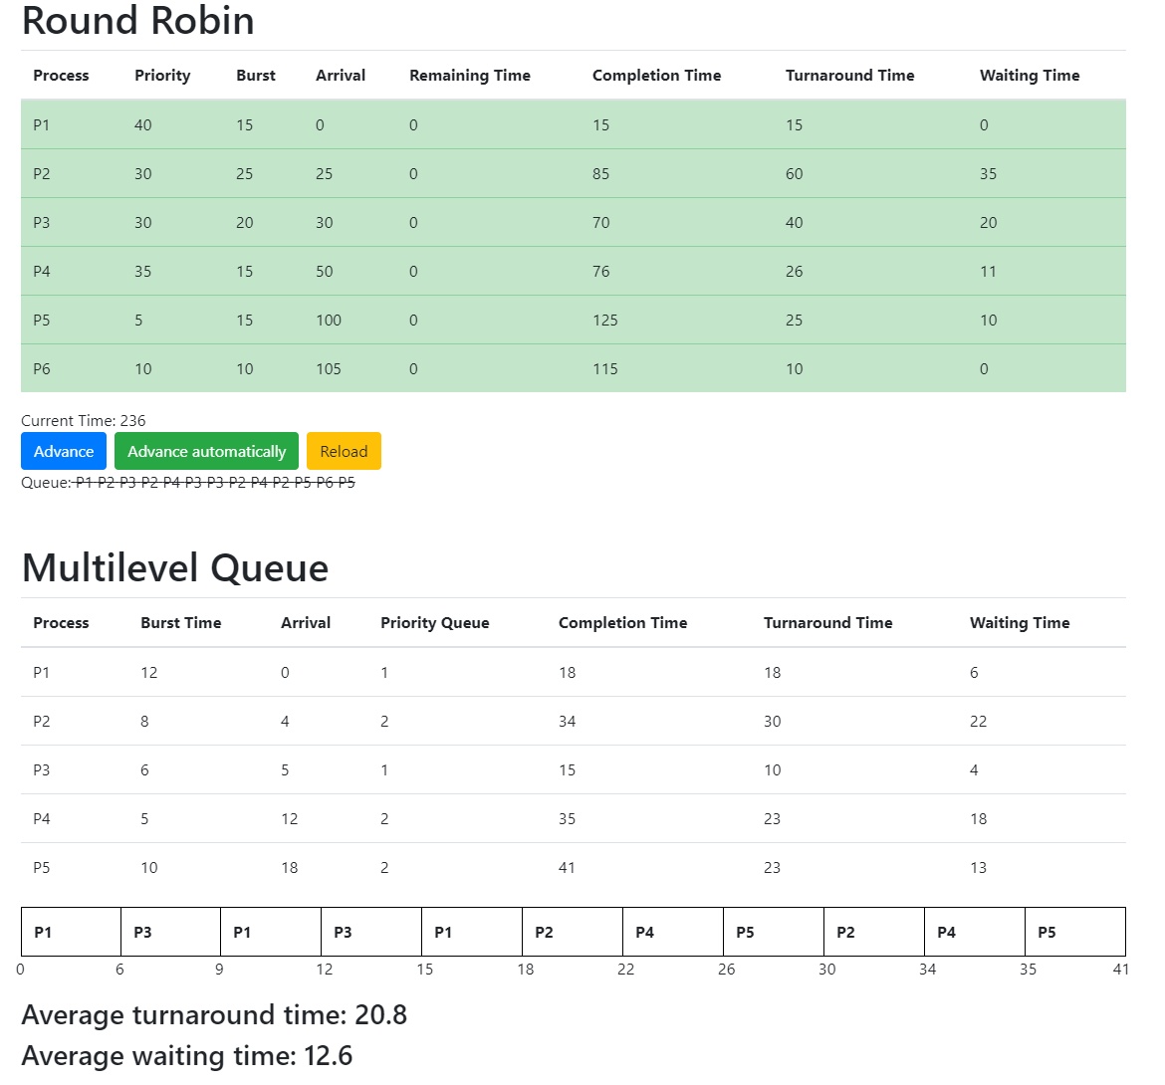

The programs output can be matched to the Gant charts in the introduction.