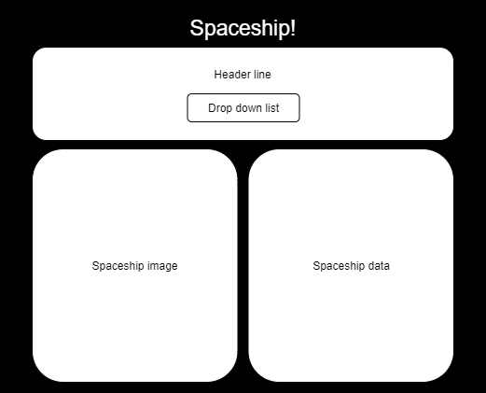**Spaceship webpage wireframe**

V1: Page title. Header with drop down list. Spaceship image and data displayed.

V2: Spaceship image and data displayed in two separate dividers.

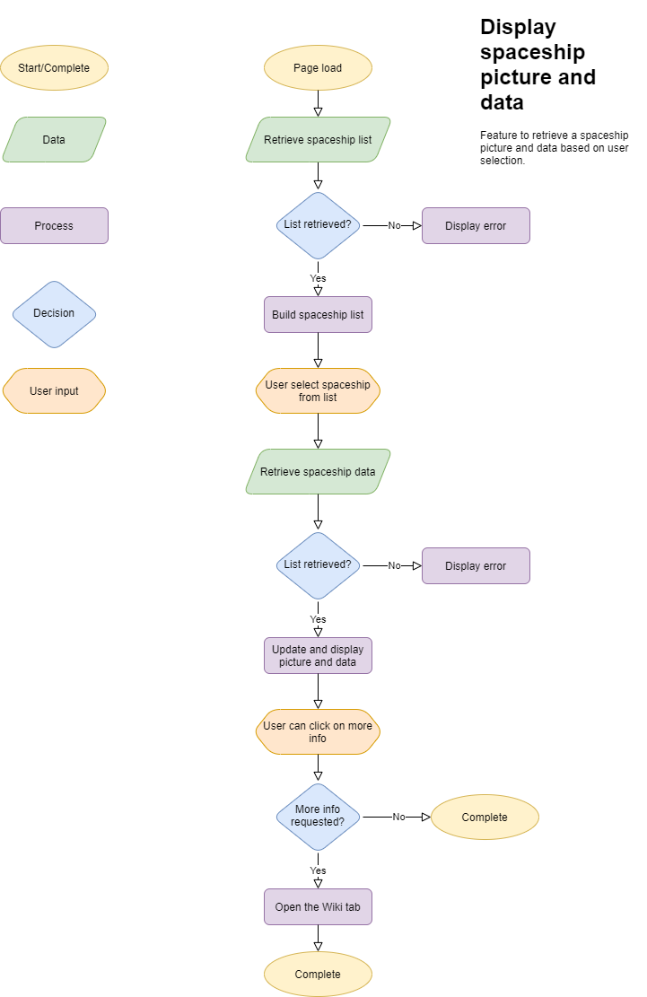**Spaceship webpage flowchart**

V1: Retrieve image and date upon user selection

V2: Added a “get more info” button that link to the wiki page