**Electronics**

Dedicated electronics has been developed for the SuperNEMO demonstrator. Six

racks arranged on the electronic platform next to the detector contain all the

electronics dedicated to the calorimeter, tracker and calibration systems. The racks are organized into separate crates that handle the High Voltage control and monitoring(xx crates), the readout of the calorimeter and tracker signals (6 crates in total), and the LED calibration system (xx crates).

The calorimeter electronics was realised at LAL while the tracker

electronics was developed jointly by the French and English teams.



Figure 1 Picture of a Calorimeter crate (for one of the Main Walls) in an electronic rack module.

**Global architecture of the readout electronics**

The role of the readout electronics is to detect and gather the analogue signals from the 712 optical modules of the Calorimeter and from the 2040 Geiger cells of the Tracker, to convert them into digital signals and to transport them to the computers for data storage and offline analysis.

A smart triggering system is implemented in order to reject the noise from the optical modules (by a factor 100) and spurious events in the tracker. The goal of the trigger system is to keep only physics events that associate energy deposit in the calorimeter and a track in the tracker. A dedicated trigger strategy is also implemented in the case of a Bi-Po process (permitting to measure **208**Tland **214**Bi contaminations due to Radon), which corresponds to the detection of an electron followed by a delayed α particle in the tracker without energy deposit in the calorimeter.

The global architecture (cf. figure …) of the readout electronics is based on different elements: the Frond End Boards (calorimeter and tracker), the Controller boards and the Trigger board.

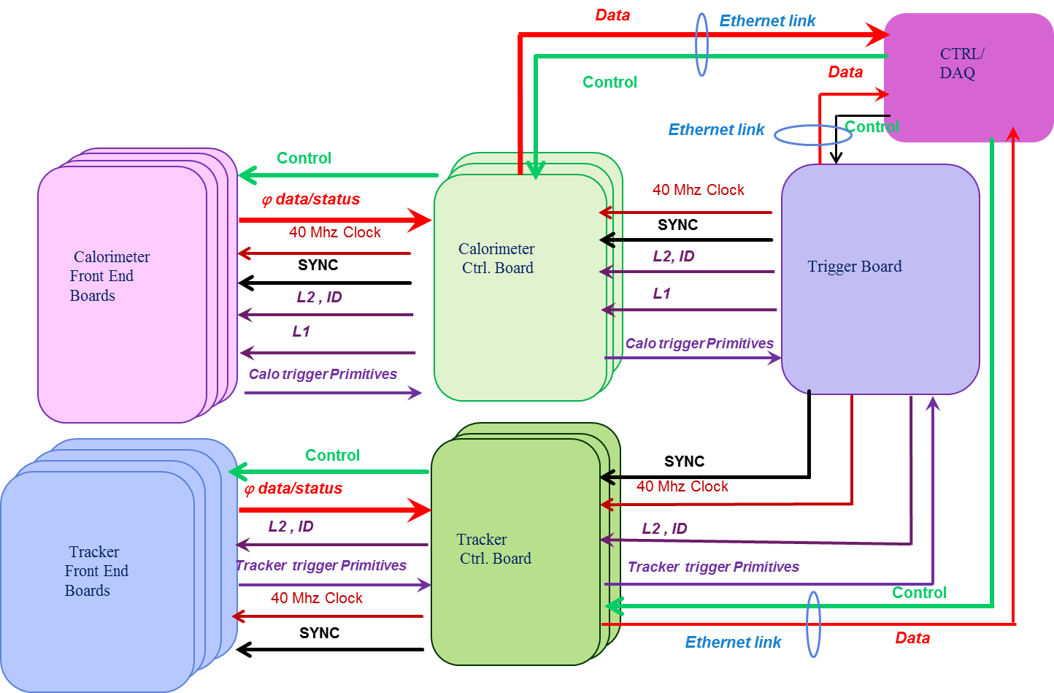

Figure 2: Global architecture of the control and readout electronics of the Detector

**Calorimeter Front End electronics**

The Calorimeter Frond End board (developed by LAL) is a 16-channel waveform digitizer based on the SAMLONG analog memory ASIC (developed by LAL/IRFU) running at 2.56 Giga-sample per second. It permits recording a signal depth of 1024 samples (corresponding to 400 ns) and converting data over 12 bits. The signal is time tagged at a few picosecond rms.

The digitization of the calorimeter pulses for SuperNEMO is an innovation compared to NEMO-3 where only the amplitude and the arrival time of the pulses were digitized and readout by the electronics.

Thanks to the digitized waveforms, we can perform an exhaustive feature extraction from the signal: baseline, time, amplitude and charge are available. We can also distinguish between successive pulses on the same channel within the 400 ns time window of the waveform.

There are two different thresholds on each channel (Low Threshold and High Threshold) that are used to open gates for the calorimeter trigger primitives.

These trigger primitives are then processed by the Trigger board, in association with the Tracker primitives, to build the Trigger decisions.

There are 52 Calorimeters Front End boards in total, housed in three different crates:

* 2 crates dedicated to the Main Walls housing 20 FEBs each, connected to 13 PMT signals each.
* 1 crate for the X-Wall and Gamma-Vetos housing 12 FEBs, connected to 16 PMT signals each.

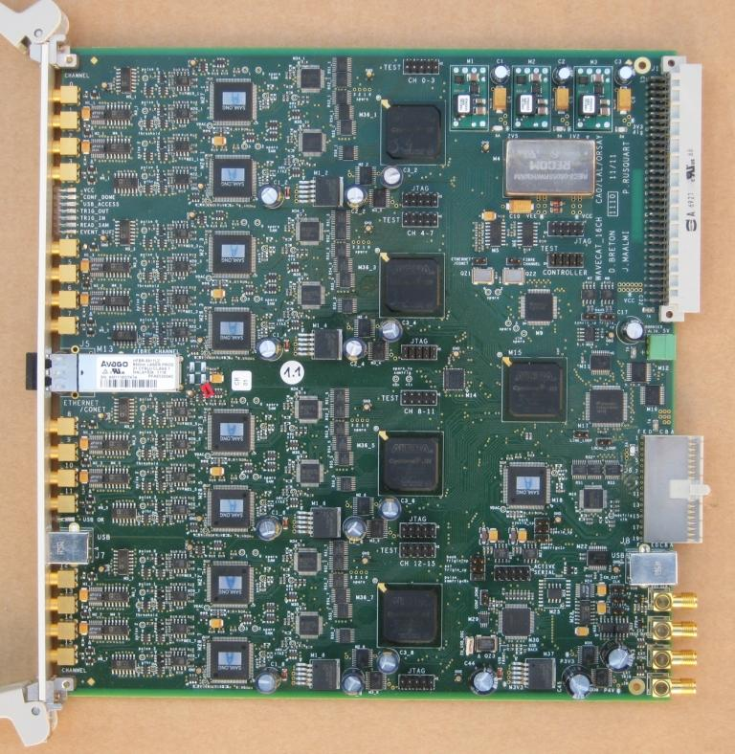 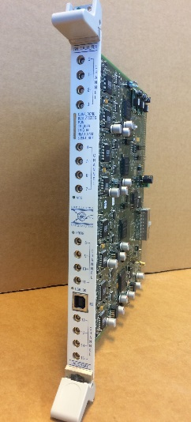

Figure 3 Calorimeter Front End Board



**Tracker Front End electronics**

The Tracker Front End board is based on a pair of custom ASICs called FEAST (developed by LPC Caen) which extract all the timing information from the anode and cathode signals of a Geiger cell.

Each Tracker FEB houses 108 channels and handles two tracker chamber rows per side, which corresponds to 36 cells in total. In fact each tracker chamber row contains 9 Geiger cells that corresponds to 3 electronic signals (or channels): one Anode signal and two Cathode signals (top and bottom).

The tracker FEB prepares also the seeds for the tracker Trigger primitives processed by the Trigger board, in association with the calorimeter primitives to build the Trigger decisions.

There are 3 tracker crates, housing 19 Front End boards each. (57 tracker FEBs in total).

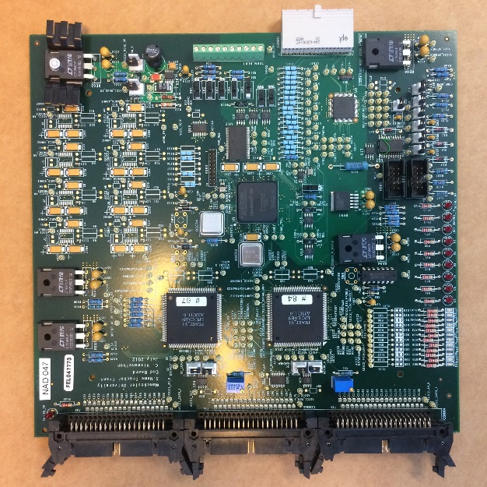

**The Controller Boards**

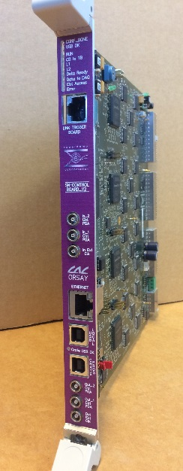

Each electronic crate (calorimeter or tracker) is controlled and readout through a Controller board situated at the middle of the crate**.**

The Controller board distributes over a custom backplane to the Front End boards:

* the 40MHz system clock
* the signals permitting to synchronize the whole crate
* the trigger decisions (L1 and L2) coming from the Trigger board.
* The serial control links ( for register configuration)
* The signals for FPGA firmware re-configuration.

It gathers from the Front end boards:

* the Trigger Primitives, aggregates them and transmits them to the Trigger board.
* the serial data links containing ‘physics’ or ‘control’ data, concentrates and transmits trough a single Giga-bit UDP interface the ‘physics data’ to the Data Acquisition Sytem (DAQ) and the ‘control data’ to the Control and Monitoring System (CMS)

**The Trigger Board**

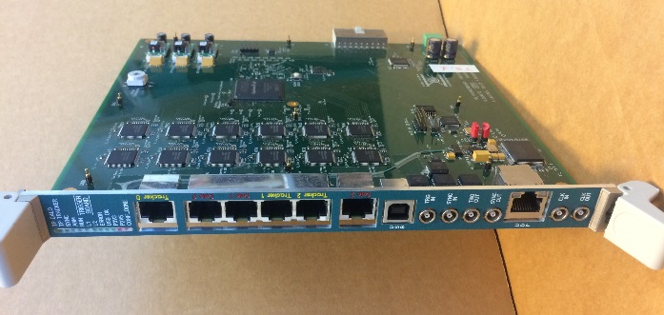

The Trigger Board is the heart of the Trigger and Timing system. It is in charge of building the Trigger decisions and of distributing to the Controller Boards via RJ45 CAT7 cables:

* the 40 MHz system clock
* the signals permitting to synchronize the whole system (the 6 electronics crates)
* the trigger decisions (L1 and L2)

It gathers from the Controller boards:

* the serial links carrying the Trigger Primitives (tracker and calorimeter)

The Trigger decision strategy is based on multiplicity threshold crossings in the calorimeter associated (in space and time) with track patterns in the Tracker (simple patterns). Special patterns for the delayed alphas (coincidences between events) are also looked for.

The Trigger board has its own Giga-bit UDP interface connected to the DAQ and CMS systems. It sends to the DAQ an image of the whole detector’s Trigger Primitives at each trigger decision.

**Calibration racks**

Two racks are dedicated to the electronics of the demonstrator's

calibration systems (one for the deployment system and one for the light injection

system).

The electronics commissioning has begun in June 2018 at Manchester and is fully

completed. I participated in the timing calibration of the front-end boards, which

I discuss in Chapter 6.