Smart Classroom Energy System

Decision Tree Evaluation — Secondary Dataset
This document summarizes the preliminary retraining performed using the uploaded smart_lighting_dataset_2024.csv secondary dataset.

Dataset summary
Records: 12,000. Columns in original file: 17. Missing values: 0. Target: lighting_action_class (numeric codes 0, 1, 2).

Method
A stratified 80/20 train-test split was used with random_state=42. A scikit-learn pipeline applies OneHotEncoder to categorical context fields and passes numeric predictors to a DecisionTreeClassifier (Gini criterion, max_depth=5, min_samples_leaf=10, class_weight='balanced'). The target is the dataset-provided class field; this work does not invent new target labels.

Test metrics
Test sample count: 2,400. Accuracy: 0.8329 (83.29%).
Class | Precision | Recall | F1-score | Support
0 | 0.744 | 0.771 | 0.757 | 798
1 | 0.886 | 0.939 | 0.912 | 1419
2 | 0.750 | 0.279 | 0.406 | 183

Confusion matrix
Rows represent actual class; columns represent predicted class. Label order is [0, 1, 2].
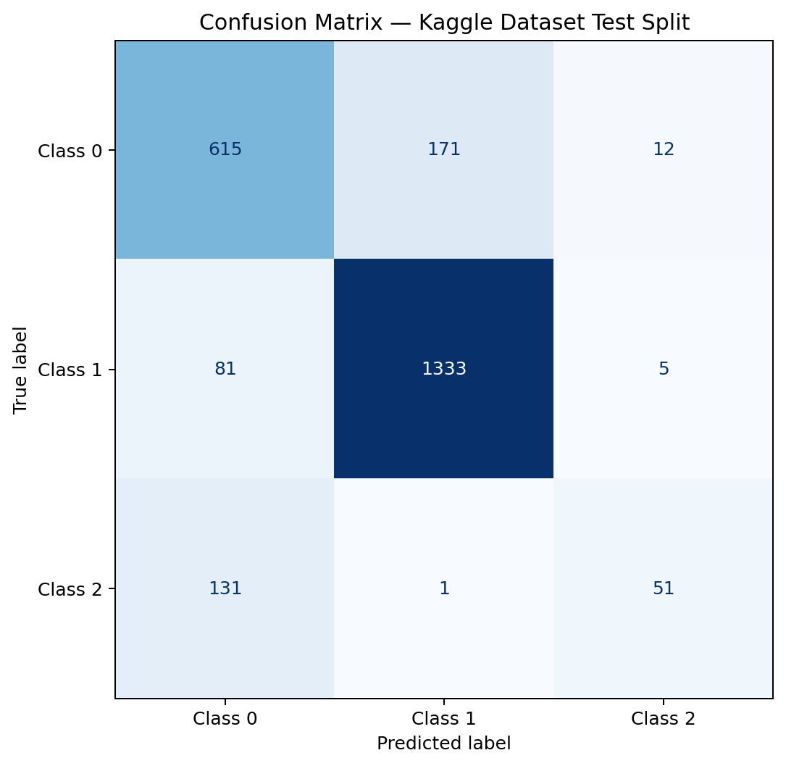

Dataset label clarification required
The supplied CSV contains numeric class codes 0, 1, and 2 but does not contain a textual mapping column. The official Kaggle dataset page must be consulted to identify the human-readable meaning of each code. Until verified, this report intentionally preserves numeric class codes and does not equate them to ON/OFF/DIM.

Limitations
The metrics represent a held-out test split of this secondary dataset. They do not establish accuracy in a real classroom or physical relay operation. Additional validation with local classroom sensor measurements is recommended.

Dataset reference
Kaggle secondary dataset supplied by the project owner as smart_lighting_dataset_2024.csv. Exact dataset title, creator, and URL are to be confirmed against the original Kaggle page before submission.

