**Image Classification Task Design Document**

**Task:** Create an image classification model, which will identify a given input image.

**Technology:** To develop the image classification I have used VGG16 CNN.

**Architecture Diagram:**

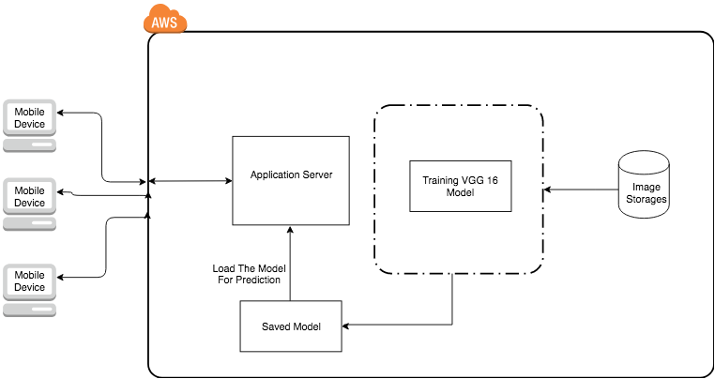

**VGG16 Net Architecture Diagram:**

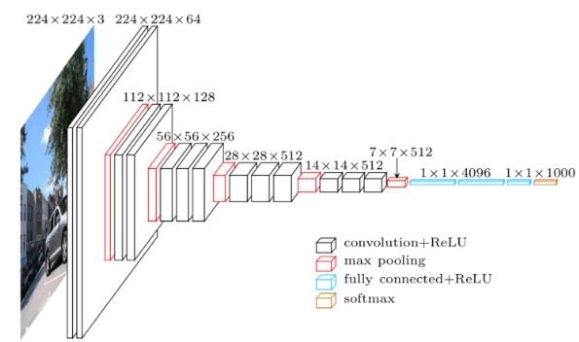

**Testing Accuracy:** After resizing the training images into 224 X 224 pixels and train the VGG16 model till 5 Epoch. Finally I have received **84%** accuracy. The VGG16 net internal architecture diagram is as follow.

