# **Java training(EMP111)**

Assignment - 1

### 

### Q1: Write a program to initialize an integer array with values and check if a given number is present in the array or not.If the number is not found, it will print -1 else it will print the index value of the given number in the GIVEN array

### If the Array elements are {1, 4, 34, 56, 7}

### And the search element is 90, then the

### Output expected is -1.

**Ans: -**

import java.util.*;

public class Main {

public static void main(String[] args) {

Scanner scan = new Scanner(System.in);

int arr[];

int n,i,res,s;

arr = new int[10];

System.out.print("\n Enter the number of elements: ");

n=scan.nextInt();

System.out.println("\n Enter the elements: ");

for(i=0;i<n;i++)

arr[i]=scan.nextInt();

System.out.print("\n Enter the element to be searched: ");

s=scan.nextInt();

res = search(n,arr,s);

System.out.println("The index of "+s+" is "+res);

}

public static int search(int n, int[] arr,int s) {

int i;

for(i=0;i<n;i++)

{

if(s==arr[i])

return i;

}

return -1;

}

}

**Output:**

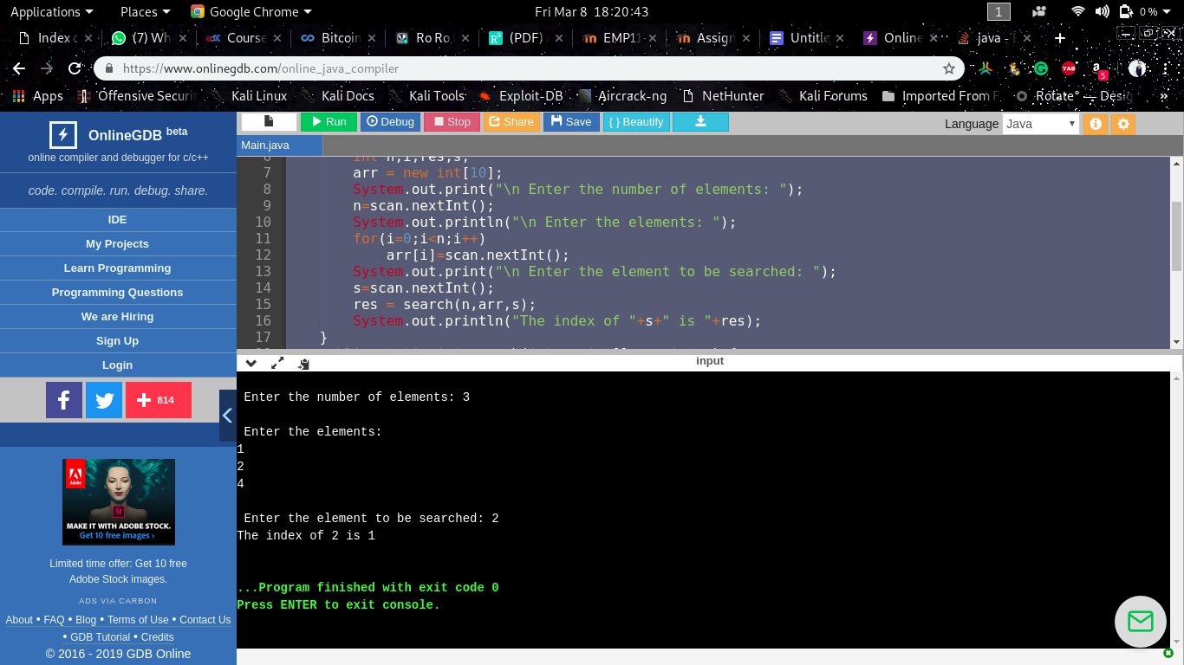

### Q2: Write a program to accept gender ("Male" or "Female") and age from command line arguments and print the percentage of interest based on the given conditions.If the gender is 'Female' and age is between 1 and 58, the percentage of interest is 8.2%.If the gender is 'Female' and age is between 59 and 100, the percentage of interest is 9.2%.If the gender is 'Male' and age is between 1 and 58, the percentage of interest is 8.4%.If the gender is 'Female' and age is between 59 and 100, the percentage of interest is 10.5%.

**Ans: -**

public class b {

public static void main(String[] args) {

String gender = args[0];

int age = Integer.parseInt(args[1]);

if (!gender.equals("Male") && !gender.equals("Female"))

System.out.println("Invalid gender");

if (age < 1 || age >= 100)

System.out.println("Invalid age");

if (gender.equals("Female") && (age >= 1 && age <= 58)) {

System.out.println("Interest = 8.2%");

} else if (gender.equals("Female") && (age >= 59 && age <= 100)) {

System.out.println("Interest = 9.2%");

} else if (gender.equals("Male") && (age >= 1 && age <= 58)) {

System.out.println("Interest = 8.4%");

} else if (gender.equals("Male") && (age >= 59 && age <= 100)) {

System.out.println("Interest = 10.5%");

}

}

}

**Output:**

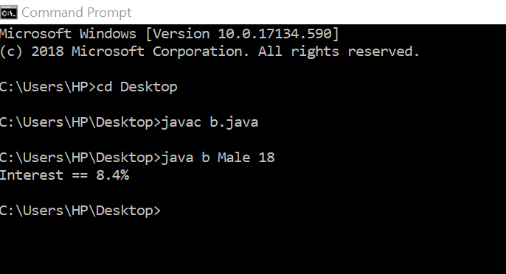

### Q3: Write a program to print even numbers between 23 and 57. Each number should be printed in a separate row.

**Ans:-**

import java.util.*;

public class Main {

public static void main(String[] args) {

int i;

for(i=23;i<=57;i++)

if(i%2==0)

System.out.println(i);

}

}

**Output:-**

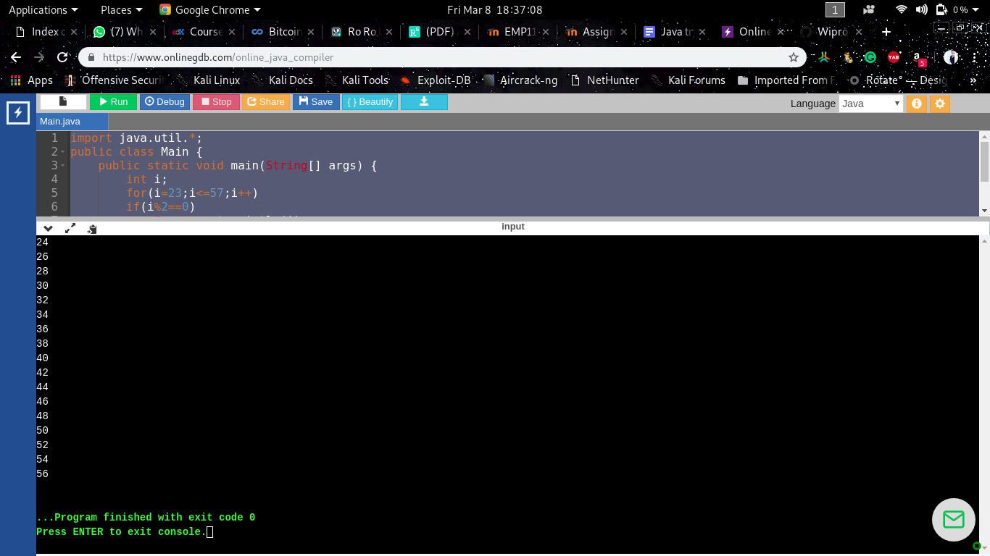

### Q4: Write a Program that accepts two Strings as command line arguments and generate the output in the required format.

### Example:

### If the two command line arguments are Wipro and Bangalore then the

### Output generated should be Wipro Technologies Bangalore.

### If the command line arguments are ABC and Mumbai then

### Output generated should be ABC Technologies Mumbai

**Ans:-**

import java.util.*;

public class a {

public static void main(String[] args) {

System.out.println(args[0]+" Technologies "+args[1]);

}

}

**Output:-**

