Rock choir Phase 1
* Login:
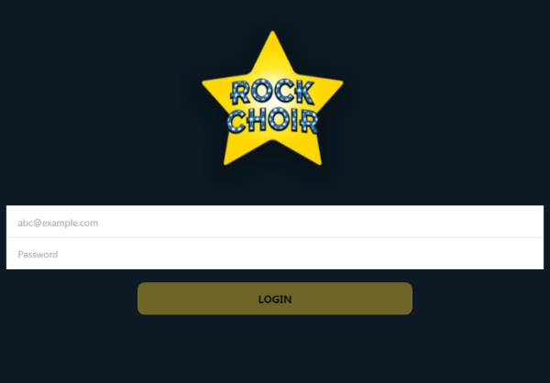
Here user able to login.
API Details:
Requested URL: https://rockchoir.magentrix.com/rest/2.0/login?un="username"&pw="password"
API Response: if login successfully we get session id other vise login fail error

* Home page:
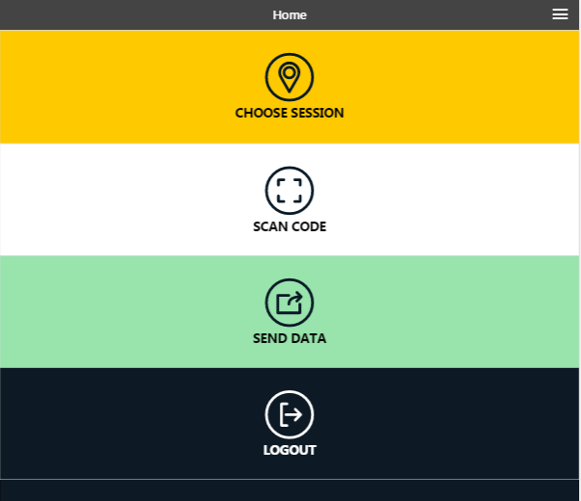
Here we display menu list like, choose session, scan code, send data ,logout
*Choose Session:
a) Location List:
API Details:
Requested URL: https://rockchoir.magentrix.com/rest/2.0/query?q=FROM Force. Force__Venue__c
API Response: Here we get list location

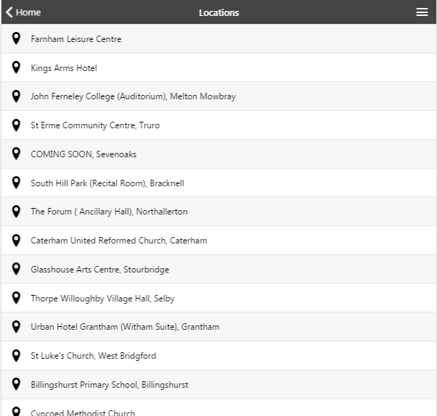
Here we get all available Location list.
b) Session list:
When user clicks on particular location we get session list of that location
API Details:
Requested URL: https://rockchoir.magentrix.com/rest/2.0/query?q=FROM Force.Force__Choir_Group__c WHERE Venue__c = " venueId ''
API Response: Here we get list session with respect to location

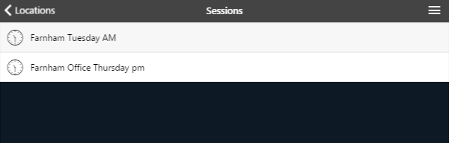

c)Schedule list :
when user click on particular session list , we get schedule list of that session.
API Details :
Requested URL: https://rockchoir.magentrix.com/rest/2.0/query?q=FROM Force.Force__Choir_Session__c WHERE Choir_Group__c =' groupId '
API Response: Here we get list session with respect to session
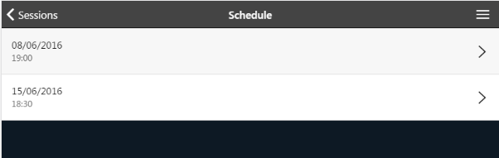

* Scan code:
Once user schedules session, next step is scan code. Here user scans Barcode. We have used 3rd party plugin which is compatible to phonegap.

* Send Data
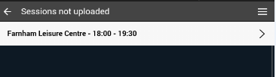
Once user done with scan code, next step is upload session data.
Here user uploads session data To CRM
API Details:
Requested URL: https://rockchoir.magentrix.com/rest/2.0/create?e=Force__Card_Scan__c
with data : Card_Number__c from scanned barcode & session_id

