PROJECT PROPOSAL
Computerization of the manual patient record system at Chiweshe Clinic in Mazowe District

STATEMENT OF PROBLEM

Input Problems
- Shortage of OPD Registers and Tally forms which are bought by the District Hospital can lead to important patient information not being recorded resulting in compilation of reports e. g Monthly Surveillance Report missing some information on diseases per month.
- Some members of staff forget to tally the patient details in the T3 or T6 Tally Forms that are used in the compilation of Monthly and Annual reports which results in the report missing some information on patient details affecting decision making by the District Hospital.
- Some members of staff can write patient details like age that are illegible because it is tiresome to treat, record and tally all patients leading to writing a report like Monthly Surveillance Report based on wrong information affecting decision making by the District Hospital.

Processing Problems
- There are many mistakes and errors in the entering of patient records because of lack concentration due to repetition which is not always accurate leading to entering of wrong data on the files affecting decision making.
- There is delay in calculations when recording totals on the T5 which delays compilation of Weekly Surveillance Reports that are needed on weekly basis disrupting work at the clinic.

Storage Problems
- OPD Registers and other books in which patient records are recorded are not large enough to store large volumes of patient details which then results in shortage of books like OPD Registers disrupting operations

Description of the current system

At Chiweshe Rural Clinic, patients are treated and then recorded manually in the book files. The patient has to go through the Reception where demographic data is recorded on the Out Patient Department Card (OPD Card) which the patient brings at the clinic by the receptionists. Each patient has got his or her OPD Card on which treatments of the patient are recorded. The patient further goes into the Observation Room where treatments and patient details are then recorded in the various books. In the Observation Room, the patient is first recorded in the Out Patient Department Register (OPD) before being recorded in any book. The clinics also produce reports at the end of the week, month and year.

DATA FLOW IN THE EXISTING SOLUTION

The manual Patient Record System uses the following books:

- Out Patient Department Register (OPD)
- Chronic Register
- Antenatal care Book
- Post Natal Book

- T3
- STI Register
- Child Delivery Book
- T6
- T5

DATA ITEMS IN EACH FILE

OPD Register

- Patient Number
- Patient Name
- Age
- Sex
- Weight
- Treatment
- Date
- Village
- Payment

Antenatal Care Book

- Patient Number from OPD Register
- Date
- Patient Name
- Village from OPD Register
- Parity (Number of children)
- Condition
- Treatment
- Number of visits

Child Delivery Book

- Patient Number from Antenatal Care Book
- Patient Name
- Village from Antenatal care Book
- Age
- Parity from Antenatal Care Book
- Condition
- Weight
- Post Natal Care Date
- Duration

Post Natal Book

- Patient Number from Child Delivery Book
- Patient Name
- Birth Weight from Child Delivery Book
- Condition
- Current weight
- Child Name

STI Register

- Patient Number from OPD Register
- Patient Name
- Date
- Age
- Sex
- Marital Status

- Treatment
- Village

Chronic Register

- Patient Number from OPD Register
- Patient Name
- Village
- Treatment

DESCRIPTION OF THE EXISTING SOLUTION

OPD Register
All patients are first recorded in the OPD Register before being entered in any book. This book contains demographic data that is patient name, village, weight and age that are obtained from the OPD card. The data on the OPD card is first recorded on the reception. Information in the OPD Register is recorded in the Observation Room where Treatments are carried also out After the patient has been treated the patient’s treatment and other details are entered in the other books then the treatments are recorded in the OPD Register. After the treatments have been entered in all the required books, it is then entered on the OPD card.
STI Register
This book is for recording patients who suffer from Sexually Transmitted Infections. The patient is first recorded in the OPD Register and then recorded in this book if he or she suffers from an STI. This book contains Patient Name, Patient Number, Age, Sex obtained from the OPD Register. The patient’s age, sex and the disease the patient is suffering from are then tallied in T3 tally form. After being tallied the treatment that the patient has received is transferred to the OPD Register.
Flow of data
1 2
OPD Register
STI Register
T3

3

Key
1. Patient Numbers, Patient Name, Age, Sex
2. Disease Name, Age, Sex
3. Treatment
Chronic Register
This book is for recording patients who suffer from chronic diseases like epilepsy, diabetics, asthma and hypertension. The patient’s demographic data is first recorded in the OPD Register and then recorded in this book if he or she suffers from a chronic disease. After the patient’s details which include name and number have been recorded in the Chronic Register from the OPD register, the treatment is then recorded in the Chronic Register and further recorded back in the OPD register after being tallied in the T3 form e.g.

1 2
OPD Register
Chronic Register
T3
3

Key
1. Patient Numbers, Patient Name, Age, Sex
2. Disease Name and type, Age, Sex
3. Treatment

Antenatal Care Book
This is a book for recording antenatal care patients or pregnant mothers. The patient’s demographic data is first recorded in the OPD Register. The book contains a Number of Visits column where the patient is ticked e.g. a patient who has come for her second visit she is ticked like what is shown below

Number of visits

First Visit | Second Visit | Third Visit

The patient is then further tallied in the T6 under her Age and Repetition of Visits.

Child Delivery Book
This is a book for recording all patients who have given birth or delivered at the clinic. The book contains Village of patient and Parity obtained from Antenatal Care Book. The patient is then given the post natal care date on which the patient comes either after six weeks or ten days.

Post Natal Care Book
All the patients who come back after six weeks or ten days from birth for postnatal checks are recorded in this book. The current conditions of the mother and child are all recorded in this book. The patient’s record from the Child Delivery Book is searched where the child’s birth weight is obtained and then recorded in the Post Natal Care Book. This weight is used to compare with the current weight enabling them to see if the baby is gaining or not and to see the baby’s requirements.

T3 (Tally Form)
Patient Age, Sex and Disease Name from Chronic and STI Register are tallied in this form. They do so by canceling a zero under the Disease Name, Age and Sex. At the end of the month, the number of cancelled zeros is then counted to find the total number of patients of the certain age groups and sex who suffer from a certain disease. These totals are then transferred to theT5 Totals Form that is used to make reports that are sent to the District Hospital.

T6 (Tally Form)
The repetitions of visits of antenatal care patients from Antenatal Care Book are tallied in this form. Also the treatment that the infant gets, the infant’s age and sex from Post Natal Care Book are tallied in this form when the patient comes back for postnatal checks. The patient is tallied under the day or week of postnatal visit in this form. The patient is tallied by canceling a zero under the details of the patient. At the end of the month, the number of zeros is then counted under each category or treatment type. The totals are then transferred to the T5 Totals Form that is used to compile reports.

T5 (Totals Form)
All the totals from the T6 and T3 are entered in this form which is created on monthly basis. This is used during analysis when compiling reports since the totals on this form will be compared to find the disease that mostly affected people and the possible reasons for the outbreak. Each month a T5 is created.

Reports Compiled
At the clinic the following reports are compiled:
Weekly Surveillance Report
This report is compiled on a weekly basis. This report contains information obtained from the T3 Tally Form which is a consolidation of the OPD, STI and the Chronic Register. The information on these tally forms is important to the clinic in order for them to make analysis on the information and to figure out what may be the reasons for such results on the tally forms. The report is sent to the District Hospital where it is used for decision-making. This report helps the District Hospital to think of ways that may reduce the problems or disease like health education.

Monthly Surveillance Report
This report is compiled on monthly basis and is also sent to the District Hospital. This report is compiled using the T5 Totals Form that is also updated on monthly basis. This report uses all the information obtained from all the books. After analysis of information on the T5, they try to find ways to reduce such problems which are also written on the report. This report is used for decision making by the District Hospital. This also helps the District Hospital to think of ways to reduce the problem or disease by health education.

Annual Surveillance Report
This is compiled on annual basis and is also sent to the District Hospital. This is compiled using the T5s of all the twelve months and also uses all the books in the system. They find the totals of all the diseases of the year and the disease with the most patients. This report is also used for decision making by the District Hospital.

T3 (Tally form)
Disease | Under 10 Yrs |  | 10-20 Yrs |  | 20Yrs and Over |  | Total
 | Male | Female | Male | Female | Male | Female | Male | Female
E.g. Malaria | 00000 | 00000 | 00000 | 00000 | 00000 | 00000

T6 (Tally form)
Type of treatment |  | EPI Vaccination
 |  | Under 1Yr |  |  | 1-4Yrs |  |  | 5 Yrs and over |  |  | Total
 |  | Male | Female |  | Male | Female |  | Male |  | Female | Male |  | Female
E.g. BCG Initial |  | 00000 | 00000 |  | 00000 | 00000 |  | 00000 |  | 00000
 |  |  |  | Antenatal and Post Natal Care
 |  |  |  | Below 16 Yrs |  |  | 16-25 Yrs |  | 25 Yrs and Over |  |  | Total
First Antenatal Visits  Repeat Antenatal Visits | Under 16 weeks |  |  | 0000000000 |  |  | 0000000000 |  | 0000000000
First Antenatal Visits  Repeat Antenatal Visits | 16-27 weeks |  |  | 0000000000 |  |  | 0000000000 |  | 0000000000
First Antenatal Visits  Repeat Antenatal Visits | 28 weeks and over |  |  | 0000000000 |  |  | 0000000000 |  | 0000000000
First Antenatal Visits  Repeat Antenatal Visits | 2nd-5th visits |  |  | 0000000000 |  |  | 0000000000 |  | 0000000000
First Antenatal Visits  Repeat Antenatal Visits | 6th visit and over |  |  | 0000000000 |  |  | 0000000000 |  | 0000000000
Post Natal Check Up | At 10 Days |  |  | 0000000000 |  |  | 0000000000 |  | 0000000000
Post Natal Check Up | At 6 Weeks |  |  | 0000000000 |  |  | 0000000000 |  | 0000000000

T5 (Totals form)

DATA FLOW DIAGRAM
5 1 4 2 1 7 2
STI Register
Chronic Register
Post Natal Book
Child Delivery Book
3 2
OPD Register
Antenatal Care Book
8 6 8 10 9
T5
T3
T6

Key to the Data flow diagram
1. Patient Number, Patient Name, Age, Village and Sex are posted to STI Register from OPD Register.
2. Treatment from Post Natal Care, STI Register and Chronic Register is posted back to OPD Register.
3. Patient Number and Village are posted to Antenatal Care Book from OPD Register.
4. Village and Parity are posted to Child Delivery Book from Antenatal Care Book.
5. Patient Number and Birth Weight are posted to Post Natal Book from Child Delivery Book.
6. The Repetition of visits is then tallied in the T6 Tally form from Antenatal Care Book.
7. Infant Age and Sex from Post Natal Care Book are posted to the T6 Tally Form where they are tallied
8. Patient Age, Sex and Disease Name are posted into the T3 Form where they are tallied from Chronic and STI Register
9. Totals of patients Treatments under Disease Name, Age, and Sex.
10. Totals of EPI Treatments and Repetition of Patient visits are posted into the T5 Totals Form.

Research instruments

It was difficult for may own, to analyses the problems faced by Chiweshe Clinic in Chiweshe, so I used the following methods of gathering information
- Questionnaire. See on appendix 1.0
- Record Inspection. See on appendix 1.1
- Interview. See on appendix 1.2
- Observation. See on appendix 1.3

PROBLEMS FACED DURING INVESTIGATION

During my investigation I faced a number of problems due to mainly workers’ attitude, many of them were rather convictional and were against the introduction of the new system. It was my duty to explain to them advantages of the computer system and it was my assumption safeguarding their jobs. However I received information form those who wish and I separated myth and exaggeration in order to solve with particular problems

Appendix 1.0

1Questionnaire

I set simple questions then I sent to Chiweshe Clinic, it takes longer to response the questions that I have sent. I received responses after a month but they were not clear, however it gives me vision to analyses the current problems as an analyst.
- How the current systems operate?
The patient has to go through the Reception where demographic data is recorded on the Out Patient Department Card (OPD Card) which the patient brings at the clinic by the receptionists. Each patient has got his or her OPD Card on which treatments of the patient are recorded. The patient further goes into the Observation Room where treatments and patient details are then recorded in the various books. In the Observation Room, the patient is first recorded in the Out Patient Department Register (OPD) before being recorded in any book. The clinics also produce reports at the end of the week, month and year.

- Is it reliable and why?
No because Some members of staff forget to tally the patient details in the T3 or T6 Tally Forms that are used in the compilation of Monthly and Annual reports which results in the report missing some information on patient details affecting decision making by the District Hospital.
Some members of staff can write patient details like age that are illegible because it is tiresome to treat, record and tally all patients leading to writing a report like Monthly Surveillance Report based on wrong information affecting decision making by the District Hospital.

- How they overcome errors?
OPD Registers and other books in which patient records are recorded are not large enough to store large volumes of patient details which then results in shortage of books like OPD Registers disrupting operations

- Where they kept patient records?
OPD Registers and other books in which patient records are recorded are not large enough to store large volumes of patient details which then results in shortage of books like OPD Registers disrupting operations

Appendix 1.1

2) RECORD INSPECTION

When I visited at Chiweshe Clinic I saw the head of administration office .He reviewed few records and some were destroyed by termites, and some were written wrongly because they upgrade the Weekly Surveillance, Monthly Surveillance Report and Annual Surveillance Report with irrelevant data so the district hospital would received wrong result. Patients were putted his information on the wrong tally this may caused to obtain irrelevant patient’s results. I discovered that it is time consuming because they is a lot of work needed to be done because after compiled the report ,they wrote a backup of every report.
ADVANTAGES OF RECORD INSPECTION
  - Results can be obtained more quickly
  - Relatively cheap
DISADVANTAGES OF RECORD INSPECTION
  - Results can be faulty if a non-representative sample is taken.
  - Final system from the model can prove to be costly in the long run because of accumulated changes and reworking.

Appendix 1.2

3INTERVIEW

When I complete with record inspection I moved to the interview were I gather a lot of information about the existing system and I also select myth and exaggeration from the information I obtained. On Monday morning at half past ten I had a meeting with Dr Gumbo we discuss the following issues;

Privilege; how are you Dr.
Dr Gumbo; fine and how you are, may you please take a set.
Privilege; thank you sir, I had something to discuss.
Dr Gumbo; What is it my dear?
Privilege; May tell me about the current system.
Dr Gumbo; in our current system, firstly we use manual system to take details of patients using ballpoints, pens and antenatal care book
Privilege; so Dr what about the storage is it safe?
Dr Gumbo; It’s a good question, we had shelves on the walls and some of useful information we kept on card box’s
Privilege; is it reliable
Dr Gumbo; no because they is a lot of queries and errors.
Privilege; thanks for your contribution.
Dr Gumbo; you are well come

ADVANTAGES OF INTERVIEW

  - Provide a good chance of obtaining considerably accurate information especially if actual system users are interviewed
  - Facts can be verified
  - It provides can opportunity to overcome resistance
  - It is flexible and direct

DISADVANTAGES OF INTERVIEW

- They can be time consuming as many users are to be interviewed
- It is difficult to analyze every users response during an interview
- The interview becomes expensive if interviewee has to come from a distant place due to transport, accommodation, catering and other related costs.

REQUIREMENTS SPECIFICATIONS

Input hardware
- 5 Compaq PS2 Keyboard is required
- 5 Optical scrolled mouse is required
Processing Hardware
- A 2.8GHz Intel Pentium 4 Processor is required
Storage Hardware
- A 80GB 7200RPM Ultra DMA Hard drive is required to:
Software specification
Visual Basic 6.0
Microsoft Access 2007
Norton Antivirus 2013
Operating System Windows8

AIMS AND OBJECTIVES

The computerized system will be able to:
- Store large volumes of patient records reducing the problem of having to buy for example OPD Registers and Tally forms regularly.
- Reduce the time to produce weekly, monthly and annual reports since the computer will be able to carry out all the additions of the number of patients and automatically producing reports reducing delays in decision making by the District Hospital.
- Ensure that patient records are less likely to get lost since data is stored on a hard disk which is stronger than books, so patient treatments for example can then be retrieved in future if needed for carrying out mortems when a patient dies.
- Reduce errors in addition of the total number of patients during the transfer of figures from T3 and T6 forms into the T5 since they are done by the computer which increases efficiency in report production and decision making by the District Hospital
- Reduce the number of books used at the clinic by combining some of the books like STI, Chronic and OPD Register into one book reducing the cost of buying many books.
- Produce reports faster for example the Weekly Surveillance Report for the decision process to be faster and to determine what has to be done
- Eliminate the use of Tally forms which may lack some information because some of the information might have not been tallied and also difficult to maintain hence reports will contain correct statistics since calculations are done automatically.
- Offer privacy to STI Register records that need to be kept private and can only is accessed by anyone responsible by use of data security measures.
- Ensure the entry of correct data by carrying out validation on data during entry for the correct compilation of reports.

DESIGN

EVALUATION OF THE EXISTING SOLUTION

Advantages of the existing solution
- The current system is cheap to maintain since it uses low cost materials like books, pens and rulers that are cheap and locally available.
- The current system is not disturbed by power cuts other than in a computerized environment where power cuts result in work being distracted.
- The system does not require highly skilled workers but those who can read and write hence it reduces expenses of employing highly skilled workers.
- The current system has less or no electricity expenses since it uses materials that do not require electricity.

Disadvantages of the existing solution
- The current system requires large physical storage space since it uses many books like Tally Forms.
- The current system does not always produce accurate totals when they want to produce the Annual Surveillance Report since they are done manually resulting in doing wrong analysis using wrong figures.

EVALUATION OF POSSIBLE SOLUTION

- Card index system
At the clinic they may also use a card index filing system as an alternative system. This system is also manual system but there is an improvement on the system in current use. Each patient has got his or her card and the cards will be arranged in trays named according to files. The cards in the trays will be arranged in alphabetical order using the first letters of the patient’s surname. The receptionists record the patient’s name, address, village, weight and age on the card on the reception. When the patient has received treatment, the condition and treatment are then recorded on the card in the Observation Room and then the card is returned to the Reception and then put in the tray. This card can still be used several times when the patient comes to get treatment at the clinic.

Advantages of a card index filing system
- The system is easy to use therefore many people will understand the system.
- The system can be used even in the absence of electricity.
- The system requires no special machines therefore less expensive to restore or maintain.
- The system uses hardcopies which can be carried around while data is entered in each department.
- Patient records can be searched faster since the system offers direct-sequential access to records.

Disadvantages of a card index filing system
- The system still requires large physical storage space for the trays.
- The system requires too much stationary like cards since each patient has his or her card which results in costs making it an expensive system.

- Off the shelf
This is whereby the organization opts to buy a software package from a software vender .Usually this software is authorized software dealers that do not sale pirated software.

ADVANTAGES OF THE OFF THE SHELF

- Off the shelf software tends to be relatively cheap. The cost of development can be channeled to other uses.
- Save time as compared to developing a new system
- It has guarantee of success, since it is a tried and tested system
- Support is guaranteed from the software vender

DISADVANTAGES OF THE OFF THE SHELF

- Off the shelf software can be highly complex, that is, it will include large sections that you will never use
- Your competitors are on your level, as t6he same system can be brought by your competitors, thereby making it very difficult to gain a competitive advantage from its use.
- You will have to make adjustments; this means that you work in order to fit with the way the system has been deigned.
- The organization will not own the software, since it will depend on the software vender when wanting amendments or even on support of the system.
- It tends to be costly, since the organization will be paying annual licenses
- It might fail to meet the desired user specification.

- Bespoke
This is the developing of the new system within the organization. This involves the designing, developing and implementing the new system which is specifically meant to solve the problems with the current manual Loan Tracking system in place. The System can however, be modified in future to handle the ever changing business requirements.

ADVANTAGES OF THE BESPOKE

- Bespoke software is unique, more importantly it will suite your financial base and your unique requirements.
- Bespoke software develops with your business; it is much more flexible than packaged software and can be modified and changed over time as your requirements and business practices.
- It is easy to use, this is because it will work in the way the organization want, therefore it requires less supervision and this results in the reduction of errors..
- It increase productivity, customized applications increase productivity by automating repetitive tasks.
- Business information is easier to understand, because customized software incorporate your business knowledge and information can be integrated from desperate existing applications.
- It gives the organization an upper hand, thus professionally developed bespoke software give the organization significant business advantages over competitors.

Disadvantages
- It is not tried and tested.
- It takes to implement.
ACTION PLAN

Gantt chart

January February March April May June

Analysis

Design

Programming

Testing

Documentation

OVERALL PLAN
flex

PATIENT RECORD SYSTEM
MAIN MENU
Patients Registration Menu
MS Word
Exit to Ms Vb
Exit to Desktop
Patent Report
Patient Registration
Sex Registration Report
Patient Type Registration Report
Exit Registration

Patient Treatments Menu

Patient Treatments Menu

Antenatal Care
Child Births
Post Natal Care
OPD Treatments

3

Observation
Patient Report
Visits Report
Births Registration
Birth Report
Birth Summary Report

Observation
Patient Report
Visits Report
OPD Treatments
Patient Treatments
Treatments Summary

Output Design

Anti Natal Care
- Anti Natal Care Patient Report: Shows the details of Anti Natal Care Patients and the treatments that the patient receives on each visit. This report helps the District Hospital to see any improvements on each patient and to see the treatment that each patient gets on each visit. See on appendix 0.5

Child Births
- Child Birth Report: Shows the birth details of a patient and the child showing if there wee any complications during birth. This report helps the District Hospital to see any complications on birth on a patient and the details of the patient. See on appendix 0.1

- Child Births Sex Report: Shows the total births received at a specific period. This report helps to see the total births for a certain period. This helps the Hospital to determine if there is need for improvement on the number of staff to cater for the increase in birth cases.

Child Birth Report
Appendix: 0.1
CHIWESHE RURAL DISTRICT COUNCIL
CHIWESHE CLINIC
Child Birth Report

Birth Date Abnormality
Birth Time Birth Complication
Birth Weight Complication Type
Labour Duration Child Location
P n c Date

Antenatal Care Patient Report
Appendix: 0.5

CHIWESHE RURAL DISTRICT COUNCIL
CHIWESHE CLINIC

Antenatal Care Patient Report

Complaint

Patient No Patient Name

I D No Sex

Age yrs Village

Children Patient Type

Pregnancy Period

INPUT DESIGN
OPD TREATMENT FORM

CHIWESHE RURAL DISTRICT COUNCIL
CHIWESHE CLINIC
OPD TREATMENT FORM

Record No Month

Visit Date Weight

Patient No Treatment

Temperature Next Date

Sex Disease

Village Treatment

Save
Locate
Check Registration

Delete
Return
Update

PATIENT REGISTRATION FORM

CHIWESHE RURAL DISTRICT COUNCIL
CHIWESHE CLINIC
PATIENT REGISTRATION FORM

ID No Patient Name

Sex m/f Registration Date

Age Patient Type

Village Disease Type

Disease

Save
Search
Updating

Delete
Close

Child delivery form

CHIWESHE RURAL DISTRICT COUNCIL
CHIWESHE CLINIC
CHILD DELIVERY FORM

Patient No Month

Birth Date Birth Time

Child No Child sex

Birth Weight Child condition

Child Abnormality Labour Duration

Birth Complication
PNC Date
Complication Type

Save

Delete
Anti Natal Care
Update

Exit
Locate

Patient Reg

Data storage design

Data Dictionary
The following table shows the data items, their data type and their descriptions
Data Item | Data Type | Width | Description
Patient Number | Number | 4 | The number that a patient is given when he or she is registered at the clinic
Record Number | Number | 5 | The code of a record
Date in | Date | 10 | The date at which the Patient is first registered at the clinic
Sex | Text | 1 | The sex status of a patient
Age | Number | 2 | The current age of a patient
Visit Date | Date | 10 | The date at which a patient visits the clinic to get treatment
Month | Date | 7 | The month of patient visit or treatment
Period | Number | 2 | The current pregnancy period number of a patient
Weight | Number | 4 | The mass of a patient
Next Date | Date | 10 | The next date of visit of a patient
Birth Date | Date | 10 | The date at which a patient is delivered
Child Number | Number | 5 | The number given to a child on the delivery date
PNC Date | Date | 10 | The date of Post Natal
Temperature | Number | 2 | The body temperature of a patient

Accessing the file
Random access method is to be used by the system analyst because it is very fast and efficient for an application where every record needs to be processed and updated.
Indexed sequential organization is to be used because the records should be arranged in order that is easy to access each time.

Patient Master File
File name: patient master file
Description: holds details of a patient
File code: PMF
File organization: sequential
Method of updating: sequential
Primary key: patient number
Storage medium: hard disk

FIELD NAME DATA TYPE FIELD SIZE

Patient number Text 5

Patient ID Text 12

Patient name Text 12

Surname Text 9

Date of birth Date 8

Sex Character 6

Medical aid Text 10

File security
- To ensure security of data
- There must not be overlapping of responsibilities and jobs
- Passwords must be used to control access if machines are networked.
- Passwords should be frequently changed.
- Workers should be given access rights to some information by use of different passwords to prohibit access to certain information held in the database to prevent
- Unauthorized access by other employees of the hospital should be strictly restricted, machine readable cards or door guards can be used to secure such places like the operating room
- There should be immediate removal of employees’ access rights who have left the office either by resignation, for example by changing all the passwords.
- All work must be saved frequently to provide an efficient back up means and should be kept off the site.
System security
- Doors should be securely locked and security alarms installed.
- Keeping efficient backups off line must prevent loss caused by hard disk.
- Security guards must be posted around the operating premises.

_{ENTITY RELATIONSHIP}

NURSE
WARD

PATIENTS

DOCTOR
PATIENTS

MODULES

Module Name: Patient Record System Main Menu
Module Purpose To provide sub menus for the Patient Record System
Called Patient Registration Menu and Patients Treatments Menu
Called From Patient Record System

Module Name: Patient Registration Menu
Module Purpose To provide Menu options for Patient Registration
Called Patient Registration Form, Patient Report, Sex Registration Report, Patient Type Registration Report and Registration Summary Report
Called From Patient Record System Main Menu

Module Name: Patient Treatments Menu
Module Purpose To provide menu options for Patient Treatments Files
Called Anti Natal Care Observations, Anti Natal Care Patient Report, Anti Natal Care Visits Report, Birth Registration, Birth Report, Birth Summary Report, Post Natal Care Observations, Post Natal Care Birth Report, Post Natal Care Visits Report, OPD Treatments, Patients Treatments and Treatments Summary
Called From Patient Record System Main Menu

Module Name: Patient Registration Form
Module Purpose For entry of Patient Registration records

Called From Patient Registration Menu

Module Name: Patient Report
Module Purpose Selects a patient record from the Patient Registration File which is used to produce the Patient Report

Called From Patient Registration Menu

Module Name: Sex Registration Report
Module Purpose Selects records from the Patient Registration File of a certain period to produce the Sex Registration report

Called From Patient Registration Menu

Module Name: Patient Type Registration Report
Module Purpose Selects records from the Patient Registration File of a certain period to produce the Patient Type Registration report

Called From Patient Registration Menu

Module Name: Registration Summary Report
Module Purpose Selects all records from the Patient Registration File for that period which are summarized to produce the Patient Type Registration report

Called From Patient Registration Menu

Module Name: Anti Natal Care Observations
Module Purpose For entry of Anti Natal Care Patient records

Called From Patient Treatments Menu

Module Name: Patient Report
Module Purpose Selects a patient record from the Anti Natal Care File which is used to produce the Patient Report

Called From Patient Treatments Menu

Module Name: Birth Registration
Module Purpose For entry of childbirths records

Called From Patient Treatments Menu

Module Name: Birth Report
Module Purpose Selects a patient record from the Child Births File to produce the Births Report of a certain patient
Called From Patient Treatments Menu

Module Name: Post Natal Care Observations
Module Purpose For entry of Anti Natal Care Patient records

Called From Patient Treatments Menu

Module Name: Patient Report
Module Purpose Selects a patient record from the Post Natal Care File which is used to produce the Patient Report

Called From Patient Treatments Menu

Module Name: Visits Report
Module Purpose Selects records from the Post Natal Care file of a certain period to produce a report on the monthly visits

Called From Patient Treatments Menu

Module Name: OPD Treatments
Module Purpose For OPD patients’ entry

Called From Patient Treatments Menu

Module Name: Patient Treatments
Module Purpose Selects a patient record from the OPD File which is used to produce the Patient Report

Called From Patient Treatments Menu

Module Name: Treatments Summary
Module Purpose Selects records from the Patient Registration File for a certain period to produce the OPD Treatments Summary report

ALGORITHMS
Module Name: OPD Disease Treatments Summary
Module Purpose Selects records from the Patient Registration File of a certain period to produce the OPD Treatments Summary report

Start

Open OPD

Open Register Patient File

Read Patient Record from OPD

Display Treatment Record

End of File

NO

YES
Calculate Average

Calculate Total Patient

Summary Report
Stop

Module Name: Patient Treatments
Module Purpose Selects a patient record from the OPD File which is used to produce the Patient Report
Start

Open OPD& Treatments File

Open Patient Registration File

Number =entered patient number

Number =Records

No

Yes
Display Record

End of file

No

Yes
Output Report

Stop

Module Name: Post Natal Care Patient
Module Purpose Selects a patient record from the Post Natal Care File which is used to produce the Patient Report

Start

Input Patient Number

Patient Number = entered number

Display Records

End of File

No

Yes
Calculate total visits per month

Output Report

Stop

USER INTERFACE
The system uses manual input to enter data into the system, these are keyboard and mouse

MAIN MENU

CHIWESHE RURAL DISTRICT COUNCIL
CHIWESHE CLINIC
PATIENT RECORD SYSTEM MAIN MENU

Patient Registration Menu
Patient Treatments Menu

Add user

PATIENT REGISTRATION MENU
CHIWESHE RURAL DISTRICT COUNCIL
CHIWESHE CLINIC
PATIENT REGISTRATION MENU

Patient Registration
Patient Report

Post Natal Care Form

CHIWESHE RURAL DISTRICT COUNCIL
CHIWESHE CLINIC
POST NATAL CARE FORM

Record No Visit Month

Patient No

Child No Mum Weight
Child Name Mom Temp

Child Weight Mum Condition
Child Temp Mum complication
Complexity
Child Condition
Mum Treatment
Child Complication
PNC Date

Complication Type

Child Treatment

Save
Update
Check Child Delivery Record
Check Pat Registration

Delete
Locate
Close

HARDWARE REQUIREMENTS

Input Hardware
- A Compaq PS2 Keyboard is required to:
- Enter patient details during the patient visit to the clinic into the computer system.
- Respond to error messages when entering patient details.
- Select menu options by using arrow keys.
- An optical scrolled mouse is required to:
- Select menu options and icons.
- Select required patient details when it is to be deleted or copied.
Processing Hardware
- A 2.8GHz Intel Pentium 4 Processor is required to:
- Create reports by using the required data.
- Check if the entered details of patients on certain fields are within set range.
- Perform arithmetic operations on the number of patients when creating reports.

Storage Hardware
- A 80GB 7200RPM Ultra DMA Hard drive is required to:
- Store patient records in the computer system for future use.

Output Hardware
- A Dot Matrix Printer is required to:
- Print weekly, monthly and annual surveillance reports at the end of the week, month and year.
- A Liquid Crystal Display Monitor is required to:
- Display patient details currently being entered into the computer.
- Display the surveillance reports before being printed.
- Display a record that had been in computer memory after being retrieved.
- Display error messages if errors arise during transcription.

TESTING STRATEGY

TESTING OF STANDARD AND EXTREME DATA
Variable | Data type | Test Data | Comment
Patient Number  digits) | numeric | 00001 | Correct format and size (0???? – 5
Record Number  digits) | numeric | 00001 | Correct format and size (0???? – 5
Date in | Date/time Correct format (mm/did/yyyy) |  | 01/09/2014
Age | Number | 17 | Correct range (>=15)
Visit Date | Date | 12/31/2014 | Correct format (mm/did/yyyy)
Month | Date | 12/2014  (mm/yyyy) | Correct format
Period | Number | 32 | Correct range (>0)
Weight | Number | 52 | Correct range (>=40)
Birth Date | Date | 12/31/2014 | Correct format (mm/did/yyyy)
Child Number  digits) | Numeric | 00001 | Correct format and size (0???? – 5
PNC Date | Date | 12/31/2014 | Correct format (mm/did/yyyy)
Temperature | Number | 36 | Numeric (>=35 and <=40)

TECHNICAL DOCUMANTATION

Application Name Patient Record System
Application Design Designed using Microsoft Vb Application
Application Date August 2014
Application Author: Privilege Mahuma
Program Purpose: The program allows:
- The entering of patient records in the patient registration and treatments files.
- Storing large volumes of patient records in the various files of the system.
- The automatic production of reports like OPD Treatments Patient Report and Child Births Sex
- The automatic calculation of totals and averages for the production of reports
- The deletion of individual records which are no longer required
- Produce hardcopies of the reports produced in the system

Module listing. See on page 28
- This had been descried on page 28
Algorithm . See page 31
- This had been listed on page 31
Data dictionary . See on page 25
- This had been described on page 25

Coding

USER DOCUMANTATION

Program name: PATIENT RECORD SYSTEM
Program purpose:
- To enter patient details into the computer system for storage.
- To produce weekly, monthly and annual surveillance reports using the various reports.
Processor type: 2.8GHz Intel® Pentium® 4 Processor
Program location: C/My Documents/F4 2012/Show/Patient Record System

STARTING PROCEDURES
- Click on the patient record system on the desktop
- Select setup of patient record system
- Then it shows login form

Login Form

This allows the user to access to the patient record system
- Enter the username and password
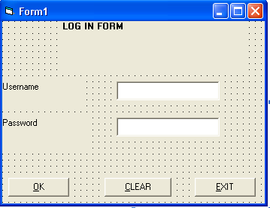

Menu Navigation
Patient Record System Main Menu
This is the form which linked to all forms
On the menu click on the:
- Patient Registration Menu command button for patient registration.
- Patients Treatments Menu command button for patient treatments registration.
- Exit command button for exiting to the Visual Basic.

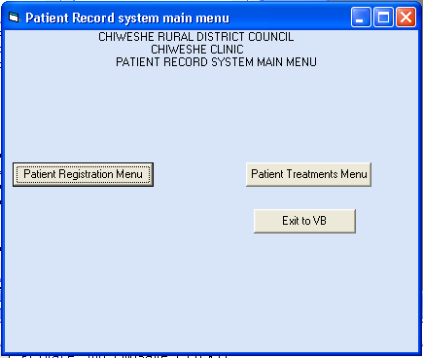

PATIENT REGISTRATION MENU
This form directs the user to the patient registration form and patient registration report.
When you click on the Patient Registration Menu icon or command button from the Main Menu, the following is displayed.
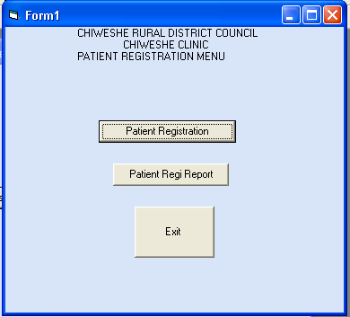

- The Patient Registration icon on the Patient Registration Menu displays the form on which patient details are entered like the form shown below
Patient Registration Form
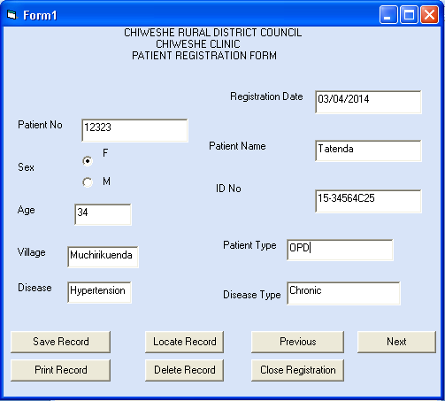

On the Patient Registration Form click on:
- Save Record icon when you have finished entering a record for the record to be stored in the computer.

- Print Record icon to print the displayed record if the printer is connected.
- Delete Record icon to remove the record in the computer memory in the event that a patient dies to save space in the Patient Registration File where unnecessary records have to be deleted. When you click on the icon the computer then displays a message to make sure that you want to delete the record as follows

- Close Registration icon to close the Registration form back to the Patient Registration Menu.

- The Exit Registration icon or command button exits the Patient Registration Menu back to the Main Menu

PATIENT TREATMENTS MENU

This form links antenatal care, child birth, post natal, o p d treatment and it shows reports of patient report, birth report, patient and patient treatment.
When you click on the Patients Treatments Menu from the Main Menu, the following is displayed
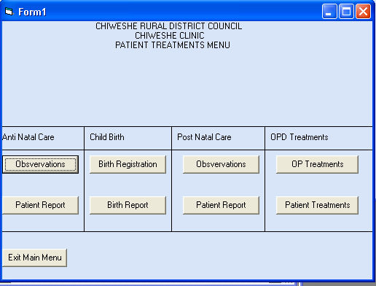

Anti Natal Care form
This is a form for recording antenatal care patients or pregnant mothers and is located within patient treatment form

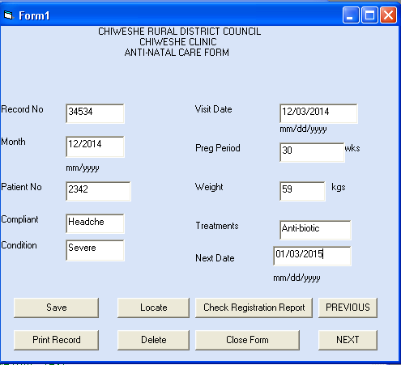

On the Anti Natal Care Form click on:
- Save Record icon when you have finished entering a record for the record to be stored in the computer.
- Locate Record to search a particular patient record in the file. The computer then asks for Record Number by displaying the following message

- Print Record icon to print the displayed record if the printer is connected.
- Delete Record icon to remove the record in the computer memory. When the user clicks on the icon the computer then displays a message to make sure that the record has successfully deleted.

- Check Registration Record icon to display the record of the patient in the Patient Registration File.
- Close form icon to close the Anti Natal Care form back to the Patient Treatments Menu.

Existing the patient record system

- Click exit to the patient record system main menu and then it shows a massage box shown below

Testing and coding

Normal testing

Testing for saving

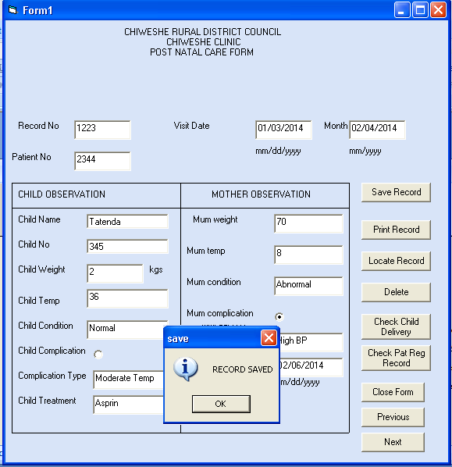

The record successfully saved because the patient number has four digits

Testing for deleting
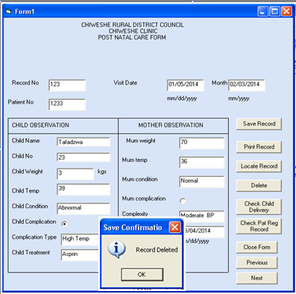This shows that the record has been successfully deleted

Abnormal Testing
Testing for outrange
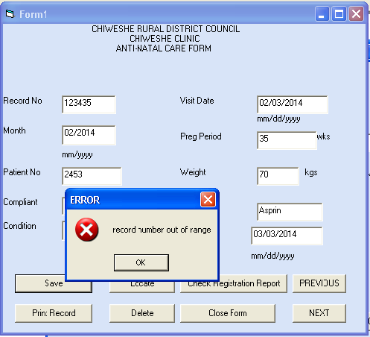

Record number in antenatal care form is outrange since the record number requires 5 digits

Testing for format

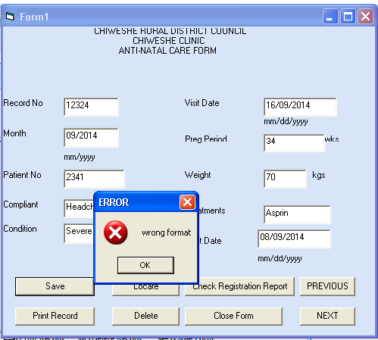

This shows that the date is in wrong format

Testing for incomplete

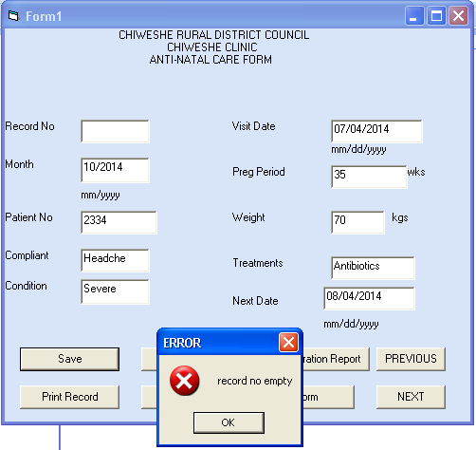

This error massage shows the incomplete of required information

EVALUATION OF COMPUTERISED SOLUTION

The computerized Patient Record System has managed to meet the aims and objections listed on page 14. It has managed to solve some of the limitations met with the manual Patient Record System. It has managed to:
- Store large volumes of patient records of the different files of the system like OPD Register and Patient Registration safely without the storage drive getting worn out. It has achieved this because large volumes of patient records of the system have been stored in the different files and the data was able to be retrieved when needed for use.
- Reduce the time to produce monthly and annual reports based on for example Patient Registration Summary and Patient Reports since it was able to carry out all the additions of the number of patients and automatically produce reports eliminating the problem of delays in decision-making by the District Hospital.
- Reduce errors in calculating of the total number of patients during the creation of reports are done by the computer which increases efficiency in report production and decision making by the District Hospital.

- Reduce the number of books used at the clinic by combining some of the books like STI, Chronic and OPD Register into one book.
- Eliminate the use of Tally forms which reduces the number of books used which is manageable.

The computerized solution failed to:
- Produce reports which could be compiled on weekly basis
- Offer privacy to patient records through use passwords and file encryption since books like STI need complete privacy.
- To allow duplication of files to enable data recovery in the event that the data is lost
- To calculate the number of visits

OPPORTUNITIES FOR FURTHER DEVELOPMENT

The computerized solution could be further developed to cope with its failures. It could be developed to:
- Produce weekly surveillance reports based on the Patient Registration and Treatment.
- Ensure privacy to data for example STI records by use of passwords and encryption.
- Introduce the use of network system to allow viewing of reports or records from a distance.
- Use an Expert System to carry out patient diagnosis for use by those patients who are shy to tell human doctors.
- Include back-up files to enable restoration of data when corrupted or lost.
- Incorporate a game to provide entertainment the system users.

