

Functional Safety Concept Lane Assistance

**Document Version: [Version]**

**Template Version 1.0, Released on 2017-06-21**



# 

# Document history

|  |  |  |  |
| --- | --- | --- | --- |
| Date | Version | Editor | Description |
| 5/23/2018 | 1.0 | Gireek Bansal | First attempt |
|  |  |  |  |
|  |  |  |  |
|  |  |  |  |
|  |  |  |  |

# Table of Contents

Document history

Table of Contents

Purpose of the Functional Safety Concept

Inputs to the Functional Safety Analysis

Safety goals from the Hazard Analysis and Risk Assessment

Preliminary Architecture

Description of architecture elements

Functional Safety Concept

Functional Safety Analysis

Functional Safety Requirements

Refinement of the System Architecture

Allocation of Functional Safety Requirements to Architecture Elements

Warning and Degradation Concept

# 

# Purpose of the Functional Safety Concept

For identifying new requirements and allocating these requirements to system diagrams. The functional safety concept does not go into technical details but only looks at the general functionality of the item. Technical safety requirements will be reached through functional safety concepts.

# Inputs to the Functional Safety Concept

## Safety goals from the Hazard Analysis and Risk Assessment

|  |  |
| --- | --- |
| **ID** | **Safety Goal** |
| Safety_Goal_01 | The oscillating steering torque from the Lane Departure Warning function shall be limited. |
| Safety_Goal_02 | The Lane Keeping Assistance function shall be time limited, and additional steering torque shall end after a given time interval so the driver cannot misuse the system for autonomous driving. |

## Preliminary Architecture

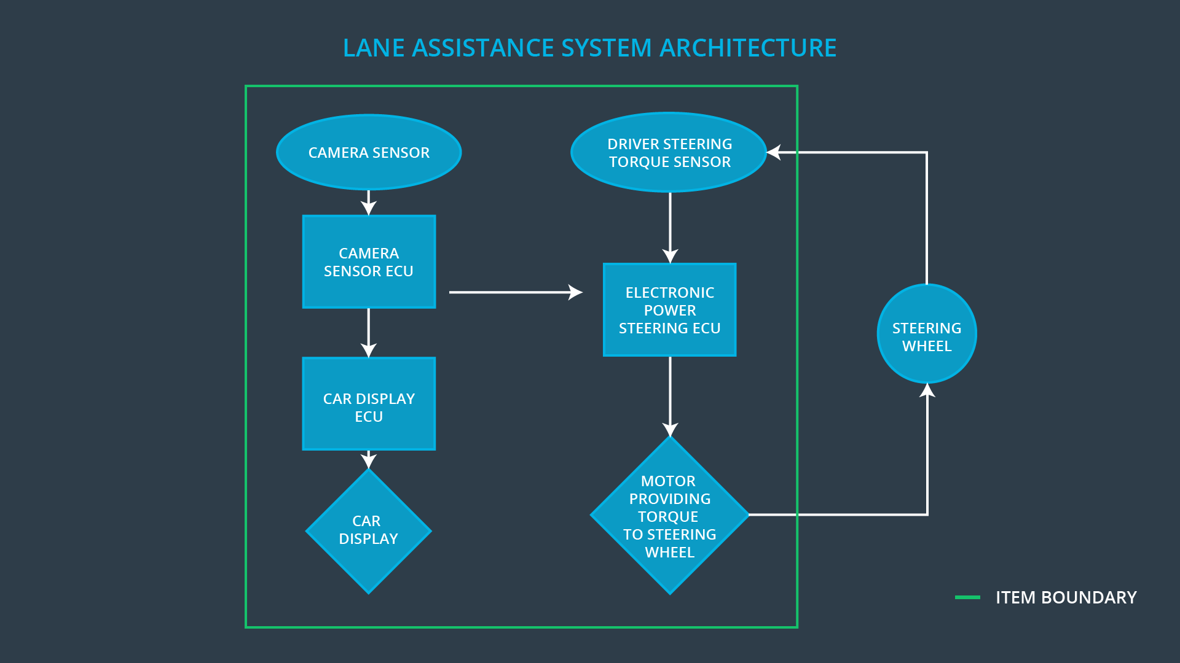

### Description of architecture elements

|  |  |
| --- | --- |
| **Element** | **Description** |
| Camera Sensor | Takes the photos of the external environment and passes them on to the Camera sensor ECU |
| Camera Sensor ECU | Analyzes the photos to calculate the car’s position w.r.t. the lane. |
| Car Display | A display screen to let the driver know about the car’s status and for any type of warnings. |
| Car Display ECU | The brain behind the Car display to update driver of things to be concerned about. |
| Driver Steering Torque Sensor | Gives the measure of the torque applied to the steering wheel by the driver. |
| Electronic Power Steering ECU | With the knowledge received from the Driver Steering Torque Sensor it requests the necessary torque to be applied by the Motor actuator. |
| Motor | Responsible for applying the torque to the steering wheel. |

# Functional Safety Concept

The functional safety concept consists of:

* Functional safety analysis
* Functional safety requirements
* Functional safety architecture
* Warning and degradation concept

## Functional Safety Analysis

|  |  |  |  |
| --- | --- | --- | --- |
| **Malfunction ID** | **Main Function of the Item Related to Safety Goal Violations** | **Guidewords (NO, WRONG, EARLY, LATE, MORE, LESS)** | **Resulting Malfunction** |
| Malfunction_01 | Lane Departure Warning (LDW) function shall apply an oscillating steering torque to provide the driver a haptic feedback | MORE | The LDW applied an oscillating torque with a very high torque amplitude. |
| Malfunction_02 | Lane Departure Warning (LDW) function shall apply an oscillating steering torque to provide the driver a haptic feedback | MORE | The LDW applied an oscillating torque with a very high torque frequency. |
| Malfunction_03 | Lane Keeping Assistance (LKA) function shall apply the steering torque when active in order to stay in ego lane | NO | The LKA is not limited in time duration which lead to misuse as an autonomous driving function. |

## 

## Functional Safety Requirements

Lane Departure Warning (LDW) Requirements:

|  |  |  |  |  |
| --- | --- | --- | --- | --- |
| **ID** | **Functional Safety Requirement** | **ASIL** | **Fault Tolerant Time Interval** | **Safe State** |
| Functional  Safety  Requirement  01-01 | The Lane Departure Warning item shall ensure that the lane departure oscillating torque amplitude is below Max_Torque_Amplitude. | C | 50 ms | Vibration torque amplitude below Max_Torque_Amplitude. |
| Functional  Safety  Requirement  01-02 | The Lane Departure Warning item shall ensure that the lane departure oscillating torque frequency is below Max_Torque_Frequency. | C | 50 ms | Vibration frequency is below Max_Torque_Frequency. |

Lane Departure Warning (LDW) Verification and Validation Acceptance Criteria:

|  |  |  |
| --- | --- | --- |
| **ID** | **Validation Acceptance**  **Criteria and Method** | **Verification Acceptance**  **Criteria and Method** |
| Functional  Safety  Requirement  01-01 | Validate that the Max_Torque_Amplitude is the right amount that it doesn’t create loss of steering and can warn the driver too. | Verify that the system automatically turns off if the warning exceeds Max_Torque_Amplitude |
| Functional  Safety  Requirement  01-02 | Validate that the Max_Torque_ Frequency is the right amount that it doesn’t create loss of steering and can warn the driver too. | Verify that the system automatically turns off if the warning exceeds Max_Torque_Frequency |

Lane Keeping Assistance (LKA) Requirements:

|  |  |  |  |  |
| --- | --- | --- | --- | --- |
| **ID** | **Functional Safety Requirement** | **ASIL** | **Fault Tolerant Time Interval** | **Safe State** |
| Functional  Safety  Requirement  02-01 | The Lane Keeping Assistance function shall be time limited, and additional steering torque shall end after a given time interval so the driver cannot misuse the system for autonomous driving. | B | 500 ms | Lane Keeping Assistance torque is zero |

Lane Keeping Assistance (LKA) Verification and Validation Acceptance Criteria:

|  |  |  |
| --- | --- | --- |
| **ID** | **Validation Acceptance**  **Criteria and Method** | **Verification Acceptance**  **Criteria and Method** |
| Functional  Safety  Requirement  02-01 | Validate the Max_Duration chosen not allow the driver to use the car as self-driving car | Verify the system deactivates automatically if the LKA torque application duration exceeded Max_duration. |

## Refinement of the System Architecture

## 

## Allocation of Functional Safety Requirements to Architecture Elements

|  |  |  |  |  |
| --- | --- | --- | --- | --- |
| **ID** | **Functional Safety Requirement** | **Electronic Power Steering ECU** | **Camera ECU** | **Car Display ECU** |
| Functional  Safety  Requirement  01-01 | The Lane Departure Warning item shall ensure that the lane departure oscillating torque amplitude is below Max_Torque_Amplitude. | **x** |  |  |
| Functional  Safety  Requirement  01-02 | The Lane Departure Warning item shall ensure that the lane departure oscillating torque amplitude is below Max_Torque_Frequency. | **x** |  |  |
| Functional  Safety  Requirement  02-01 | The Lane Keeping Assistance function shall be time limited, and additional steering torque shall end after a given time interval so the driver cannot misuse the system for autonomous driving. | **x** |  |  |

## Warning and Degradation Concept

|  |  |  |  |  |
| --- | --- | --- | --- | --- |
| **ID** | **Degradation Mode** | **Trigger for Degradation Mode** | **Safe State invoked?** | **Driver Warning** |
| WDC-01 | Turn off LDW functionality | Malfunction_01  Malfunction_02 | Yes | Lane departure warning on car display |
| WDC-02 | Turn off LKA functionality | Malfunction_03 | Yes | LKA warning on display |