

Technical Safety Concept Lane Assistance

**Document Version: [Version]**

**Template Version 1.0, Released on 2017-06-21**



# Document history

|  |  |  |  |
| --- | --- | --- | --- |
| Date | Version | Editor | Description |
| 5/23/2018 | 1.0 | Gireek Bansal | First Attempt |
|  |  |  |  |
|  |  |  |  |
|  |  |  |  |
|  |  |  |  |

# 

# Table of Contents

Document history

Table of Contents

Purpose of the Technical Safety Concept

Inputs to the Technical Safety Concept

Functional Safety Requirements

Refined System Architecture from Functional Safety Concept

Functional overview of architecture elements

Technical Safety Concept

Technical Safety Requirements

Refinement of the System Architecture

Allocation of Technical Safety Requirements to Architecture Elements

Warning and Degradation Concept

# Purpose of the Technical Safety Concept

The purpose of the technical safety concept is to convert functional requirements into technical requirements and is an in-depth representation of the item’s technology. Functional safety concept was a part of concept phase but this is a part of product development phase.

# Inputs to the Technical Safety Concept

## Functional Safety Requirements

|  |  |  |  |  |
| --- | --- | --- | --- | --- |
| **ID** | **Functional Safety Requirement** | **ASIL** | **Fault Tolerant Time Interval** | **Safe State** |
| Functional  Safety  Requirement  01-01 | The Lane Departure Warning item shall ensure that the lane departure oscillating torque amplitude is below Max_Torque_Amplitude | C | 50 ms | Vibration torque amplitude below Max_Torque_Amplitude. |
| Functional  Safety  Requirement  01-02 | The Lane Departure Warning item shall ensure that the lane departure oscillating torque frequency is below Max_Torque_Frequency. | C | 50 ms | Vibration frequency is below Max_Torque_Frequency. |
| Functional  Safety  Requirement  02-01 | The Lane Keeping Assistance function shall be time limited, and additional steering torque shall end after a given time interval so the driver cannot misuse the system for autonomous driving. | B | 500 ms | Lane Keeping Assistance torque is zero |

## Refined System Architecture from Functional Safety Concept

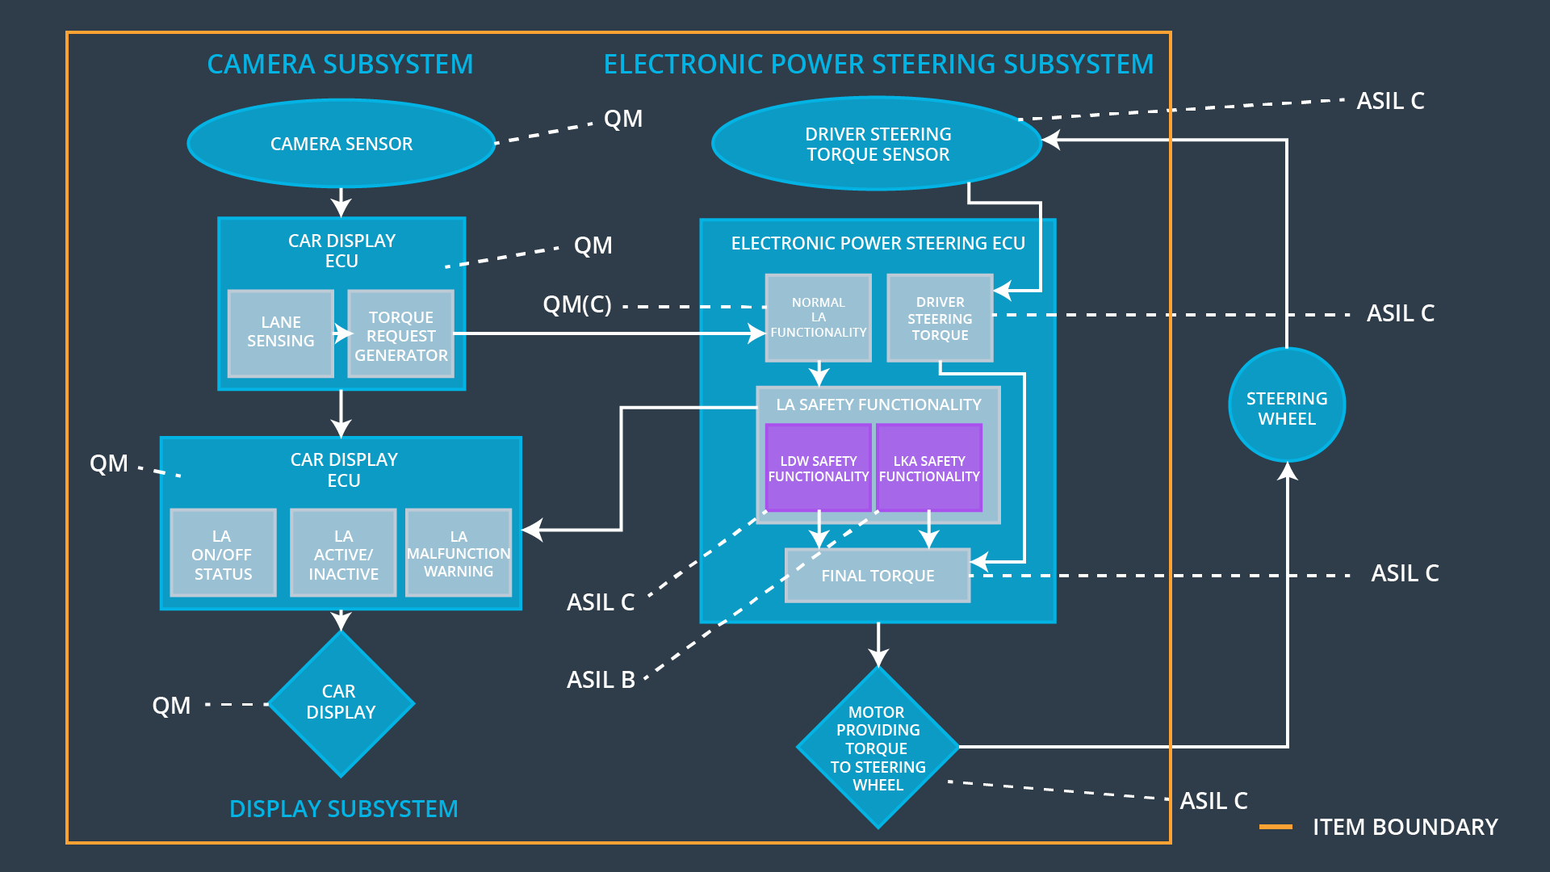

### 

### Functional overview of architecture elements

|  |  |
| --- | --- |
| **Element** | **Description** |
| Camera Sensor | Takes the photos of the external environment and passes them on to the Camera sensor ECU |
| Camera Sensor ECU - Lane Sensing | Analyzes the photos to calculate the car’s position w.r.t. the lane. |
| Camera Sensor ECU - Torque request generator | It calculates the torque required to re-center the car w.r.t. to the lane |
| Car Display | A display screen to let the driver know about the car’s status and for any type of warnings. |
| Car Display ECU - Lane Assistance On/Off Status | Knowledge about On/off status of lane assistance system is provided to car display by Car Display ECU - Lane Assistance On/Off Status |
| Car Display ECU - Lane Assistant Active/Inactive | Indicates if lane assistance functionality is functioning as required. |
| Car Display ECU - Lane Assistance malfunction warning | Indicates if a malfunction has hit the Lane assistance functionality |
| Driver Steering Torque Sensor | Gives the measure of the torque applied to the steering wheel by the driver. |
| Electronic Power Steering (EPS) ECU - Driver Steering Torque | Software which receives the driver’s torque request from the steering wheel. |
| EPS ECU - Normal Lane Assistance Functionality | Software receives the camera sensor ECU torque request. |
| EPS ECU - Lane Departure Warning Safety Functionality | Software ensures the torque amplitude and frequency are below specific maximum values. |
| EPS ECU - Lane Keeping Assistant Safety Functionality | Software keeps the check that LKA is not activated for more than a specific time duration. |
| EPS ECU - Final Torque | Combines the torque request from both LKA and LDW to send to motor |
| Motor | Responsible for applying the torque to the steering wheel after getting from EPS ECU - Final Torque |

# Technical Safety Concept

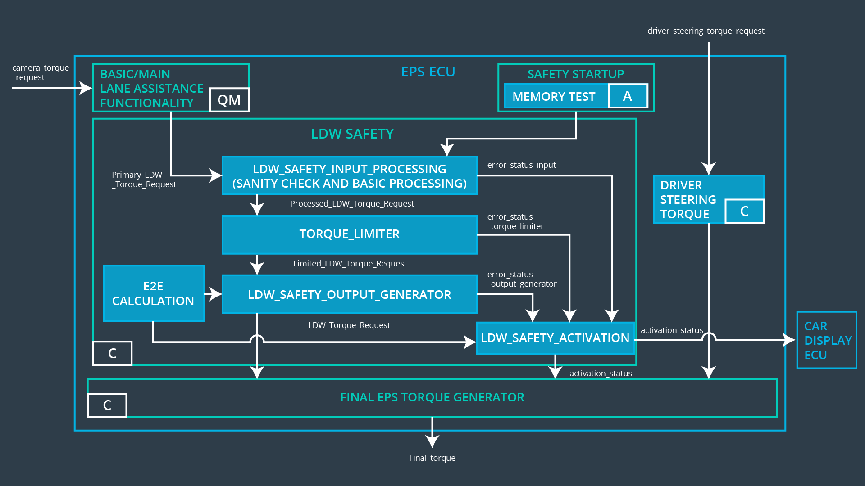

## Technical Safety Requirements

**Lane Departure Warning (LDW) Requirements:**

Functional Safety Requirement 01-01 with its associated system elements

(derived in the functional safety concept)

|  |  |  |  |  |
| --- | --- | --- | --- | --- |
| **ID** | **Functional Safety Requirement** | **Electronic Power Steering ECU** | **Camera ECU** | **Car Display ECU** |
| Functional  Safety  Requirement  01-01 | The lane keeping item shall ensure that the lane departure oscillating torque amplitude is below Max_Torque_Amplitude | X |  |  |

Technical Safety Requirements related to Functional Safety Requirement 01-01 are:

|  |  |  |  |  |  |
| --- | --- | --- | --- | --- | --- |
| **ID** | **Technical Safety Requirement** | **ASIL** | **Fault Tolerant Time Interval** | **Architecture Allocation** | **Safe State** |
| Technical  Safety  Requirement  01 | The Lane Departure Warning safety component shall ensure that the amplitude of the LDW_Torque_Request sent to the ‘Final electronic power steering Torque’ component is below Max_Torque_Amplitude | C | 50 ms | LDW_safety | LDW_Torque_Request is set to zero. |
| Technical  Safety  Requirement  02 | On failure detection by LDW it shall be deactivated and LDW_torque_request reset to zero. | C | 50 ms | LDW_safety | LDW_Torque_Request is set to zero. |
| Technical  Safety  Requirement  03 | When the LDW has been deactivated ‘LDW safety’ shall send a signal to car display ECU to turn on warning for the driver. | C | 50 ms | LDW_safety | LDW_Torque_Request is set to zero. |
| Technical  Safety  Requirement  04 | Memory tests shall be conducted at start of EPS ECU for checking memory faults. | A | Ignition cycle | Safety start up | LDW_Torque_Request is set to zero. |
| Technical  Safety  Requirement  05 | The integrity of data transmission for LDW_Torque_Request signal shall be ensured. | C | 50 ms | Data transmission integrity check | LDW_Torque_Request is set to zero. |

Functional Safety Requirement 01-2 with its associated system elements

(derived in the functional safety concept)

|  |  |  |  |  |
| --- | --- | --- | --- | --- |
| **ID** | **Functional Safety Requirement** | **Electronic Power Steering ECU** | **Camera ECU** | **Car Display ECU** |
| Functional  Safety  Requirement  01-02 | The lane keeping item shall ensure that the lane departure oscillating torque frequency is below Max_Torque_Frequency | X |  |  |

Technical Safety Requirements related to Functional Safety Requirement 01-02 are:

|  |  |  |  |  |  |
| --- | --- | --- | --- | --- | --- |
| **ID** | **Technical Safety Requirement** | **ASIL** | **Fault Tolerant Time Interval** | **Architecture Allocation** | **Safe State** |
| Technical  Safety  Requirement  01 | The Lane Departure Warning safety component shall ensure that the amplitude of the LDW_Torque_Request sent to the ‘Final electronic power steering Torque’ component is below Max_Torque_Frequency | C | 50 ms | LDW_safety | LDW_Torque_Request is set to zero. |
| Technical  Safety  Requirement  02 | On failure detection by LDW it shall be deactivated and LDW_torque_request reset to zero. | C | 50 ms | LDW_safety | LDW_Torque_Request is set to zero. |
| Technical  Safety  Requirement  03 | When the LDW has been deactivated ‘LDW safety’ shall send a signal to car display ECU to turn on warning for the driver. | C | 50 ms | LDW_safety | LDW_Torque_Request is set to zero. |
| Technical  Safety  Requirement  04 | Memory tests shall be conducted at start of EPS ECU for checking memory faults. | A | Ignition cycle | Safety start up | LDW_Torque_Request is set to zero. |
| Technical  Safety  Requirement  05 | The integrity of data transmission for LDW_Torque_Request signal shall be ensured. | C | 50 ms | Data transmission Integrity check | LDW_Torque_Request is set to zero. |

**Lane Keeping Assistance (LKA) Requirements:**

Functional Safety Requirement 02-1 with its associated system elements

(derived in the functional safety concept)

|  |  |  |  |  |
| --- | --- | --- | --- | --- |
| **ID** | **Functional Safety Requirement** | **Electronic Power Steering ECU** | **Camera ECU** | **Car Display ECU** |
| Functional  Safety  Requirement  02-01 | The lane keeping item shall ensure that the lane keeping assistance torque is applied for only Max_Duration | X |  |  |

Technical Safety Requirements related to Functional Safety Requirement 02-01 are:

|  |  |  |  |  |  |
| --- | --- | --- | --- | --- | --- |
| **ID** | **Technical Safety Requirement** | **ASIL** | **Fault Tolerant Time Interval** | **Allocation to Architecture** | **Safe State** |
| Technical  Safety  Requirement  01 | The LKA safety module shall keep the duration of LKA_Torque_Request sent to the steering component below Max_Duration | B | 500 ms | LKA_safety | LKA_Torque_Request is set to zero. |
| Technical  Safety  Requirement  02 | On failure detection by LKA it shall be deactivated and LKA_torque_request reset to zero. | B | 500 ms | LKA_safety | LKA_Torque_Request is set to zero. |
| Technical  Safety  Requirement  03 | When the LKA has been deactivated ‘LKA safety’ shall send a signal to car display ECU to turn on warning for the driver. | B | 500 ms | LKA_safety | LKA_Torque_Request is set to zero. |
| Technical  Safety  Requirement  04 | Memory tests shall be conducted at start of EPS ECU for checking memory faults. | A | Ignition cycle | Safety Start up | LKA_Torque_Request is set to zero. |
| Technical  Safety  Requirement  05 | The integrity of data transmission for LKA_Torque_Request signal shall be ensured. | B | 500 ms | Data transmission integrity check | LKA_Torque_Request is set to zero. |

## Refinement of the System Architecture

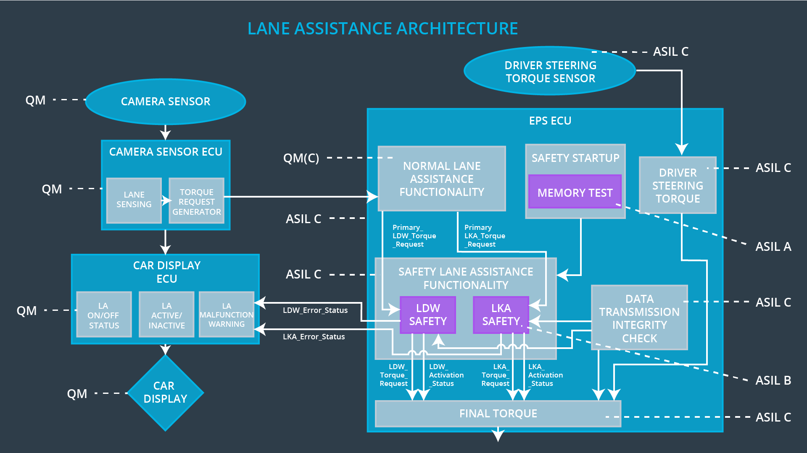

## Allocation of Technical Safety Requirements to Architecture Elements

All technical requirements are allocated to the Electronic Power Steering ECU.

## 

## Warning and Degradation Concept

|  |  |  |  |  |
| --- | --- | --- | --- | --- |
| **ID** | **Degradation Mode** | **Trigger for Degradation Mode** | **Safe State invoked?** | **Driver Warning** |
| WDC-01 | Turn off Lane Departure Warning functionality | Malfunction_01,  Malfunction_02 | Yes | Lane Departure Warning Malfunction Warning on Car Display |
| WDC-02 | Turn off Lane Keeping Assistance functionality | Malfunction_03 | Yes | Lane Keeping Assistance Malfunction Warning on Car Display |