**Full Stack Assignment**

Name:Gireesh R Haridas

USN:01fe20mca026

**MONGO DB:**

**Collection Name : BOOKS**

**INSERTING DATA INTO COLLECTION : BOOKS**

**Query1:**

**db.Books.insertOne({"Book_Title":"Java","Author":"Horstmann","Publisher":"prentice","edition":11,"Year_of_pub":2011,"ISBN":0-345-24223-8});**

**Query2:**

**2.db.Books.insertOne({"Book_Title":"Line of Fire","Author":"Brian Paddick","Publisher":"Simon ","edition":3,"Year_of_pub":2008,"ISBN":979-82-7213-496-0});**

**Query3:**

**db.Books.insertOne({"Book_Title":"Line of Fire","Author":"Brian Paddick","Publisher":"Simon ","edition":3,"Year_of_pub":2008,"ISBN":978-82-7213-496-0});Document4:**

**Query4:**

**db.Books.insertOne({"Book_Title":"AGameofThrones","Author":"Martin","Publisher":"BantamSpectra","edition":9,"Year_of_pub":2016,"ISBN":968-82-7223-496-0});**

**Query5:**

**db.Books.insertOne({"Book_Title":"The girl in room 105","Author":"chetan Bhagat","Publisher":"Westland","edition":3,"Year_of_pub":2018,"ISBN":978-82-7223-497-0});**

**Query6:**

**db.Books.insertOne({"Book_Title":"python","Author":"matthes","Publisher":"john","edition":3,"Year_of_pub":2019,"ISBN":978-82-7223-498-0});**

**Query7:**

**db.Books.insertOne({"Book_Title":"Alchemist","Author":"panlo coelno","Publisher":"harper","edition":3,"Year_of_pub":2018,"ISBN":978-81-7223-498-0});**

**Query8 :db.Books.insertOne({"Book_Title":"python","Author":"john Zelle","Publisher":"Rossum","edition":3,"Year_of_pub":2012,"ISBN":0-332-24223-9});**

**Query9:**

**db.Books.insertOne({"Book_Title":"C++","Author":"stanley","Publisher":"jossee","edition":5,"Year_of_pub":2016,"ISBN":0-342-24223-9});**

**Query10:**

**db.Books.insertOne({"Book_Title":"Java","Author":"scott","Publisher":"shroff","edition":4,"Year_of_pub":2012,"ISBN":0-343-24223-9});**

**Query11:**

**db.Books.insertOne({"Book_Title":"Java","Author":"herbert","Publisher":"McGraw","edition":8,"Year_of_pub":2014,"ISBN":0-344-24223-9});**

**Query12:**

**db.Books.insertOne({"Book_Title":"Java","Author":"joshua","Publisher":"wesley","edition":4,"Year_of_pub":2016,"ISBN":0-345-24223-9});**

**Query13:**

**db.Books.insertOne({"Book_Title":"Java","Author":"Horstmann","Publisher":"prentice","edition":11,"Year_of_pub":2011,"ISBN":0-345-24223-8});**

**Display the documents of collection BOOKS :**

**Db.BOOKS.find()**

**To Update :**

**db.Books.updateOne({"Book_Title":"python"},{$set:{edition :4}});**

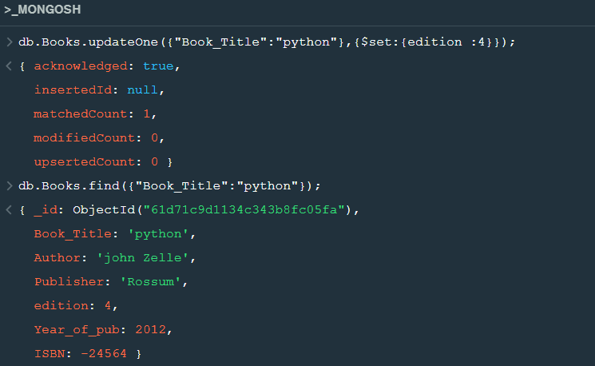

**Delete Operation :**

**db.Books.deleteOne({"Author":"Horstmann"});**

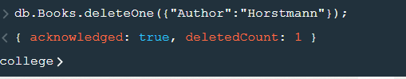

**Queries**

1. **Retrieve the books which contains the title as java(case in-sensitive)**

**db.Books.find({"Book_Title" : { '$regex':/^Java$/i}});**

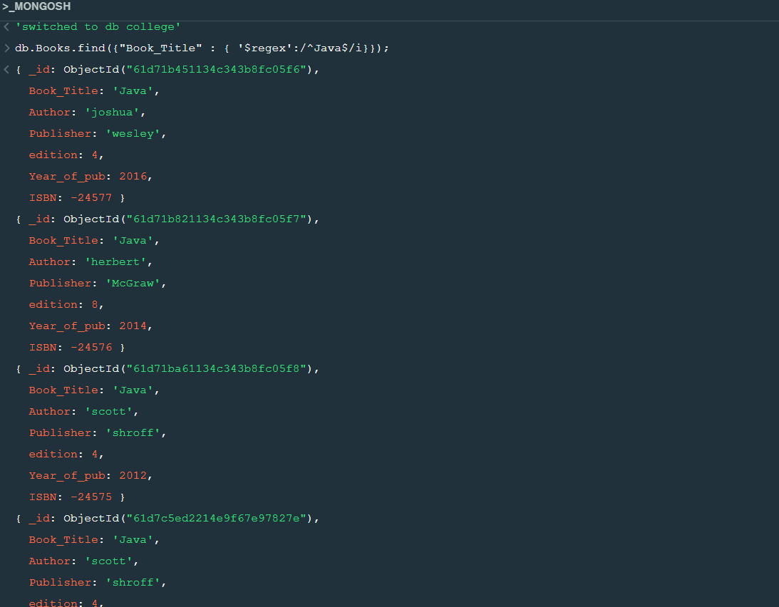

**2. Retrieve the books which contains the title as java and year of publication is greater than 2015**

**db.Books.find({Book_Title:"Java",Year_of_pub:{$gt:2015}});**

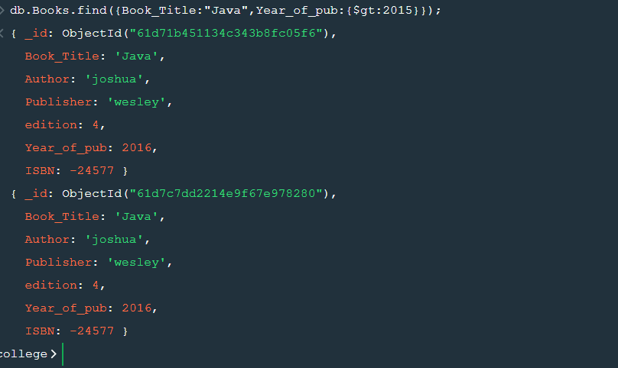

**3.Retrieve the books whose edition is between 3rd and 4th**

**db.Books.find({edition:{$gte:3,$lte:4}});**

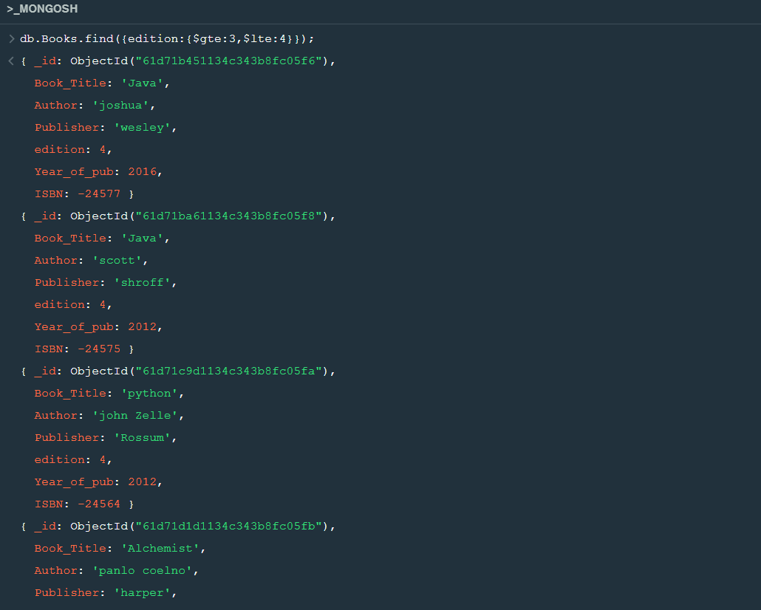

**4. Retrieve the name of the author who has published more than two books.**

**db.book.find({"Author":{$gt:2}}).count();**