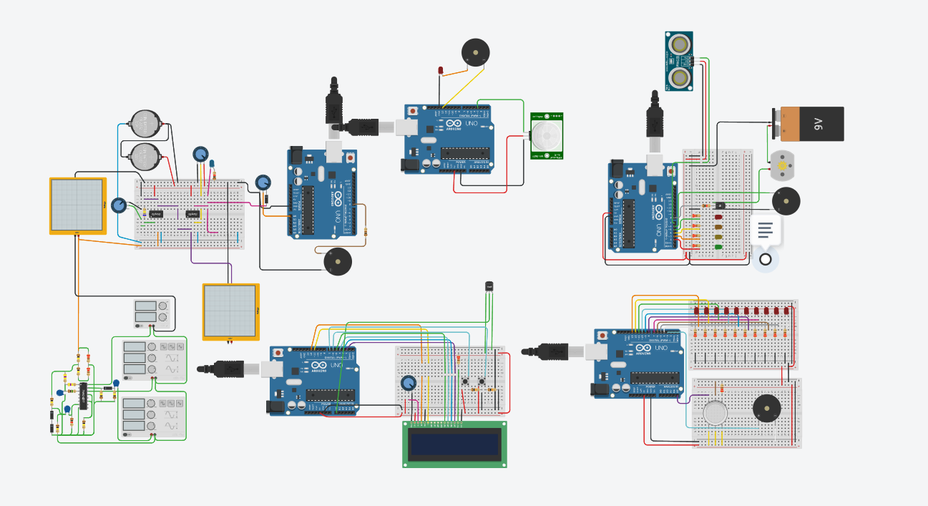

Code:

// C++ code

//

int distanceTreshold = 0;

int cm = 0;

long readUltrasonicDistance(int triggerPin, int echoPin)

{

pinMode(triggerPin, OUTPUT); // Clear the trigger

digitalWrite(triggerPin, LOW);

delayMicroseconds(2);

// Sets the trigger pin to HIGH state for 10 microseconds

digitalWrite(triggerPin, HIGH);

delayMicroseconds(10);

digitalWrite(triggerPin, LOW);

pinMode(echoPin, INPUT);

// Reads the echo pin, and returns the sound wave travel time in microseconds

return pulseIn(echoPin, HIGH);

}

void setup()

{

pinMode(2, OUTPUT);

pinMode(3, OUTPUT);

pinMode(4, OUTPUT);

pinMode(5, OUTPUT);

pinMode(8, OUTPUT);

pinMode(6, OUTPUT);

}

void loop()

{

distanceTreshold = 300;

cm = 0.01723 \* readUltrasonicDistance(7, 7);

if (cm > distanceTreshold) {

digitalWrite(2, LOW);

digitalWrite(3, LOW);

digitalWrite(4, LOW);

digitalWrite(5, LOW);

digitalWrite(8, HIGH);

noTone(6);

}

if (cm <= distanceTreshold && cm > distanceTreshold - 75) {

digitalWrite(2, LOW);

digitalWrite(3, LOW);

digitalWrite(4, LOW);

digitalWrite(5, LOW);

digitalWrite(8, HIGH);

noTone(6);

delay(1000); // Wait for 1000 millisecond(s)

digitalWrite(2, HIGH);

}

if (cm <= distanceTreshold - 75 && cm > distanceTreshold - 150) {

digitalWrite(2, HIGH);

digitalWrite(3, LOW);

digitalWrite(4, LOW);

digitalWrite(5, LOW);

digitalWrite(8, HIGH);

noTone(6);

delay(1000); // Wait for 1000 millisecond(s)

digitalWrite(3, HIGH);

}

if (cm <= distanceTreshold - 150 && cm > distanceTreshold - 225) {

digitalWrite(2, HIGH);

digitalWrite(3, HIGH);

digitalWrite(4, LOW);

digitalWrite(5, LOW);

digitalWrite(8, HIGH);

noTone(6);

delay(1000); // Wait for 1000 millisecond(s)

digitalWrite(4, HIGH);

}

if (cm <= distanceTreshold - 225 && cm > distanceTreshold - 285) {

digitalWrite(2, HIGH);

digitalWrite(3, HIGH);

digitalWrite(4, HIGH);

digitalWrite(5, LOW);

digitalWrite(8, HIGH);

delay(1000); // Wait for 1000 millisecond(s)

digitalWrite(5, HIGH);

}

if (cm <= distanceTreshold - 285) {

digitalWrite(2, HIGH);

digitalWrite(3, HIGH);

digitalWrite(4, HIGH);

digitalWrite(5, HIGH);

digitalWrite(8, LOW);

tone(6, 523, 1000); // play tone 60 (C5 = 523 Hz)

}

}