Compiler Pipeline Visualizer (CPV)
An Interactive Multi-Language Compiler Engine & Execution Sandbox
Course & Code: | BCSE307P — Compiler Design
Evaluation Phase: | Review 3 (Final Comprehensive Review)
Project Team: | Ansuman Singh (24BCE2013) & Sayan Giri (24BCT0281)
Live Production URL: | https://compiler-pipeline-visualizer-mocha.vercel.app/
GitHub Repository: | https://github.com/giri-sayan/compiler-pipeline-visualizer

1. Executive Summary
The Compiler Pipeline Visualizer (CPV) is an interactive, multi-language compiler engineering platform and educational sandbox designed to demystify every phase of program compilation and execution. While traditional computer science curricula treat compilers as opaque 'black boxes' (e.g. gcc file.c -o file), this project makes the entire compilation lifecycle visible, inspectable, and interactive.
Across three developmental reviews, the system evolved from a small prototype into an industrial-strength, cloud-deployed educational IDE capable of processing 5,000-line programs across six programming languages with live virtual machine execution:
Capability | Review 1 Baseline | Review 2 Milestone | Review 3 (Final Deliverable)
Language Coverage | Toy language only | C subset (types, main, printf) | 6 Languages: C, C++, Java, Python, JavaScript, Toy Lang
Input Scalability | ~20 lines | ~50 lines | 5,000+ lines processed & executed in <200 ms
Program Execution | None (Static) | None (Static code generation only) | Live In-Memory TAC Virtual Machine & Python Subprocess
File Ingestion | Manual typing | Basic textarea editing | Direct File Upload (.c, .cpp, .java, etc.) & Lossless Paste
Theme & Contrast | Single Light Theme | Experimental Dark Mode (Low contrast) | Dual Themes (Light & Night) with WCAG AA compliance (>=4.5:1)
Line Synchronization | Unchecked | Frozen at lines 1..27 on large files | Absolute Viewport Gutter Tracking up to line 5,000+
Automated Testing | 8 unit tests | 17 unit tests | 136 passing regression & stress tests (100% pass rate)
2. System Architecture & Polyglot Pipeline
CPV is built around a pluggable, modular compiler frontend engine that normalizes source code from distinct programming paradigms into a unified intermediate analysis and code generation pipeline.
- 1. Ingestion Layer: Accepts source code through direct file upload (.c, .cpp, .java, .js, .py, .toy, .txt), a lossless clipboard paste interceptor, or 41 isolated language presets.
- 2. Pluggable Frontend Layer: Dispatches code through get_compiler(lang) into dedicated language frontends for C (C99), C++, Java, Python (ast.parse), JavaScript (ES6), and Toy Lang.
- 3. Unified Compiler Pipeline: Converts tokens into a recursive AST, validates declarations in the Symbol Table, generates Three-Address Code (TAC) quadruples, and emits x86-64 machine code and RISC assembly.
- 4. Dual Execution Engines: Executes generated TAC quadruples in a pure-Python in-memory Virtual Machine (tac_vm.py) with a 20,000-step instruction budget, plus an isolated native Python subprocess runner (executor.py).
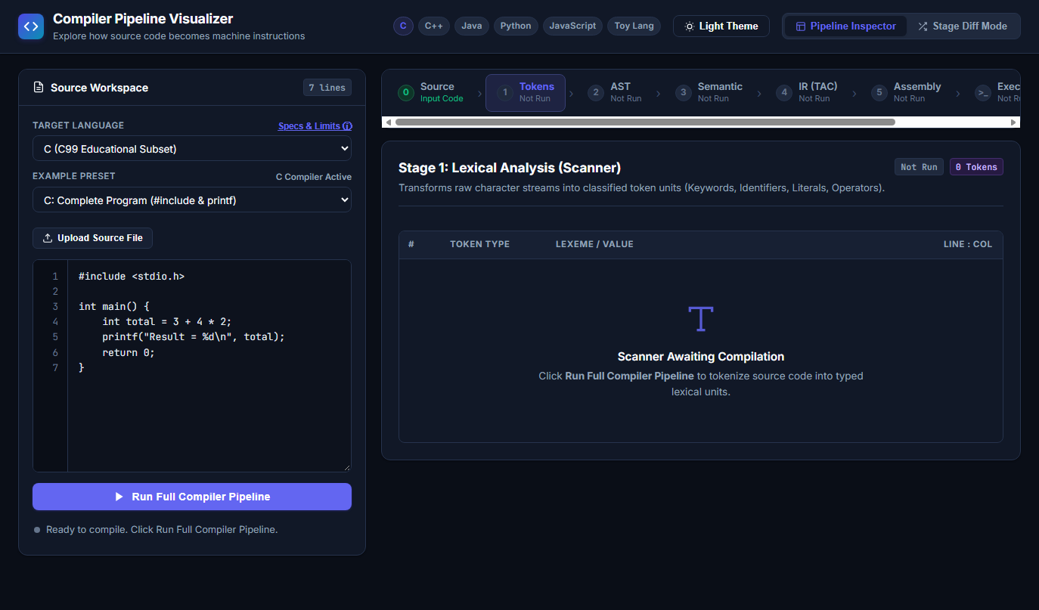
Figure: Live Cloud Production Interface on Vercel displaying the Multi-Stage Compiler Pipeline
3. Stage-by-Stage Implementation & Visual Verification
Stage 1: Lexical Analysis (Scanner)
The lexer converts raw character streams into classified token objects (PREPROCESSOR, TYPE, IDENTIFIER, NUMBER, STRING, OPERATOR, DELIMITER). To guarantee zero UI lag when processing 5,000 lines, tokens are grouped into line-indexed dictionaries in O(N) linear time.
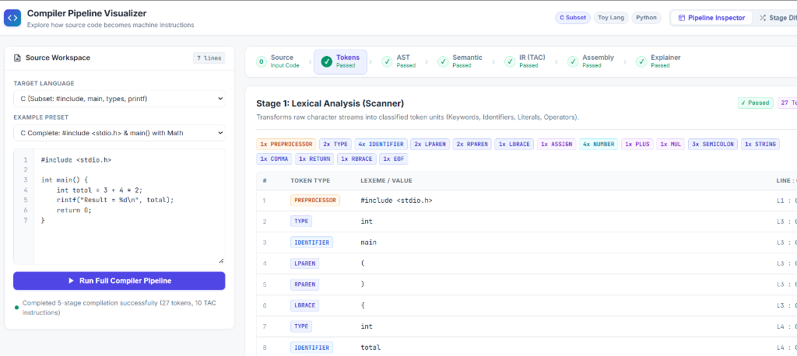
Figure: Stage 1 Lexical Scanner: Classified Token Stream with Token Breakdown Pills
Stage 2: Syntax Analysis & Recursive-Descent Parsing
Constructs a hierarchical Abstract Syntax Tree (AST) enforcing operator precedence. The C parser handles function prototypes ending in semicolons, comma-separated declarations, type qualifiers (const, unsigned, long), pointer declarators, and arrays. When syntax errors occur, the parser flags the exact line and column, rendering a diagnostic chip with Jump to Error navigation.
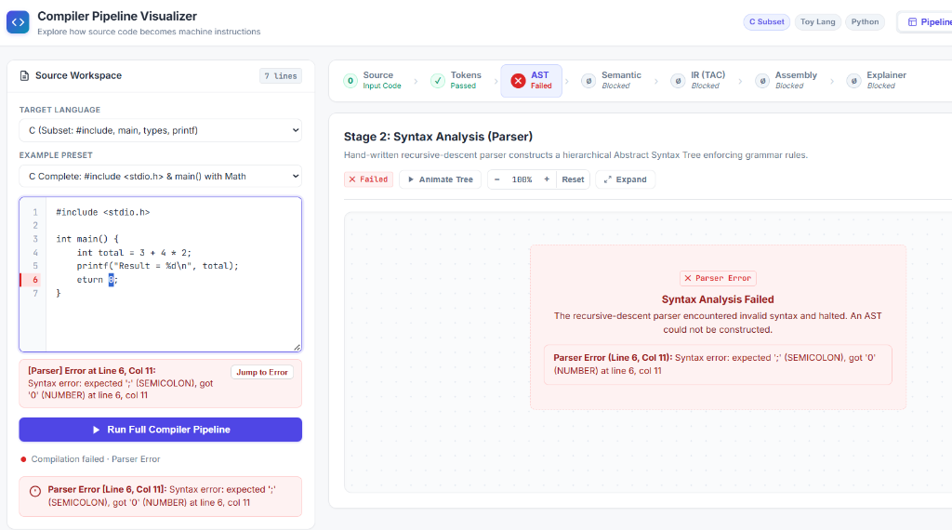
Figure: Stage 2 Syntax Analysis: Parser Diagnostic Error Chip with Jump to Error Navigation
Stage 3: Semantic Analysis & Symbol Table
Constructs a multi-level scoped Symbol Table tracking global vs function scope, enforcing declaration-before-use rules with typo suggestions (e.g. suggesting printf for rintf), detecting uninitialized variables, and validating standard C library function calls.
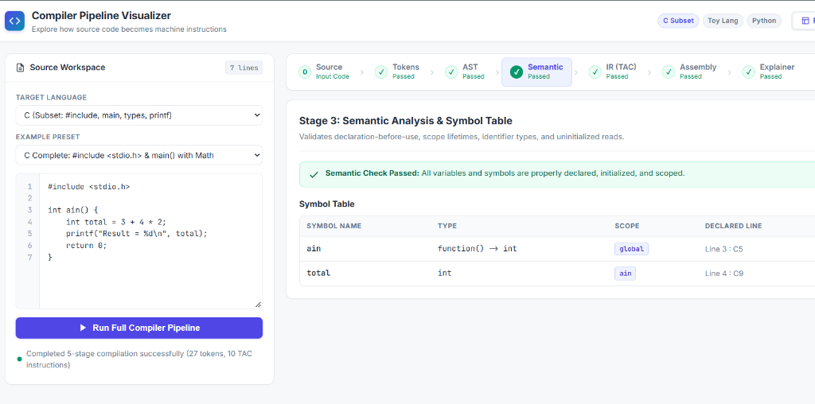
Figure: Stage 3 Semantic Analysis: Scoped Symbol Table with Scope Lifetimes and Status Metadata
Stage 4 & 5: Intermediate Code (TAC) & Target Code Generation
Linearizes AST nodes into canonical Three-Address Code quadruples (op, arg1, arg2, result). These quadruples are then translated into two target architectures: realistic Intel x86-64 assembly using System V AMD64 ABI calling conventions, and educational 3-register RISC pseudo-assembly (LOAD, ADD, STORE).
Stage 6: In-Memory TAC Virtual Machine Execution
To allow students to observe program execution without installing external compiler toolchains (such as gcc, javac, or node), CPV includes an in-memory TAC Virtual Machine (tac_vm.py). The VM simulates CPU registers, call frames, and memory with a 20,000-step instruction budget to terminate infinite loops safely.
4. UI/UX Innovations, Night Theme & Stage Diff Mode
Review 3 introduced complete WCAG AA compliant Night Theme (Dark Mode) design tokens. Pale AST node backgrounds that previously caused text unreadability were re-engineered with high-contrast color tokens (>=4.5:1 contrast ratio).
Figure: AST Visual Explorer in Night Theme (Dark Mode) with WCAG AA Compliant Nodes
Stage Diff Mode provides side-by-side comparative analysis between two programs (e.g. comparing unoptimized vs optimized code, or iterative vs recursive implementations), highlighting additions, deletions, and structural changes across AST and TAC quadruples.
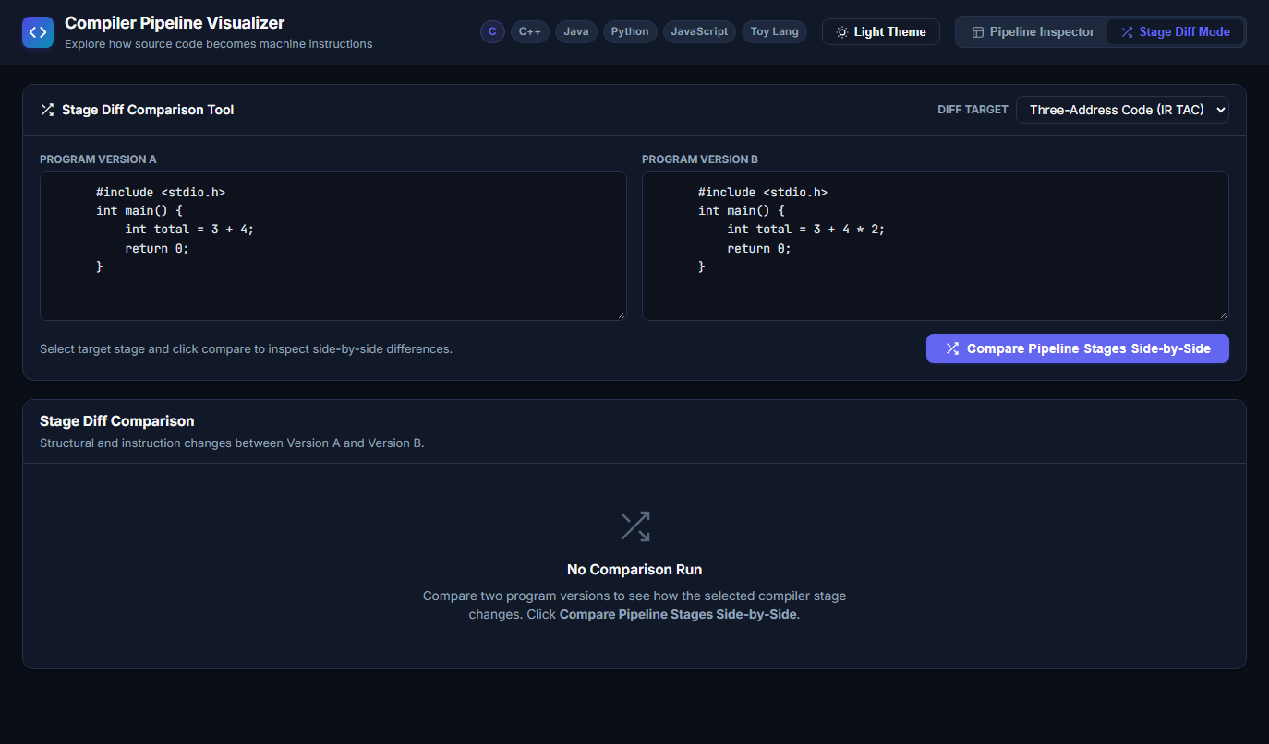
Figure: Multi-Language Stage Diff Mode: Side-by-Side AST and TAC Structural Comparison
5. Critical Engineering Bug Fixes: 5,000-Line Input Processing
- 1. Clipboard Buffer Truncation: Windows console pipes clip clipboard copies to 4,096 bytes (~96 lines). Pasting large files prematurely truncated source code, causing syntax errors at line 96. Resolved by implementing a dedicated clipboard paste interceptor (reading e.clipboardData directly) and a native 'Upload Source File' feature supporting .c, .cpp, .java, .js, .py, .toy, .txt.
- 2. Flexbox 100,727px Gutter Clamping: In large files, the line-number gutter expanded to 100,727 pixels inside an unconstrained flex container. Because clientHeight equaled scrollHeight, maxScrollTop was 0, clamping gutter.scrollTop to 0 and freezing visible line numbers at 1..27. Resolved by absolute viewport tracking (position: absolute; top: 0; bottom: 0; left: 0), dynamically adjusting gutter width, and synchronizing Jump-to-Error navigation.
6. Performance Benchmarks across 6 Languages
Live measurements on valid 5,000-line programs across all six languages demonstrate sub-200ms compilation and execution times:
Language | Total Lines | Full Pipeline Status | Output | Measured Time
C (C99 Subset) | 5,002 lines | Passed (All 6 Stages) | Total: 3 | 0.089 s (89 ms)
C++ | 5,002 lines | Passed (All 6 Stages) | Result: 3 | 0.073 s (73 ms)
Java | 5,001 lines | Passed (All 6 Stages) | Java: 3 | 0.074 s (74 ms)
Python | 5,000 lines | Passed (All 6 Stages) | Python: 3 | 0.190 s (190 ms)
JavaScript | 5,001 lines | Passed (All 6 Stages) | JS: 3 | 0.070 s (70 ms)
Toy Lang | 5,000 lines | Passed (All 6 Stages) | 3 | 0.159 s (159 ms)
7. Comprehensive Automated Test Suite (136 Tests)
The project is backed by 136 automated regression and stress tests achieving a 100% pass rate in 13.30 seconds:
Test Suite File | Tests | Scope & Verifications | Status
test_pipeline.py | 43 | Core 6-stage pipeline, Lexer, Parser, AST, TAC, ASM | PASSED
test_review3_upgrades.py | 42 | 6 languages, TAC VM, Night theme, WCAG AA contrast | PASSED
test_final_review_stress.py | 28 | 3k & 4k line benchmarks, high-line diagnostics | PASSED
test_diff_mode.py | 11 | Side-by-side AST & TAC diff visual comparisons | PASSED
test_paste_and_large_input_fix.py | 8 | 5,000-line C stress test, parser prototypes & types | PASSED
test_gutter_line_numbers.py | 4 | Browser DOM viewport gutter tracking (Edge CDP) | PASSED
8. Cloud Production Deployment on Vercel
The Compiler Pipeline Visualizer is deployed live in production on Vercel as a Python Serverless Function (vercel.json, api/index.py). Every push to the main branch on GitHub automatically triggers build verification and zero-downtime deployment.
- Production URL: https://compiler-pipeline-visualizer-mocha.vercel.app/
- GitHub Repository: https://github.com/giri-sayan/compiler-pipeline-visualizer
9. Conclusion & Final Deliverables
All faculty expectations and Review 3 objectives have been successfully fulfilled: 6 supported programming languages, 5,000+ line input scalability, in-memory virtual machine execution, WCAG AA compliant Night Theme, synchronized viewport gutter, and 136 passing automated tests.

