

Department of Engineering

Session 2026-27
PROMPT ENGINEERING
(Course Code: BCO610A)

Submitted By: Submitted To:
Name – Ankit Kumar Giri Mr. Ajay Sharma
Enrollment No. – 25BCON1276 Prompt Engineering
Branch – B.Tech. CSE (AI&DS),
Semester - 3

C – Programmes
- Factorial :

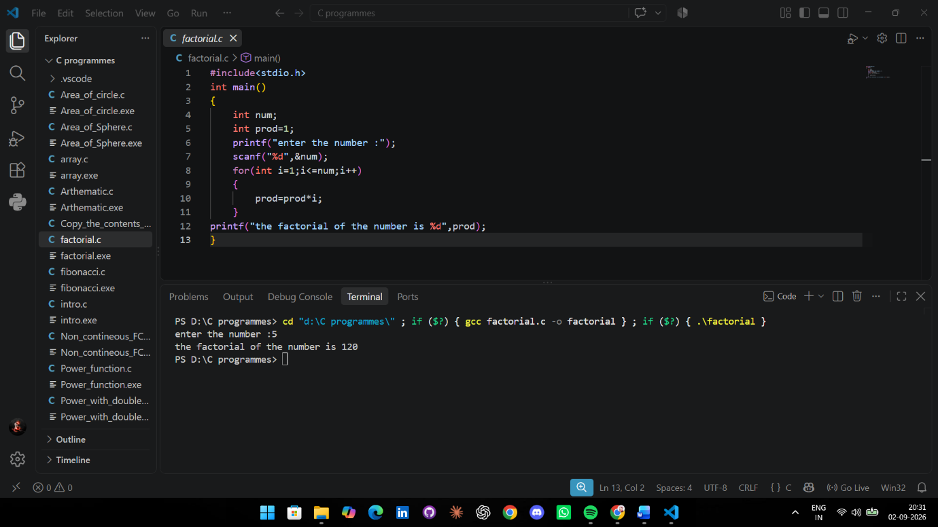

- Fibonacci :

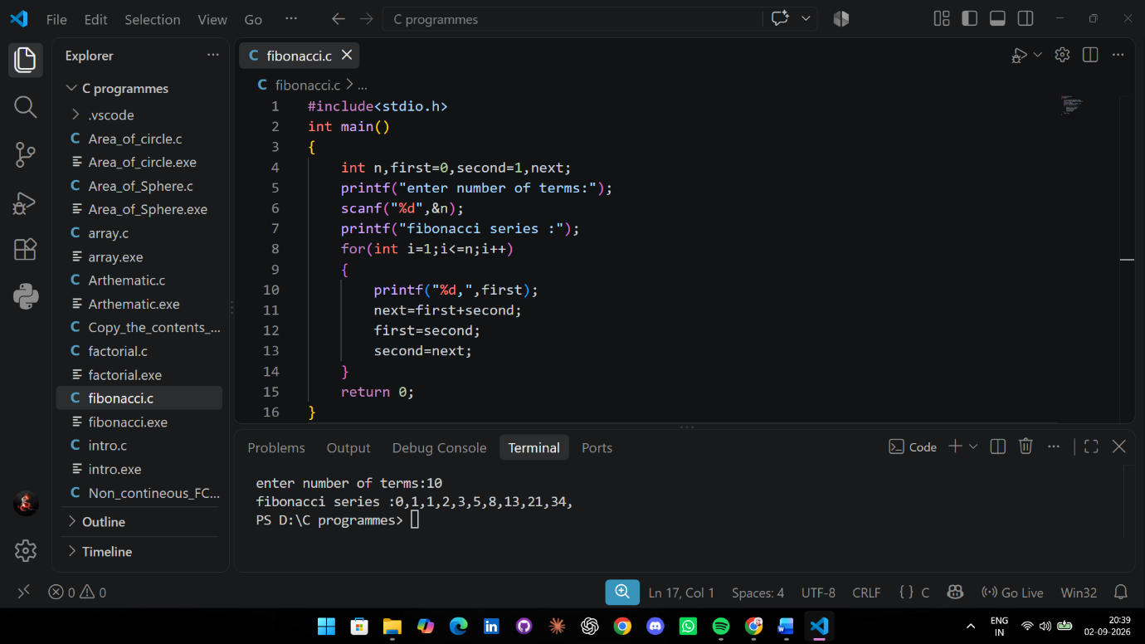
- Structure :

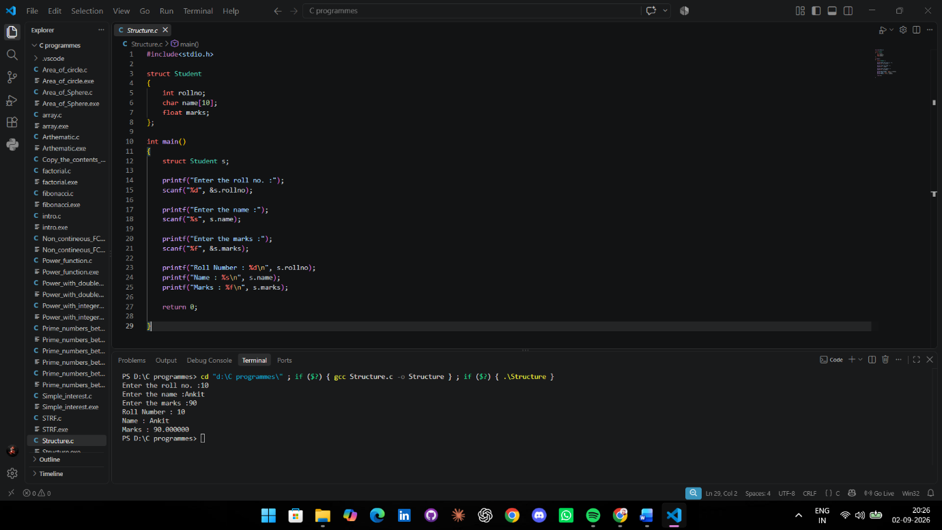

Factorial Programme in Python without AI

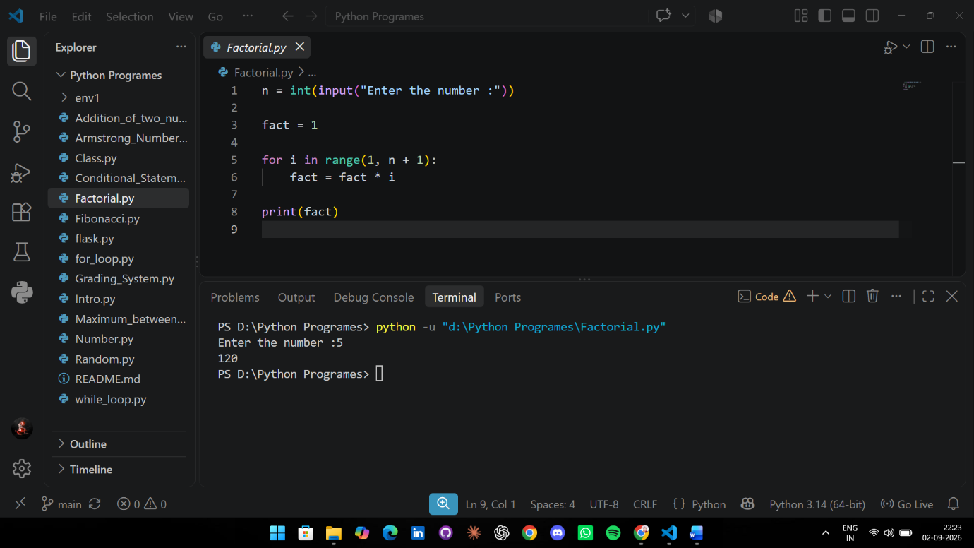
AI – Assisted Translation
- Fibonacci :

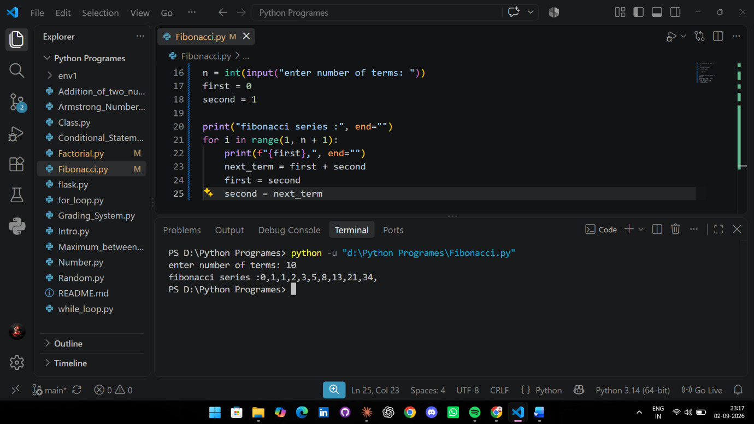

- Class :

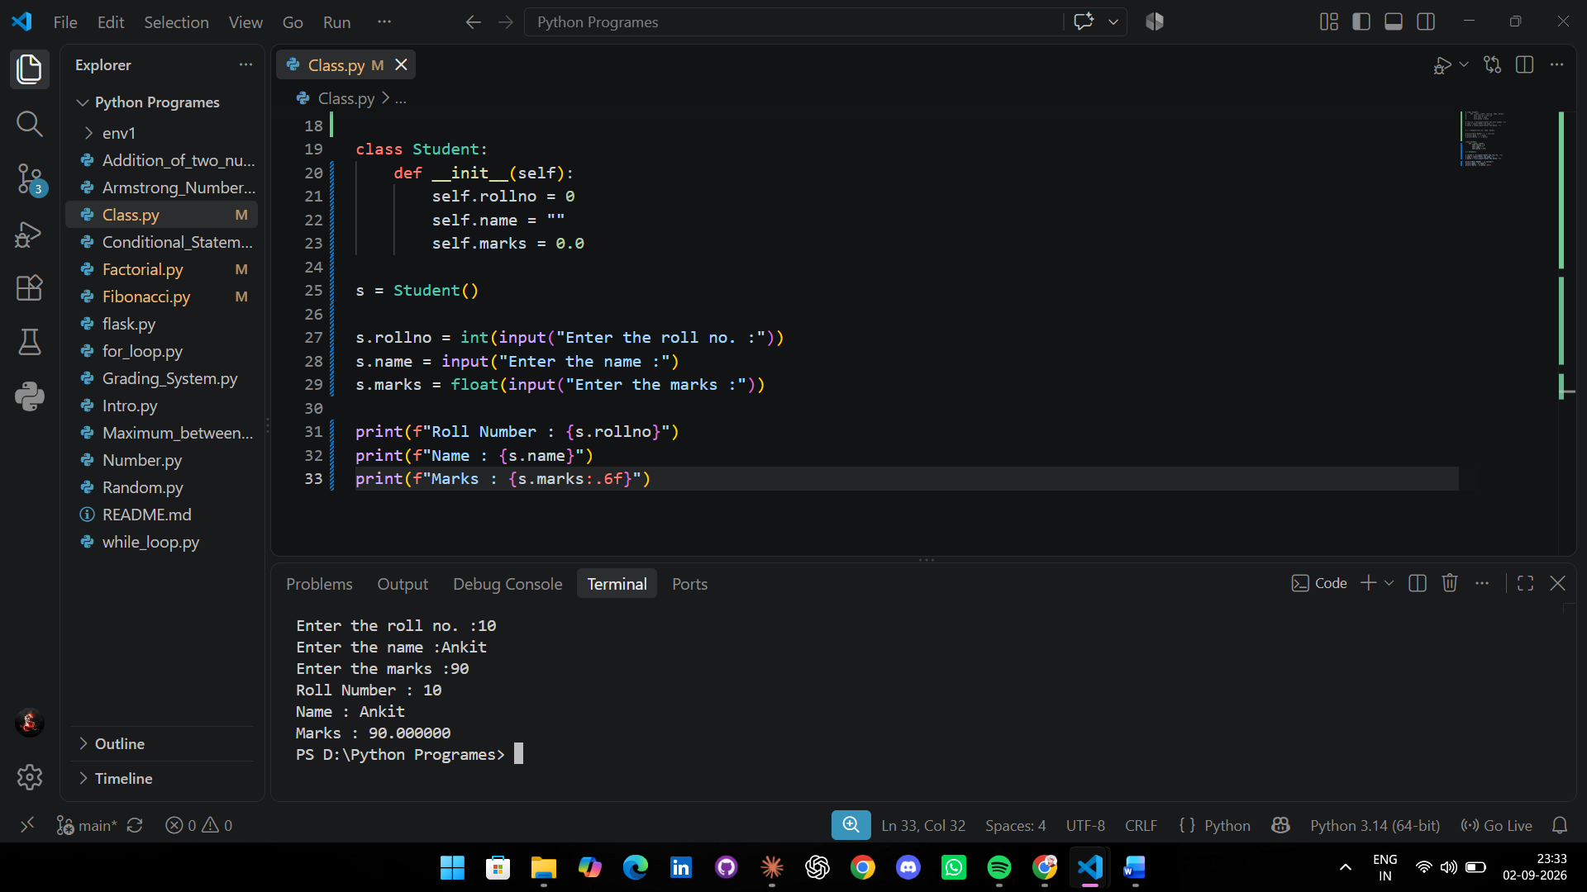
Mismatches and Fixes

- Fibonacci — Mismatches and Fixes :
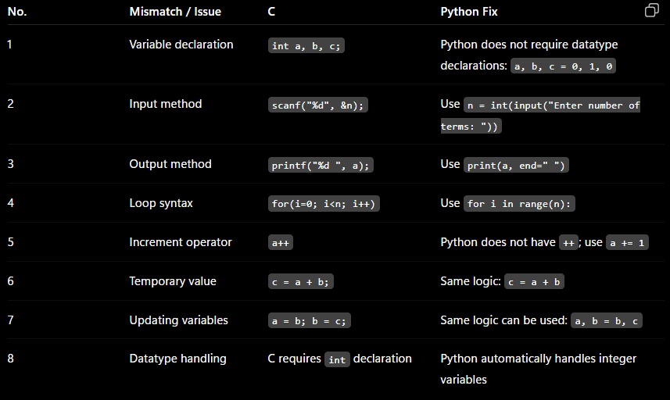

- Structure — Mismatches and Fixes :
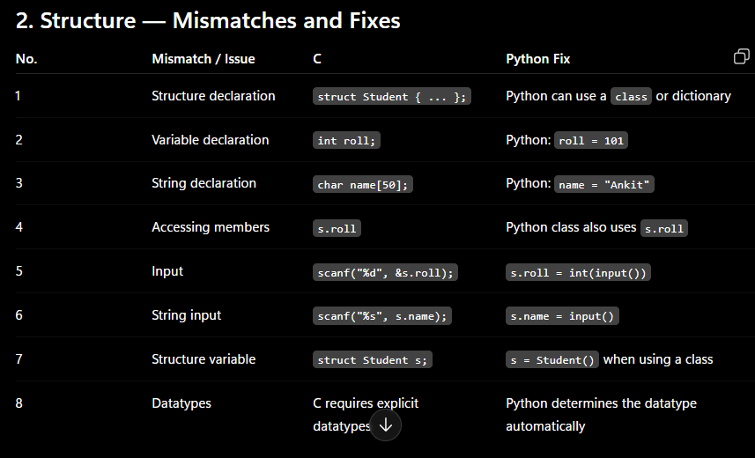
Review of the hand written Factorial program

* input() takes the number from the user.
* int() converts the input into an integer.
* fact = 1 initializes the factorial.
* range(1, n + 1) generates numbers from 1 to n.
* fact = fact * i multiplies each number into fact.
* print(fact) displays the final factorial.

Verdict of the hand written Factorial program

The handwritten Python program is correct. It successfully calculates the factorial of a given number using a for loop. There are no major syntax or logical errors in the program.

8-Row Cheat Sheet

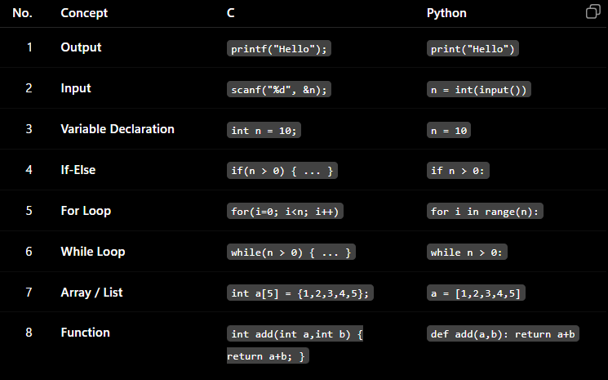

Personal Reflection

Personal Reflection
Through this assignment, I learned how to translate C programs into Python and understand the differences between the two languages. I learned that Python has simpler syntax and does not require explicit variable declarations like C. While translating the Fibonacci and Structure programs, I understood the differences in loops, input/output, arrays, and data structures.
I also learned that AI-generated code should not be accepted blindly. Sometimes the logic or syntax may need to be checked and corrected. By running the programs and comparing their outputs, I learned how to identify mismatches and fix them.
Reviewing the handwritten factorial program helped me understand how to check a program for syntax and logical errors. Overall, this assignment improved my programming skills and gave me a better understanding of how the same problem can be solved in both C and Python.

