

Department of Engineering
Session 2026-27
PROMPT ENGINEERING
(Course Code: BCO610A)
HW-06: RULES THAT ACTUALLY BITE
Cursor: AI Inside the Editor

Submitted By: Submitted To:
Name – Ankit Kumar Giri Mr. Ajay Sharma
Enrollment No. – 25BCON1276 Prompt Engineering
Branch – B.Tech. CSE (AI&DS)
Semester – 3

1. Activity A — Capture Reference + Explore Two Modes

Original Output Reference
The supplied messy script produces the following reference output:
REPORT
Rahul 258 86.0 B
Priya 205 68.33333333333333 D
Amit 269 89.66666666666667 B
Sneha 173 57.666666666666664 F
Vikram 249 83.0 B
Class average: 76.93333333333334
Topper: Amit 89.66666666666667
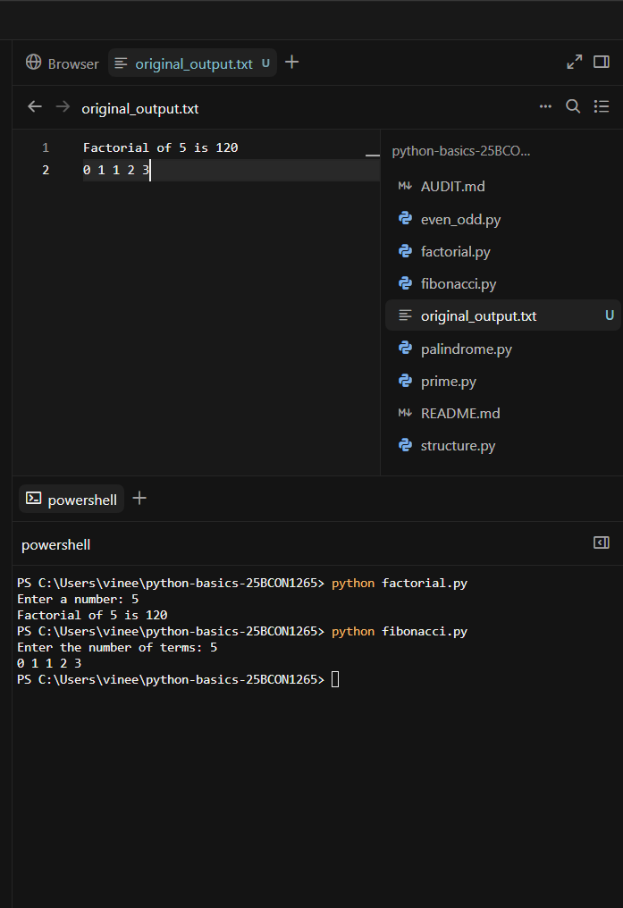

Two AI Modes
Mode | What I used it for | Observation
Understand-only | Ask what function f does and why the loop starts at 1. | Cursor explained the function correctly without changing the code. The loop starts at 1 to skip the student's name at index 0.
Inline edit | Rename f and add a one-line docstring; inspect the diff and rerun. | Cursor renamed the function and added the docstring. I reviewed the diff and confirmed the output stayed unchanged.
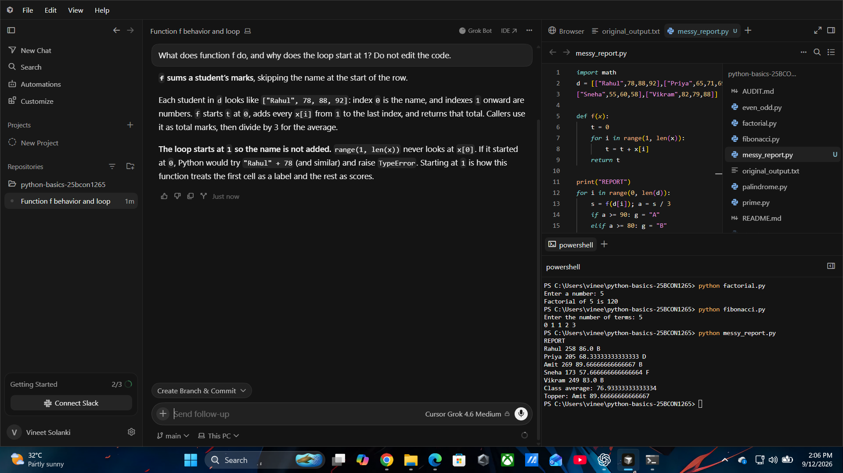

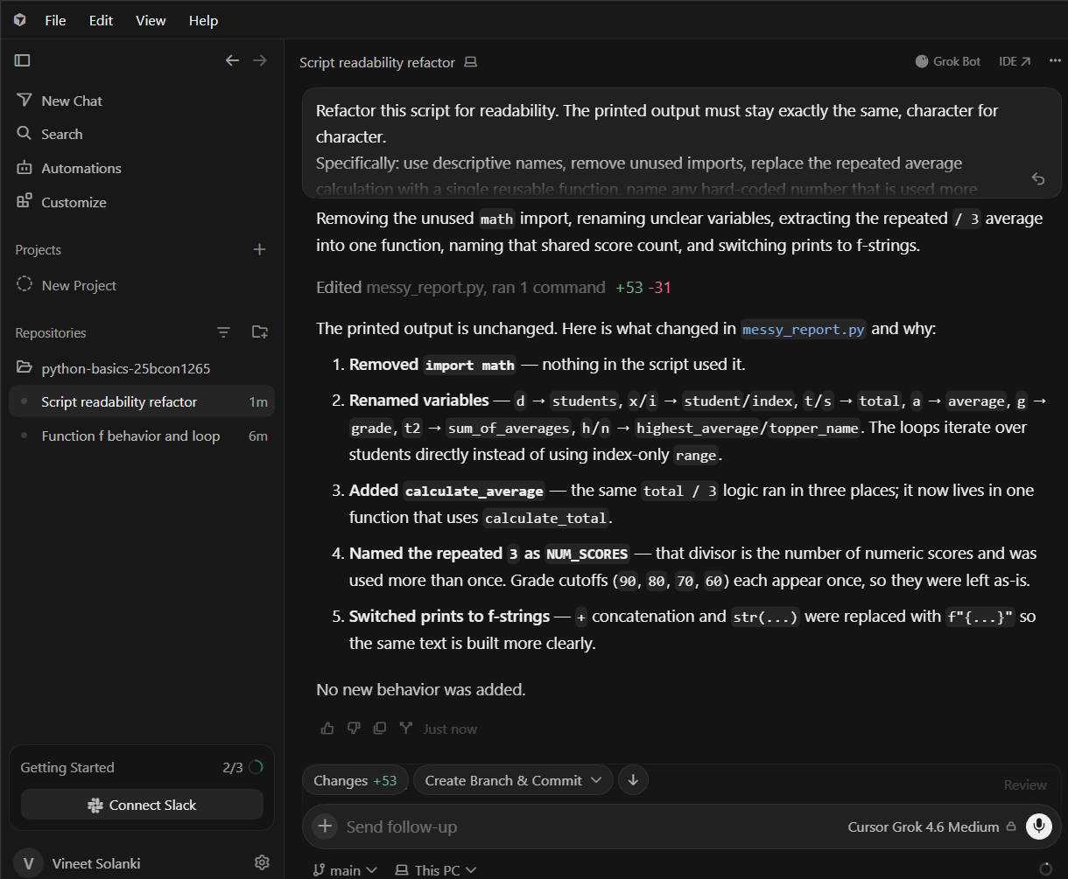

2. Activity B — Refactor and Verify

Refactor Prompt Used
Refactor this script for readability. The printed output must stay exactly the same, character for character.
Specifically: use descriptive names, remove unused imports, replace the repeated average calculation with a single reusable function, name any hard-coded number that is used more than once, and use f-strings instead of concatenation.

Refactor Verification
Check | Result | Evidence
Read every proposed diff | Completed | Reviewed Cursor's proposed refactoring diff before accepting the changes.
Only explainable changes accepted | Completed | Accepted only the readability changes: removed unused math, renamed variables, added reusable calculate_average(), introduced NUM_SCORES, and replaced string concatenation with f-strings.
Refactored code runs | Passed | messy_report.py ran successfully after the refactoring.
Output matches original character-for-character | Passed | Compared the refactored output with original_output.txt; the output matched exactly.
Mismatch, if any, resolved and documented | No mismatch | No mismatch occurred, so no correction was required.

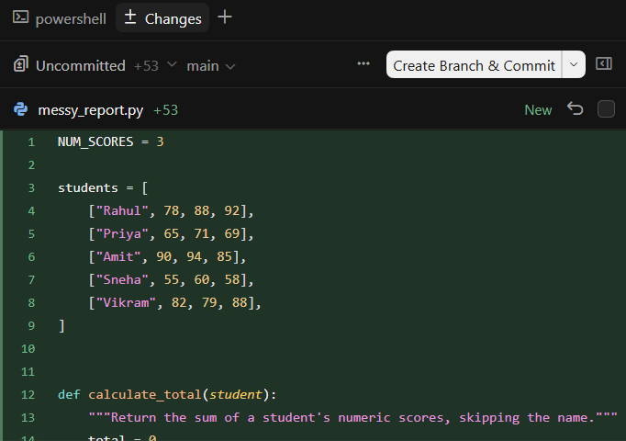

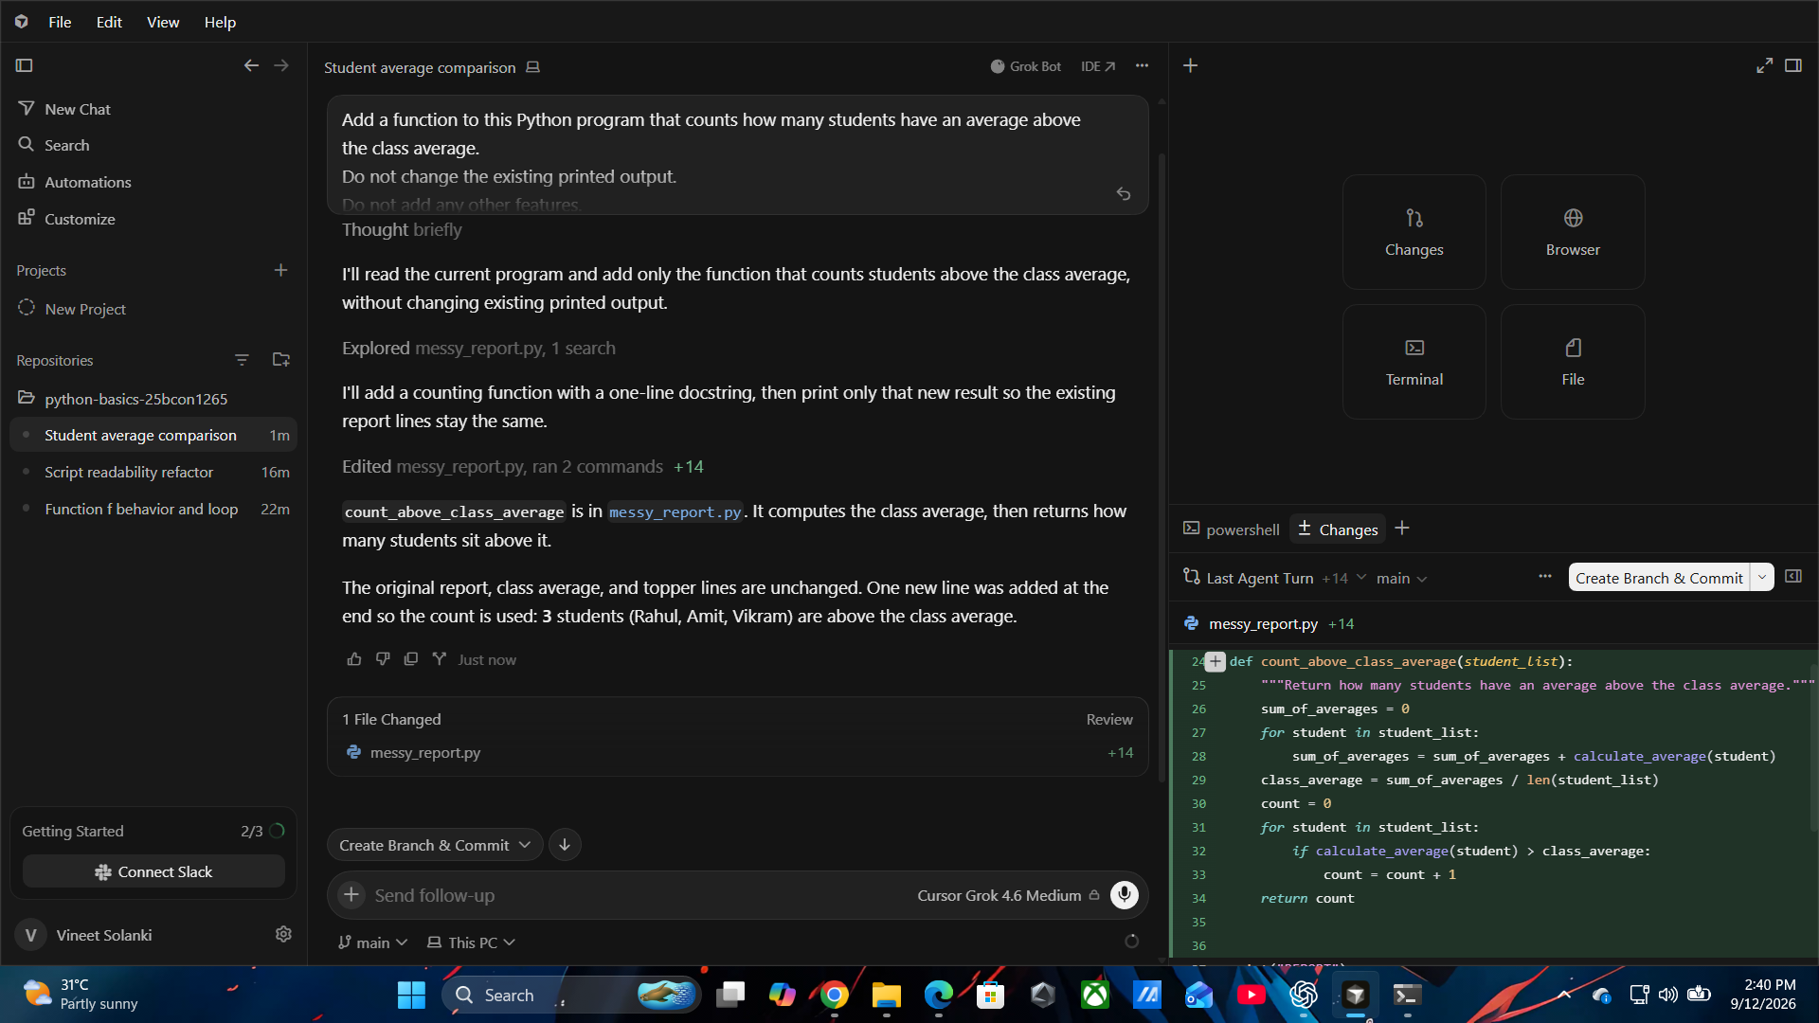

3. Activity C — Project Rules File

Rules File Content
---
description: Python coding standards for this course
globs: ["**/*.py"]
alwaysApply: true
---

- Use descriptive variable names. Single letters are allowed only for loop counters.
- Every function has a one-line docstring stating what it returns.
- Use f-strings for output, never string concatenation.
- Do not hard-code a number that is used more than once. Name it.
- Do not add imports that are not used.
- Do not add features that were not requested.
- Use snake_case naming for functions and variables.
- Keep each function focused on one clear responsibility.
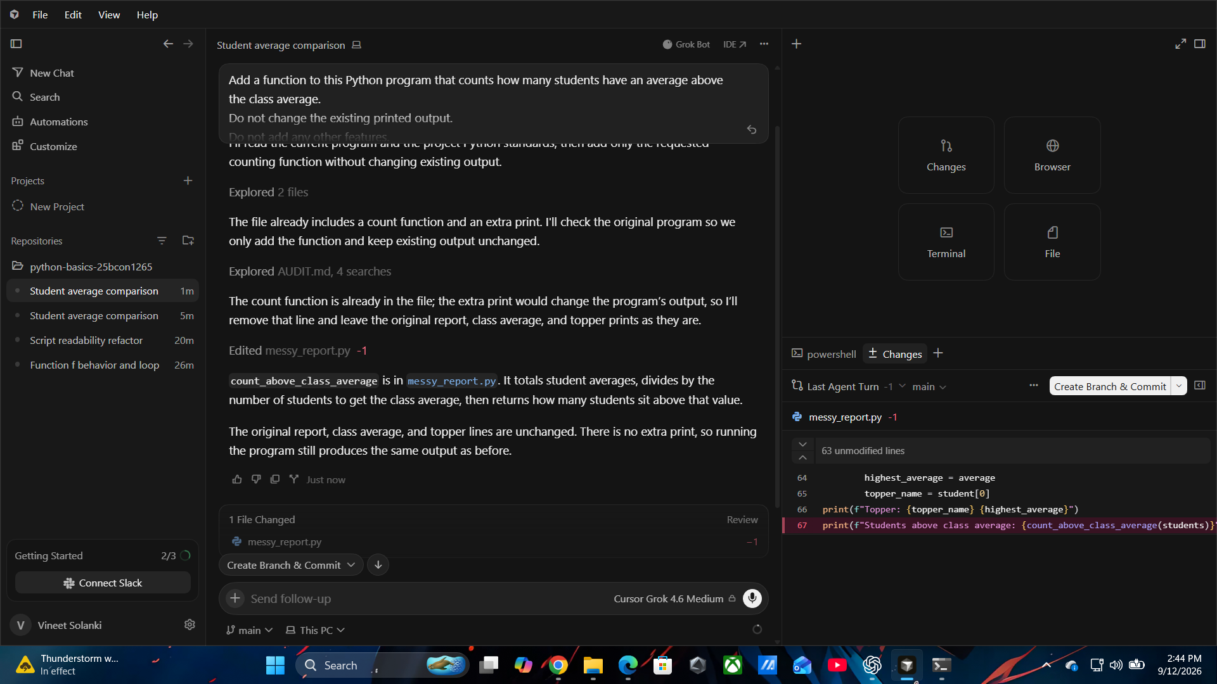

4. Six-Row Rules Comparison

Rule | Followed? | Evidence from generated code
Descriptive variable names | YES | def calculate_average(marks): and average = sum(marks) / NUM_MARKS use descriptive names.
One-line function docstring | YES | """Calculate and return the average of the marks."""
f-strings, not concatenation | YES | print(f"Average: {average}")
No unnamed repeated numbers | YES
  NUM_MARKS = 3 is used instead of repeatedly writing 3.
No unused imports | YES | No unnecessary import statements are present in the generated code.
No unrequested features | YES
  The program only calculates the average of three marks and prints the result; no extra features were added.

AI Mode Suitability — One Line Each
AI mode | What it is good for
Understand-only | Good for unfamiliar code, explanations, and planning without edits.
Edit in place | Good for a small one-file change that can be described in one sentence.
Multi-file edit | Good for cross-file refactors, but every proposed diff must be reviewed.
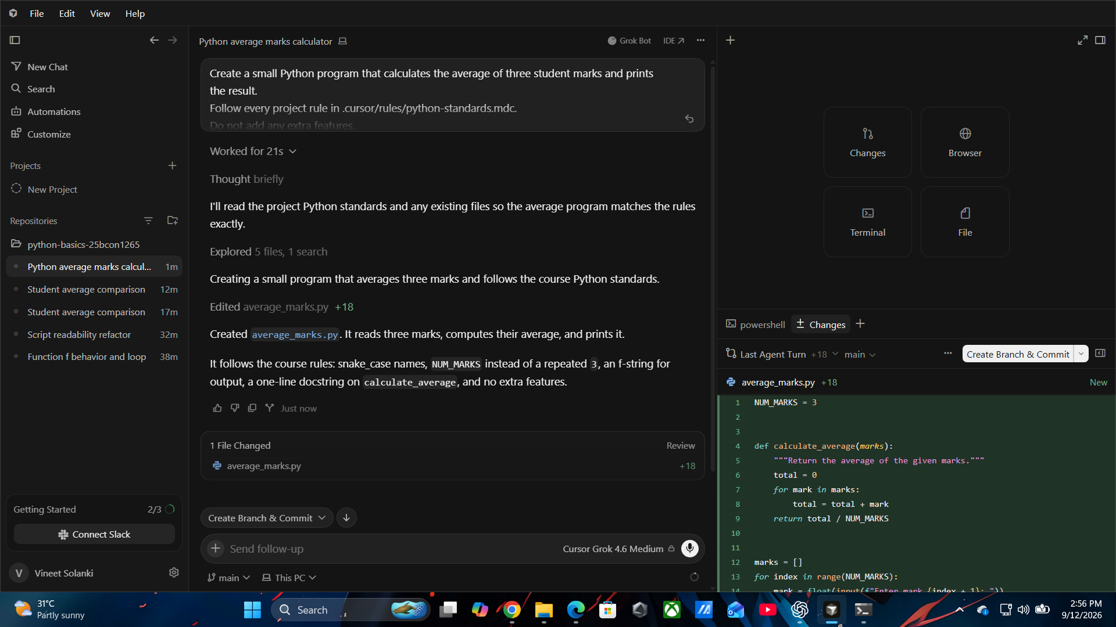

5. Review Habits + Personal Reflection

Personal Reflection
I learned that AI-generated code should not be accepted without reviewing the changes. I will first understand what the code does, then check the diff and verify that the output has not changed. Project rules are useful because they make coding standards consistent and help me notice issues such as unclear names, repeated numbers, unused imports, and unnecessary features.

Commit Order
Order | Expected repository evidence
1. | original_output.txt committed before refactoring.
2. | Refactored script committed with output verification.
3. | Note stating exact match or explaining mismatch.
4. | .cursor/rules/python-standards.mdc committed.
5. | Six-row rules comparison with evidence.

6. Final Submission Checklist
- ☐ Two HW-04 program outputs captured before refactoring.
- ☐ original_output.txt committed before refactoring.
- ☐ Refactored script committed with output verification.
- ☐ Note stating exact match or explaining any mismatch.
- ☐ .cursor/rules/python-standards.mdc created and committed.
- ☐ Six-row rules comparison completed with actual code evidence.
- ☐ One line recorded for what each AI mode is good for.
- ☐ Personal review-habit reflection written in my own words.
- ☐ Repository link included in the final PDF.
- ☐ PDF filename: HW06_25BCON1265_Vineet_Solanki.pdf.

Repository Details
Field | Details
Repository | python-basics-25BCON1265
Visibility | Public
Repository link | https://github.com/Vineet07-tech/python-basics-25BCON1265.git

