

Department of Engineering
Session 2026-27
PROMPT ENGINEERING
(Course Code: BCO610A)
HW-07: FOUR PROBLEMS, HONEST LOGS
AI as a Hint, Not an Answer

Submitted By: | Submitted To:
Name – Ankit Kumar Giri | Mr. Ajay Sharma
Enrollment No. – 25BCON1276 | Prompt Engineering
Branch – B.Tech. CSE (AI&DS)
Semester – 3

1. HW-07 — Objective and Requirements

HW-07 is based on the Session 7 theme “AI as a Hint, Not an Answer”. The purpose is to solve four new Easy interview problems independently first, then use AI only in a controlled way for hints and later review.

Requirement | Content to Submit
Four new Easy problems | Four student-written solutions.
Independent attempt | An initial attempt before AI assistance.
Hint logs | Timestamp, what I tried, hint received, and what I did next.
Complexity analysis | Time and space complexity based on the actual code.
AI review | AI review of each working solution without rewriting it.
Disagreement resolution | Verification of any AI claim that conflicts with my own analysis.
Hardest problem | My first wrong approach and why it failed.
Reflection | My own reflection about where I get stuck and what I learned.
Git | One commit per problem.

2. Rules I Will Follow

- Spend the first 15 minutes attempting the problem before relying on AI hints.
- Ask for hints, not solutions or code.
- Log every hint and what I tried before asking.
- Submit only code I typed and can explain.
- Use AI for review only after my solution works.

3. Four Problems Selected for HW-07

Problem 1 — Contains Duplicate
Problem: Given an integer array, return true if any value appears at least twice; otherwise return false.
Test cases:
- [1,2,3,1] → true
- [1,2,3,4] → false
- [1,1] → true

Problem 2 — Valid Anagram

Problem: Given two strings, return true if the second string is an anagram of the first; otherwise return false.
Test cases:
- "anagram", "nagaram" → true
- "rat", "car" → false
- "a", "a" → true

Problem 3 — Valid Palindrome

Problem: Given a string, determine whether it is a palindrome after converting letters to lowercase and ignoring non-alphanumeric characters.
Test cases:
- "A man, a plan, a canal: Panama" → true
- "race a car" → false
- " " → true

Problem 4 — Maximum Subarray

Problem: Given an integer array, find the contiguous subarray with the largest sum and return that sum.
Test cases:
- [-2,1,-3,4,-1,2,1,-5,4] → 6
- [1] → 1
- [5,4,-1,7,8] → 23

Problem 1 — Contains Duplicate
Given an integer array, return true if any value appears at least twice; otherwise return false.

3.1 Define Input and Output

Item | Write before coding
Input | An integer array.
Output | True if a value appears more than once, otherwise False.
Edge case | [1, 1] contains duplicate values.

3.2 Hint Log

Timestamp | Level | What I tried before asking | What the hint said | What I did next
-- |  | I solved the problem independently | No hint used | Tested the solution on all three test cases.
  No AI hint

3.3 Final Student-Written Solution

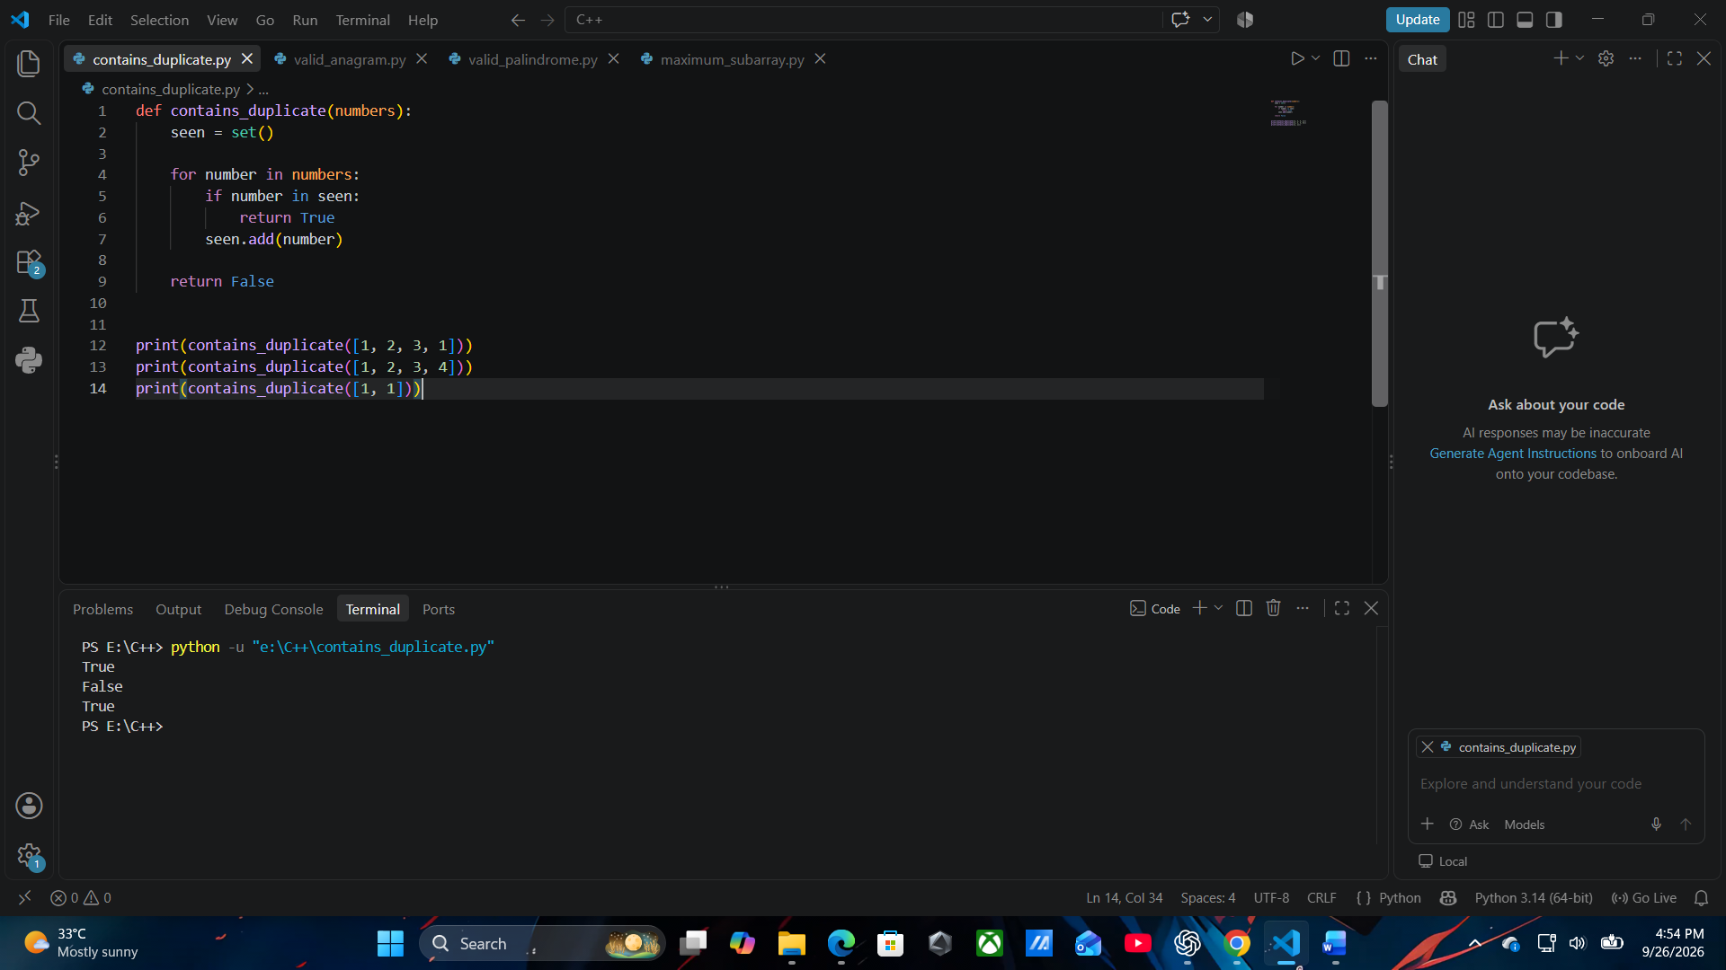

3.4 Test Results

Test | Expected | Actual | Result
A | true | True | Pass
B | false | False | Pass
C | true | True | Pass

3.5 My Complexity Claim Before AI Review

Type | My claim | Why, from my code
Time | [O(n)] | The loop checks each element once, so time is O(n).
Space | [O(n)] | The set may store up to n elements, so extra space is O(n).

3.6 AI Review
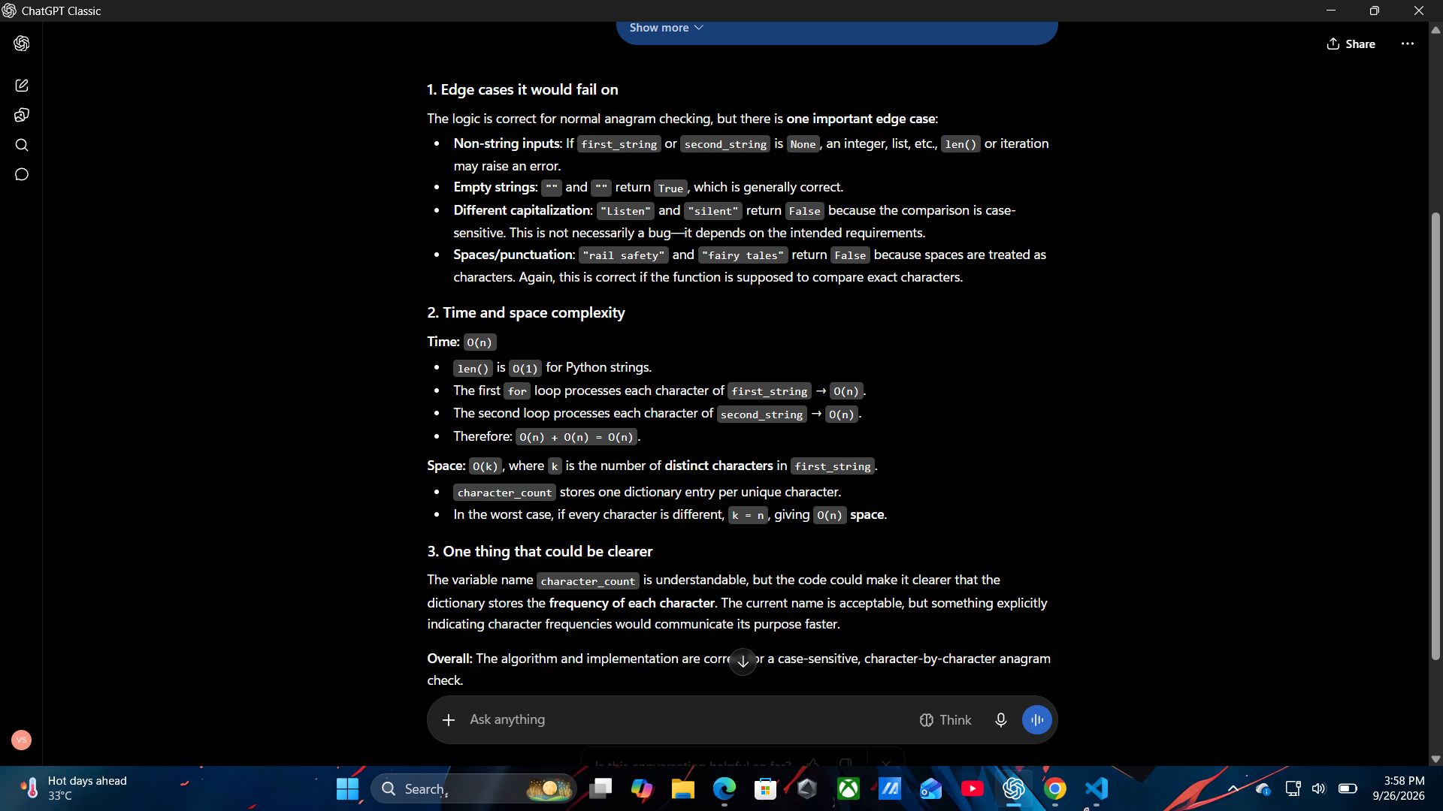

Problem 2 — Valid Anagram
Given two strings, return true if the second string is an anagram of the first; otherwise return false.

3.1 Define Input and Output
Item | Write before coding
Input | Two strings.
Output | True if both strings are anagrams; otherwise False.
Edge case | Two identical single-character strings, such as "a" and "a"

3.2 Hint Log
Timestamp | Level | What I tried before asking | What the hint said | What I did next
-- | No AI hint | I solved the problem independently. |  | Tested the solution on all three test cases.
  No hint used.

3.3 Final Student-Written Solution
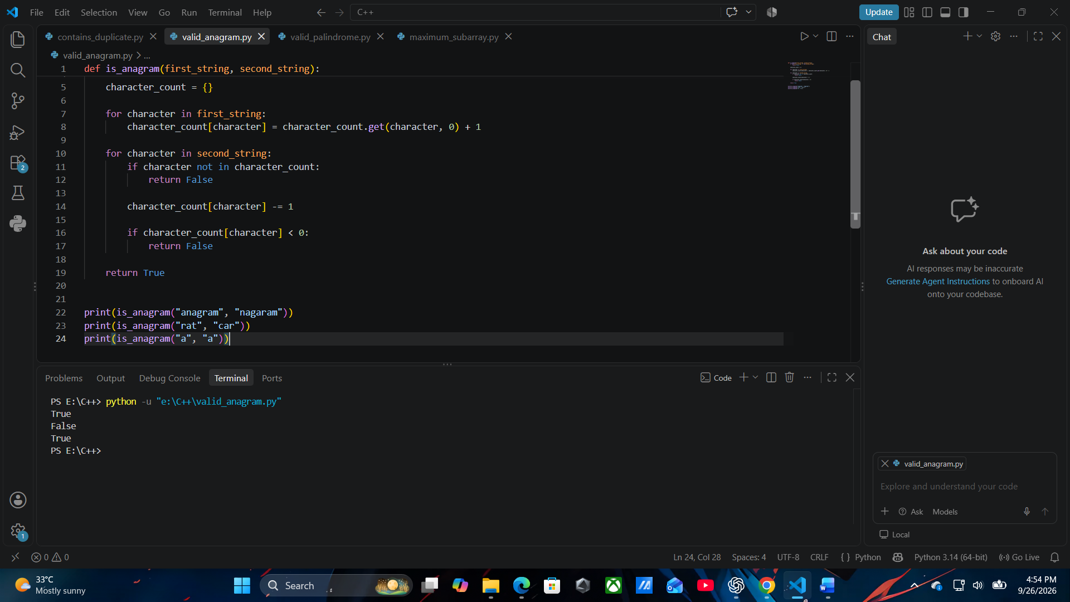

3.4 Test Results
Test | Expected | Actual | Result
A | true | True | Pass
B | false | False | Pass
C | true | True | Pass

3.5 My Complexity Claim Before AI Review
Type | My claim | Why, from my code
Time | [O(n)] | The strings are scanned once, so time is O(n).
Space | [O(n)] | The dictionary can store character counts, so extra space is O(n).

3.6 AI Review
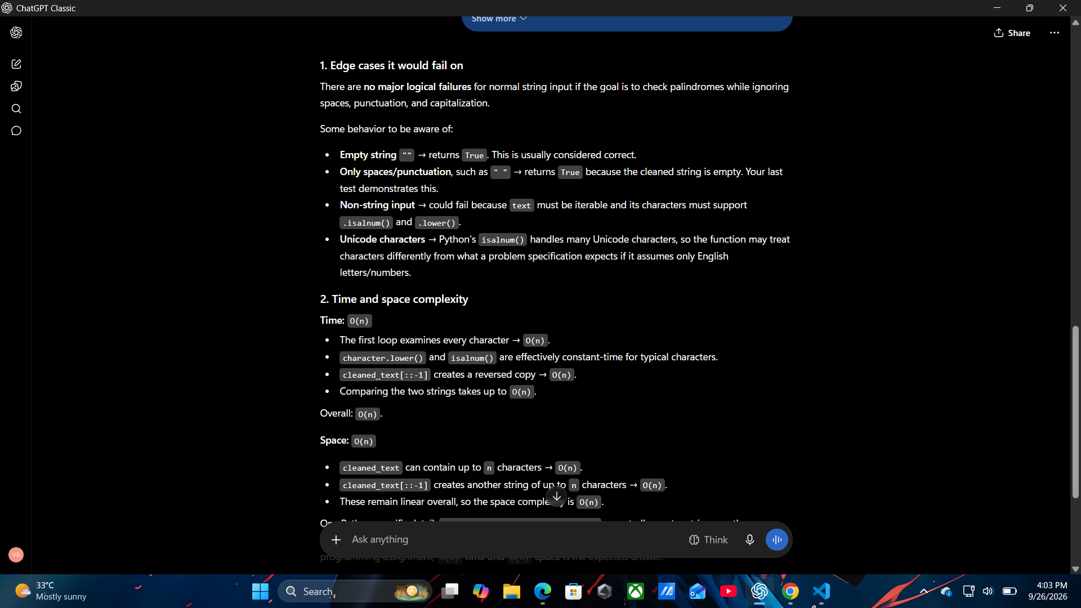

Problem 3 — Valid Palindrome
Given a string, determine whether it is a palindrome after converting letters to lowercase and ignoring non-alphanumeric characters.

3.1 Define Input and Output
Item | Write before coding
Input | A string.
Output | True if the string is a palindrome after ignoring non-alphanumeric characters and case; otherwise False.
Edge case | An empty/space-only string.

3.2 Hint Log
Timestamp | Level | What I tried before asking | What the hint said | What I did next
-- | No AI hint | I solved the problem independently. | No hint used. | Tested the solution on all three test cases.

3.3 Final Student-Written Solution

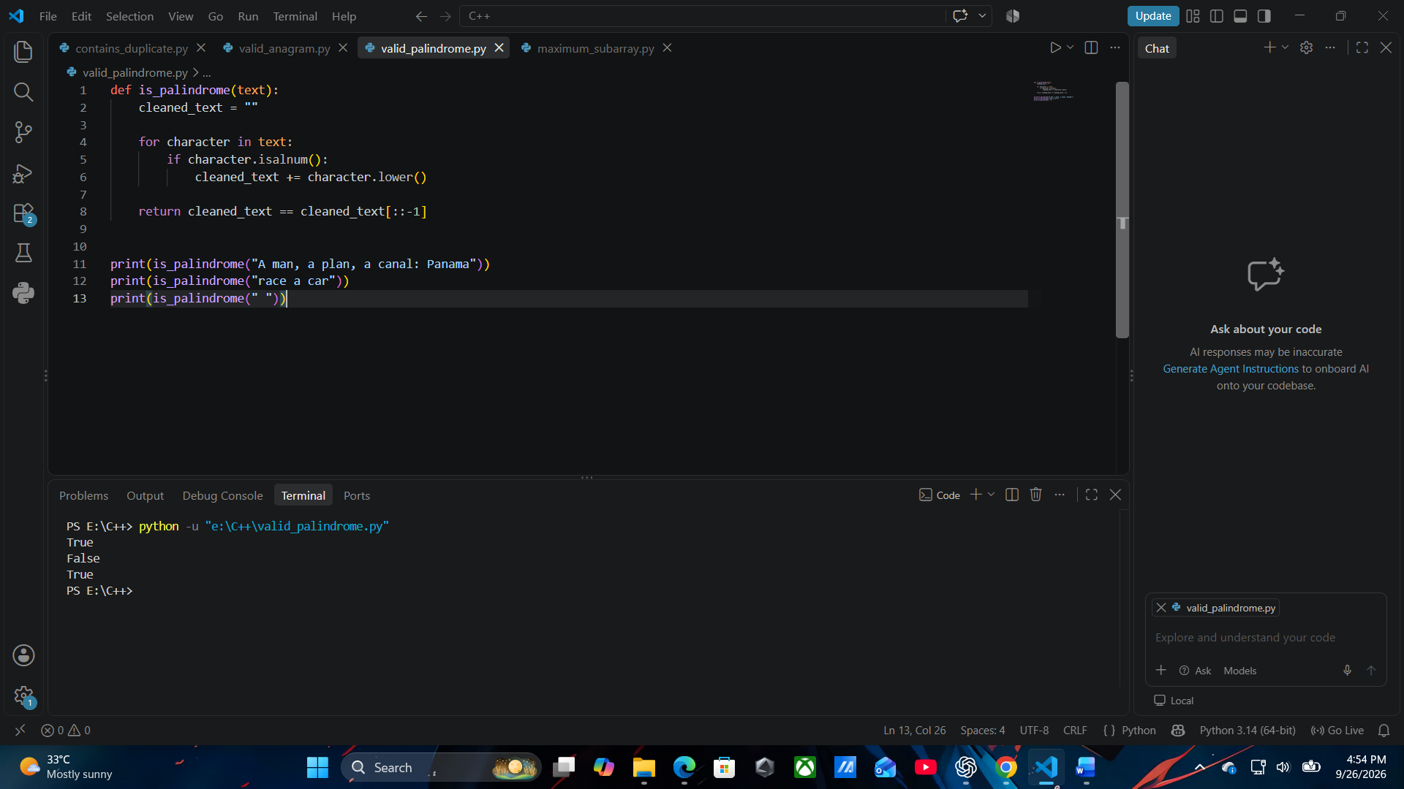

3.4 Test Results
Test | Expected | Actual | Result
A | true | True | Pass
B | false | False | Pass
C | true | True | Pass

3.5 My Complexity Claim Before AI Review
Type | My claim | Why, from my code
Time | [O(n)] | The string is scanned once, so the time complexity is O(n)
Space | [O(n)] | A cleaned string is created, requiring O(n) extra space.

3.6 AI Review

Problem 4 — Maximum Subarray
Given an integer array, find the contiguous subarray with the largest sum and return that sum.

3.1 Define Input and Output
Item | Write before coding
Input | An integer array.
Output | The maximum sum of any contiguous subarray.
Edge case | An array containing only one element, such as [1].

3.2 Hint Log
Timestamp | Level | What I tried before asking | What the hint said | What I did next
-- | No AI hint | I solved the problem independently. | No hint used. | Tested the solution on all three test cases.

3.3 Final Student-Written Solution

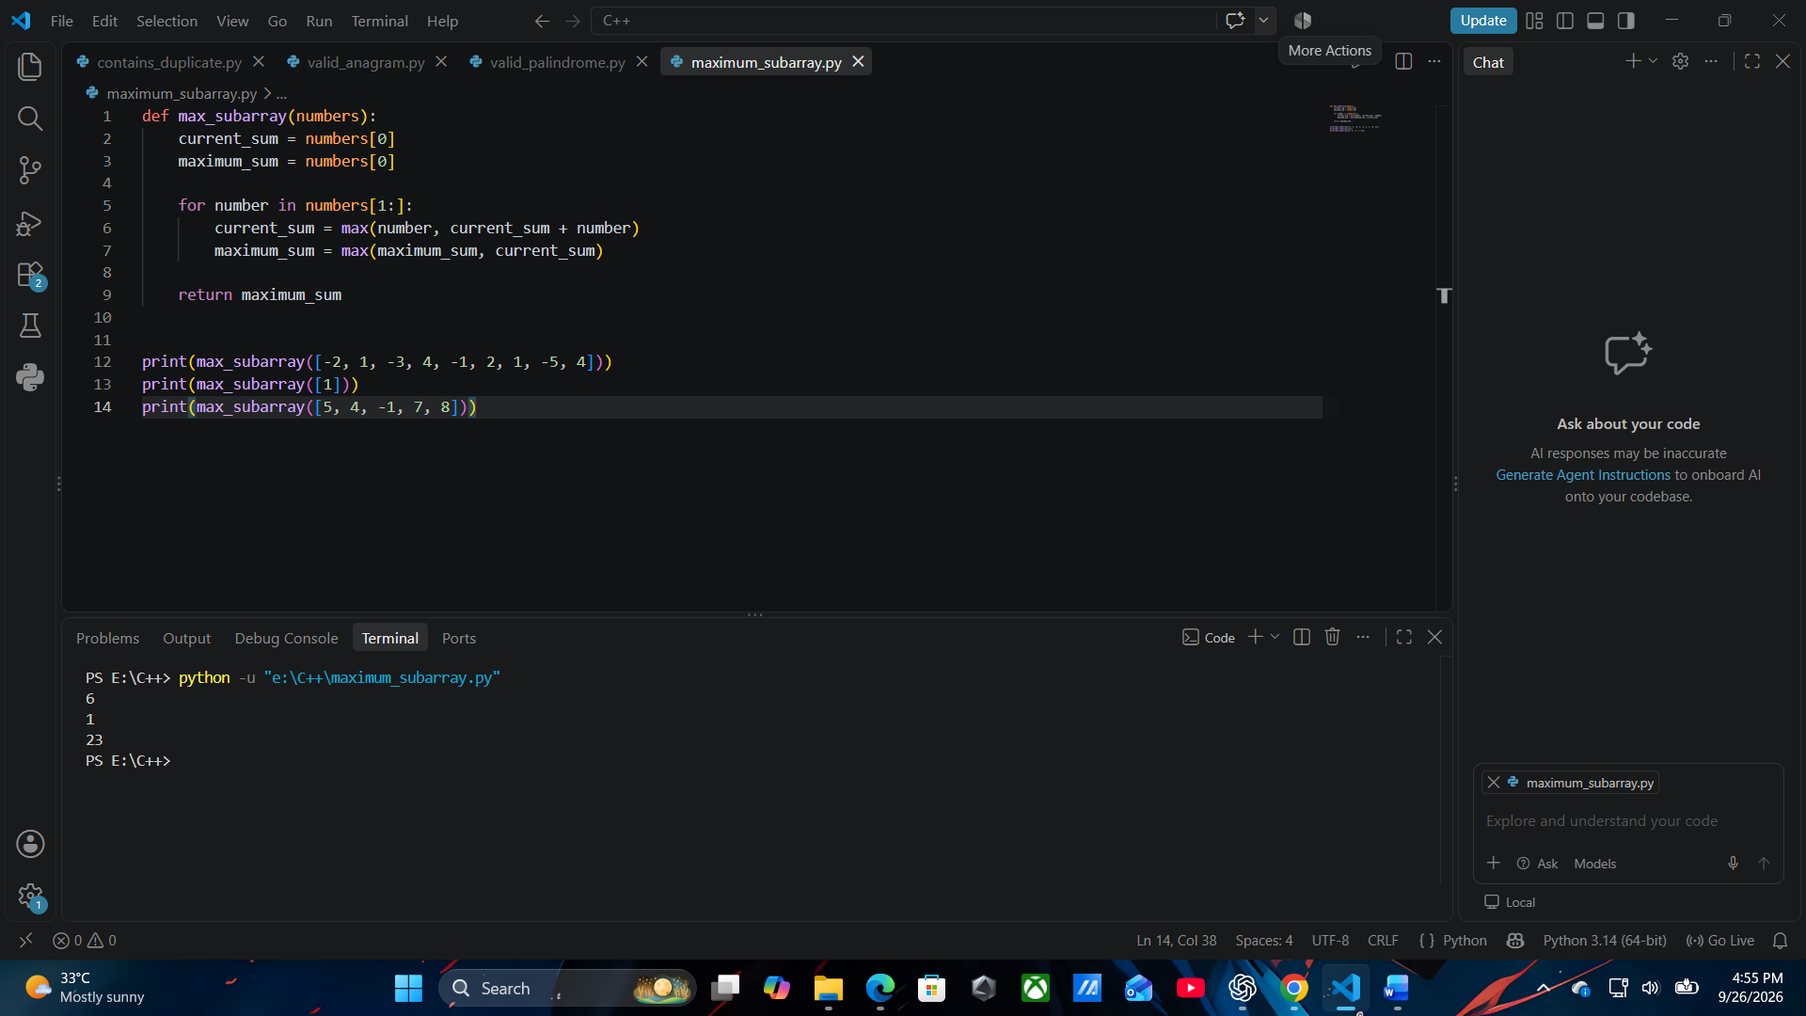

3.4 Test Results
Test | Expected | Actual | Result
A | 6 | 6 | Pass
B | 1 | 1 | Pass
C | 23 | 23 | Pass

3.5 My Complexity Claim Before AI Review
Type | My claim | Why, from my code
Time | [O(n)] | The array is scanned once, so the time complexity is O(n)
Space | [O(1)] | Only a few variables are used, so extra space is O(1).

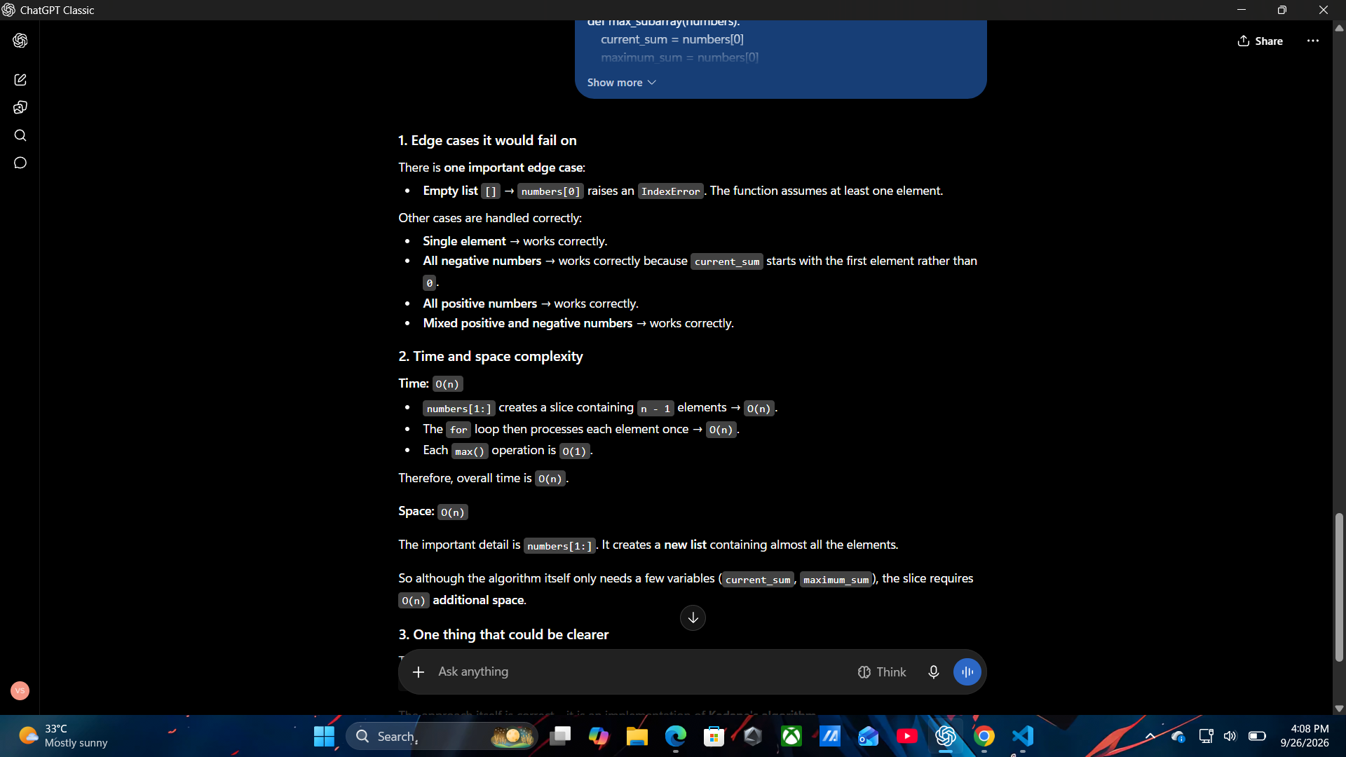
3.6 AI Review

8. Hardest Problem — First Wrong Approach
Choose the problem that genuinely caused the most difficulty.
Point | My actual experience
Problem name | Maximum Subarray
First wrong approach | I first tried checking different contiguous subarrays and their sums.
Why I thought it would work | I thought comparing all possible sums would give the maximum.
What failed | It would require checking many subarrays and could be slow.
What I changed | I decided to keep the best sum ending at the current position.
Final approach | I scan the array once using the current sum and maximum sum.

9. Complexity Disagreement Resolution

Problem | AI claim | My analysis | Evidence | Final conclusion
Problem 1 | No disagreement — O(n), O(n) | O(n), O(n) | One loop + set | Matched
Problem 2 | No disagreement — O(n), O(n) | O(n), O(n) | Two scans + dictionary | Matched
Problem 3 | No disagreement — O(n), O(n) | O(n), O(n) |  | Matched
  One scan + cleaned string
Problem 4 | No disagreement — O(n), O(1) | O(n), O(1) |  | Matched
  One loop + two variables

10. Complexity Summary
Problem | Time | Space | Justification
Contains Duplicate | O(n) | O(n) | One loop + set
Valid Anagram | O(n) | O(n) | Two scans + dictionary
Valid Palindrome | O(n) | O(n) | One scan + cleaned string
Maximum Subarray | O(n) | O(1) | One loop + two variables

11. Personal Reflection
I learned that I should try solving a problem myself before using AI. AI hints can help me when I get stuck, but I should still understand and verify the solution. I also learned how to check time and space complexity from my own code. In future, I will test my code with different cases and review AI suggestions before accepting them.

12. Git Commit Order

Order | Commit / Evidence
1 | Problem 1 solution committed.
2 | Problem 2 solution committed.
3 | Problem 3 solution committed.
4 | Problem 4 solution committed.

