

Department of Engineering
Session 2026-27
PROMPT ENGINEERING
(Course Code: BCO610A)
HW-08: RED BEFORE GREEN
Debugging & Testing with AI

Submitted By | Submitted To
Name – Ankit Kumar Giri | Mr. Ajay Sharma
Enrollment No. – 25BCON1276 | Prompt Engineering
Branch – B.Tech. CSE (AI&DS)
Semester – 3

1. HW-08 Objective
HW-08 focuses on specification-driven debugging: prove a bug fails, fix it, and prove the same behaviour works afterward. It also compares tests written from the specification with tests generated from broken code.
Requirement | What to submit
Specification | 6+ behaviour rows for the Python program.
Bug seeding | Three bug classes: arithmetic, boundary, unreachable branch.
RED stage | Specification tests fail against broken code.
GREEN stage | The same tests pass after the implementation fix.
AI test experiment | Generate tests from broken code and compare both suites.
README | Testing section updated and audited.
Git | RED commit before GREEN commit; work in session folder.

2. Program Used
Student Marks Utility with three functions: calculate_average(), is_passing(), and get_grade().
Repository files:
- session/student_utils.py
- session/test_student_utils.py

3. Specification — Behaviour Contract
Function | Must return | Purpose
calculate_average([80,90,100]) | 90.0 | Ordinary arithmetic
calculate_average([40]) | 40.0 | Single element; no crash
is_passing(41) | True | Above pass mark
is_passing(40) | True | Exactly at pass mark
is_passing(39) | False | Below pass mark
get_grade(95) | Distinction | Top band
get_grade(60) | First | First band
get_grade(45) | Second | Second band
get_grade(30) | Fail | Below all bands

4. Buggy Copy — Three Bug Classes

PASS_MARK = 40
def calculate_average(marks):
total = 0
for mark in marks:
total = total + mark
return total / (len(marks) - 1)
def is_passing(mark):
if mark > PASS_MARK:
return True
return False
def get_grade(average):
if average >= 60:
return "First"
elif average >= 45:
return "Second"
elif average >= 90:
return "Distinction"
return "Fail"
Bug class | Bug | Effect
Arithmetic | Divide by len(marks)-1 | Wrong average; one mark can crash.
Boundary | Use > instead of >= | 40 incorrectly fails.
Unreachable branch | >=90 check after >=60 | Distinction cannot be reached.

5. Activity A — Find and Reproduce the Bugs
Run each function and reproduce every reported bug before fixing anything.
Bug | Input | Expected | Buggy result
Arithmetic | calculate_average([80,90,100]) | 90.0 | 135.0
Arithmetic | calculate_average([40]) | 40.0 | ZeroDivisionError
Boundary | is_passing(40) | True | False
Unreachable branch | get_grade(95) | Distinction | First

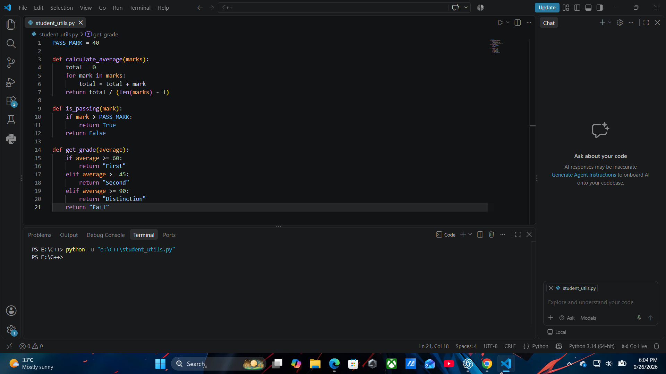

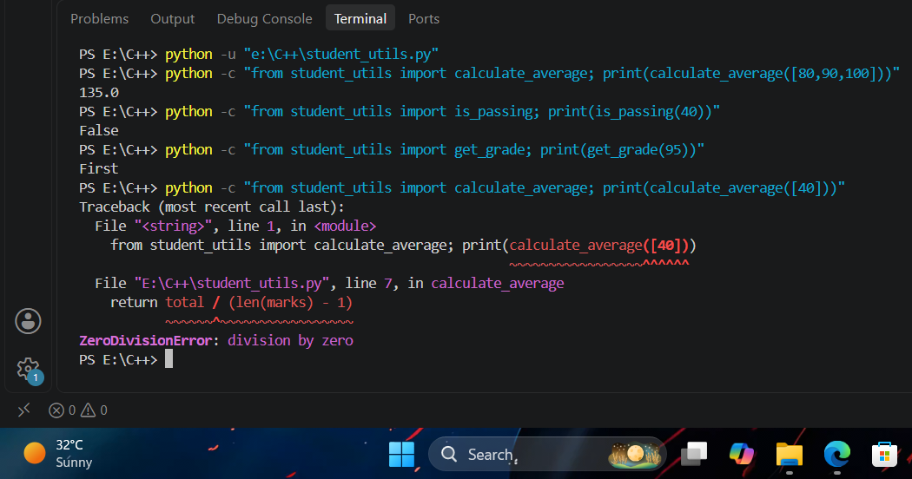

6. Activity B — Specification-Based Tests

import unittest
from student_utils import calculate_average, is_passing, get_grade
class TestStudentUtils(unittest.TestCase):
def test_average_of_three_marks(self):
self.assertEqual(calculate_average([80, 90, 100]), 90.0)
def test_average_of_one_mark(self):
self.assertEqual(calculate_average([40]), 40.0)
def test_passing_above_mark(self):
self.assertEqual(is_passing(41), True)
def test_passing_at_mark(self):
self.assertEqual(is_passing(40), True)
def test_passing_below_mark(self):
self.assertEqual(is_passing(39), False)
def test_distinction_grade(self):
self.assertEqual(get_grade(95), "Distinction")
def test_first_grade(self):
self.assertEqual(get_grade(60), "First")
def test_second_grade(self):
self.assertEqual(get_grade(45), "Second")
def test_fail_grade(self):
self.assertEqual(get_grade(30), "Fail")
if __name__ == "__main__":
unittest.main()
RED evidence | Actual result
Tests | 9
Failed tests | 3 failures + 1 error
Failing test names | test_average_of_three_marks  test_average_of_one_mark  test_passing_at_mark  test_distinction_grade
Bug mapping | test_average_of_three_marks → Arithmetic bug  test_average_of_one_mark → Arithmetic bug  test_passing_at_mark → Boundary bug  test_distinction_grade → Unreachable branch bug
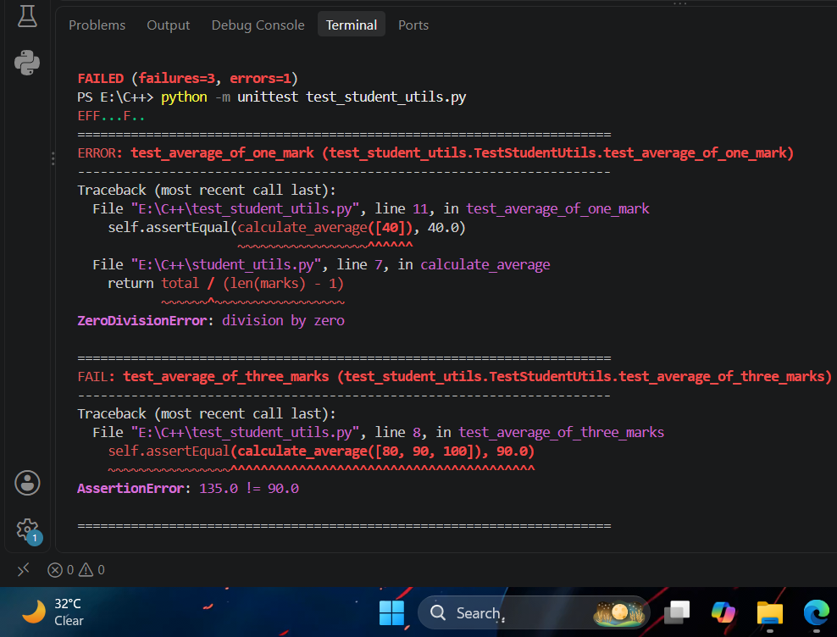

7. Bug-to-Test Mapping
Bug | Test exposing it | Evidence
Arithmetic | average_of_three_marks / average_of_one_mark | Wrong result / division by zero
Boundary | passing_at_mark | 40 returns False
Unreachable branch | distinction_grade | 95 returns First

8. RED Commit
git add session8/test_student_utils.py
git commit -m "test: add red student utility tests"
git push

9. Activity C — Fix and Go GREEN

PASS_MARK = 40
def calculate_average(marks):
total = 0
for mark in marks:
total = total + mark
return total / len(marks)
def is_passing(mark):
if mark >= PASS_MARK:
return True
return False
def get_grade(average):
if average >= 90:
return "Distinction"
elif average >= 60:
return "First"
elif average >= 45:
return "Second"
return "Fail"
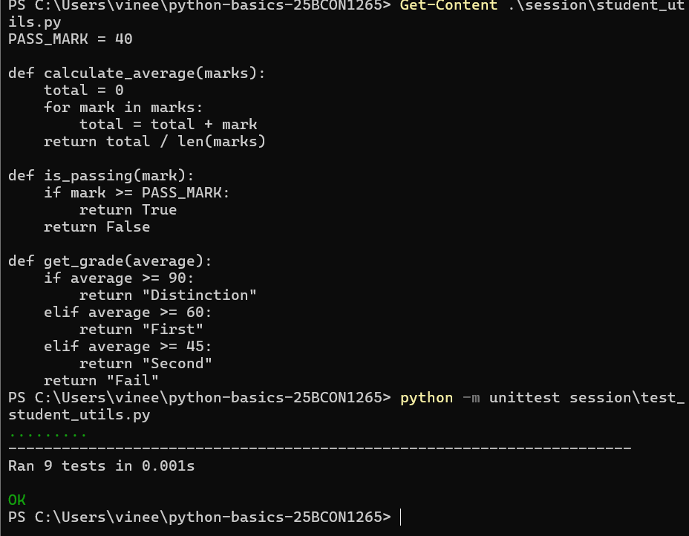
GREEN evidence | Actual result
Tests run | 9
Passed | 9
Failed | 0
Test file changed? | No

10. AI-Generated Tests from Broken Code
Use a copy of the BROKEN implementation for this experiment. Ask AI to generate tests from the implementation, without asking it to fix the code.
Prompt:
Generate unit tests for this Python module based only on its current implementation and behaviour. Do not correct the implementation. Provide the tests and briefly state what each test expects.
Aspect | Specification suite | Broken-code suite
Source | Required behaviour | Current implementation
Independence | Independent of code | Depends on code
Main purpose | Detect wrong behaviour | May mirror current behaviour
Risk | Can expose bugs | May certify bugs

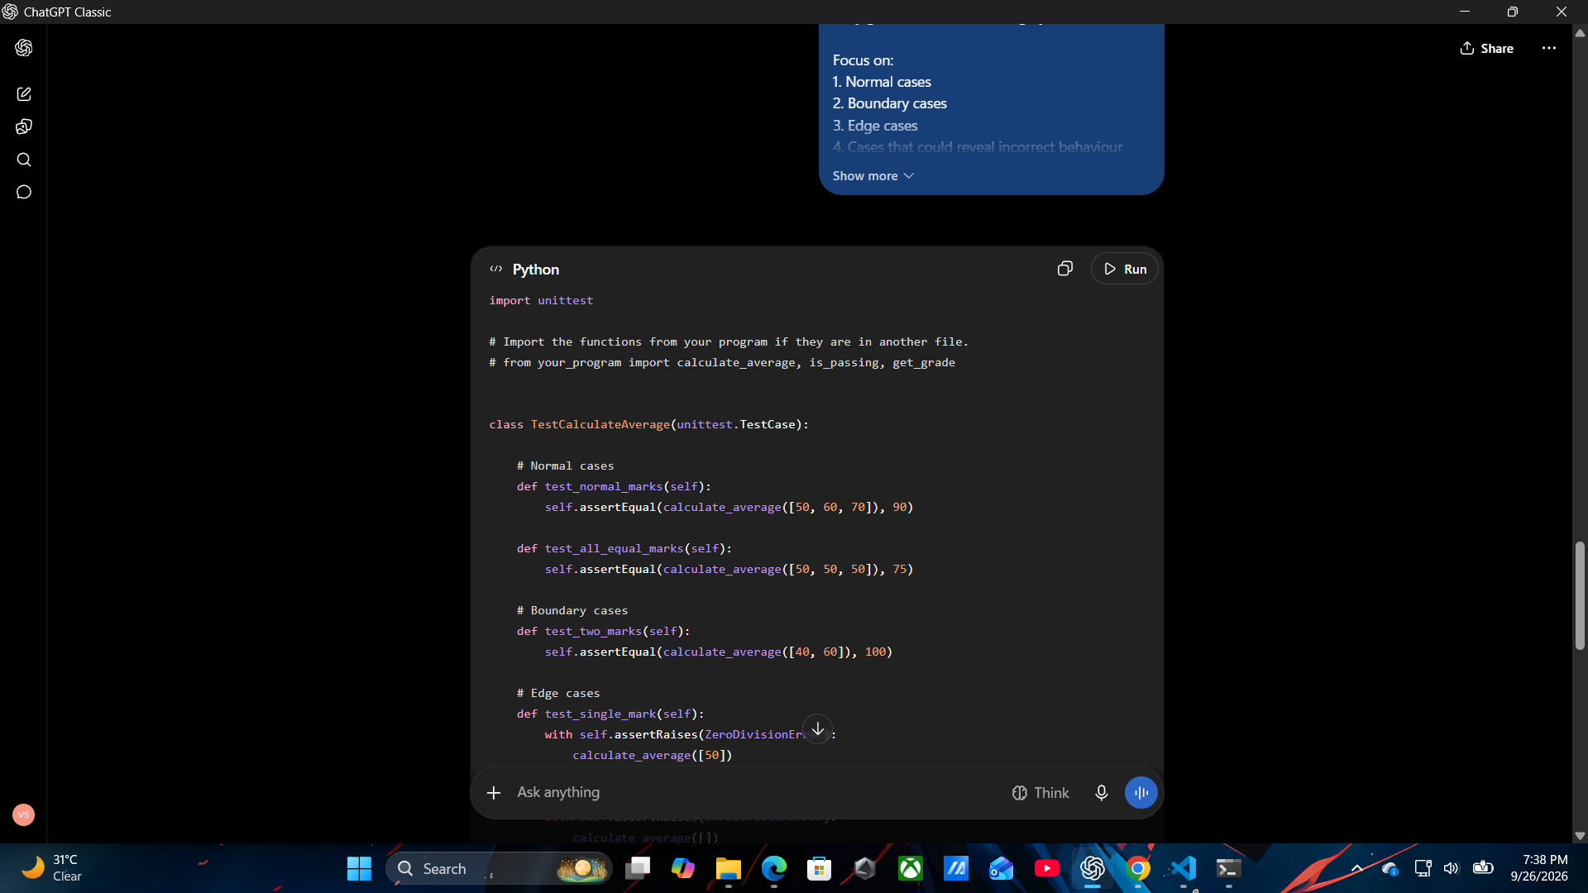

11. AI Test Experiment — Actual Result
Question | Actual result
Caught arithmetic bug? | NO
Caught boundary bug? | NO
Caught unreachable branch bug? | YES
Pass/fail count on broken code | Not executed
Main difference | AI-generated tests included more cases, but some expected results matched the buggy implementation instead of the specification.

12. Test Suite Comparison
Point | Specification-based | Implementation-based
Basis | Required behaviour | Current code
Independent? | Yes | No
Bug detection | Designed to expose wrong behaviour | May reproduce bugs
Role | Primary RED/GREEN evidence | Comparison experiment

13. README Testing Section
Add this section to README.md, then audit every claim:
### Testing
- Test file: `session8/test_student_utils.py`
- Run command: `python -m unittest session8/test_student_utils.py`
- Specification tests: 9
- Student-designed test: 1
- Tests are written from required behaviour.
- RED evidence is committed before the GREEN fix.

14. README Audit
Claim | Verified?
Test file path | YES
Run command works | YES
Test count correct | YES
RED precedes GREEN | YES
No unperformed claim | YES
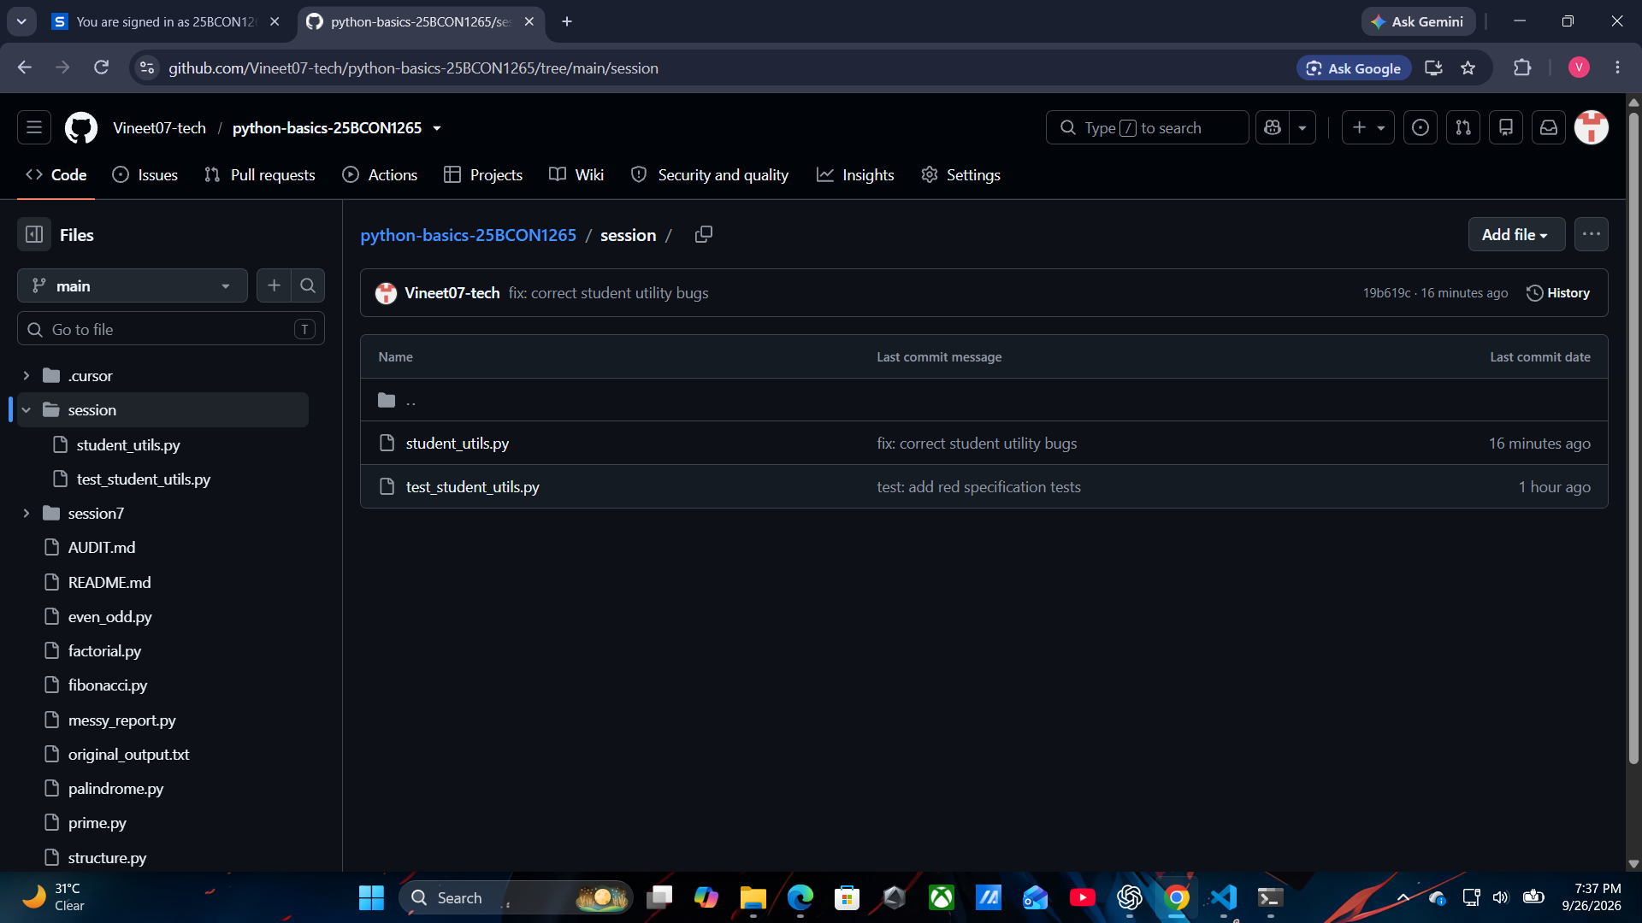

15. Git Commit Order
Order | Evidence
1 | RED test file committed before the fix.
2 | Failing test output captured.
3 | Fixed module committed in a later GREEN commit.
4 | README Testing section updated and audited.

16. Suggested Commit Messages
Stage | Commit
RED | test: add red student utility tests
GREEN | fix: correct student utility bugs
README | docs: update testing documentation

17. Personal Reflection
I learned that fixing a bug is not enough; I need to prove the failure before the fix and the pass afterward. Specification-based tests helped me check required behaviour independently of the implementation. I also learned that AI-generated tests can be misleading when they are based on buggy code, so I should verify tests against the specification.

18. Academic Integrity
I will report the actual RED and GREEN results and preserve the real commit order. I will not reconstruct a failing test after the fix, edit tests just to make them pass, or invent experiment results. Unexpected outcomes will be recorded honestly.

