Please run the Demotest.exe
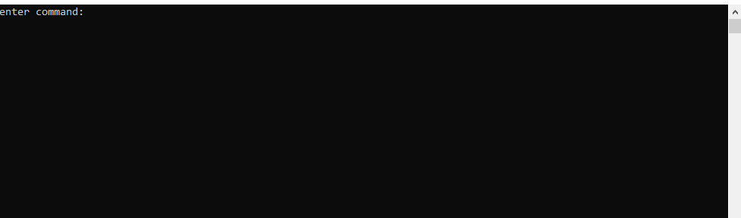
Enter the first command to create spread sheet
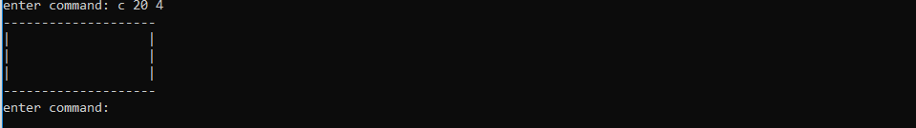

Enter second command which is first parameter for sum

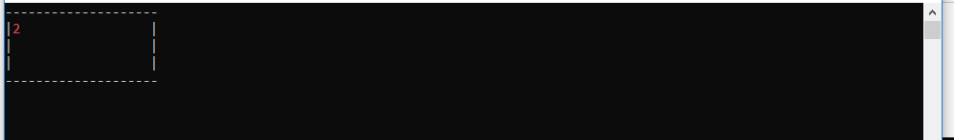
Enter any key to capture next parameter

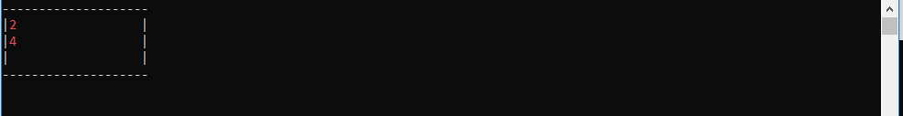
Enter any key to capture next parameter

Enter the command Q to exit

