Q. 1 Embedded device example

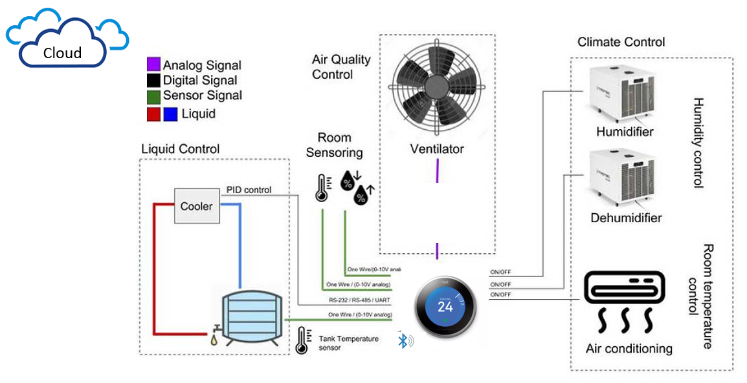

HVAC controller plays a crucial role in any modern household. A high-level function of a controller is to merely monitor the set temperature against the room temperature and throttle the HVAC system. But now a days, considering rising fuel cost and inclination towards reducing carbon footprint, consumers and legislator both demands a controller to achieve this goal with compromising the main goal. Additionally, users now a days want highly interactive graphical interface to match modern architecture. These additional requirements lead to complex controller design over traditional on-off controller. I have listed below some of development challenges faced by modern controller,

Interface

* Graphical Interface to display status and configuration menu

Response

* Very fast user interface response

Troubleshooting

* Provide error code for root cause analysis
* Increased communication interface to peripheral sensors

Reliability

* Highly reliable

Connectivity

* Support sensor network for more accurate prediction
* BLE to connect to smart phone
* Wi-Fi interface for remote setting and monitoring

Memory Space

* High memory requirement to store profiles, configuration and graphics

Power

* Low power consumption
* Battery operated

Features

* OTA feature upgrades
* Over the air diagnostics
* Artificial intelligence to predict the pattern
* Mesh sensor network
* Environmental sensor

Security

* Who can configure the controller?
* Unauthorized hacking into the system (Bluetooth, Wi-Fi etc.)

Cost

* Low cost
* Competitive to traditional controller