Task 1:

--------------

Write a Object oriented program to check whether the password is valid or not

Following are the criteria for checking the password:

1. At least 1 letter between [g-z]

2. At least 1 number between [6-9]

3. At least 1 letter between [A-Z]

4. At least 1 character from $ or # or @ or !

5. Minimum length of password: 6

6. Maximum length of password: 12

Your program should accept a sequence of comma separated passwords and will check them according to the above criteria.

Example:

If the following passwords are given as input to the program:

ABd1234@1,a F1#,2w3E*,2We3345

Then, the output of the program should be:

ABd1234@1

Passwords that match the criteria are to be printed, each separated by a comma.

- ensure that the code is implemented with proper exception handling.

- validations wherever it is required

- write the test case for each of the criteria mentioned above.

- create a test suite with all the test cases and create the final html report

Task 2:

--------------

Write a objet oriented python program to implement Employee Management System. In which you have to include the given topics as per requirement of the program: Inheritance, Lambda Expressions, Exceptional Handling and file handling.

create a menu for the user which consists of 5 different features.

1.To add an employee ( write the output to file with employee id)

2.To view details of an employee ( read from the file )

3.To remove an employee

4.To update info of an employee

5.To exit

User need to just enter the numbers as per given and it will perform the task.

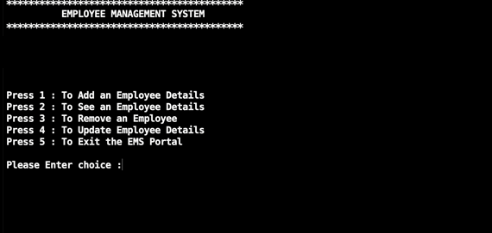

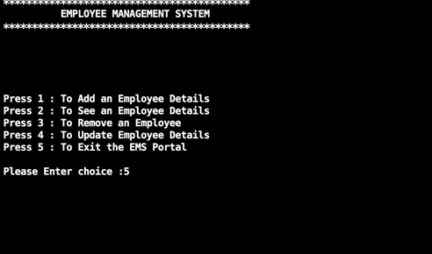

Task 3:

--------------

Write a program to read realestate.csv and insert all the records to excel file and the excel file should be today’s timestamp ( Eg: 25_Nov_2022.xlsx )

- write the separate test cases to check whether the

excel file is created or not,

size of the file is greater than zero or not

-write the test case whether the no. of records in realestate.csv and database records are equal or not.

-write the test case whether the count of columns in file and database are equal or not.

- you can also add other required test cases if required

-create a test suite with all the test cases

Also write a program to convert realestate.csv to the json file ( dictionary of dictionaries )