**Build a RAG System**

**Problem Statement:**

Organizations stores the manuals, policy documents, legal contracts or any other documents in unstructured format like pdfs. In this case study use any Life Insurance Policy pdf document like *"* *Principal-Sample-Life-Insurance-Policy.pdf"*, and retrieve instant and accurate answers from the document.

Traditional keyword-based search leads to inefficient contextual information, missed insights and further leads to frustrated users.

The case study should concentrate on the below points.

* Understand the context of the question,
* Match semantically similar but differently worded content,
* And synthesize answers across multiple sections.

**Why LangChain/ LlamaIndex is an ideal framework?**

LangChain and LlamaIndex (formerly GPT Index) are two of the most popular frameworks for building GenAI-powered applications, especially ones that use large language models (LLMs) with external data. Here's a breakdown of why they are considered ideal frameworks:

**LlamaIndex:** Ideal for Connecting LLMs to CustomData

LlamaIndex focuses on **making external data (e.g., PDFs, Notion, databases) accessible to LLMs** through structured ingestion and retrieval pipelines. It excels in **indexing, querying, and retrieval augmentation**.

1. **Flexible Data Ingestion:** It supports complex data sources and lets you preprocess, chunk, and embed documents with full control.
2. **Advanced Indexing Techniques:** Offers vector, keyword, tree, and hybrid indices for optimized retrieval depending on the use case.
3. **RAG-Friendly:** Designed specifically for **retrieval-augmented generation**, with built-in support for query transformations, summarization, and reranking.
4. **Composable Query Engines:** Let you chain together multiple indices, routers, and retrieval strategies.
5. **Seamless LangChain Integration:** LlamaIndex works beautifully as a retriever inside LangChain, letting you get the best of both worlds.

**Use Cases:** AI over private data (e.g., PDF Q&A, Notion docs, SQL), Custom search engines, Knowledge management tools, Legal, finance, or healthcare data querying

**LangChain:** Ideal for Building Agentic and Modular LLM Apps

LangChain is a **framework for developing applications powered by LLMs** that need to interact with outside tools, data sources, or workflows. It shines in orchestrating **multi-step reasoning**, calling APIs, and integrating components like memory, tools, and agents.

1. **Modular Components :** LangChain abstracts common patterns: prompts, chains, tools, memory, agents, and retrievers. This makes it easy to plug-and-play components and swap models or tools.
2. **Agent Support:** Enables dynamic decision-making by LLMs using "tools" — for example, an LLM deciding when to call a calculator or search engine.
3. **Data-Aware Applications:** LangChain integrates with vector stores (e.g., Pinecone, FAISS), document loaders, and retrievers to enable **retrieval-augmented generation (RAG)**.
4. **Tool Ecosystem:** It supports LangServe for deploying chains as APIs, LangGraph for building complex workflows, and LangSmith for debugging and monitoring.
5. **Model Agnostic:** Works with OpenAI, Anthropic, Cohere, Azure, HuggingFace, and even local models.

**Use Cases:** AI Assistants (e.g., chatbots that use tools), RAG Pipelines, Workflow agents (e.g., coding agents, financial analysts), API-calling bots

In this Case study, we use both llama index and langchain as they are good for “Document Q&A (RAG)”

**Data Sources:**

1. **Source file:** Text-based PDF document *"* *Principal-Sample-Life-Insurance-Policy.pdf"*
2. **Format:**  
   These are multi-page PDF loaded directly from Google Drive (/content/drive/MyDrive/helpmate_ai/Policy_Documents).
3. **Preprocessing:**

**Llamaindex:** In Pdf, pages are splitted andblank pages are removed. Used chunksize=1024 and chunk_overlap=100  
**Langchain**: PDFs are split into overlapping text chunks to retain context between chunks. chunksize=1000 and chunk_overlap=100

**System Architecture:**

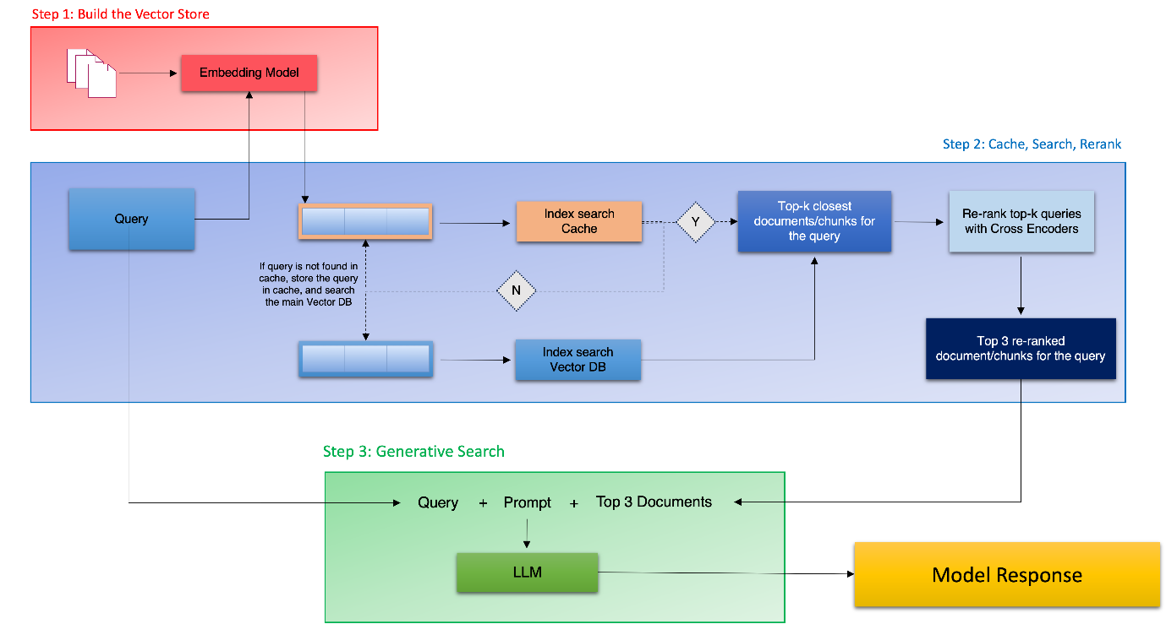

**System Design:**

**1. Innovation and Creativity in System Design**

The system intelligently combines LLMs with domain-specific documents (e.g. PDFs, policies). This is done using **RAG (Retrieval-Augmented Generation)**, allowing the model to answer questions accurately based on real, up-to-date information — not just what it was trained on. This is innovative because it turns static data into a dynamic, conversational AI system.

**2. Optimum System Architecture, Workflow, and Implementation**

The architecture is modular and scalable:

* **Input**: PDFs or documents are loaded and split into small chunks preserving semantic flow.
* **OpenAI Embeddings**: Each chunk is converted into a vector using an embedding model (e.g. text-embedding-ada-002).
* **Vector stores:** Chroma is used as vector store to have fast similarity search. We can use FAISS also.
* **CrossEncoder for Reranking**: A second filtering layer ensures better precision of context retrieved.
* **Open AI Model**: Model='gpt-3.5-turbo', temperature=0 are used for fast, reliable response generation with factual consistency.
* **Output**: The LLM generates a context-aware, accurate response.

**Llamaindex**: Sequence of questions are answered

**LangChain Expression Language (LCEL)**: Questions are answered with chat like model and exits chat in case of “quit”

**3. Appropriate Use of LangChain / LlamaIndex Components**

* **LangChain** is used for building structured workflows: chains, prompts, chat memory
* **LlamaIndex** (if integrated) excels at indexing and querying large structured/unstructured document sets.
* **Embeddings + Vector Store**: Enable semantic search for document retrieval.
* **LLMs (e.g. GPT-3.5)**: Generate human-like, contextually accurate answers from retrieved info.

**Llamaindex Flow chart:**

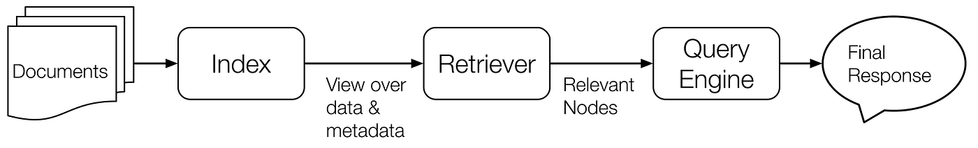

This is a flow chart for llamaindex. The pdf document are collected from the source directory. The document is chunked and indexed and stored in vectorstore. The retriever will find the relevant data based on queries. Response synthesizer will create a response and the Query engine will co-ordinate everything using the LLM and provides the final response.

**Langchain Flow chart:**

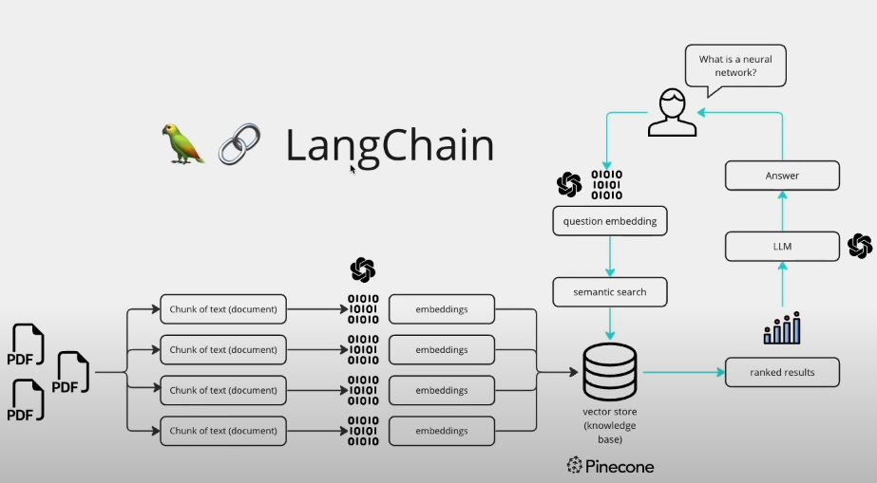

This is a flow chart for langchain. The pdf document are collected from the source directory. The document is chunked and embedded and stored in vectorstore(knowledge base). Based on the user questions as inputs the semantic search is done on knowledge base and returns the results which is ranked later and send to the LLM as response to user query.

### **Challenges Faced**

* **Chunk Quality**: Overlap needed to be tuned carefully — too little caused loss of context, too much created redundancy.
* **Reranking Efficiency**: Integrating the CrossEncoder re-ranker required additional computation but significantly improved result quality.
* **Context Management**: Keeping responses grounded strictly to the source documents needed robust prompt templates.
* **Colab Storage Paths**: Ensuring persistence and reusability required managing custom file paths inside Google Drive.

### **Lessons Learned:**

* RAG pipelines are powerful but require tuning of chunking and context retrieval
* Re-ranking adds major boost to answer relevance
* LangChain simplifies orchestration but needs careful prompt engineering
* Persistent storage is critical in Colab-based projects

**Results:**

**Llamaindex query results:**

**# Query 1**

Query("What risks or events are covered under this policy?")

Query : What risks or events are covered under this policy?

Response : The policy covers accidental death and dismemberment resulting from events such as willful self-injury, disease or medical treatment complications, participation in certain criminal activities, involvement in specific aeronautic activities, military duty, war, alcohol use exceeding legal limits, operation of a vehicle or boat under the influence, unauthorized drug use, and injuries not related to employment for wage or profit.

- Page 58: This policy has been updated effective January 1, 2014 PART IV - BENEFITS GC 6015 Section B - Member Accidental Death and Dismemberment Insurance, Page 6 a. willful self-injury or se...

- Page 27: This policy has been updated effective January 1, 2014 PART III - INDIVIDUAL REQUIREMENTS AND RIGHTS GC 6006 Section A - Eligibility, Page 2 If a Member's Dependent is employed and is covered u...

- Page 13: This policy has been updated effective January 1, 2014 GC 6002 PART I - DEFINITIONS, PAGE 5 a. A licensed Doctor of Medicine (M.D.) or Osteopathy (D.O.); or b. any other licensed health ...

**# Query 2**

**Query("what is the life insurance coverage for disability")**

Query("what is the life insurance coverage for disability")

The life insurance coverage for disability includes provisions for ADL Disability or Total Disability. To be eligible for Coverage During Disability, a Member must meet certain qualifications such as becoming ADL Disabled or Totally Disabled while insured for Member Life Insurance, being under the care of a Physician, providing proof of disability when required, and undergoing Medical Examinations or Evaluations as needed. Written proof of ADL Disability or Total Disability must be submitted to the insurance provider within a specified timeframe, and further proof may be requested periodically. If the Member passes away while disabled, final proof of disability continuation must be provided to the insurance provider.

- Page 49: This policy has been updated effective January 1, 2014 PART IV - BENEFITS GC 6013 Section A - Member Life Insurance, Page 4 Payment of benefits will be subject to the Beneficiary and Facilit...

- Page 51: This policy has been updated effective January 1, 2014 PART IV - BENEFITS GC 6013 Section A - Member Life Insurance, Page 6 Coverage During Disability will cease on the earliest of: (1) the...

- Page 50: This policy has been updated effective January 1, 2014 PART IV - BENEFITS GC 6013 Section A - Member Life Insurance, Page 5 The Principal may require that a ADL Disabled or Totally Disabled Me...

**# Query 3**

Query("Summarize the key benefits from the insurance policy documents.")

Query : Summarize the key benefits from the insurance policy documents.

Response : The risks or events covered under this policy include accidental death and dismemberment that are not a result of willful self-injury, disease or medical treatment complications, participation in criminal activities, certain aeronautic activities, military duty, war, excessive alcohol consumption, drug use, or injuries sustained during employment for wage or profit.

- Page 58: This policy has been updated effective January 1, 2014 PART IV - BENEFITS GC 6015 Section B - Member Accidental Death and Dismemberment Insurance, Page 6 a. willful self-injury or se...

- Page 27: This policy has been updated effective January 1, 2014 PART III - INDIVIDUAL REQUIREMENTS AND RIGHTS GC 6006 Section A - Eligibility, Page 2 If a Member's Dependent is employed and is covered u...

- Page 13: This policy has been updated effective January 1, 2014 GC 6002 PART I - DEFINITIONS, PAGE 5 a. A licensed Doctor of Medicine (M.D.) or Osteopathy (D.O.); or b. any other licensed health ...

**# Query 4**

Query("What riders or add-ons are available?")

Query : What riders or add-ons are available?

Response : The risks or events covered under this policy include accidental death and dismemberment that are not a result of willful self-injury, disease or medical treatments, participation in criminal activities, certain aeronautic activities, military duty, war, excessive alcohol consumption, drug use, and injuries sustained during employment for wage or profit.

- Page 58: This policy has been updated effective January 1, 2014 PART IV - BENEFITS GC 6015 Section B - Member Accidental Death and Dismemberment Insurance, Page 6 a. willful self-injury or se...

- Page 27: This policy has been updated effective January 1, 2014 PART III - INDIVIDUAL REQUIREMENTS AND RIGHTS GC 6006 Section A - Eligibility, Page 2 If a Member's Dependent is employed and is covered u...

- Page 13: This policy has been updated effective January 1, 2014 GC 6002 PART I - DEFINITIONS, PAGE 5 a. A licensed Doctor of Medicine (M.D.) or Osteopathy (D.O.); or b. any other licensed health ...

**Langchain results: (Screenshots)**



