Tester note: Navigate to the claim intake screen before submitting.
Claimant ID: CL-99231, verify the record loads correctly.
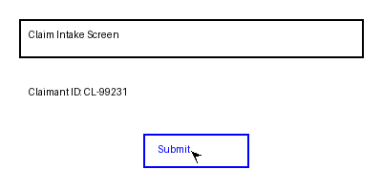
Click Submit to finalize the claim.
