**Pizza_sales SQL Queries**

1.Total price

select sum(total_price) AS Total_price from pizza_sales

Result :

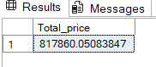

2.Average order value

select sum(total_price)/count(DISTINCT order_id) AS Avg_ord_val from pizza_sales

Result :

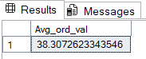

3.Total pizza sold

select sum(quantity) as Total_pizza_sold from pizza_sales

Result:

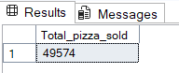

4. Total orders

select count(DISTINCT order_id) as Total_orders from pizza_sales

Result :

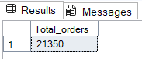

5.Avg Pizza per order

select CAST(CAST(sum(quantity) as DECIMAL(10))/CAST(count(DISTINCT order_id) as DECIMAL(10)) as DECIMAL(10,2)) as Pizza_per_order from pizza_sales

Result :

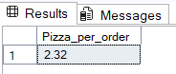

**CHART REQUIREMENTS**

1.Daily trend for total orders

select DATENAME(DW,order_date) as order_day,count(DISTINcT order_id) as total_orders from pizza_sales

group by DATENAME(DW,order_date)

Result:

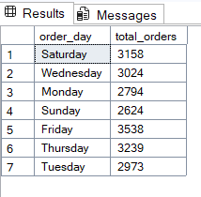

2.monthly trend for total orders

select DATENAME(MONTH,order_date) as order_month ,count(DISTINcT order_id) as total_orders from pizza_sales

group by DATENAME(MONTH,order_date)

order by total_orders desc

Result:

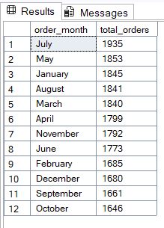

3.Total percentage for each category

select pizza_category,sum(total_price)*100/(select sum(total_price) from pizza_sales ) as percentage from pizza_sales

group by pizza_category

Result :

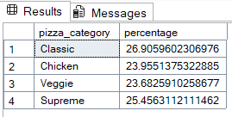

4.Percentage of sales by pizza_size

select pizza_size,sum(total_price)*100/(select sum(total_price) from pizza_sales ) as percentage from pizza_sales

group by pizza_size

order by percentage desc

Result :

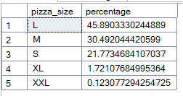

Query for ONLY WITH 2 DECIMAL POINTS:

select pizza_size,CAST(sum(total_price)*100/(select sum(total_price) from pizza_sales )AS DECIMAL(10,2)) as percentage from pizza_sales

group by pizza_size

order by percentage desc

upgeded query:

select pizza_size,CAST(sum(total_price) as decimal(10,2)),CAST(sum(total_price)*100/(select sum(total_price) from pizza_sales where DATEPART(quarter,total_price)=1)AS DECIMAL(10,2)) as percentage from pizza_sales

where DATEPART(quarter,order_date)=1

group by pizza_size

order by percentage desc

Result:**Quartarly values**

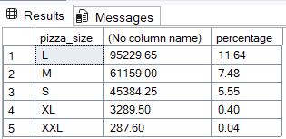

5.Total pizza sold by category

select pizza_category,CAST(sum(total_price) as decimal(10,2)) as total_price,count(quantity) as quantity from pizza_sales

group by pizza_category

Result:

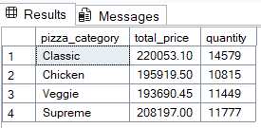

6.Top 5 pizza by price:

select top 5 pizza_name,CAST(sum(total_price) as decimal(10,2)) as total_price,count(quantity) as quantity from pizza_sales

group by pizza_name

order by total_price desc

Result:

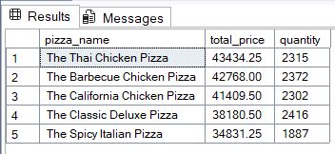

7. Bottom 5 pizza by price:

select top 5 pizza_name,CAST(sum(total_price) as decimal(10,2)) as total_price,count(quantity) as quantity from pizza_sales

group by pizza_name

order by total_price asc

Result:

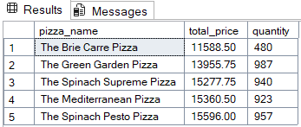

8.Top 5 pizza by quantity:

select top 5 pizza_name,CAST(sum(total_price) as decimal(10,2)) as total_price,count(quantity) as quantity from pizza_sales

group by pizza_name

order by quantity desc

Result:

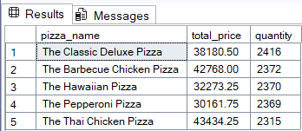

9. Bottom 5 pizza by quantity:

select top 5 pizza_name,CAST(sum(total_price) as decimal(10,2)) as total_price,count(quantity) as quantity from pizza_sales

group by pizza_name

order by quantity asc

Result:

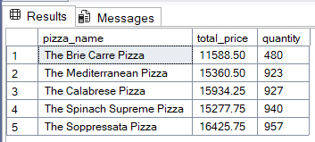

10.Top 5 pizza by order count:

select top 5 pizza_name,count(DISTINCT order_id) as order_count from pizza_sales

group by pizza_name

order by order_count desc

: Result

