SNAPSHOT
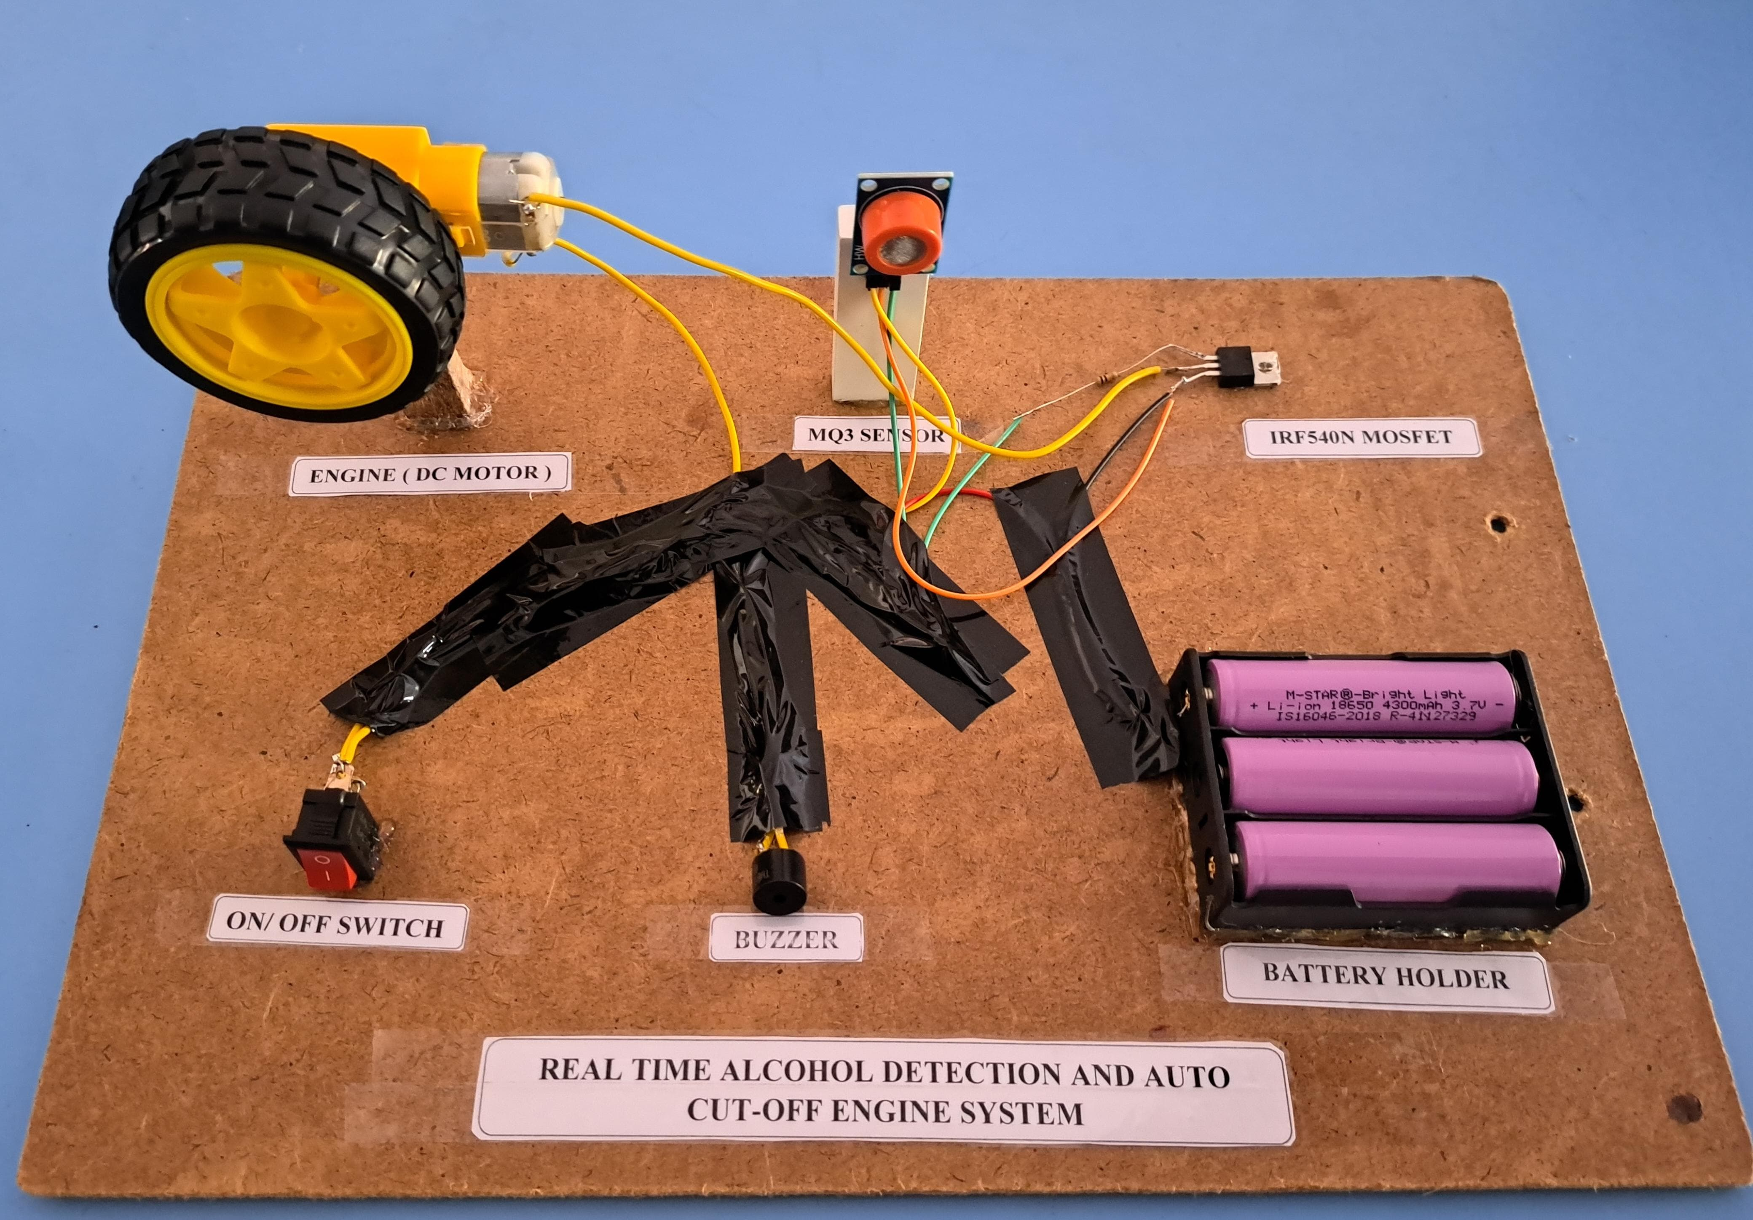

CONCLUSION
- In conclusion, the implementation of a real-time alcohol detection and auto cut-off engine system is essential for enhancing road safety by preventing accidents caused by drunk driving.
- This technology protects not only the driver and passengers but also other road users, promoting responsible driving behaviour and reducing alcohol-related accidents.

BLOCK DIAGRAM / CIRCUIT DIAGRAM

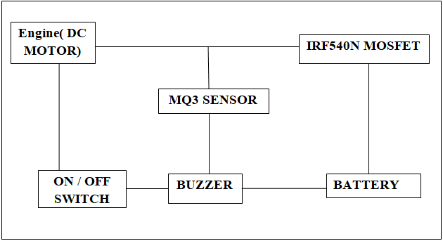

ABSTRACT
- The Alcohol Detection and Auto Cut-off Engine System is a safety feature installed in vehicles to detect alcohol in the driver's breath or blood.
- If alcohol is detected above a set limit, the system automatically shuts off the engine, preventing the driver from operating the vehicle while impaired.
- This technology aims to reduce the risk of alcohol-related accidents and promote safer driving habits.

DESCRIPTION
- The Alcohol Detection and Auto Cut-off Engine System is a sophisticated safety feature designed to prevent drunk driving incidents.
- By employing advanced sensors, this system accurately detects alcohol levels in the driver's breath or blood. If impairment is detected above a predetermined threshold, the system immediately disables the vehicle's engine, preventing the driver from operating the vehicle while under the influence.
- This proactive approach significantly reduces the risk of alcohol-related accidents and promotes responsible driving behaviour, thereby enhancing road safety for all road users.

INTRODUCTION
- The Alcohol Detection and Auto Cut-off Engine System revolutionizes road safety by tackling drunk driving head-on.
- Using advanced sensors, it swiftly detects alcohol levels in the driver's breath or blood. If impairment is detected, the system takes immediate action, cutting off the engine to prevent the vehicle from being driven.
- This innovative technology not only saves lives but also sends a clear message about the importance of responsible driving.
- By removing the possibility of operating a vehicle while under the influence, this system significantly reduces the risk of alcohol-related accidents on our roads.

STUDENT NAME : GIRIDHAR Y, VIGNESH P, TAMILSELVAN C, HARINI S
MENTOR/GUIDED BY : Mr. RAJESH K , ASSISTANT PROFESSOR / ECE
MAKE A PRODUCT (MAP)
REAL TIME ALCOHOL DETECTION AND AUTO CUT-OFF ENGINE SYSTEM

KNOWLEDGE INSTITUTE OF TECHNOLOGY
An Autonomous Institution

Kakapalayam (PO), Salem – 637 504

