TEMPERATURE SENSOR

PROTOTYPE :

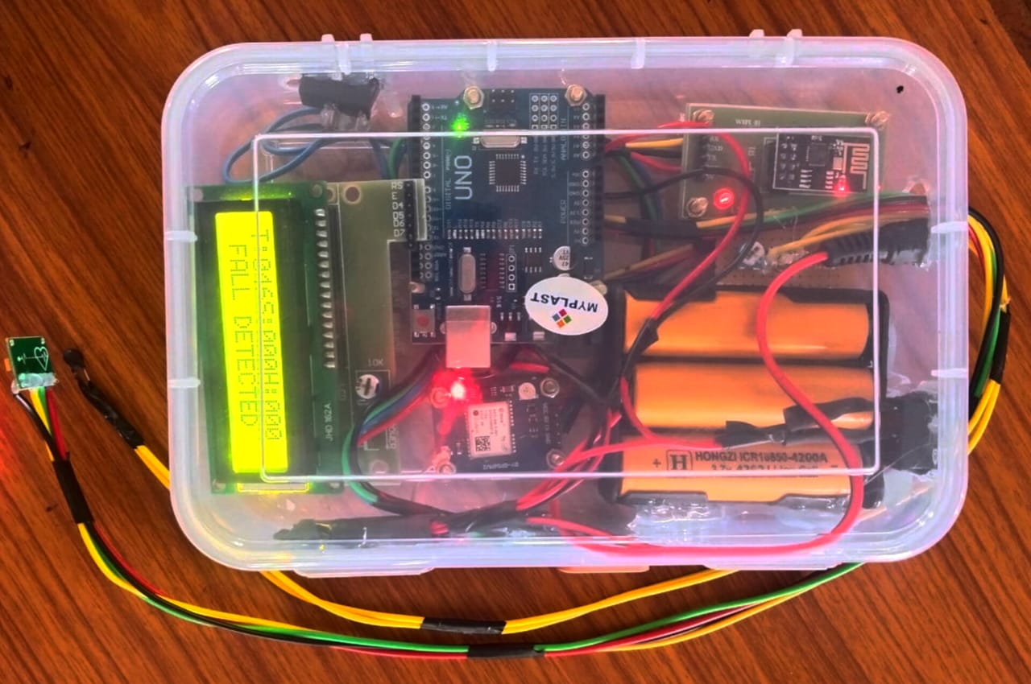

HARDWARE USED
- Arduino Uno
- LCD
- Temperature Sensor
- Heartbeat Sensor
- SpO2 sensor
- GPS
- Accelerometer Sensor
- IoT

PROPOSED SOLUTION:
Objective: Developing a wearable device powered by IoT technology.
Function: Continuously monitor blood flow in the cardiovascular system.
Key Feature: Real-time detection of clots or blockages.
Benefit: Provides early warnings to prevent heart-related issues.
Customizable Alerts: Users set personalized notifications, alerting them only when critical health thresholds are reached.

PROBLEM IDENTIFIED:
- Current methods for monitoring blood flow are often invasive, time-consuming, or lack real-time data, making it difficult for healthcare professionals to track a patient's condition continuously and effectively.

SOFTWARE TOOLS USED
- Arduino IDE
- Android Studio
PROGRAMMING LANGUAGES USED
- Java (Application)
- C(Arduino Uno)

TECHNOLOGIES USED:

Target Audience:
- Elderly Individuals
- Chronic Disease Patients
- Caregivers
- Health Enthusiasts
- Fitness Users
- Healthcare Providers

“REAL-TIME CONTINOUS BLOOD FLOW AND CLOT DETECTION IN THE CARDIOVASCULAR SYSTEM USING IOT”

IoT
LCD
HEARTBEAT SENSOR
ARDUINO UNO
BLOCK DIAGRAM:
CONCLUSION:
- Improved Monitoring: Continuous tracking enhances patient safety.
- Wider Accessibility: Affordable devices so, serve more users.
- Real-Time Alerts: Immediate notifications for health issues.
- Caregiver Support: Facilitates communication and monitoring (Between Patients and caregivers).

STUDENTS NAME : GIRIDHAR Y, ROHINI M, HARINI R G, RAJESWARI S, SHRIRAM U V
MENTOR/GUIDED BY : Mrs HEMALATHA R, AP/ECE, KIOT


