Target Audience:
- Outdoor Travelers and Hikers: Generate power in remote areas.
- Emergency Responders: Power essential gadgets during rescue missions.
- Health & Fitness Users: Track steps while generating electricity.
- Eco-Tech Enthusiasts: Promote sustainable living through innovation.
- Students and Hobbyists: Ideal for learning wearable tech and green energy.

PROTOTYPE:



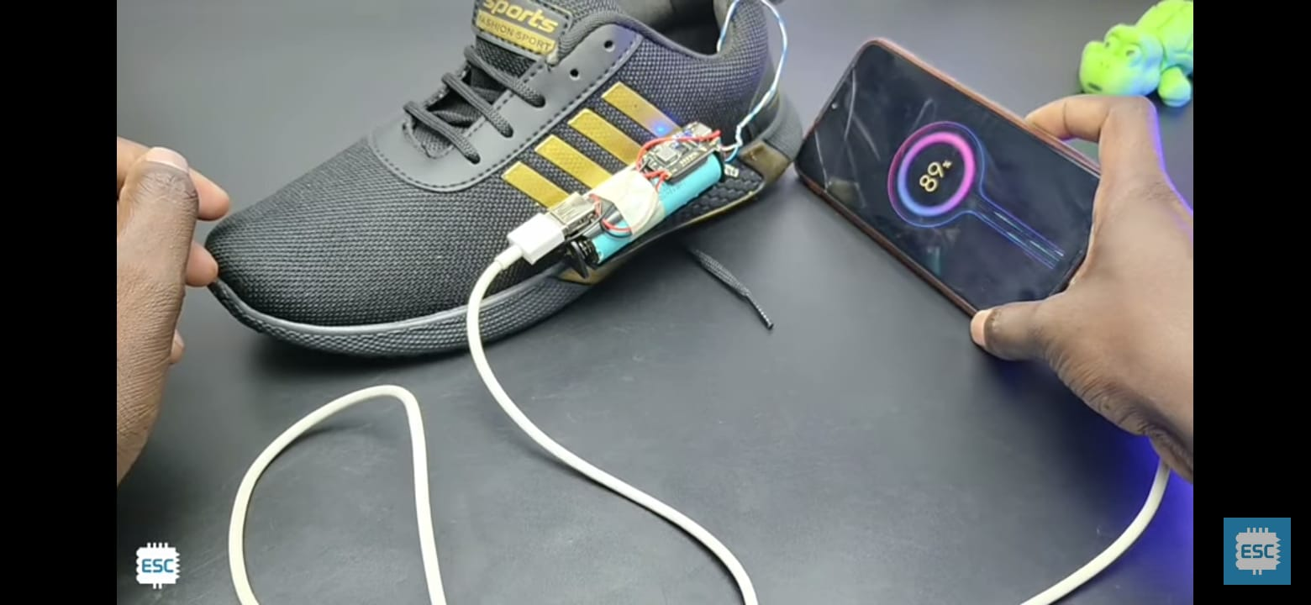

COMPONENTS USED:
- Piezoelectric discs
- Diodes (1N4007)
- Electrolytic Capacitor (470μF, 25V)
- TP4056 Li-ion charging module
- Lithium-ion 3.7V rechargeable battery
- USB Type-A female charging port
- FR4 PCB sheet (fiberglass)
- LED indicators
- Jumper wires

CONCLUSION:
Walk-Charger is a practical step toward wearable green technology. It not only serves as a sustainable solution for mobile energy needs but also demonstrates how simple motion can be harnessed to make our daily activities more efficient and eco-conscious. With real-world utility, scalable design, and deep relevance to today’s energy challenges, this project stands as a meaningful contribution to green innovation in wearable electronics.

KEY FEATURES:
- Converts motion into electricity using piezoelectric, solenoid, and gear-based mechanisms
- Real-time energy storage with USB output to charge low-power devices
- Lightweight, compact, and embedded inside shoe sole
- Portable, off-grid solution for outdoor use, emergencies, and daily wear.



PROBLEM IDENTIFIED:
Modern portable devices demand frequent charging, but access to power sources during travel, outdoor activities, or emergencies is limited. Existing energy sources are not always sustainable or wearable. Traditional charging methods depend on the availability of power outlets and batteries, which are not always convenient, sustainable, or eco-friendly. There is a growing need for alternative energy sources that are wearable, non-invasive, and user-driven.

PROPOSED SOLUTION:
Objective: To design and implement a wearable energy harvesting system that captures kinetic energy from walking and converts it into usable electrical energy. The goal is to promote sustainable technology and offer a portable charging solution for small electronic devices.
Description: This project introduces a walk-charger system integrated into shoes that generates power using kinetic energy. As the user walks, piezoelectric discs embedded in the sole convert motion into electricity. The energy is rectified, regulated, and stored in a rechargeable battery, which can be used to power USB-chargeable devices. The solution is sustainable, wearable, and ideal for emergency and outdoor use.
“Walk-Charger: Electricity-Generating Smart Shoes for Sustainable Wearable Power”

CIRCUIT DIAGRAM:


