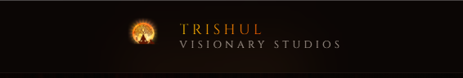

Not Clearly Visible

Founder’s Vision and B Narendra Reddy name is not clearly Visible
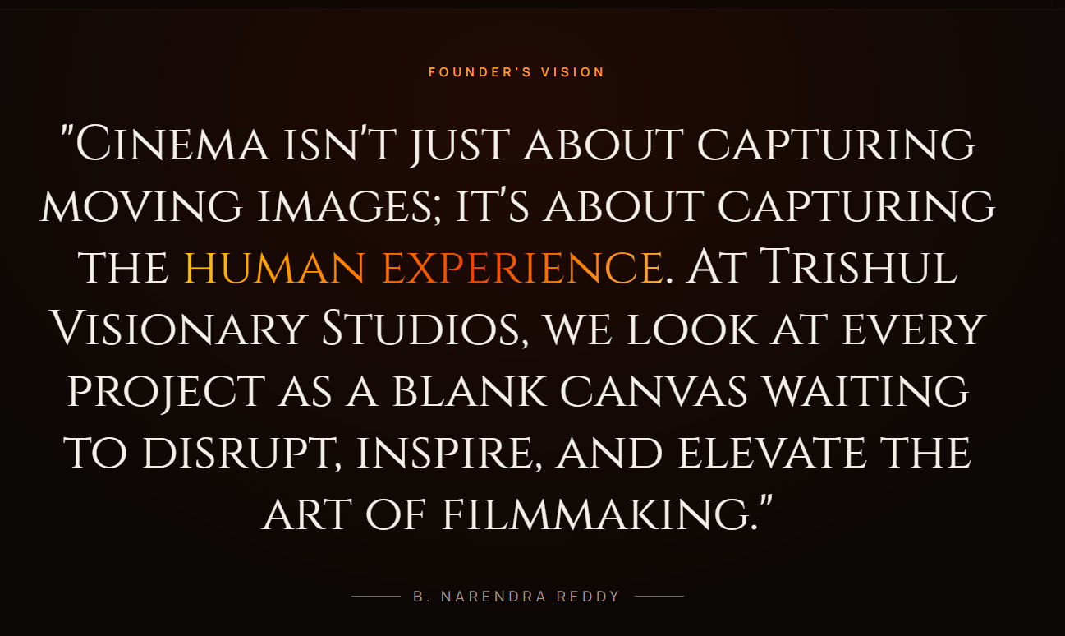

Same here
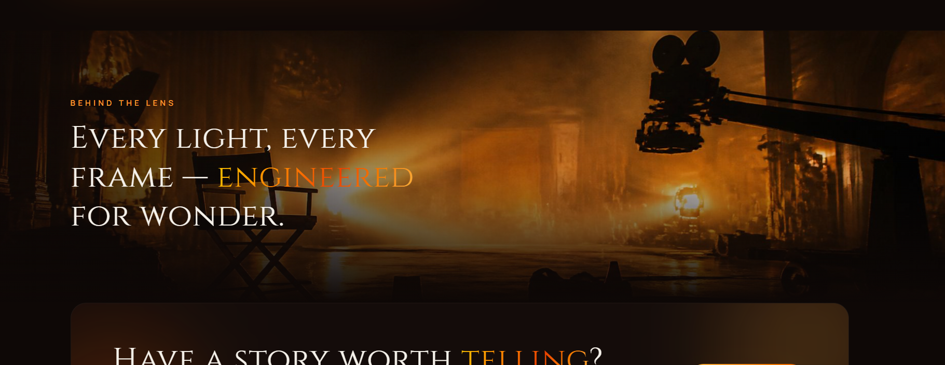

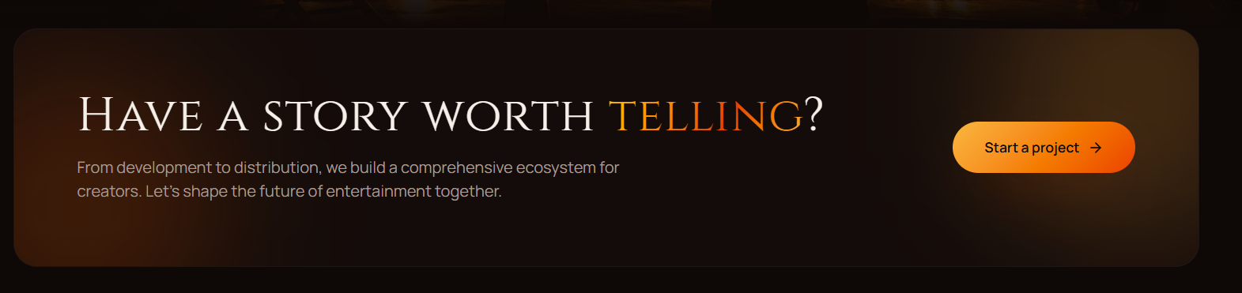

Change the Button to Start a Story and it should go to a form either a form with in the website which trigger an email or just a Google Form with attachment or just a link which downloads a pdf so they can read and submit the story via email

TRISHUL VISIONARY STUDIOS
STORY SUBMISSION FORM
Writer Details
- Writer Name:
- Mobile Number:
- Email:
- City:
- Previous Released Films:
- Languages Comfortable In:

Story Details
Working Title

Genre
□ Comedy
□ Family Drama
□ Action
□ Thriller
□ Crime
□ Horror
□ Love Story
□ Fantasy
□ Mythology
□ Period Drama
□ Sci-Fi
□ Other

Logline (Maximum 50 Words)
Describe the story in one powerful sentence.

Story Synopsis (Maximum 1 Page)
Must include:
- Beginning
- Main Conflict
- Interval
- Climax
- Ending
(No suspense withholding)

Hero Profile
- Age:
- Background:
- Character Arc:
- Star Hero / Mid-range Hero / New Hero

Why Will Audience Buy A Ticket?
Maximum 5 points.

Comparable Films
Closest 3 films:

Target Audience
□ Family Audience
□ Youth Audience
□ Mass Audience
□ Multiplex Audience
□ PAN India Audience
□ OTT Audience

Budget Range
□ Under ₹5 Cr
□ ₹5-15 Cr
□ ₹15-30 Cr
□ ₹30-50 Cr
□ ₹50 Cr+

Franchise Potential
□ Single Film
□ Sequel Possible
□ Franchise Potential

Attached Material
□ Synopsis
□ Screenplay
□ Scene Order
□ Character Sketches
□ Mood Board

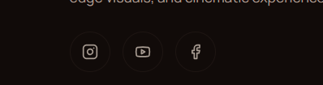

We need to have X and not face book.
Youtube:
https://www.youtube.com/@TrishulVisionaryStudios
X: https://x.com/TrishulVSoffl
Insta: https://www.instagram.com/trishulvisionarystudios

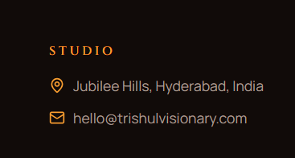

This and all other contact information
Kavuri Hills, Hyderabad, India
Email: Info@trishulvisionarystudios.in

ABOUT US PAGE
Same not visible
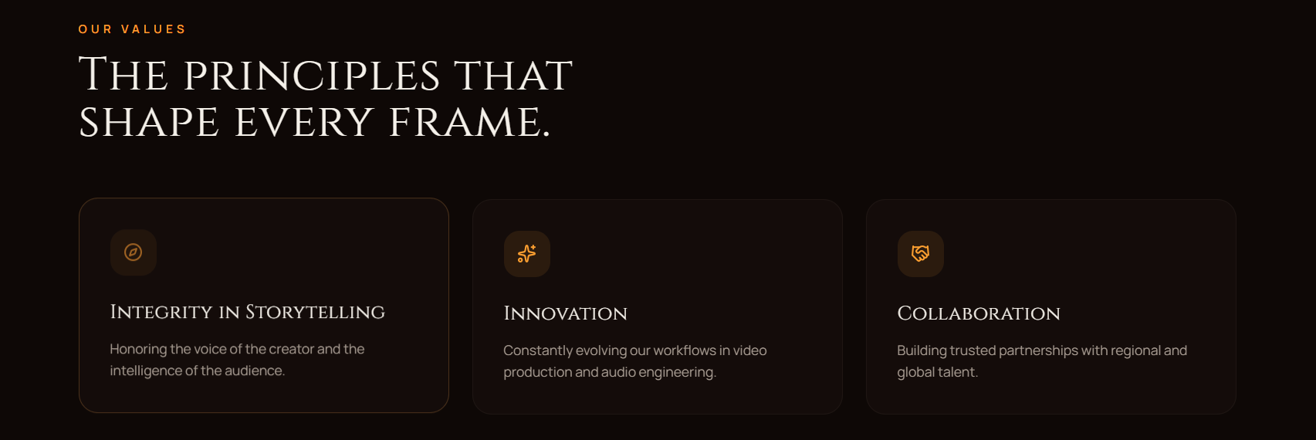

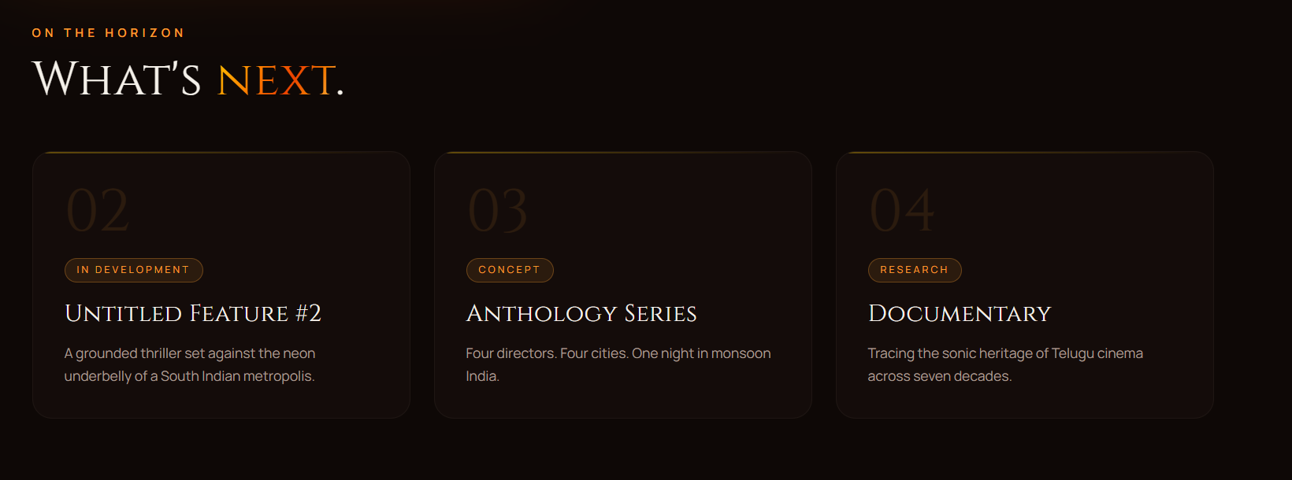
RR9
TVS05
AB#05

