Python Script approach (Current approach):
1. Images:
Stage 1: Crop & Isolate Pure Graphics:
- Detect image candidates — collects bounding boxes from three sources:
  - Raster images & logos (page.get_image_info())
  - Vector drawings — schematics, icons, diagrams (page.get_drawings())
  - Full-page separator lines and header/footer elements are filtered out.
- Transitive clustering (merge_rects_transitive) — merges overlapping/nearby bounding boxes into consolidated figures using a gap-based connected-component algorithm (gap_x=15, gap_y=12 pt).
- Text masking — paints white rectangles over all text spans inside each crop region, so only the pure visual graphics (logos, lines, boxes, shapes, icons) remain. Barcodes and QR codes are excluded.
- Crop & save as grayscale PNG files at 150 DPI, organized as Output/Cropped_Images/<pdf_name>/page_XXX/crop_XX_<label>.png.

Stage 2: Comparison:
Core Algorithm — cv2.matchTemplate with TM_CCOEFF_NORMED
This is the Normalized Cross-Correlation Coefficient method. It slides the English crop image across the translated page image and computes a normalized similarity score (0.0 – 1.0) at every position.
Search Strategy
- Priority 1 — Same page: Check the corresponding page in the translated PDF first.
- Priority 2 — Adjacent pages: If the same-page score is below threshold (80%), search ±4 pages sorted by distance — this handles layout shifts where translated text causes graphics to move to nearby pages.

Key challenges:
It Crop the table as the images.
Actual table in pdf:
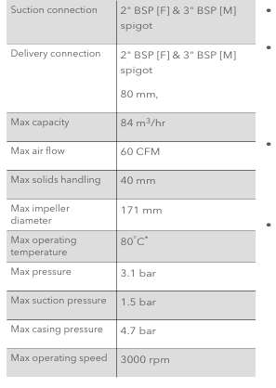
Considering as
image

What PyMuPDF sees | What the code does | Result
Table cell borders → get_drawings() | Treats as vector graphic elements | ✅ Added as image candidate
Gray row shading → get_drawings() | Treats as filled rectangle graphic | ✅ Added as image candidate
All nearby elements merged | merge_rects_transitive(gap=12) | 🔗 Combined into one big box
Detects it's inside a table region | Labels as "table_image" | ❌ Still cropped, not excluded

- Tables:
pdfplumber works directly on the PDF structure (not rendered images). It reads the raw PDF drawing commands.

What pdfplumber does internally:
Step 1: Read PDF → extract all line/rect objects from the page
(these are vector drawing commands, not pixels)
Step 2: Filter by strategy ("lines") → keep only explicit line objects
(ignores text edges, curves, etc.)
Step 3: Find intersections between horizontal and vertical lines
Step 4: Build a grid from those intersections
┌───┬───┐
│ │ │ ← each cell is formed by 4 intersecting lines
├──┼───┤
│ │ │
└───┴───┘
Step 5: Return table bounding boxes + cell structure

Key challenges:
- Borderless tables
- Table overflow to next page.
- Drawings are consider as tables
- A diagram with crossing arrows:
↗
────── ← horizontal line
↘
pdfplumber: "That's a table!" ❌

- A bordered warning box with an internal divider:
┌─────────────┐
│ ⚠ WARNING │
│─────────────│ ← just a visual separator
│ Do not... │
└─────────────┘
pdfplumber: "That's a 2-row table!" ❌

- Header banner line crossing a sidebar line:
═══════════════════
│
│ ← page layout element
pdfplumber: "That's a table!" ❌
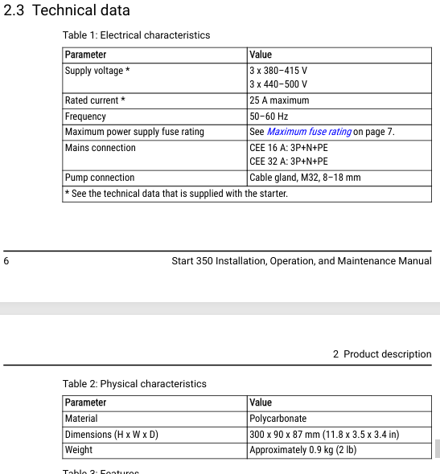
Text comparison:
"A program without AI cannot distinguish between a real body paragraph, a table cell, a diagram label, or a repeated header, and cannot handle the fact that translated text naturally changes paragraph counts and page layouts."

Key challenges:
- Page Boundaries Cut Paragraphs in Half:
On small page sizes (A5 / A6):
- An English paragraph fits neatly at the bottom of Page 3.
- The translated version is 30% longer — the first 3 lines stay on Page 3, and the last 2 lines spill onto Page 4.
- The computer now counts 1 English paragraph vs. 2 Translated blocks, triggering a False Error even though the text is 100% correct.

