**8. JavaScript Conditional Statements and Loops**

a. Write a program which asks the user to enter three integers, obtains the numbers from the user and outputs HTML text that displays the larger number followed by the words “LARGER NUMBER” in an information message dialog. If the numbers are equal, output HTML text as “EQUAL NUMBERS”.

HTML SCRIPT:

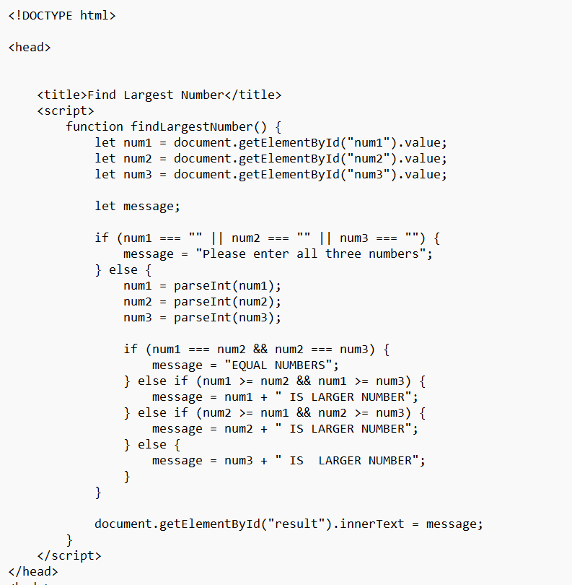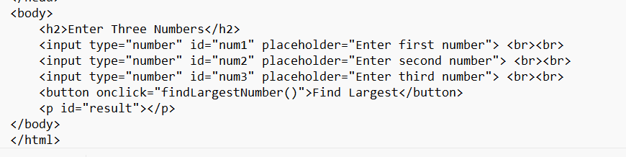

OUTPUT:

b. Write a program to display week days using switch case.

HTML SCRIPT:

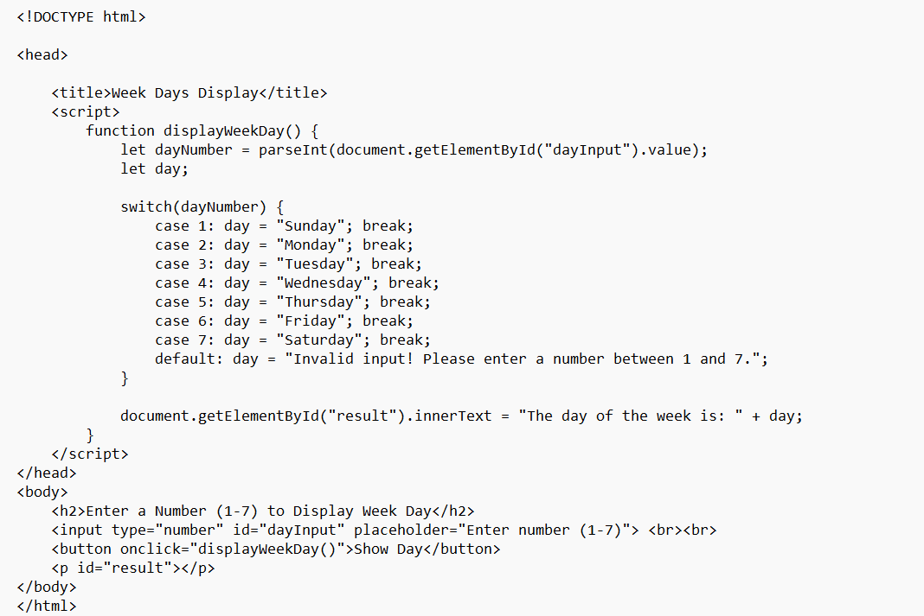

Output:

c. Write a program to print 1 to 10 numbers using for, while and do-while loops.

HTML SCRIPT:

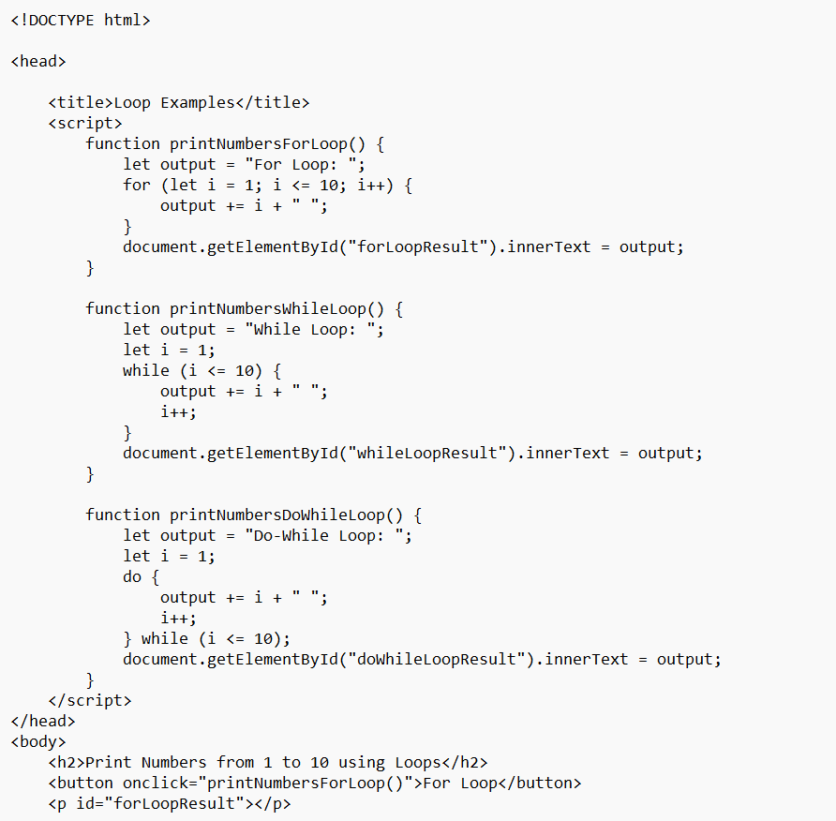

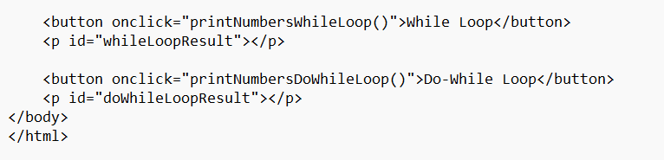

Output:

d. Write a program to print data in object using for-in, for-each and for-of loops

HTML SCRIPT:

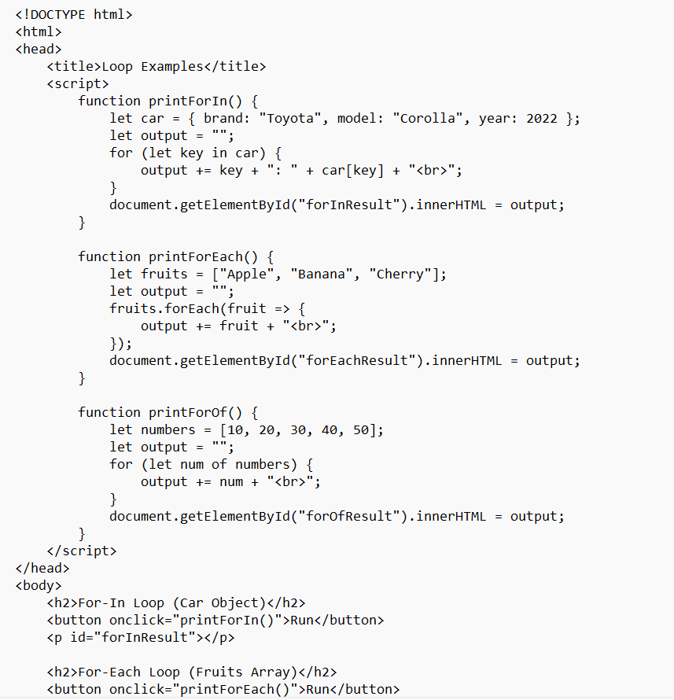

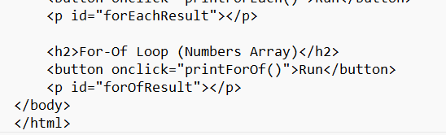

Output:

e. Develop a program to determine whether a given number is an ‘ARMSTRONG NUMBER’ or not. [Eg: 153 is an Armstrong number, since sum of the cube of the digits is equal to the number i.e.,13 + 53+ 33 = 153]

HTML SCRIPT:

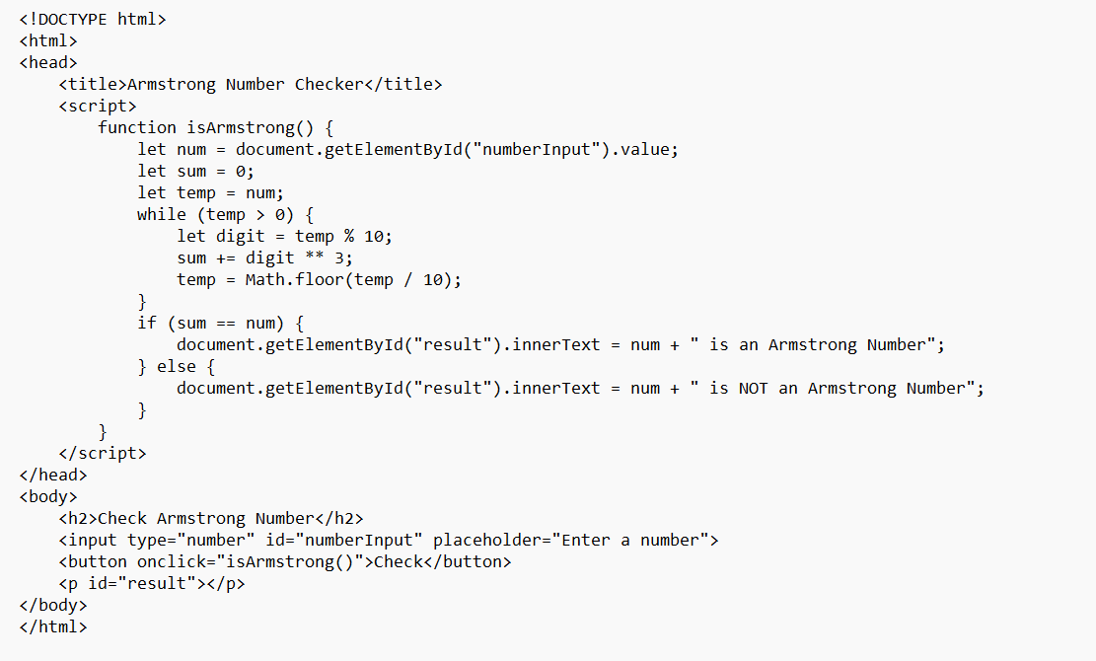

Output:

f. Write a program to display the denomination of the amount deposited in the bank in terms of 100’s, 50’s, 20’s, 10’s, 5’s, 2’s & 1’s. (Eg: If deposited amount is Rs.163, the output should be 1-100’s, 1-50’s, 1- 10’s, 1-2’s & 1-1’s)

HTML SCRIPT:

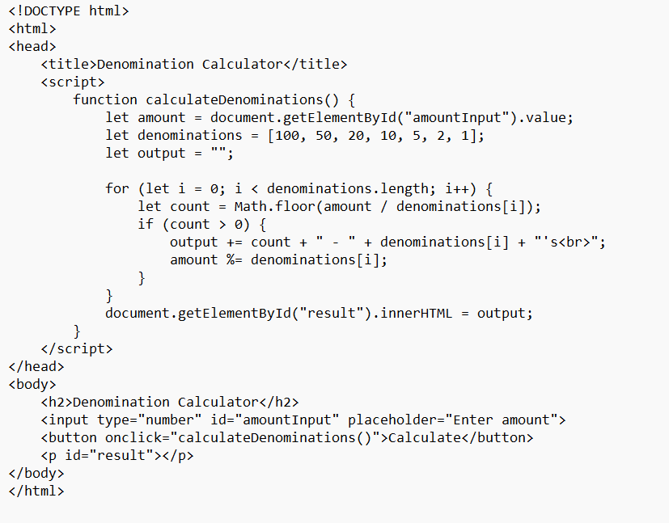

Output: