Question

Output

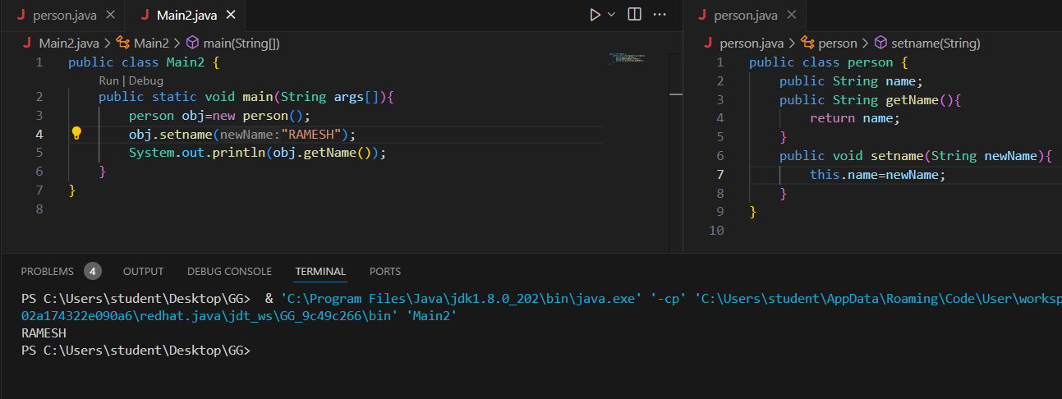

2) 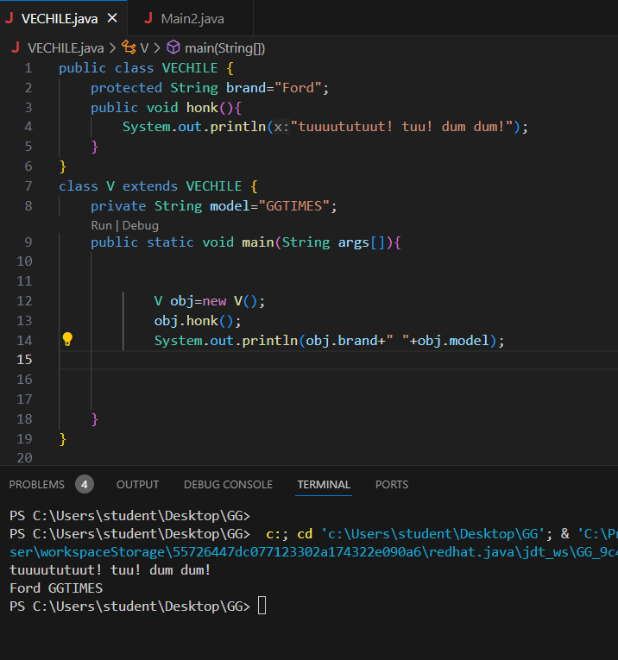

public class VECHILE {

    protected String brand="Ford";

    public void honk(){

        System.out.println("tuuuututuut! tuu! dum dum!");

    }

}

class V extends VECHILE {

    private String model="GGTIMES";

    public static void main(String args[]){

            V obj=new V();

            obj.honk();

            System.out.println(obj.brand+" "+obj.model);

    }

}

3)

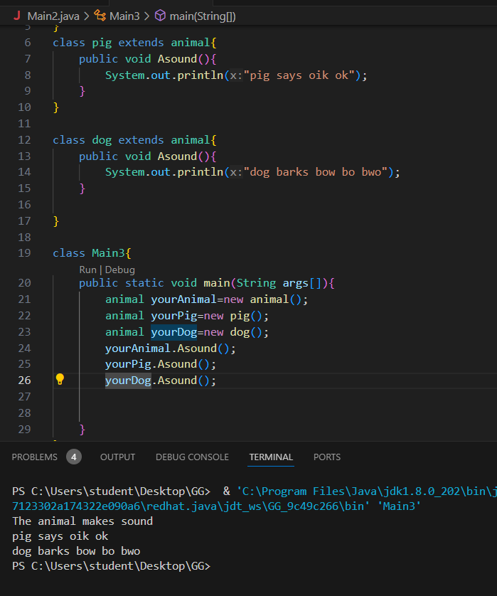

class animal{

    public void Asound(){

        System.out.println("The animal makes sound");

    }

}

class pig extends animal{

    public void Asound(){

        System.out.println("pig says oik ok");

    }

}

class dog extends animal{

    public void Asound(){

        System.out.println("dog barks bow bo bwo");

    }

}

class Main3{

    public static void main(String args[]){

        animal yourAnimal=new animal();

        animal yourPig=new pig();

        animal yourDog=new dog();

        yourAnimal.Asound();

        yourPig.Asound();

        yourDog.Asound();

    }

}

5)

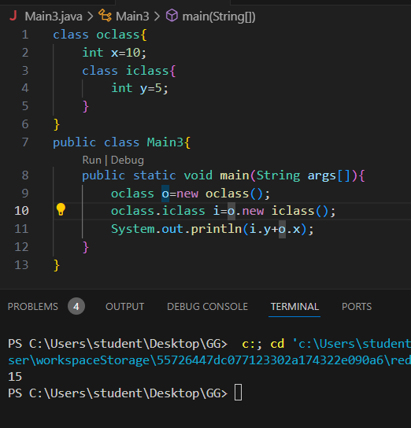

class oclass{

    int x=10;

    class iclass{

        int y=5;

    }

}

public class Main3{

    public static void main(String args[]){

        oclass o=new oclass();

        oclass.iclass i=o.new iclass();

        System.out.println(i.y+o.x);

    }

}

6)

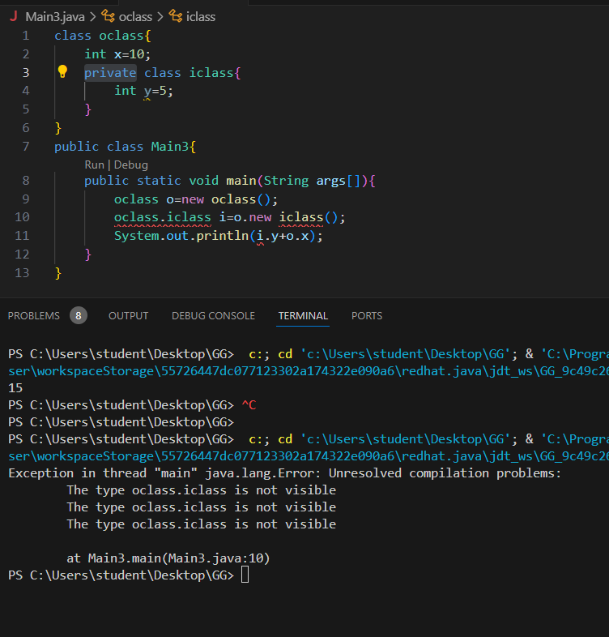

7)

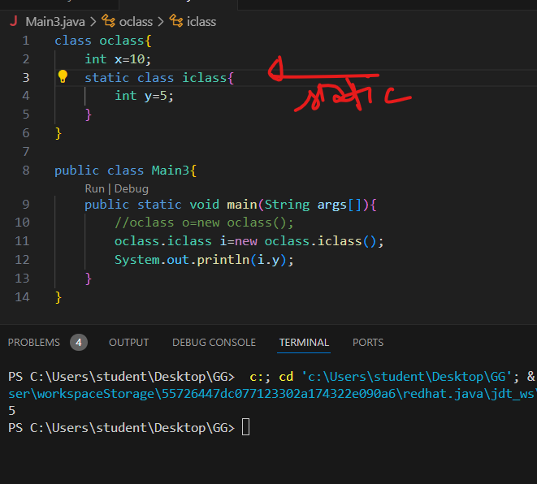

class oclass{

    int x=10;

    static class iclass{

        int y=5;

    }

}

public class Main3{

    public static void main(String args[]){

        //oclass o=new oclass();

        oclass.iclass i=new oclass.iclass();

        System.out.println(i.y);

    }

}

8)

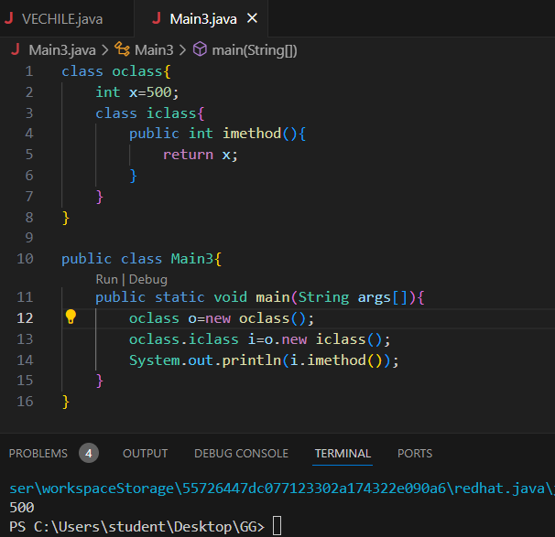

class oclass{

    int x=500;

    class iclass{

        public int imethod(){

            return x;

        }

    }

}

public class Main3{

    public static void main(String args[]){

        oclass o=new oclass();

        oclass.iclass i=o.new iclass();

        System.out.println(i.imethod());

    }

}

9) abstract

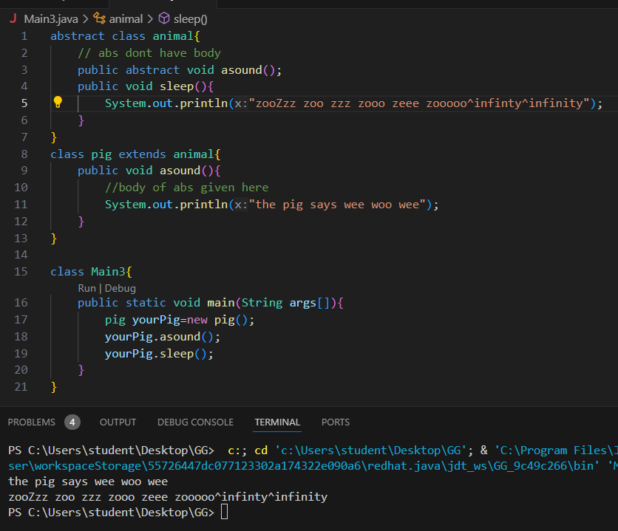

abstract class animal{

    // abs dont have body

    public abstract void asound();

    public void sleep(){

        System.out.println("zooZzz zoo zzz zooo zeee zooooo^infinty^infinity");

    }

}

class pig extends animal{

    public void asound(){

        //body of abs given here

        System.out.println("the pig says wee woo wee");

    }

}

class Main3{

    public static void main(String args[]){

        pig yourPig=new pig();

        yourPig.asound();

        yourPig.sleep();

    }

}

10)

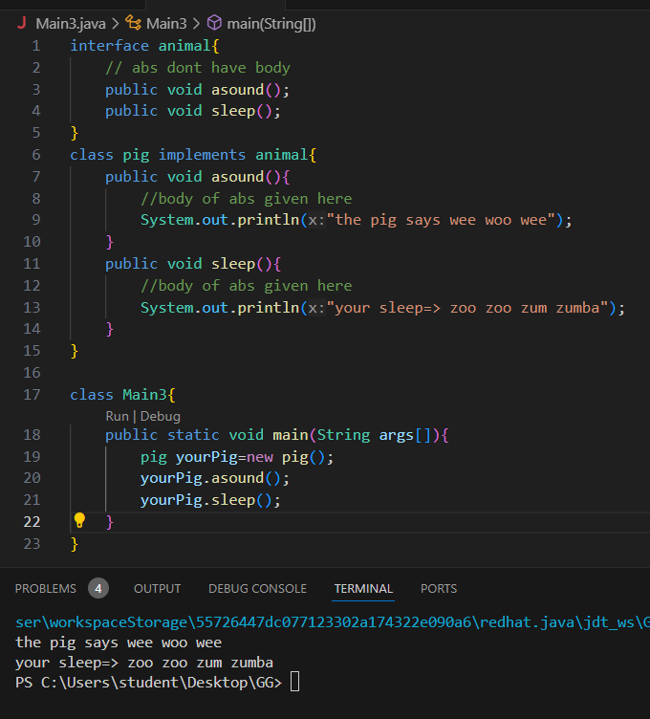

interface animal{

    // abs dont have body

    public void asound();

    public void sleep();

}

class pig implements animal{

    public void asound(){

        //body of abs given here

        System.out.println("the pig says wee woo wee");

    }

    public void sleep(){

        //body of abs given here

        System.out.println("your sleep=> zoo zoo zum zumba");

    }

}

class Main3{

    public static void main(String args[]){

        pig yourPig=new pig();

        yourPig.asound();

        yourPig.sleep();

    }

}