1.

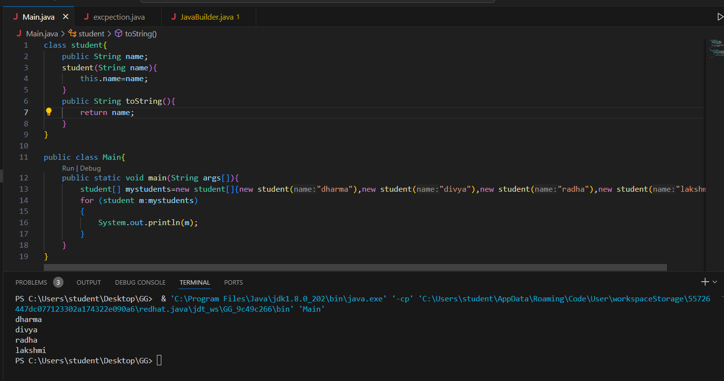

2.

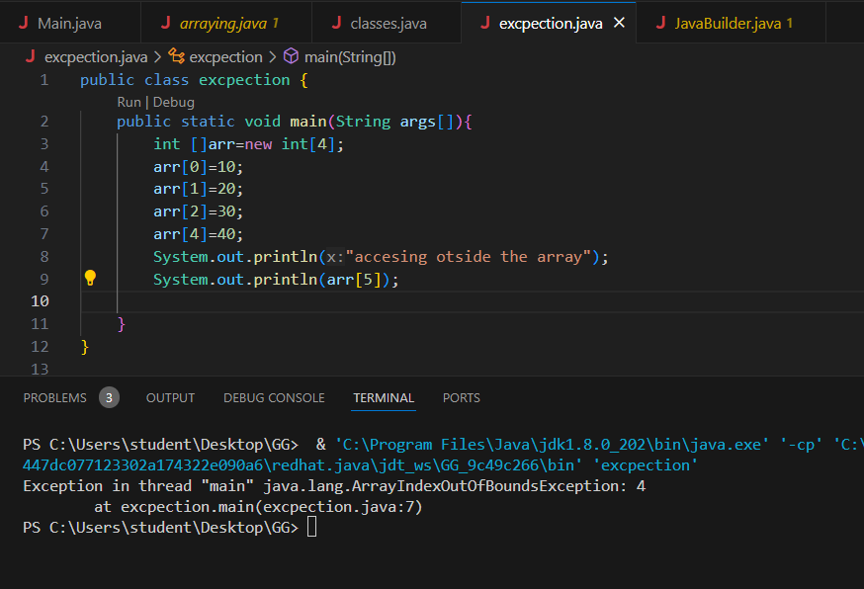

public class excpection {

    public static void main(String args[]){

        int []arr=new int[4];

        arr[0]=10;

        arr[1]=20;

        arr[2]=30;

        arr[4]=40;

        System.out.println("accesing otside the array");

        System.out.println(arr[5]);

    }

}

3.multi dimensional arrays

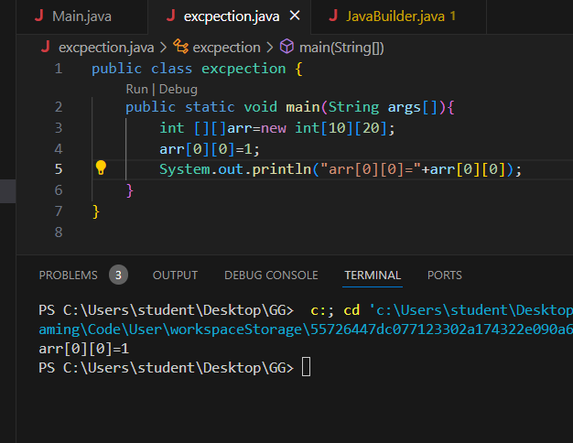

public class excpection {

    public static void main(String args[]){

        int [][]arr=new int[10][20];

        arr[0][0]=1;

        System.out.println("arr[0][0]="+arr[0][0]);

    }

}

4.

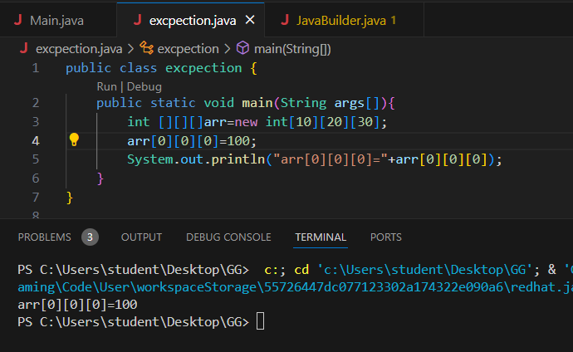

public class excpection {

    public static void main(String args[]){

        int [][][]arr=new int[10][20][30];

        arr[0][0][0]=100;

        System.out.println("arr[0][0][0]="+arr[0][0][0]);

    }

}

5.

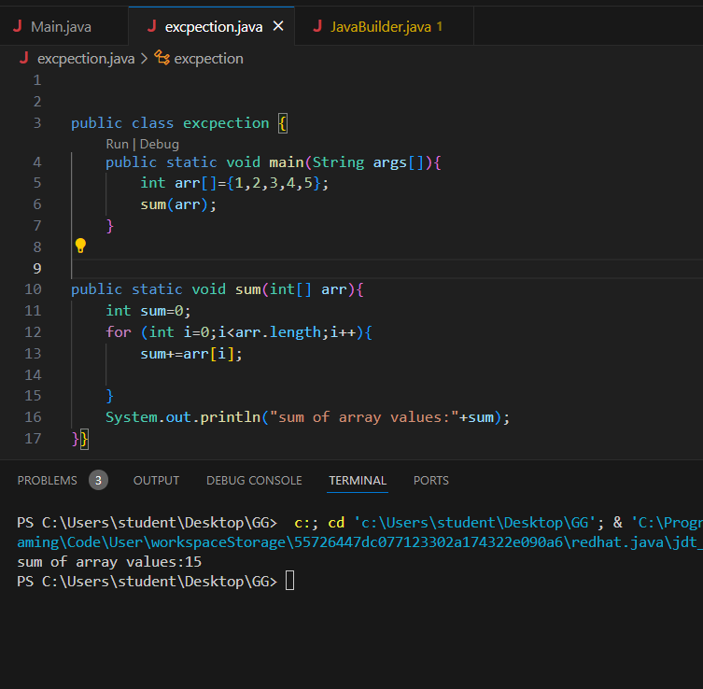

public class excpection {

    public static void main(String args[]){

        int arr[]={1,2,3,4,5};

        sum(arr);

    }

public static void sum(int[] arr){

    int sum=0;

    for (int i=0;i<arr.length;i++){

        sum+=arr[i];

    }

    System.out.println("sum of array values:"+sum);

}}

6.

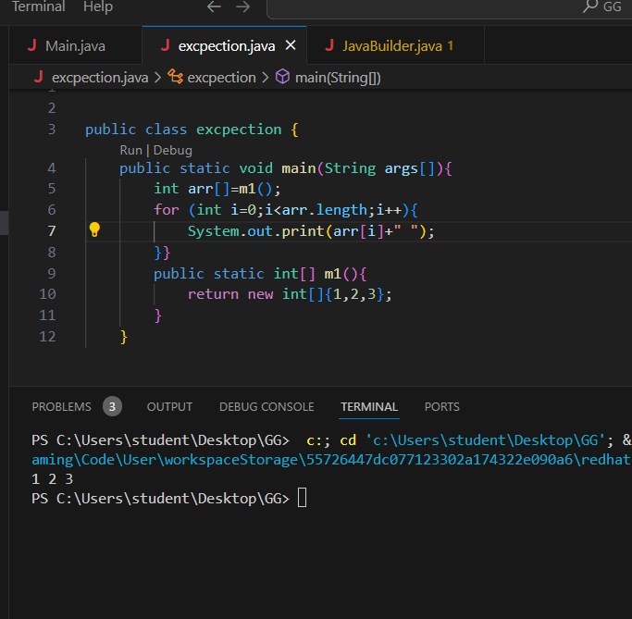

public class excpection {

    public static void main(String args[]){

        int arr[]=m1();

        for (int i=0;i<arr.length;i++){

            System.out.print(arr[i]+" ");

        }}

        public static int[] m1(){

            return new int[]{1,2,3};

        }

    }

7.

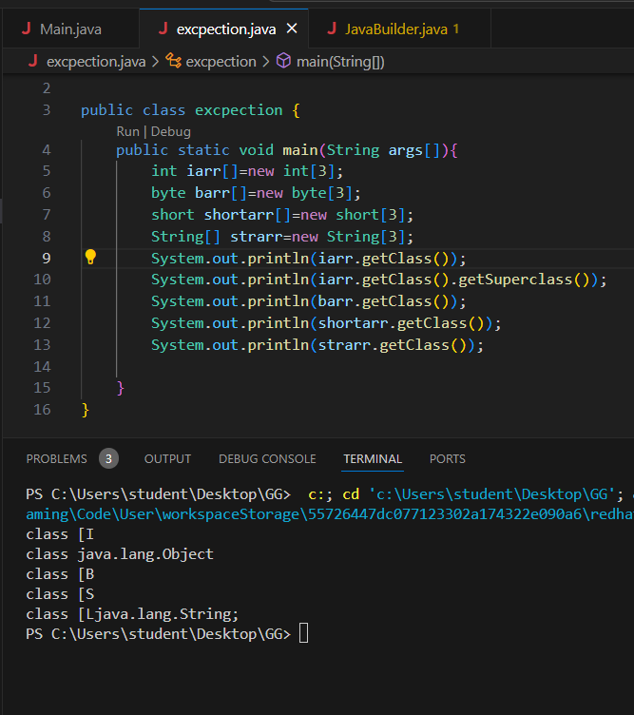

public class excpection {

    public static void main(String args[]){

        int iarr[]=new int[3];

        byte barr[]=new byte[3];

        short shortarr[]=new short[3];

        String[] strarr=new String[3];

        System.out.println(iarr.getClass());

        System.out.println(iarr.getClass().getSuperclass());

        System.out.println(barr.getClass());

        System.out.println(shortarr.getClass());

        System.out.println(strarr.getClass());

    }

}

8. cloning

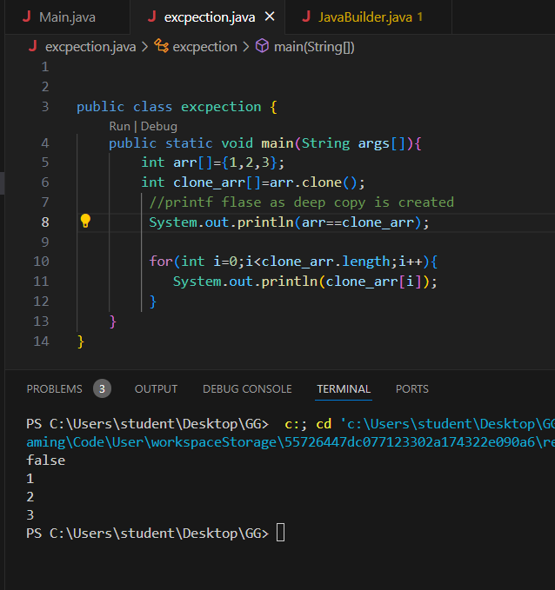

public class excpection {

    public static void main(String args[]){

        int arr[]={1,2,3};

        int clone_arr[]=arr.clone();

         //printf flase as deep copy is created

         System.out.println(arr==clone_arr);

         for(int i=0;i<clone_arr.length;i++){

            System.out.println(clone_arr[i]);

         }

    }

}

9. cloning mutli dimenstional array

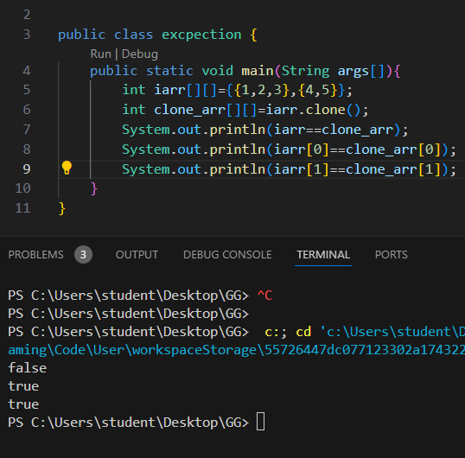

public class excpection {

    public static void main(String args[]){

        int iarr[][]={{1,2,3},{4,5}};

        int clone_arr[][]=iarr.clone();

        System.out.println(iarr==clone_arr);

        System.out.println(iarr[0]==clone_arr[0]);

        System.out.println(iarr[1]==clone_arr[1]);

    }

}