**// TYPE CASTING INT->DOUBLE**

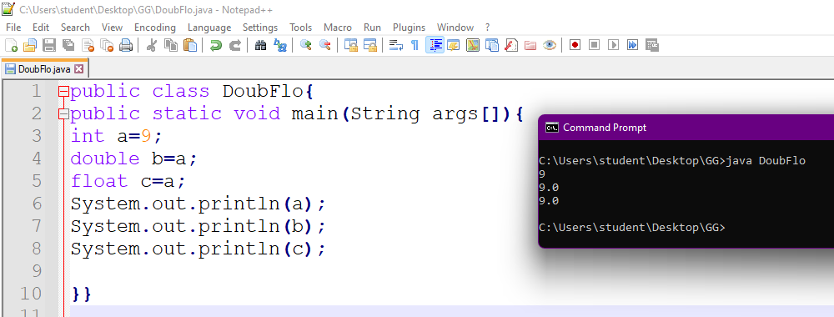

**// Type casting int -> float**

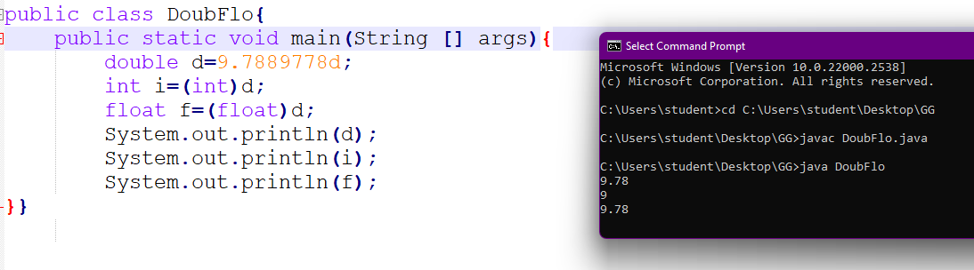

**//String + Number**

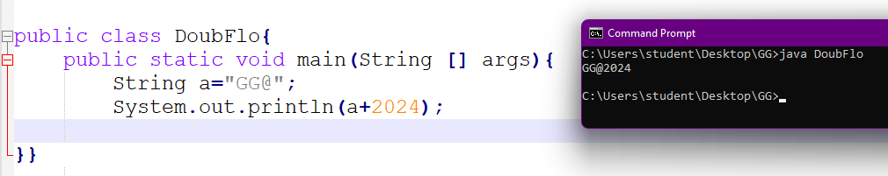

public class DoubFlo{

public static void main(String[] args){

int a=10;

double b=10.9;

int x=(int)(a+b);

System.out.println(x);

}}

//ternary operator

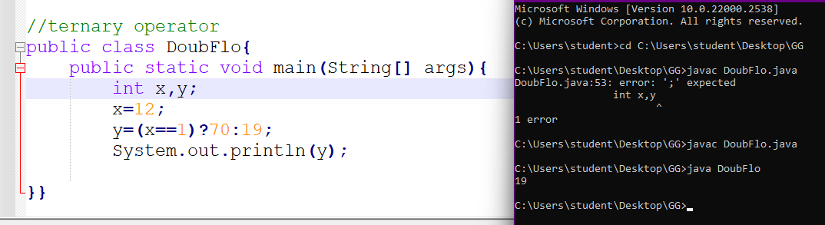

//length of the string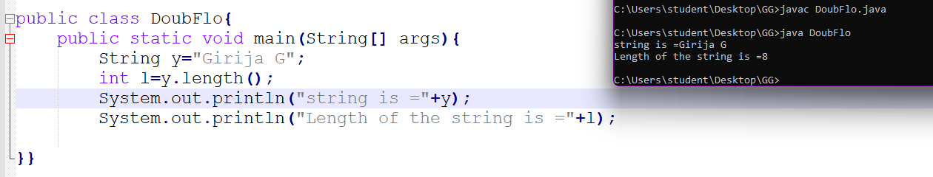

// convert to uppercase and lowercase

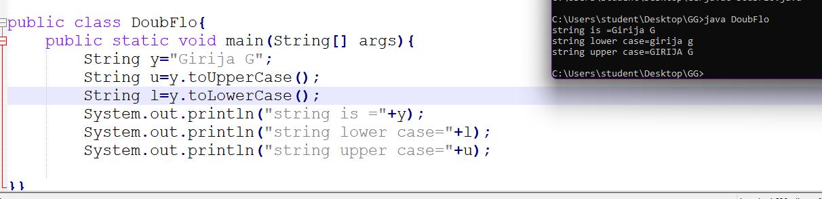

//indexOf() method

