03-09-2024

Tuesday

..

(

1)formatting date and time

Import java.LocalDateTime

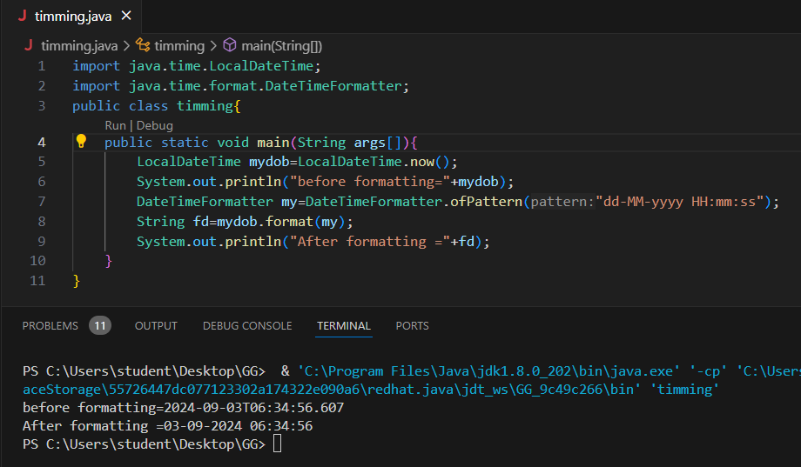

import java.time.LocalDateTime;

import java.time.format.DateTimeFormatter;

public class timming{

    public static void main(String args[]){

        LocalDateTime mydob=LocalDateTime.now();

        System.out.println("before formatting="+mydob);

        DateTimeFormatter my=DateTimeFormatter.ofPattern("dd-MM-yyyy HH:mm:ss");

        String fd=mydob.format(my);

        System.out.println("After formatting ="+fd);

    }

}

2)

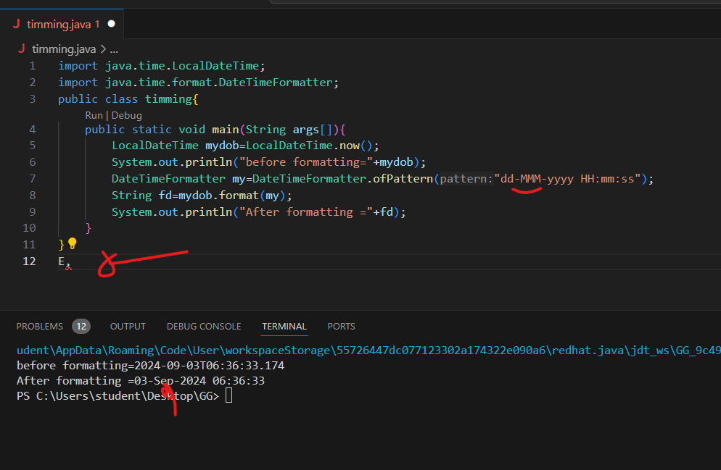

2) EXTRACTING NUMBERS FROM DATE AND TIME

IMPORTANT

**INHERITANCE**

**HYBRID AND MUTIPLE NOT SUPPORTED**

**Classes and objects**

OVERLOAIDNG,OVERDIFDING

diffrence

**class,subclass/child class,super class/parent class/base class**

**resuabliity**

**interface->implements**

**inheritance->extends**

**extnds->^^the functionlaity**

1. 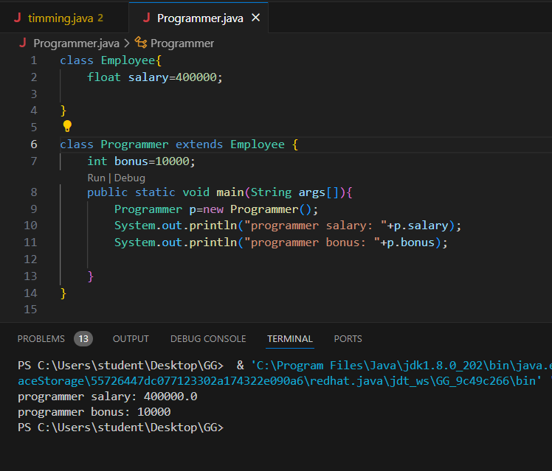
2. class Employee{
3. float salary=400000;
4. }
5. class Programmer extends Employee {
6. int bonus=10000;
7. public static void main(String args[]){
8. Programmer p=new Programmer();
9. System.out.println("programmer salary: "+p.salary);
10. System.out.println("programmer bonus: "+p.bonus);
11. }
12. }

**Single**

**Multilevel**

**Hybrid**

**Class gg**

**Imnew**

**// You are using Java**

**import java.util.Scanner;**

**class Triangle{**

**int a;**

**int b;**

**int c;**

**void area(){**

**double s=(a+b+c)/2.0;**

**double ar=Math.sqrt(s*(s-a)*(s-b)*(s-c));**

**System.out.printf("Area of the triangle: %.1f",ar);**

**}**

**Triangle(){**

**}**

**Triangle(int a,int b,int c){**

**this.a=a;**

**this.b=b;**

**this.c=c;**

**}**

**}**

**class Area{**

**public static void main(String args[]){**

**Scanner sc=new Scanner(System.in);**

**int a=sc.nextInt();**

**int b=sc.nextInt();**

**int c=sc.nextInt();**

**if((a+b>c) && (a+c>b)&& (b+c>a)){**

**//if**

**Triangle tr=new Triangle(a,b,c);**

**tr.area();**

**}**

**else{**

**System.out.println("Invalid triangle");**

**}**

**}**

**}// You are using Java**

**import java.util.Scanner;**

**class CharacterChecker{**

**void checkAlphabetType(char c){**

**if((c>='a' && c<='A')&&(c>='A'&&c<='Z')){**

**if (c=='a'||c=='e'||c=='i'||c=='o'||c=='u'||c=='A'||c=='E'||c=='I'||c=='O'||c=='U'){**

**System.out.println(c+": vowel");**

**}**

**else{**

**System.out.println(c+": consonant");**

**}**

**}**

**else{**

**System.out.println(c+": not an alphabet");**

**}**

**}**

**}**

**class Main{**

**public static void main(String args[])**

**{**

**Scanner sc=new Scanner(System.in);**

**char c=sc.next().charAt(1);**

**CharacterChecker ch=new CharacterChecker();**

**ch.checkAlphabet(c);**

**}}**