StringTokenizer

1.

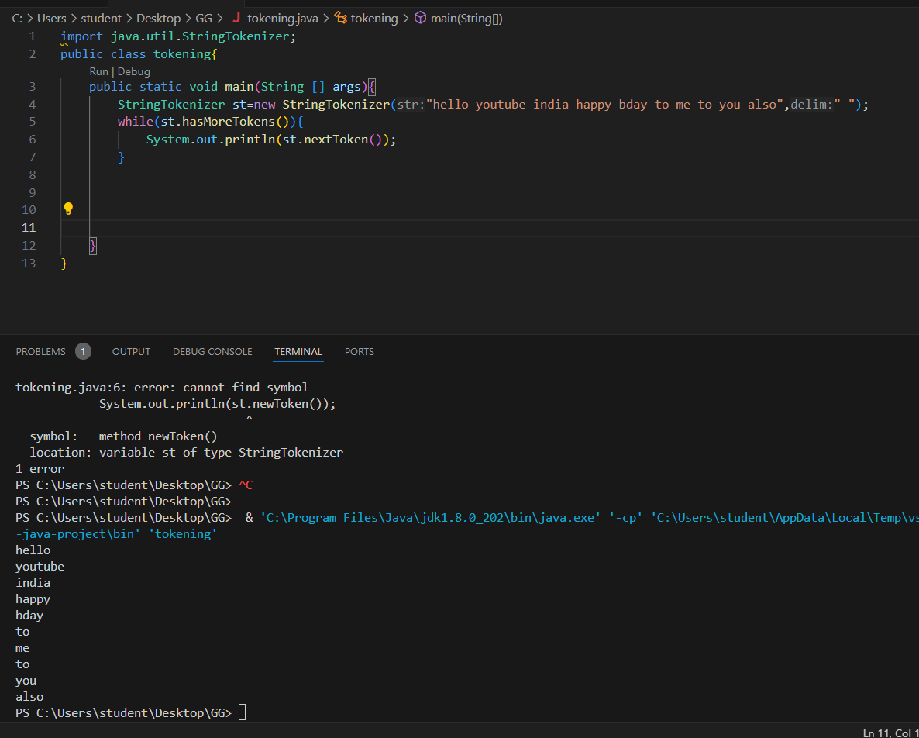

import java.util.StringTokenizer;

public class tokening{

    public static void main(String [] args){

        StringTokenizer st=new StringTokenizer("hello youtube india happy bday to me to you also"," ");

        while(st.hasMoreTokens()){

            System.out.println(st.nextToken());

        }

    }

}

1..

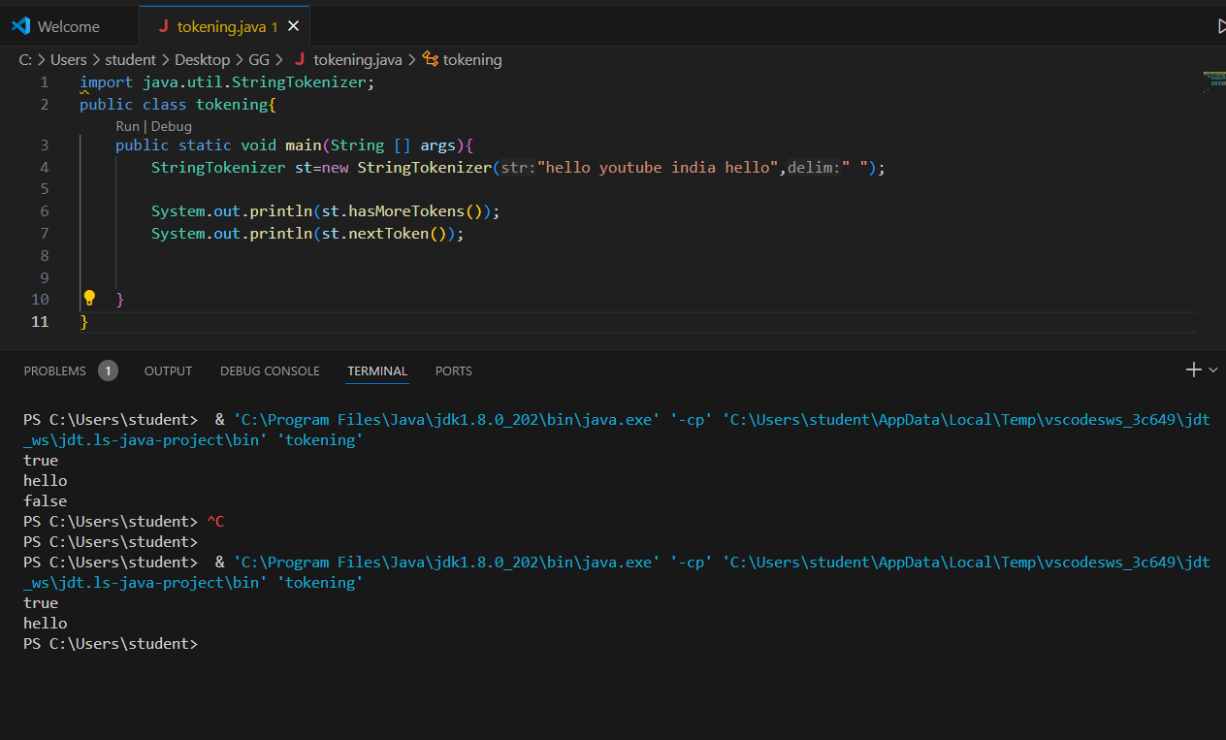

import java.util.StringTokenizer;

public class tokening{

public static void main(String [] args){

StringTokenizer st=new StringTokenizer("hello youtube india hello"," ");

System.out.println(st.hasMoreTokens());

System.out.println(st.nextToken());

2.st.nextToken()

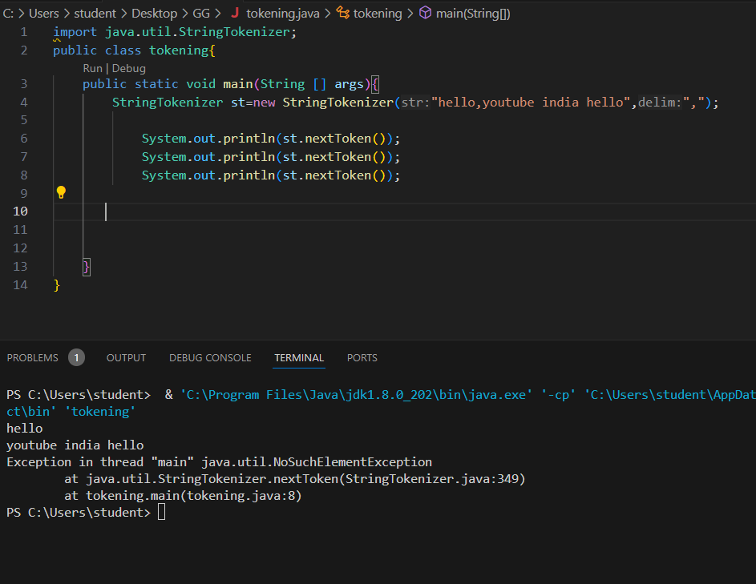

import java.util.StringTokenizer;

public class tokening{

public static void main(String [] args){

StringTokenizer st=new StringTokenizer("hello,youtube india hello",",");

System.out.println(st.nextToken());

System.out.println(st.nextToken());

System.out.println(st.nextToken());

}

}

}

}

3. st.hasMoreElements()

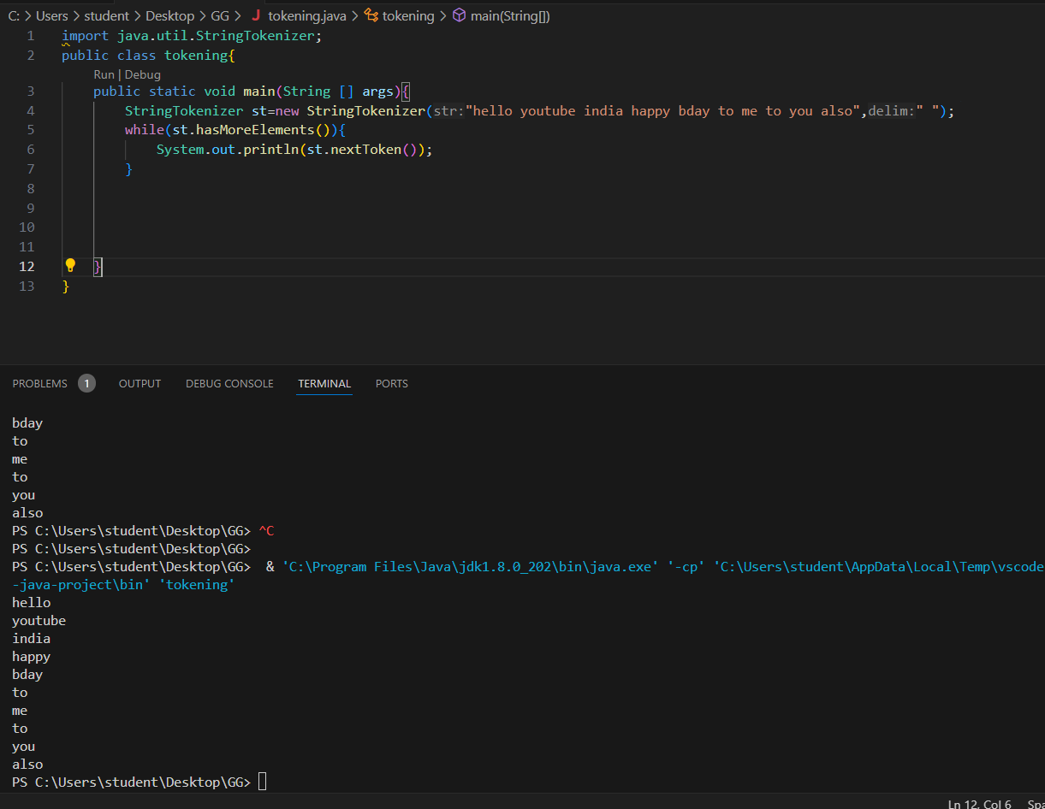

import java.util.StringTokenizer;

public class tokening{

    public static void main(String [] args){

        StringTokenizer st=new StringTokenizer("hello youtube india happy bday to me to you also"," ");

        while(st.hasMoreElements()){

            System.out.println(st.nextToken());

        }

    }

}

4. st.nextElement()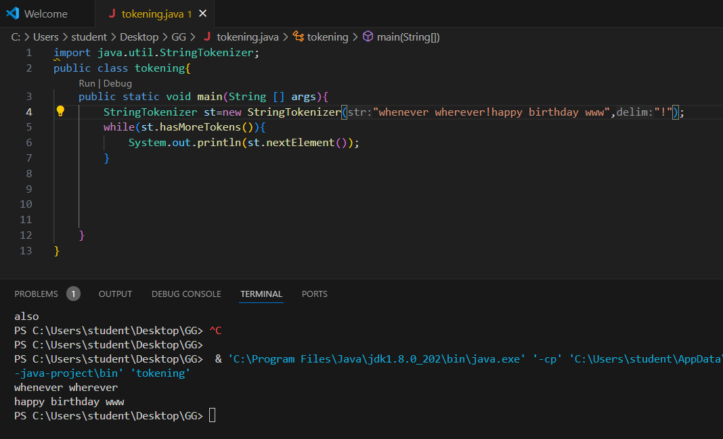

5.

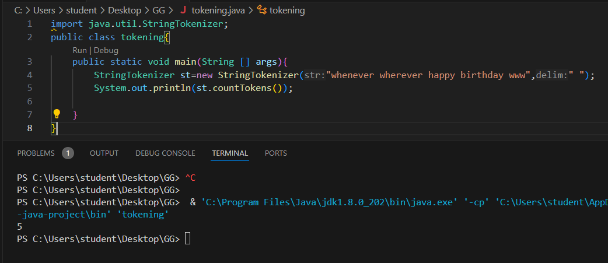

6. 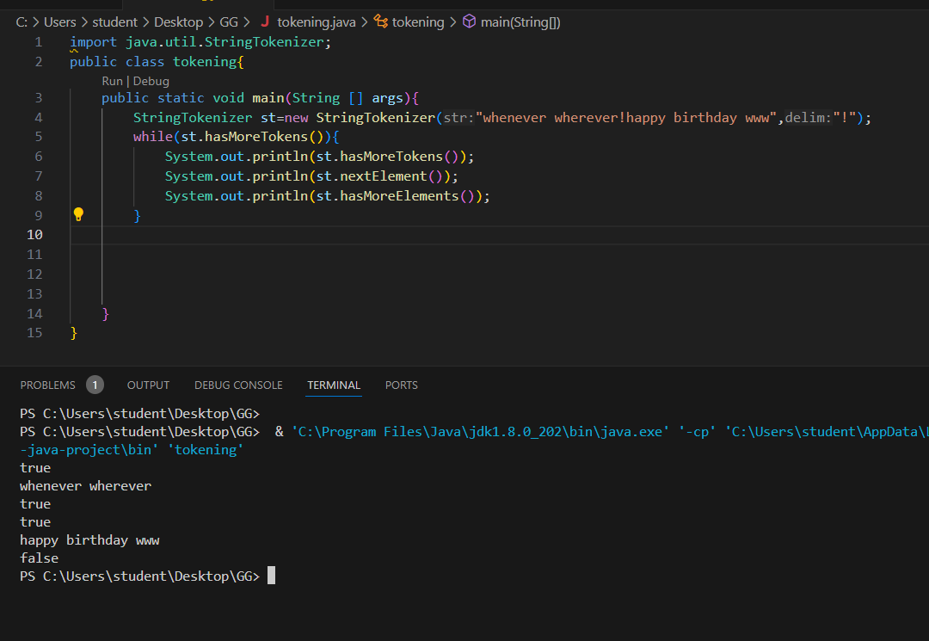

import java.util.StringTokenizer;

public class tokening{

    public static void main(String [] args){

        StringTokenizer st=new StringTokenizer("whenever wherever!happy birthday www","!");

        while(st.hasMoreTokens()){

            System.out.println(st.hasMoreTokens());

            System.out.println(st.nextElement());

            System.out.println(st.hasMoreElements());

        }

    }

}

ARRAYS IN JAVA

1.declare

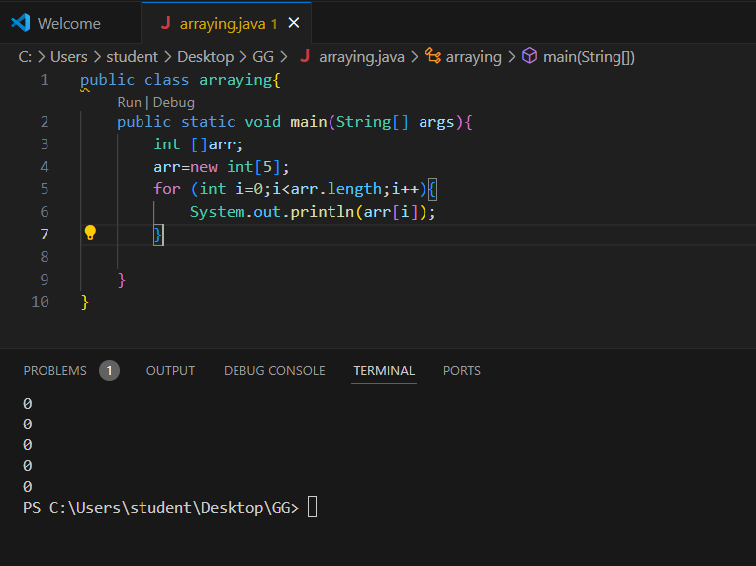

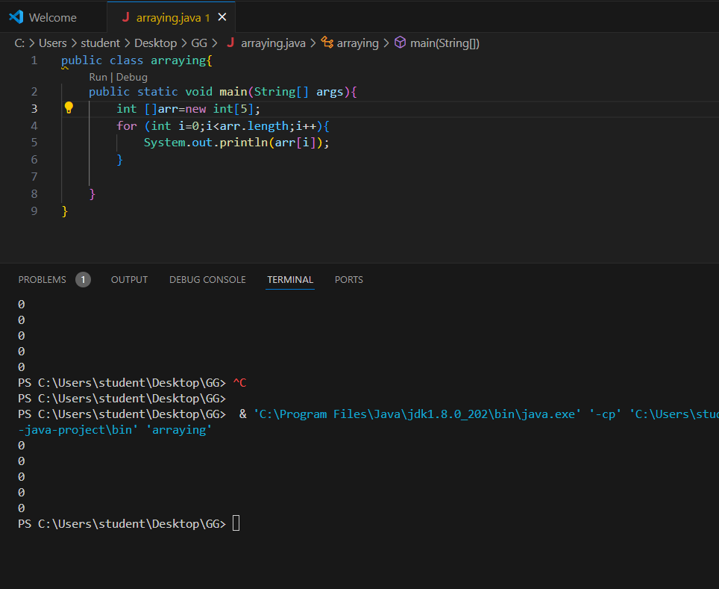

public class arraying{

    public static void main(String[] args){

        int []arr=new int[5];

        for (int i=0;i<arr.length;i++){

            System.out.println(arr[i]);

        }

    }

}

2.

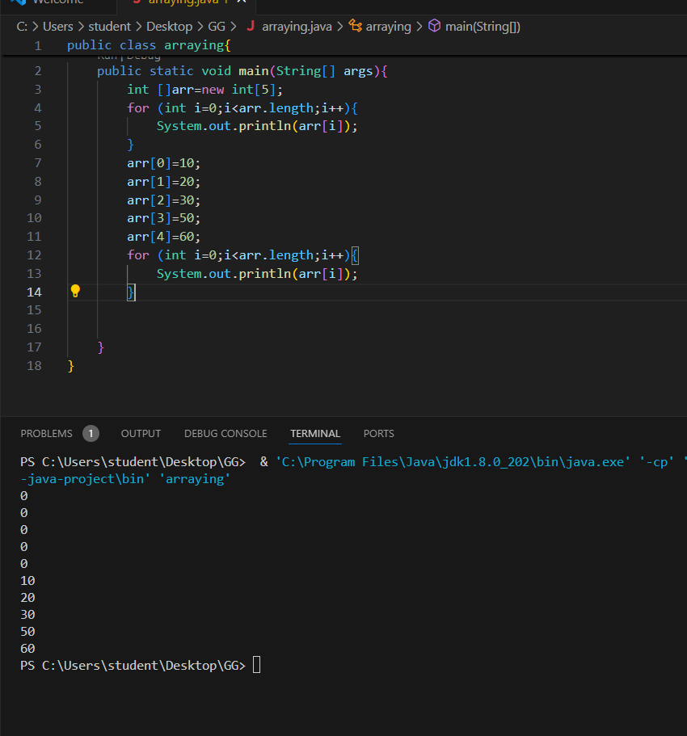

public class arraying{

    public static void main(String[] args){

        int []arr=new int[5];

        for (int i=0;i<arr.length;i++){

            System.out.println(arr[i]);

        }

        arr[0]=10;

        arr[1]=20;

        arr[2]=30;

        arr[3]=50;

        arr[4]=60;

        for (int i=0;i<arr.length;i++){

            System.out.println(arr[i]);

        }

    }

}

import java.util.Scanner;

class student{

public int roll;

public String name;

student(int roll,String name){

this.roll=roll;

this.name=name;

}

}

public class Main{

public static void main(String[] args){

System.out.println("enetr no.of student deatils=");

Scanner sc=new Scanner(System.in);

int n=sc.nextInt();

student [] arr=new student[n];

for (int i=0;i<arr.length;i++){

System.out.println("element at i="+i+": roll="+arr[i].roll+"name"+arr[i].name);

}

arr[0]=new student(1,"kamala");

arr[1]=new student(2,"galatta");

arr[2]=new student(3,"appna");

arr[3]=new student(4,"chillak");

arr[4]=new student(5,"tillak");

for (int i=0;i<arr.length;i++){

System.out.println("element at i="+i+": roll="+arr[i].roll+"name"+arr[i].name);

}

}

}